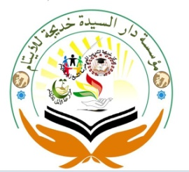

Khadija Foundation
(KHF)
Profile
JAN, 2017

Contact:
+252-63-3358318
Email: info@khadijafoundation.org
umkreem4@hotmail.com

Who We Are
Khadija Foundation is a Somaliland-based international NGO providing humanitarian support, international development, emergency aid and disaster relief in some of the Somaliland’s most deprived areas and families. Established in 2010 and rapidly growing into one of the leading charities in the Somaliland, Khadija Foundation also looks to tackle issues prevalent in the Somaliland as well, such as Education, Health, orphans, families , student support , disable children and appeals causes.

How we started

Khadija Foundation (KHF) began with a school and purchasing 100 hector of land. In the Islamic tradition, which advocates that charity starts at home, we wanted to give back to our UAE community first. And education was the best thing we knew to give.

How We Grew
Today, Khadija Foundation (KHF) is a Somaliland-based charity, and although we’ve been engaged in charitable work from the outset, education was initially our key priority. After our Somaliland schools proved to be a success, KHF started building schools overseas. Our focus was educating orphans and children from underprivileged communities. This led to our work with orphans and vulnerable families, and then to the establishment of the KHF shelters. Eventually we launched our water aid and livelihood projects, as well as the Khadija Foundation medical aid programmes. 2014 became a turning point for us, when KHF rose to the challenge of providing emergency aid during the Emergency Drought for the last years. This was our first venture into the area of Overseas Disaster Relief. That October, and in the winter months which followed, Khadjia distributed food, shelter kits and medicine to survivors of the droughts. Since then, KHF has undertaken emergency aid missions all Somaliland regions. Our support of the Somaliland droughts survivors was recognized by the United Arab Emirates in 2016.
What We Believe
At Khadija Foundation (KHF), we believe in balance without compromise. We believe in accountability and mindful giving. We believe that charity and education go hand in hand. And here’s how this translates in our work:
Working with Partners
Support Orphans
Sustainable Development

KHF believes that all human life is equal. Every community has a right to benefit from the world’s natural resources. Every person has the right to lead a self-sufficient, dignified life. Where people have been affected or uprooted by disasters and conflict, we provide relief to help them through the crisis. But KHF also believes in helping people help themselves. That’s why we run sustainable development programmes, which range from livelihood projects to long-term water aid solutions.

Our Vision

To help the orphan-child notwithstanding the physical , mental and cultural drawbacks’ they face in the environment realize their inherent potential into mature citizen and lead an independent and socially satisfying life with self-pride , self -esteem and self-confidence

Our Mission

To initiate income-generating activities for sustaining the orphans and empowering the orphans so that they can improve their readiness for the reintegration of the children back into the community and seeking sustainable life for poor families by training them through different means of creating jobs.

Our Goal
To provide the displaced orphans with basic necessities such as food and educational opportunities supporting them to contribute, share and participate in the development of their communities in order to break the vicious cycle of poverty and broken families in the society. Poverty alleviation and reducing unemployment are the additional targets of the foundation to help the community to gain stabilizing decent life condition.
What services Khadija Foundation provides:
- General charitable purposes
- Overseas aid/famine relief
- Environment/conservation/heritage
- The prevention or relief of poverty
- The advancement of health or saving of lives
- Economic/community development/employment
Khadija Foundation provides services to:
- Children/young people
- Other charities or voluntary bodies
- Elderly/old people
- The general public/mankind
- People with disabilities
What we do
Khadija Foundation (KHF) works locally and globally to alleviate the suffering of dispossessed Orphanage. Through generous donations, we’re able to make a difference and save lives. We provide:-
Sponsored Orphans
Khadija Foundation host maximum 7000 orphans for all regions of Somaliland since 2011, Khadija support same cash incentives in a monthly based in order to cover the basic needs of education fees.
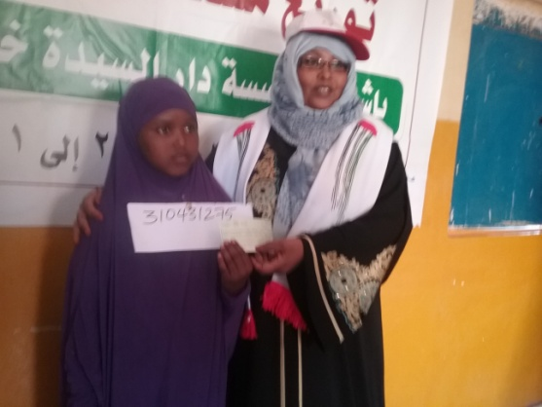

Family Needs
Khadija Foundation host 1500 families since establishment, so far 737 families. Khadija foundation provide same incentives to these families, these families aimed to support their basic needs since December, 2016.
Support Disabled Children
Khadija Foundation support handicapped children through all Somaliland regions. Khadija registered 150 disabled children. We support basic family needs including medical support for those vulnerable.
Charity Appeals
Khadija started this service in 2011. We provide basic shelter needs and we collect clothes, dry food, medicine and clothes the UAE people and finally we distributed the vulnerable families and children.
Scarifies Animal for Eid Celebrations
Khadija extremely support for mothers orphanage support for scarifies animal for the two Eid days in each year. Last year, we supported 135 Animal, 33 caw and 4 camels. After scarified the meet distribute the vulnerable communities including orphans and poor families.
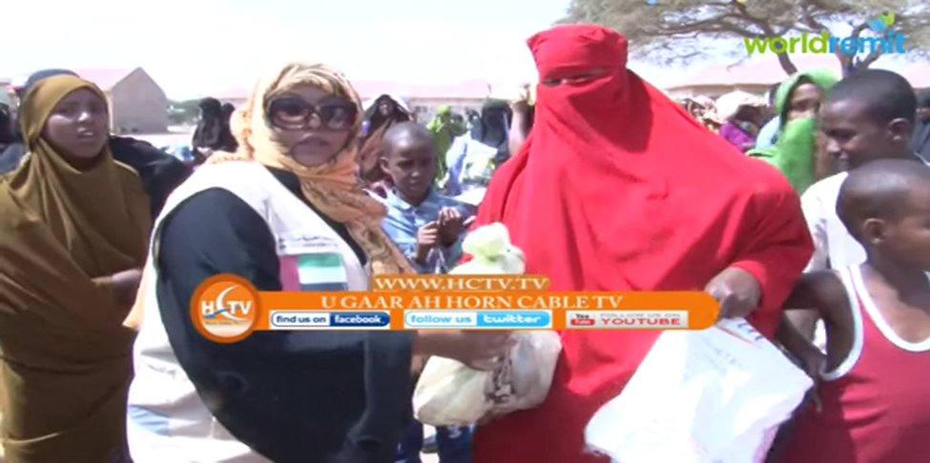
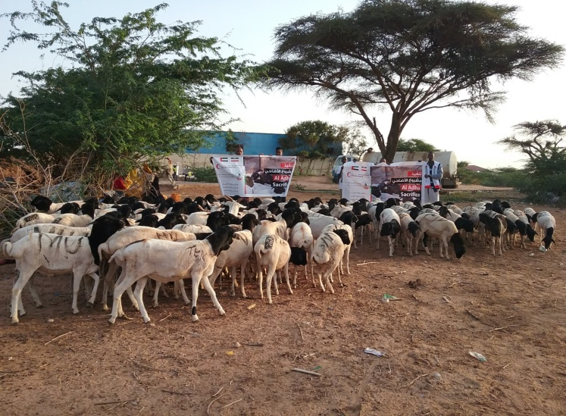

Food Banks for Poor families
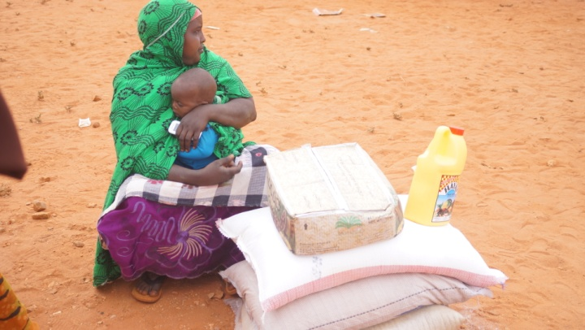
Khadija Foundation support poor families for dry food including Rice, Oil, Diet, Milk, sugar. Khadija distribute these dry food all Somaliland regions by targeting the vulnerable communities effected by droughts and other natural disasters with the respect of global warming.

A mama and her children received food bank
Cloth Distribution
Khadija foundation has strong background for collections of second hand clothes in UAE for the last four years. After collections the clothes, the foundation support to the vulnerable people specially orphans. In Eid days, Khadija provide orphans new clothes which purchased in different markets. Khadija also constructed a mosque in Kaladac village near Burao in 2012.
Orphanage Centers
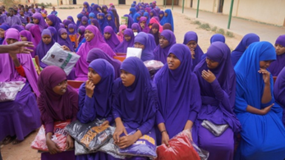
Khadija Foundation established three orphanage centers in Sheikh, Buroa and Hargeisa. The centers host 400 orphans for the three schools 250 male and 150 male. The age of these orphans between 4 up to 14 ages.

students benefiting schools constructed by Khadija foundations
