IHOPE FOUNDATION



10/23/2017
ANNUAL REPORT 2017

IHOPE FOUNDATION

ANNU A L R E P O R T 2 0 1 7

Contents
MESSAGE FROM THE BOARD OF MANAGEMENT 2
MESSAGE FROM THE TEAM LEADER 3
ABOUT US 4
OUR VISION 4
OUR MISSION 4
OUR CORE VALUES 4
2014 OUR SUCCESS 5
SEXUAL AND REPRODUCTIVE HEALTH/AIDS CAMPAIGNS 6
NUTRITIONAL SUPPORT TO PLHIVS 7
OUR IHOPE FELLOWS PROGRAM 8
IMPROVING SHELTER FOR A WIDOW LIVING WITH HIV/AIDS 9
DONATION OF MEDICAL SUPPLIES TO RURAL HEALTH FACILITIES 10
HEALTH OUTREACH PROGRAMS 10
CONCLUSION 11
OUR CONTACTS 12

MESSAGE FROM THE BOARD OF MANAGEMENT
We would like to introduce our 2017 annual report by taking a moment to say “Asante” or “Thank you” to the organizations and individuals who have partnered alongside IHOPE Foundation. We value your participation and would like to express our gratitude for supporting us in our vision of improving rural health and the environment in the Migori County, Kenya.
We believe in increasing our preparedness to face challenges and enhance our accountability not only to our partners, but also to the community. Thanks to your investment in our programming, we have been able to accomplish a great deal this year and have expanded our reach in the community to address issues of water, sanitation and health (WASH), Adolescent sexuality and provision of sanitary towels to a number of girls and sensitization programmes which targeted the artisanal gold miners on the dangers of mercury on their health, HIV/AIDS awareness with the help of our Canadian volunteers.
By employing strategic direction in our policies, resource mobilization and investing in key projects, IHOPE Foundation has assisted in the creation of a vision that encompasses the diversity of all of our beneficiaries. As such, we thank you again for sustaining community development and human rights by tangibly supporting us in the actualization of our vision, without you we could not have accomplished our goals this year.
Thank you and best wishes. Sincerely,

David O. Maganya
Founder & Director

Siobhan Brenton
Co-Founder & Director

Renee K. Bartlett
Co-Founder & Director

MESSAGE FROM THE TEAM LEADER
Thanks to your generous support, in 2017 alone we were able to achieve the following:
Our IHope Fellows program got a boost from Canadian families who are supporting two needy and bright orphans through High School education. On the same breath, Memorial University of Newfoundland Health Outreach Education and Promotion (MUNhope, Canada) is supporting one of the IHope Fellows at the Kenya Medical Training College with the sole aim of empowering the locals to undertake health related careers to boost the number of health care service providers in the rural Kenya.
Through Financial assistance from North East Ohio Medical University, we were able to reach about 400 girls with hygienic products for young women in what was dubbed ‘KEEP THE GIRL CHILD CLEAN CAMPAIGN.’
For the first time in the history of the organization, we received 4 volunteers from Canada under our Volunteer Program who assisted us both financial, donations and helping us conduct the several of our outreach programs like water and sanitation promotion, providing psychosocial support to Persons Living with HIV/AIDS besides offering Nutritional Support to 9 PLHIVs.
We received donations from Brenkir Company of Canada a number of Personal Protective Equipment (PPEs) which enabled us to efficiently and effectively sensitize the artisanal gold miners of Migori on the dangers of Mercury on their health. 17 Artisanal gold miners benefited from safety glasses, gloves and respirators besides being equipped with knowledge and skills on the best practices of Mercury handling.
Our Water, Sanitation and Health benefitted a total of 2,000 students in different schools in the rural location of Migori, Kenya. We also donated sanitation facilities-5 tanks and soaps for hand washing. Our volunteers together with our team in an effort to ensure improved sanitation in the rural villages of Ragana Community constructed a cumulative of 40 movable dish racks that help in drying the dishes hence keeping germs away, thus reduction of some infections like typhoid and cholera.
Education is a key tenet of development and is supporting this endeavour, we donated 11 wooden desks and text books to Mwanambiri Junior Academy, a number of balls to schools which aimed at integrating the fight of HIV/AIDS by keeping the kids engaged in co-curricular activities.
In order to live to the spirit of improving rural health, we shared donations which included gloves and laboratory supplies with Riat Dispensary, Sori Lakeside Maternity &Nursing Home and Mama Clinic of Migori, Kenya to make their work easy in a resource constrained funding from the Government of Kenya.
I would like to thank all of you for that exciting, fascinating year and I’m looking forward to continue growing IHope Foundation with you in the years to come.
Yours,

Dr. Jared Ndege
Team Leader

ABOUT US:
IHOPE Foundation is Non-Governmental Organization working in Migori, Kenya. We are registered by the NGO Coordination Board under Reg No:OP.218/051/14-0368/9714.
The work of IHOPE Foundation focuses on hard-to-reach and most-at-risk populations. Our services reach orphaned and vulnerable children, youth, low-income communities and the general public to improve their quality of life through responsive and innovative health programming, service delivery and capacity building in ] Kenya.
Our Programs include; IHOPE SkyMed,Water, Sanitation and Health, Mercury and Health among artisanal gold miners, Sexual and Reproductive Health/AIDS awareness targeting in and out of school youths, IHope Fellows program and psychosocial support to Persons Living with HIV/AIDS. We also run a volunteer program which gives an opportunity to give back to the rural community of Migori, Kenya.

OUR VISION:
The vision of IHOPE Foundation vision is to Improve Rural Health through innovative and creative approaches.

OUR MISSION:
IHOPE Foundation is an organization working with underserved communities to improve the quality of life for at risk populations through responsive and innovative health programming, service delivery and capacity building in both Canada and Kenya.

OUR CORE VALUES:
IHOPE Foundation has grounded core-values from which it is built:
- Service to the underprivileged to bring forth hope and change lives
- Accountability and transparency to ensure credibility
- Openness to feedback and ideas to ensure we are creative and innovative
- Quality, excellence and the continuous improvement of services to deliver high impact and cost effective support for our stakeholders
- Stakeholder participation, as community-based solutions are the key to our success

“You will never understand the relief I had after this wonderful news of my son’s scholarship. All my other children had to drop out of school - this has been my biggest worry... thank you very much.”
Mother to IHope Fellow - Phelix Wambogo after MUNhope Canada came to his rescue.

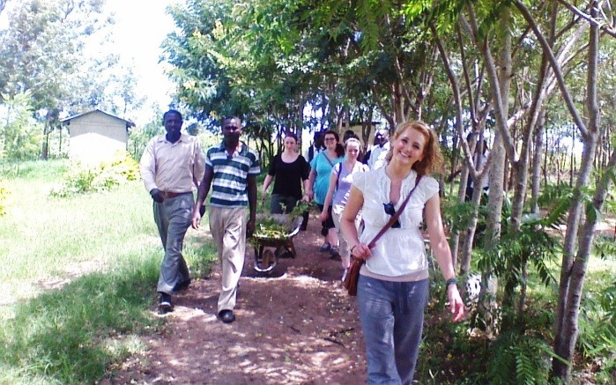
‘As a social work student, volunteering with the IHOPE Foundation gave me an amazing opportunity to observe both the strengths and challenges that are evident in Migori. The IHOPE Foundation is highly accommodating and will find ways to ensure your experience is relevant and fulfilling. My activities were extremely hands on, varied, and engaging. Working in collaboration with experienced leaders in the community was an excellent way to learn and exchange knowledge. Every individual can benefit from being immersed in the unique lifestyle and culture of the surrounding communities. The program gave me many
opportunities to utilize previous skills and attain new ones. It will leave you with amazing memories, new friends, knowledge of different cultures, and increased awareness of the complex challenges and social issues that occur in this part of the world. Volunteering with this organization is a life-changing and unforgettable experience.’

Jessica Taylor, Memorial University of Newfoundland

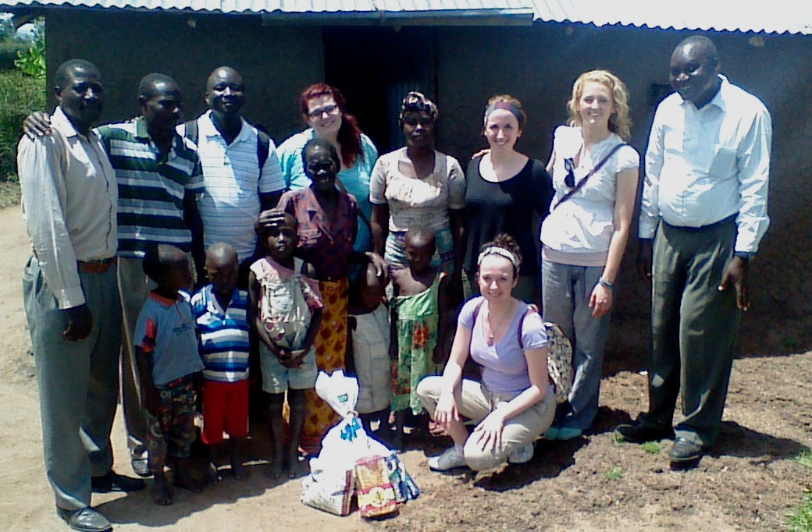
2017 OUR SUCCESS

Community Health Workers together with our volunteers donating food items to one of the Persons Living with HIV/AIDS in Ragana Community. Out team counselled and encouraged her to continue taking medication and eat healthy diet.

SEXUAL AND REPRODUCTIVE HEALTH/AIDS CAMPAIGNS
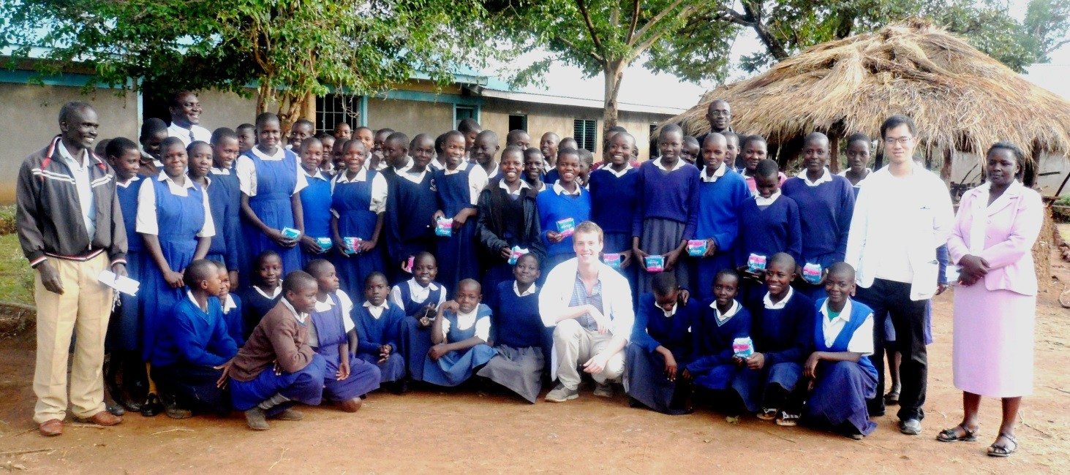
It is well known fact, that educating girls is one way of contributing to fight against poverty, building sustainable economies and contributing to healthy families in the developing countries. Unfortunately, even in countries where primary education is free and secondary education is subsidized by the governments like in Kenya, girls especially in the rural areas have continued to perform poorly compared to the boys. There are many factors that contribute to this alarming trend. They include absenteeism and drop out problems among the girls in the rural areas. Dreams of girls from poor families are sadly shelved due to challenges related to menstruation, early pregnancy, and HIV/AIDS. HIV infection rates in girls are 4 times that of boys the same age mainly because girls from poor families engage in sex at an early age as a way of earning a living.
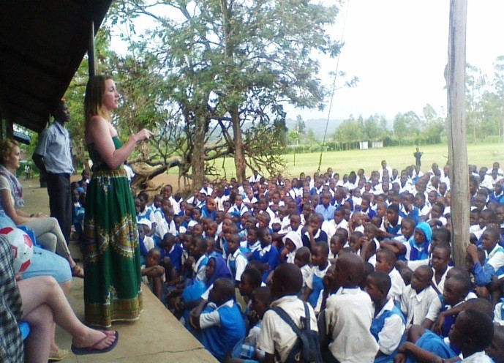
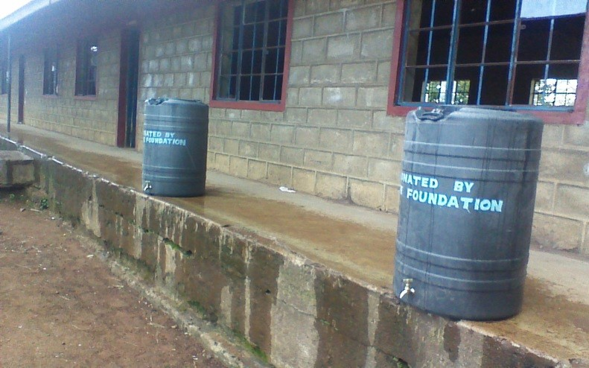
We are glad to note that through our program to schools on Sexual and Reproductive Health/AIDS, we have managed to sensitize the young boys and girls on dangers of teenage pregnancies, STIs, HIV/AIDS, Comprehensive Abortion Care and Post Abortion Care, personal hygiene and family planning options. This has indeed created impact as many young girls and boys are visiting the Youth Friendly Clinics to be assisted on reproductive health matters affecting their lives. We have also reached about 800 youths with SRH/AIDS key messages and equally donated sanitary pads to 400 girls that would keep them in school throughout hence academic improvement.
Renee Bartlett educating the pupils of Assar Johansson on the benefits of hand washing within the context of improving health.

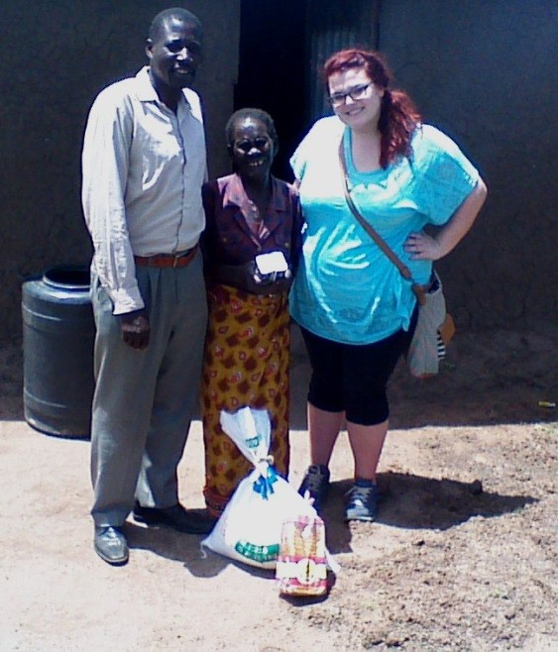
NUTRITIONAL SUPPORT TO PLHIVS
Few crises have affected human health and threatened national, social and economic progress in quite the way that HIV/AIDS has. The pandemic has had a devastating impact on household food security and nutrition through its effects on the availability, stability and access to food and its use for good nutrition.
Meeting immediate food, nutrition and other basic needs is essential if HIV/AIDS-affected households are to live with dignity and security. Providing nutritional care and support for people living with HIV/AIDS is an important part of caring at all stages of the disease.
IHope Foundation team visits a number of households and share food items with them besides providing psychosocial support to the PLHIVs.

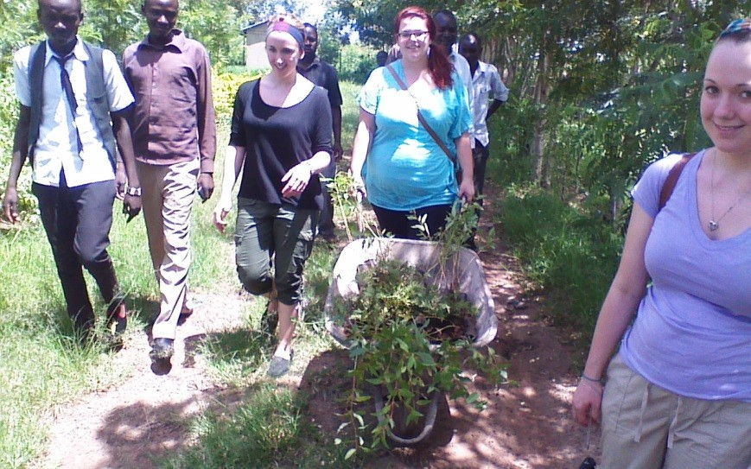
Volunteering for a worthy course, in this photo, our volunteers planting trees at Bishop Okinda Secondary School to keep the rural villages of Migori Green

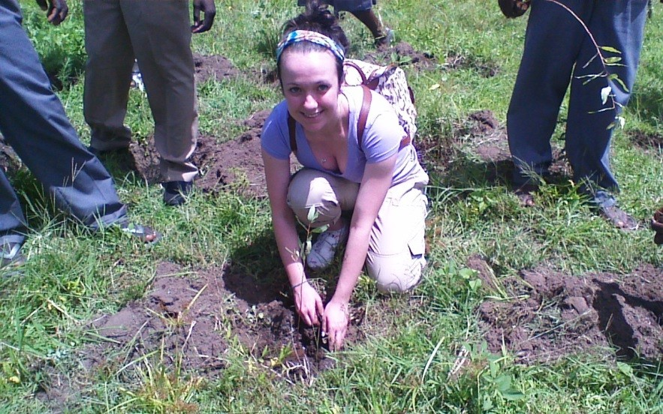

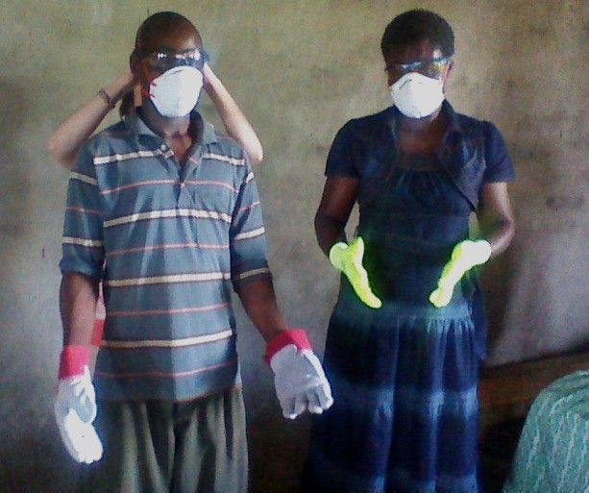
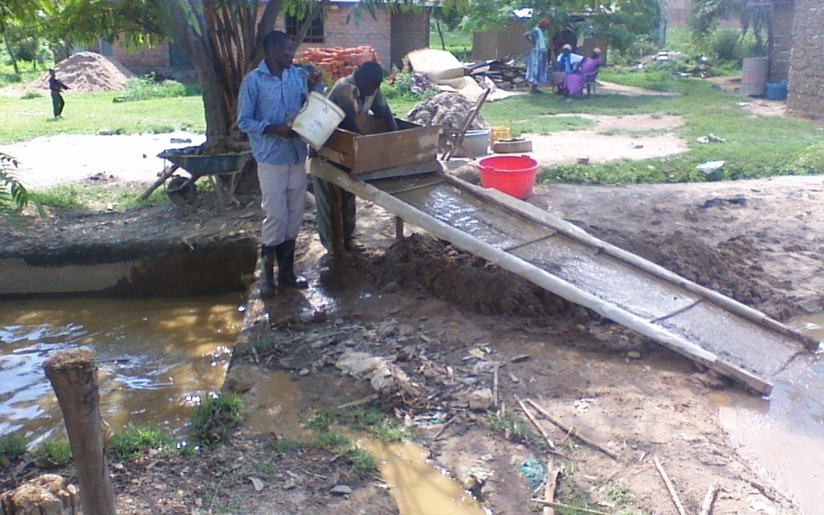
The process of gold mining in this region involves the use of mercury to extract gold particles from the earth. However, mercury is highly toxic.In this photo some of the PPEs beneficiaries are all smiles courtesy of Brenkir Company of Canada.

OUR IHOPE FELLOWS PROGRAM
We are currently supporting three needy and bright orphans to access basic education in Migori, Kenya. We are giving hope to these young boys and girls a wonderful opportunity to live a dignified life in future. The main aim of this program is to empower the orphans through health related programs in Universities and Tertiary Colleges. This relates very well with our vision of improving rural health through generation of manpower thus an increase in the number of Medical Practitioners in the rural Kenya. One of the three IHope Fellows, Phelix Wambogo is currently pursuing a Diploma in Clinical Medicine from Kenya Medical Training College and is in his Second Year of study and we have the same dream for the other remaining two.
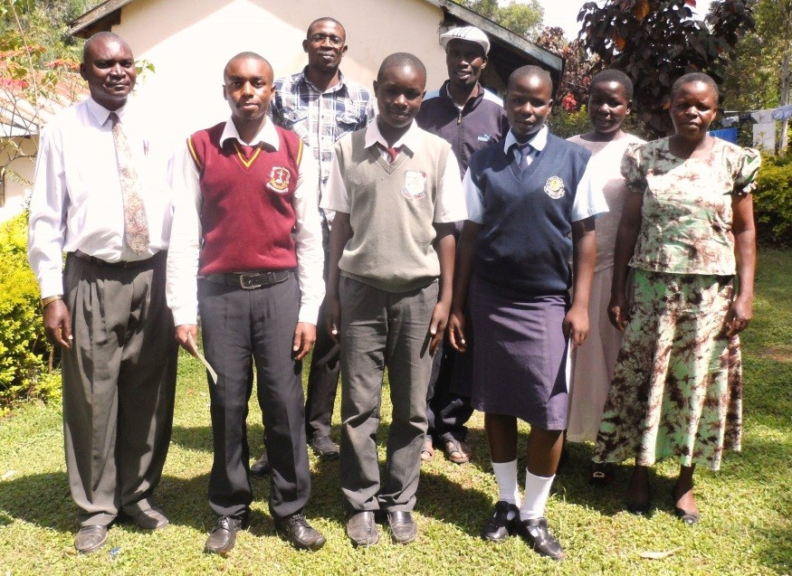
Memorial University of Newfoundland Health Outreach Promotion and Education (MUNhope, Canada) has sponsored the Medical student while the rest are by Canadian families (Glenn & Marie Bartlett, Renee Bartlett, Paula and Craig Courage, Emilly Courage) Our team wishes to thank so much the former President of MUNhope Canada, Siobhan Brenton and Renee Bartlett for spearheading the IHOPE Fellows program.

Phelix Wambogo, Tonny Okoth and Sheila Akoth, the IHope Fellows pose for a group photo with their guardians and Ihope team after being issued with cheques for their school fees.

Before Ihope Intervention (Inset Dr.Ndege sharing donations)

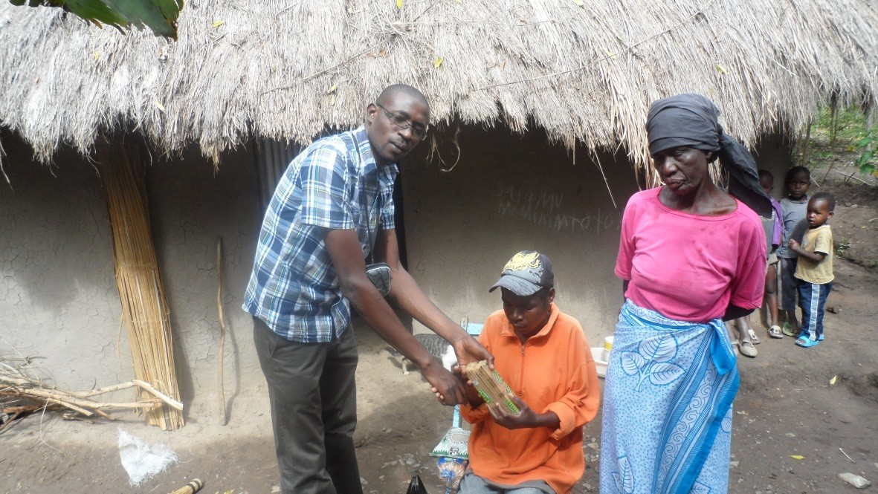
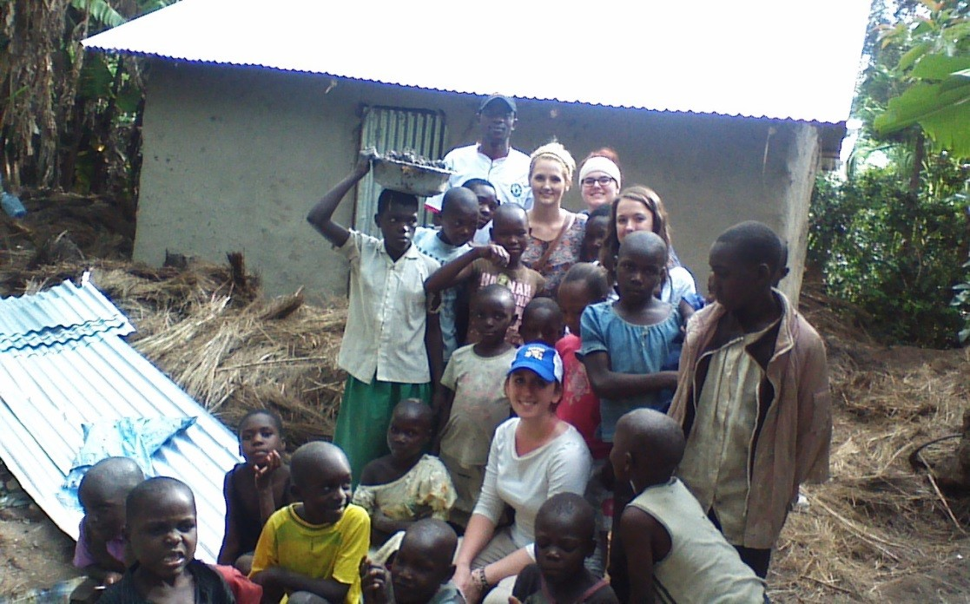
After Ihope intervention assisted with roof top replacement

The family of Jane Awino who is a widow living with HIV/AIDS is today all smiles after IHope Foundation improved their shelter. “I am glad and thankful to the Community Health Workers (CHWs) and Ihope Foundation for cushioning us from catching more cold when it rains and also security.” The jovial Jane noted.
Our volunteers donated money that was used to purchase iron sheets, round poles, nails and labour.
Jane who walks for a long distance to get the ARVs will no longer catch pneumonia due to the biting cold when it rains and we are glad that her health will improve.

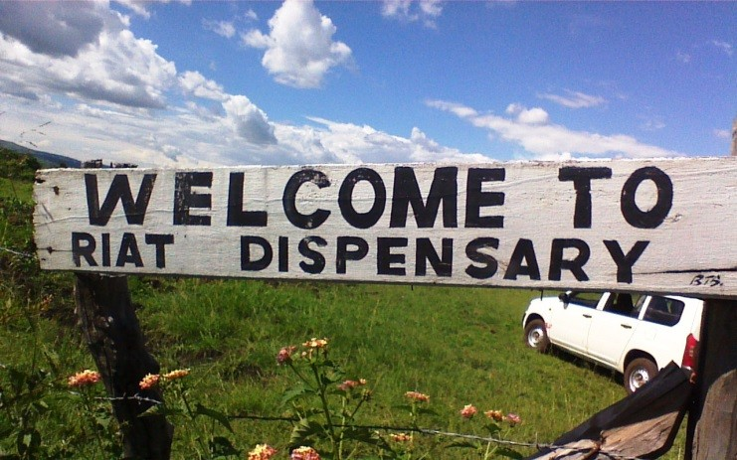
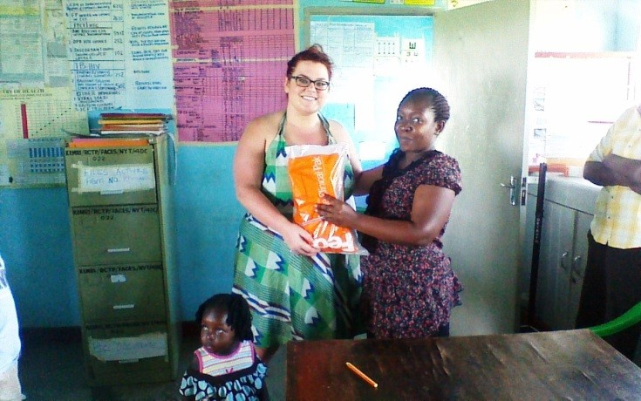
DONATION OF MEDICAL SUPPLIES TO RURAL HEALTH FACILITIES

In our efforts to improve health in the rural, we received medical supplies donations from organizations and well-wishers from Canada which we distributed to the local facilities which face a lot of challenges in the absence of these essential commodities.
In this photo, Siobhan Brenton handing over medical supplies to Riat Dispensary which serves about 6,000 locals and the HIV/AIDS infection rate stands at 12%.
We donated to other facilities like Sori Lakeside Maternity & Nursing Home, Migori Level 4 Hospital and Ragana Dispensary.

HEALTH OUTREACH PROGRAMS
Our past volunteers assisted during a Free Medical Camp organized by Kenya Red Cross to help the flood victims in Nyatike. Recently we conducted an outreach program in collaboration with Mama Clinic in Nyamanga of Suba West Division, Migori County.
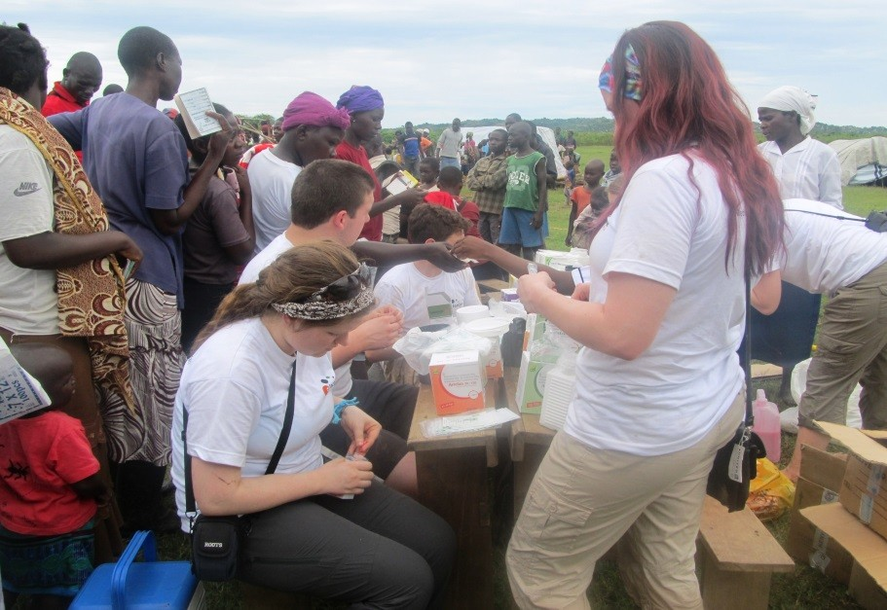
Assisting with packaging of drugs during the Free Medical Camp
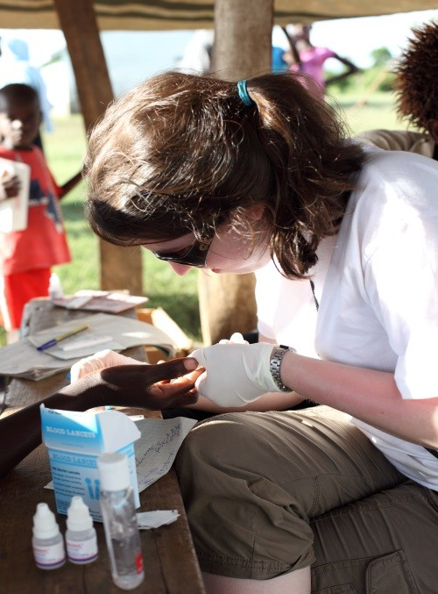
Testing a kid for malaria using RDT

We hope to continue improving rural health through innovative and creative ways and we must admit that we have so far created a lot of impact in our area of operation.
In order to maintain the positive outcomes gained last year, IHope Foundation will continue to be responsive to the guidance of its gracious contributors and the surrounding community. By learning from challenges in a way, that informs the strategic direction in our policies, resource mobilization and investment in key projects.

Migori, Kenya Office
Cosade Flats, Government Road, Opposite Migori Show Ground 1st Floor Left Wing Room 2
P.O. Box 732-40400, Migori, Kenya
+254700834913/+254720734146

Web: www.i-hopefoundation.org

E-Mail: team@i-hopefoundation.org

