KAPEDO DEVELOPMENT ORGANIZATION (KADO)

PROFILE

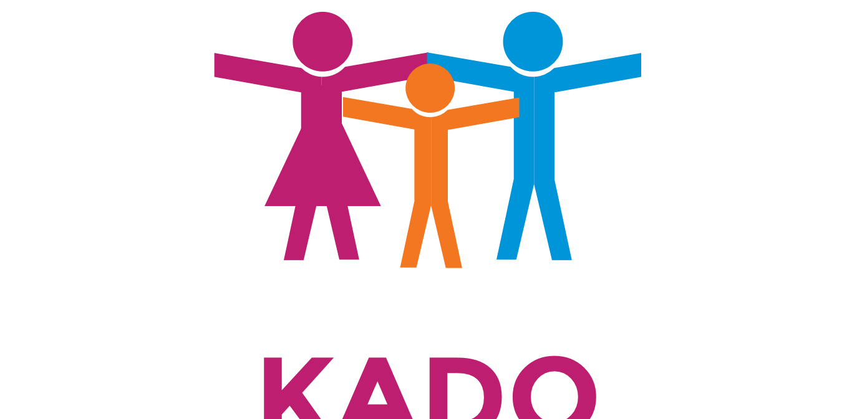

Contact Person
Hannington Eregae
Chairperson.

OFFICE HEADQUATERs  Kapedo Development Organization.  P.O Box 17 -30403,  Marigat, Kenya  Tel: 254- (0)-720 422180.  254- (0) - 726391395.  Kapedev15@gmail.com.  sireregae@gmail.com. | FIELD OFFICES  Lomelo.  Napeitom.  Kamuge.

Background

Kapedo Development organization (KADO) was founded by a group of elites in 2015 in Kapedo as a community Based Organization (CBO) to respond to numerous humanitarian challenges facing communities in Turkana East. It’s registered with the kenya social services department with registration No. DSD/TRKE/CBO/475.

Since its inception has KADO, it has been renown in Kapedo for helping the disadvantaged and providing literacy education and awareness for those with language barriers.

Through its humanitarian programs in Turkana East, KADO envisages implementation of the following programs:

- Youth vocational training and mentorship.
- Education/child development.
- Peace building and reconciliation.
- Health and HIV/AIDs awareness and preventions
- Food Security (Food aid and Livelihood)
- Water, Sanitation and Hygiene,
- Protection (Gender, GBV and Solar lighting programs)
- Shelter and Non Food Items (NFIs).
- Forest and wildlife conservation.
- Savings and revolving fund culture.

Vision

To overcome poverty through education and long-term sustainable development.

Mission

To transform lives among the vulnerable communities in Kapedo and the entire Turkana through providing an enabling environment for holistic child development and empowering the community for self reliance.

• Provision of emergency relief services whenever required.

• Provision of holistic, multi-sectoral and sustainable programs that bridge emergency relief and long-term development at the grassroots levels
• Empower communities by building capacity and by maximizing local resources in both program design implementations
• Promote self-reliance, peaceful coexistence, reintegration and protection of marginalized communities.
• Ensure all inclusive gender sensitive programs with special emphasis on women and children

Motto:
Touch a life, wipe a tear and make someone smile.

Objectives

• Promote quality and equal education for boys and girls
• Empower women and ensure their skills and participate in development initiatives, business and decision making circles
• Strengthen health care service delivery and further combat HIV/AIDs
• Increase access to safe drinking-water, basic sanitation facilities and key hygiene practices
• Improve nutrition status of malnourished children and pregnant lactating women as well as the elderly
• Provide protection for the vulnerable and marginalized and communities from Gender Based Violence (GBV) and other forms of Human rights violation.
• Improve the livelihood of disadvantaged people through eradicating poverty and hunger and achieving sustainable development in all aspects of human life
• To promote sport as a universal language special tool for peace promotion and co-existence.

Core values

This organization shall cherish the following:
Empowerment: KADO strongly believes that authentic sustainable development can only result from genuinely giving people power, wealth and capacity, hence the conscious choice to gain control over our lives.

Transparency: KADO will keep all transactions above board. We make decisions through consultation.

Accountability: KADO believes in taking responsibility of our actions and being open in the area of our work. We are accountable to ourselves, our members, our government and donors, and other partners.

Equity and Fairness: KADO believes in sharing resources based on the need and availability in a just way and treating community members, partners and collaborators with fairness and dignity.

Commitment and Teamwork: KADO believes in selfless service and passionate commitment in our work towards the betterment of the community, partners and collaborators.

Our Programmes and Activities
a. Health and Nutrition:
Various health indicators for Turkana point at a gloomy picture for its people. Diseases are rampant and aw are of this; KADO has identified health as one of the key areas to intervene to improve the lot of the Turkana people. There will be awareness on hygiene, sanitation and prevention strategies to ward off illnesses that can easily be prevented.

KADO w ill endeavor to improve on maternal health and reduce child mortality rate through education, improvement of basic health and institutions. Proper nutrition, quality preventive and curative medicine will be emphasized and support the establishment of necessary health infrastructure such, as well-equipped maternity w ards and health facilities.

Efforts are being made tow ards combating RH/HIV and AIDS and TB. This project involves awareness creation. The target groups have been girls, parents (w omen), health workers religious leaders and FGM practitioners. Attitudes, myths and believe that fuel the harmful practice among the community are identified among different community groups and focused on in awareness creation. Consultative forums and workshops are mainly used as the major strategy.

b. Livelihood:
KADO will encourage training in various skills in an attempt to fill up the high rate of unemployment among the Youths those without formal education can make it through Vocational skill training hence will be encouraged to take up the traditional “manual” jobs.

Specifically, KADO w ill financially support skill training for welding and fabrication, tailoring, life skills, carpentry, beauty & salon, Tie &dye, fish farming, book -keeping, computer, management skills and sports. So far, 38 youths (half boys and half girls) from various groups have received proficiency skills in a computer and welding and fabrication courses.

c. Education:

Education is a lifetime investment, shutting out ignorance and projecting the making of good decision at the individual, family and societal levels. Consequently, formal education will be advocated, with outreach activities lined up to ensure that children and especially the marginalized girl-child attend school. As funding allow s, there will be investments in the education of the children through support to institutions offering basic/primary education as w ell as adult literacy. It is env isaged that through education, the quality of the lives of individuals will improve in the long term.

KADO supported schools on its education project through Kapedo Trust Fund by making sure that all students completing their primary school level and attained good grades and from disadvantaged families have got access to school fees to enable them complete secondary level of education, Provision of learning kits (stationeries), text books and promoting co-curriculum activities, Providing sanitary towels and pads to adult girls in schools as girl-child education and hygiene promotions in schools.
KADO will also support the formation and training of local community education committees in education management. Specifically, KADO continues to support 4 schools in Kapedo with a mentorship and volunteers program.

D. Water, sanitation and Hygiene.
KADO continues to work toward finding ways to bring clean drinking water to the communities - both for the Pokot and Turkana tribes. The available water is both salty and hot, but with the right equipment and personnel, it could be made to provide drinking water and irrigation.Various individuals have worked on solutions to the salination of the water and as KADO we would like to partner with any local, national or international agency in provision of water because everyone has the right to water and sanitation. Water should be safe for drinking, cooking and personal hygiene. In order to promote sound environmental management, it is essential to ensure that existing water sources such as springs are protected from livestock, latrines.
KADO also plans to train communities in water resource management and hygiene. Also plans are underway to get funds and construct toilets and dumpsites for the community.

E. Protection and Gender Empowerment:
KADO w ill entrench the furtherance of space for rights of individuals and entire communities. Children and women’s rights will be supported through a gender equality program to enhance women in leadership, elimination of all forms of discrimination, protection from child abuse and exploitative labor.
KADO will actively participate by creating awareness and initiating preventive measures against GBV. It is effectively done through trainings, print material distribution, counselling and training community leaders to be advocates for prevention of violence.
KADO w ill in turn provide gender practitioners with tools of analysis and equip them with the Knowledge that they require to serve the community as w ell as for advocacy.

F. Governance and Rights:
KADO have in place a program that supports the training of community to value democratic governance, human rights, social justice, peace building, media and gender equity.
Further, instability and armed conflict in Kapedo- Pokot border, coupled with weak governance capacity to control or monitor movements across borders has created fertile grounds for the emergence of forced migration. KADO has increased the level of awareness and understanding of local authority and community stakeholders in this phenomenon. It has since engaged in enabling the collection of information on cattle rustling as well as developing a system of identification and support for affected victims.

G. Poverty Alleviation:
Border related conflict and various disasters have made entire populations reeling from a severe lack of economic dependence. Fighting poverty and eradicating extreme hunger are some of the Millennium Development Goals for which KADO is engaged in helping achieve for Turkana. The organization w ill source for funding to support income generation programs at the community level.

H. Peace building and reconciliation:

Social cohesion and networking among the locals has been enhanced by KADO involving the local community and their neighbors’ in peace building, conflict mitigation, early warning responses, peace forums, reconciliation and inter community dialogue. This has facilitated harmonious co-existence among members from different ethnic background. Awareness campaigns and training targeted leaders, clergy, youth, women and men in the communities along Turkana and Pokot corridor.

I. Hydro electricity development.

Kapedo is badly hit by inaccessibility and lack of electricity; it is relatively rich in interesting sceneries like waterfalls which may be tapped to produce hydro electric power from the Suguta river. For twenty years now, Kapedo Village has developed through trial and error their own installed micro hydro electric plant with a 5 KVA to support the village in lighting, led lamps charging, hand phones charging, missionary houses and a health facility besides other twenty seven households which have been using the power to watch television sets. It is a small dot light in the darkness.
Through financial support, KADO wishes to upgrade the plant from 5KVA dynamo to 20 to 30KVA power in order to be used by the whole community.

Strategy

• Based on the provision of services on prioritized needs of the society on the principal of non- partisanship

• Cooperate with Local, national and international organizations with genuine efforts and resources to achieve project activities

• Organize their activities in a viable standard that can be self- sustaining even when external inputs are withdrawn

• Give appropriate attention and respect to the customs, national constitution, religion, etc. of the concerned parts to avoid tension and confrontation

• Stick to its policies thoroughly to principles to avoid confusion or overlaps
Implemented projects

No | Project Title | Fund by | Type/Cluster | Location | Date
1. | Kapedo Education Trust fund | Joe Maddox/Wasunna Family | Education | Kapedo-Kenya | 2005-2015
2. | Annual English competition | Joe Maddox/Wasunna Family | Education | Kapedo-Kenya | 2005-2015
3. | Vocational training Welding/Fabrication. | Kapedo Elites Association. | Livelihood | Kapedo-Kenya | 2015.
4 | Kapedo clean-up campaign | GPUSA/Kapedo Elites | Sanitation | Kapedo-Kenya | 2015.

Organization’s governance system

KADO is under the management of the Board of Directors who draws their strength and relies on policy directives from the assembly.

The Board’s role could be summarized; reviewing policy matters, coordinating and guiding the implementation activities and other matters, delegates by the general membership council with impartiality and objectivity. At a general membership council (assembly) decisions are taken on 2/ 3-majority votes, and at board level we apply at consensus base.

Board of directors

# | Name | Sex | Title
# | Name | Sex | Title
1. | Josphat Koli Nanok | M | Patron
2. | Augustine Logiron | M | Board Chair
3. | Benson Lokwang | M | Vice Board Chair
4. | Ekuru Aukot | M | Legal Advisor
5. | Nicholas Wasunna | M | Donor funding Advisor.
6. | Francis Edome | M | Technical Advisor
7. | Vincent Palor | M | Financial Analyst
8. | Hannington Eregae | M | Chairperson
9. | Clarrison Yono | M | Secretary
10. | Jane Apetet | F | Vice Secretary
11. | Cephas Lopeyok Namaiya. | M | Organizing Secretary
12. | Sarah Akal | F | Treasurer

Board structure

Donor
Board of directors

Chairperson

Vice chairperson

Secretary

Finance
Auditor

Members

