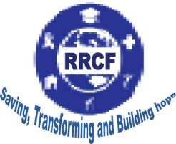
RELIEF AND RESQUE CHARITY FOUNDATION
P.O. Box 36, Kampala
Kireka - Namugongo Road, Tel: 0772 – 043406 / 0758 – 699939
Email: rereafrica@gmail.com, www.relief and resque charity foundation.org

ANNUAL REPORT

FOR

2018

1.0. Background
1.1 Relief and Resque Charity Foundation (RRCF)
Relief and Resque Charity Foundation (RRCF), the local registered nongovernment, not for profit organization established in 2014 and registered with board. RRCT promotes human values (love, faith and hope) through education and training initiatives for the disadvantaged and marginalized groups like children and youth and women.

Initially, RRCF was started as a process of encountering Orphaned and vulnerable children (OVC_{s}) and youth in a bid to assist them realize their full human potential. The main focus of RRCF is to offer adult company to children and youth from difficult social economic backgrounds through legal and psychosocial support, rehabilitation, skills training and job support through industrial placement. RRCF focus is anchored on addressing the Social cultural, social economic as well as the challenges of vulnerable communities through human rights support, education and training of human development

Since its inception its activities have grown from informal activities to an organizational structures with four main units, namely;
- RRCF Vocational Training Centre (VTC), located in Kireka along Namugongo, P.O. Box 36, Kampala – Uganda (training mainly the vulnerable boys and a few girls who have dropped out of the formal education system in the communities) and those who have completed.
- RRCF Psychosocial Programme (offering psychosocial Support to vulnerable and HIV/STD infected youth; youth and children who have got into conflict with the law and the community so are taken to Naguru Remand Home for rehabilitation).

1.2 RRCF Mission
-Promotion of human values through saving education and training initiatives for the disadvantaged groups in society
-By saving, transforming and building hope.

1.3 Specific Objectives
1. Empowerment of disadvantaged youth education and training for sustainable development and self0reliance.
2. Rehabilitation and reintegration of unaccompanied children by carrying out behavioral change programs and social integration for underprivileged youth especially street children and juvenile offenders.
3. Networking and coordinating with local and international initiatives in the sector of education and skills development, health, gender, child rights, entrepreneurship and environment issues.

1.4 Management structure
RRCF is governed by a Board of Directors comprising of five members that; (The Chair Person, the Treasurer, the Secretary and 2 members). RRCF has two Vocational training institutions headed by two principals, the principal’s work with a core management team and report to the board. RRCF has a well-established professional team with expertise in various fields like Management, Project Planning and implementation, Reporting and Documentation, Monitoring and Evaluation, counseling and Social WORK, Accounts/ book keeping, Pedagogy, Training (facilitating workshops) and computing skills.

1.5 Working experience
RRCF has a wealth experience in project design and implementation. RRCF has successfully implemented various projects in child rights protection and legal support, technical and vocational training as well as health and food security with local and international organizations such as:
- Girl child and women development Uganda
- Intergrated Family Support Uganda (IFACASU)
- ICEP – Institut Zur Cooperation bei Entwicklungs- Projekten
- Hands of Mercy Uganda
- Ministry of Education Science Technology and sports African Network for Prevention and protection Against Child abuse (ANPPCAN)

RRCF networks with other faith based organizations like: Meeting Point International and Nsambya Home Care Unit both working with people living with HIV/AIDS.
RRCF enrolls and trains vulnerable youths in technical and vocational skills identified from the community and other organizations.

2.0 RRCF Vocational Training Centre (RRCF VTC)
RRCF VTC provides vocational training to the vulnerable and most disadvantaged youths such as street children; juvenile offenders released from confinement for instance Naguru Remand Home and school dropouts up to ordinary level within the community. The centre also equips young people interested in vocational skills with courses of Carpentry and joinery: Brick/ Block laying and Concrete Practice, Welding and Metal Fabrication. In its programs and approach, RRCF VTC directly contributes to the achievement of the governments’ skills development plan.

2.1 RRCF VTC Overall goal
To educate passionate, pro-active, employable, innovative and self-driven youth of character willing and capable to face the daily societal challenges thus becoming economically and socially reliable.
2.2 RRCF VTC specific objectives
1. To enhance the quality of youth vocational competences provision.
2. To create and strengthen our Organizational and Management effectiveness in vocational education.
3. To achieve the self-sustainability of our vocational training centre.

3.0 RRCF Vocational Training Centre.
RRCF Vocational Training School is one of the programs of Relief and Resque Charity Foundation offering vocational skills training to all categories of people especially the most vulnerable youth in the society who are interested in skills acquisition for self-reliance.
We offer vocational skills to the girls orphaned mainly due to HIV/AIDS. Today RRCF enrolls all categories of vulnerable youth including a few boys to acquire different skills offered by the school. These include child mothers, youth infected and affected by the HIV/AIDS scourge; youth from very poor socio-economic background; orphans by other natural causes or armed conflicts that affected the country for many years. The training programs are both non formal and formal.

31. RRCF CVTS Specific objectives
1. Provide students with industrial, competence-based training and soft skills responsive to the market demand.
2. Have professional management staff and instructors with required knowledge base and competencies in their respective trades.
3. Expand the Production capacity RRCF CVTS’ production unit for future sustainability.

3.2 RRCF CVTS Milestone for the year
- Students Enrolment for 2017
` A total enrolment figure of 150 trainees was registered in 2015 as reflected in the table below:
Formal Course | Year | Enrolment | Male | Female
Tailoring | I | 20 | 3 | 17
Tailoring | II | 22 | - | 22
Catering | I | 18 | 2 | 16
Catering | II | 20 | - | 20
Sub-Total |  | 80 | 5 | 75
Non-formal/Modular Course
ICT | Community | 34 | 13 | 21
Tailoring | Community | 9 | - | 9
Catering | Community | 18 | 5 | 13
Hairdressing | Community | 2 | - | 2
Sweater Kitting | Community | 5 | - | 5
Basket Weaving | Community | 2 | - | 2
Sub-total |  | 70 | 18 | 52
Grand Total enrolment |  | 150 | 23(15%) | 127(85%)

- Training activities
Catering and Hotel Management
This involves competences such as Banking (Pastry); Cookery; Housekeeping; Nutrition and Front Office Operation were offered to the trainees both on formal training or the short term training/non-formal training programs.
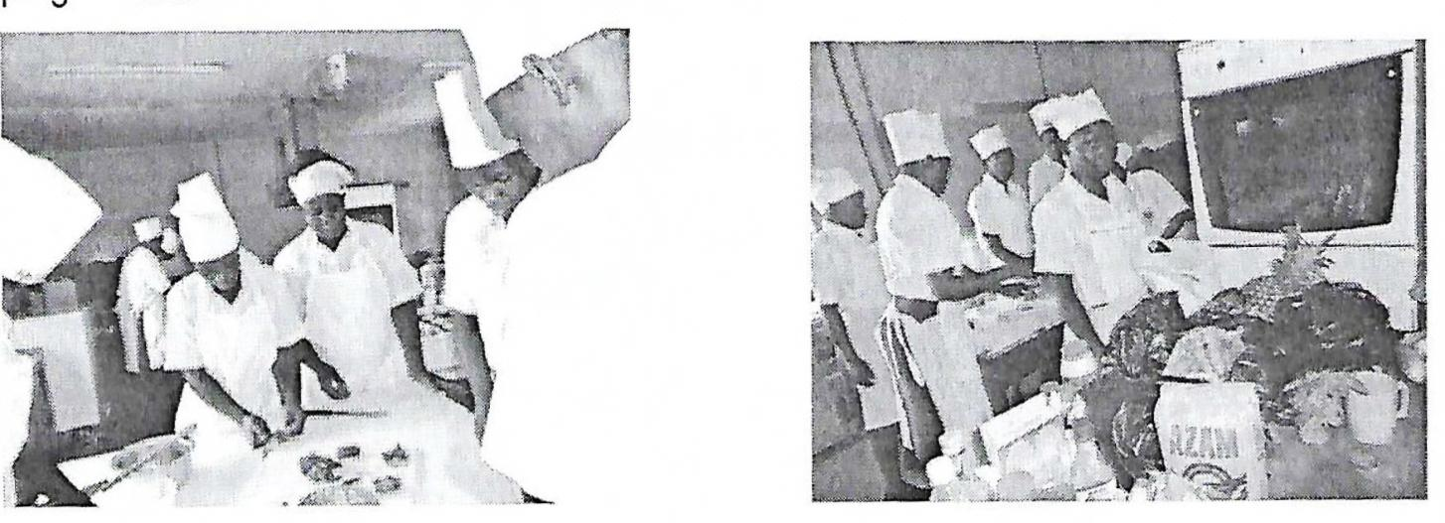

Photo 1: Catering students participate in Photo 2: Students prepare items for practical lesson
practical lesson

Tailoring Garment cutting and making
Under the Tailoring course, skills like Machine Embroidery; Screen Printing; Surface designing and Sweater Knitting formal part of this mainstream tailoring course. They were offers for those whose interest was in pursuing it for either two years or a few months in the modular training programme.
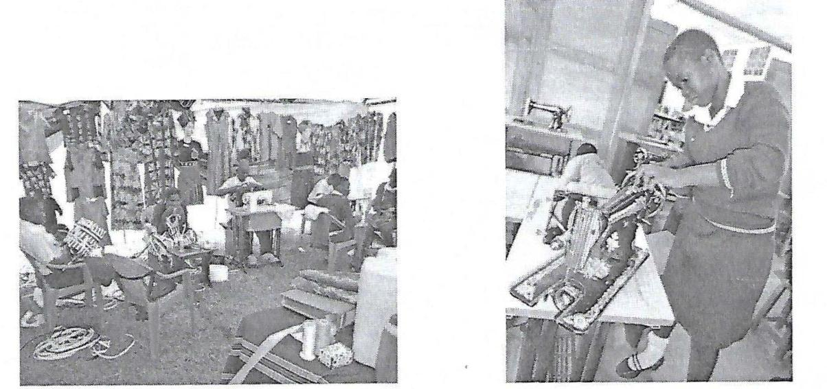

Photo 3: Tailoring students participate in an Photo 4: A student does simple maintenance
exhibition of a sewing machine

Informal Technology (IT) – (Computer) Skills
This was compulsory to every trainee regardless of the course being pursued. IT offers a wide range of creativity and innovativeness in both Tailoring and catering courses.

Photo 5: Youth from the community come for IT training during holidays.

Life skills
Students benefited from both technical and hands on training. In line with RRCF CVTS’ objectives, the training was not limited to the practical aspect only but was extended to cover soft skills as well, an area of outmost importance in their formation for better competence and relevance in the ever growing competitive labour market. Soft skills that focuses mainly on attitude change towards vocational training and work; communication and leadership skills, building self-confidence and assertiveness; HIV/AIDS, Civic Education with more focus on women participation in politics and Legal / Human Rights. The methodology used involved group and individual counseling by instructors and organized talks by guest speakers from the industry and workshops conducted.

Purchase of training tools and equipment
The school management purchased four new computers with the funds from ICEP SWEAR programme to strengthen the IT department and increase the clientele from the school and surrounding communities snot only to become computer literate but also to raise internal revenues for the institution for sustainability of the program.

Graduation
RRCF CVTS graduates 78 students who completed their different courses in 2017-2018.

Students’ assessment
The school prepared 33 students for assessment and certification set by Directorate of industrial Training (DIT). 15 were Tailoring candidates while 18 were candidates of Catering and they are now waiting for their results.

Industrial training
Out of the 33 candidates of 2017 who successfully completed their Examinations, 18 of them are already attached to industries for their industrial training that will take three months. These industries include; Serena Hotel, International Hotel Muyenga, Sports View- Kireka, Estella Hotel –Kira among others.

Social- Economic empowerment
RRCF has been offering community skills training to the juvenile community. Through its trainings on Bead making, Barbering, Candle making, Liquid soap making, Wood curving and Joinery, a number of direct and indirect beneficiaries have acquired skills that have transformed their lives. This has reached 458 direct beneficiaries throughout the entire three years of the project.
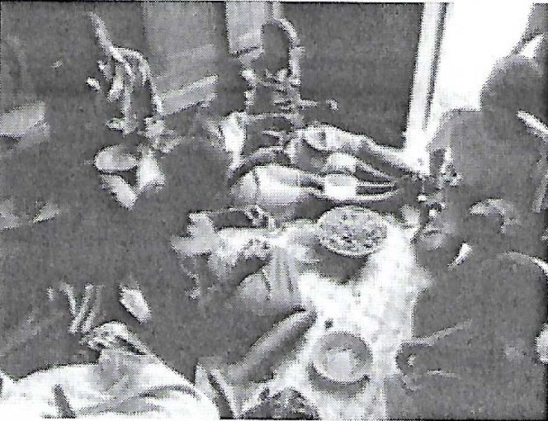

Photo 6: Juneniles being trained on jewel making using beads.

Food security and nutrition
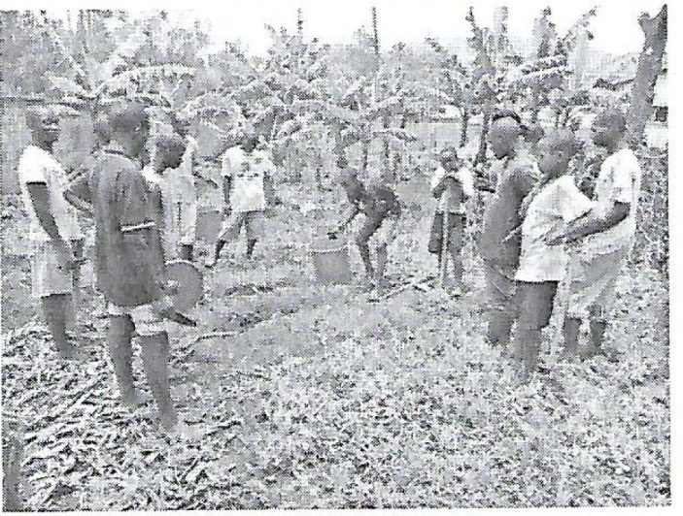
331 Juveniles have not only acquired skills in Horticulture growing but have as well benefited from the harvests to supplement on the their diet. More so the cooking demonstrations which expeoses the juveniles to nutritional knowledge and skills.

Photo 7: Juveniles trained on backyard gardening.

Child protection
RRCF has been offering child protection through its activities. These include holding interactive learning sessions with Juveniles to create awareness about their value, roles and responsibilities in the society, rehabilitation, resettlements and referrals which involve counseling and guidance (case management), legal support (accompanying juveniles to court, follow up on child case) and referring them to relevant service providers. This has been 808 benefiting from these services.

Family strengthening
Through holding dialogues with parents of the detained children, Parents have been sensitized on child protection hence increased awareness on child rights. The juveniles are receiving life skills trainings that have enhanced their health in form of improved hygiene and awareness on HIV/AIDS prevention.
A total of 250 beneficiaries have participated in family strengthening activities throughout the SCORE project.

Basic Education
Education has been a vital part of the work undertaken by RRCF. A-Social workers with help of volunteers at Naguru Remand Home. The overall objective behind offering basic teaching is to equip children with skills in reading, writing, English and Mathematics. This helps children to easily cope
(re integrate) into the main stream Education system. It also supplements Government efforts in fighting high levels of illiteracy common among most juveniles. Through different learning modalities

RRCF A-social workers have been able to foster a reading culture for all the in-mates and lay strong foundation to support those children who want to continue with their education in future. A total of 15 juveniles have been identified from the remand home to join RRCF Vocational training centre for further studies in technical and vocational courses next year. These juveniles have been partially supported by Distance support Programme from AVSI foundation.

5.0 RRC Ongoing projects
RRCF has partnered with other development organizations to implement the following projects throughout this year 2017.

1. Promotion of child rights through advocacy, legal Support and Education (IDF)
i). Increase communities’ awareness in offering protection and legal services to vulnerable children and handling issues concerning child rights and the available child protection structures.
ii). Increased capacity of stakeholders in offering protection and services to vulnerable children and handling issues concerning child rights abuse,
iii). Child rights abuse victims supported to access legal and psychosocial support services and reintegrated in community.
Under this project RRCF has worked together with the CDO_{S} of the four selected sub counties, police stations, Naguru Remand Home, Village Local Councils and referral centres to identify and follow up on child abuse cases, resettlement and reintegration of children.
This year under reporting, a number of activities have been carried and a lot has achieves as described in the table below:
Activity  Code | Activity  Description | Qtrly  Target | Overall  Target | 2014  Q1 Q2 Q3 Q4 | 2015  Q5 Q6 Q7 Q8 | Cumulative  Results
1.1 | Training for  Service providers | 50 | 200 | 50 0 0 44 | 34 54 0 65 | 247
1.2 | Training for Peer  Educators | 20 Youth | 160 | 20 20 53 271 | 20 37 20 0 | 441
1.3 | Stakeholders  Coordination | 65 per  Quarter | 260 | 0 65 62 0 | 0 56 0 98 | 281

 | Meeting
1.4 | Holding  Community dialogues with parents of children in detention centres | 50  Parents | 400 | 52 38 663 147 | 56 88 54 72 | 570
1.5 | Holding Interactive learning sessions with children in detention centres | 80  Juveniles | 640 | 96 82 50 266 | 183 90 72 130 | 969
1.6 | Support to child rights desk | 28  Parishes | 28 | 28 28 28 28 | 28 28 28 28 | 224
1.7 | Tracing and follow up | 23 Cases | 184 | 15 28 30 121 | 56 65 53 52 | 420
1.8 | Referral of child rights cases | 30 Cases | 240 | 15 58 22 91 | 48 32 42 17 | 325
1.9 | Resettlement and reintegration | 15 Children | 120 | 3 6 5 18 | 13 20 20 36 | 121
2.3 | Production of IEC  Materials | 28 Parishes | 28 | 28 28 28 28 | 28 28 28 28 | 224
 | Total | 389 | 2465 | 789 333 288 699 | 412 407 297 461 | 3686

2. Sustainable Comprehensive Response to Vulnerable Children (SCORE) Project
With support from AVSI Foundation, RRCR has been implementing SCORE project.
The Core Programme Areas of this project are:
i). Economic empowerment
ii). Food security and nutrition
iii). Child protection
iv). Family strengthening

Below are the numbers of direct beneficiaries that RRCF has reached through SCORE project interventions.
Quarters | Qr 5 2015 | Qr 6 2015 | Qr 7 2015 | Total
No. direct beneficiaries | 137 | 137 | 199 | 437

The SCORE project has given birth to a call for a sister project known as FARE – Family Resilience to start next year with support from AVSI.

3. Agri Skills for You (AS4Y)
RRCF in partnership with AVSI and support from inert Church Cooperation (ICCO) is implementing a four year Dutch funded program in Northern Uganda known as Agri Skills for You Covering the districts of Acholi Sub region (Gulu, Nwoya, Kitgum, Amuru, Agago, Pader and Lamwo).
The overall goal of the AS4Y Program is to increase income and improve food security for rural households in the northern sub-region of Acholi.
Specifically, the program aims at twin objectives of increasing the employment or self-employment and the market production of the trained youth and market oriented farmers and increasing the Agro-BTVET training providers’ capacity of promoting access to, quality and relevance of course offered.

RRCF under the AS4Y project focuses on skilling farmers and youth in profitable agricultural skills through community based trainings and BTVET training providers.

Below are the achievements and activities that have been carried out by RRCF under the AS4Y project implemented in Northern Uganda Acholi sub region:

Main Activity | Sub-Activities | Overall Targets | Achievements | Comment
Activity 2.2.1 Certification of competence Based Training for framers. | Activity 2.2.1.2 Development of CBET ATP_{S} curricula for farming groups (non-formal) – 4 modules ongoing. | 4 CBET ATP_{S} | -COWA developed 4 CBET ATP_{S} of Horticulture, pig farmer, poultry farmer and Beekeeper Farmer Field Schools (FFS). | Overall target achieved
 | Activity 2.2.1.3 Develop and support training capacity of apprenticeship centres. | 30 Practitioners | -RRCF trained 27 farmers on CBET curriculum interpretation and implementation so as to enable them train youths on apprenticeship training.  -RRCF identified 9 Agricultural Apprenticeship centres in Acholi sub region to train the youths. | Overall target achieved

Activity 2.2.3 Development and implementation of capacity building managerial plans for BTVET |  | 20 VTI managers | -RRCF trained 18 managers from 6 BTVET institutions on VTI_{S} Management skills so as to enable them to develop sustainable training courses and programmes in their institutions.  -5VTI_{S} out 6 were able to revise their institutional development plans. | 90% of the overall target and aim achieved
Activity 2.3.3 Validation of the new curricula that were developed for FFS to the level of the VTI_{S}. 4 modules |  | 4 ATP_{S} | -RRCF validated the 4 CBET ATP_{S} that were developed for FFS to the level of non-formal training in VTI_{S}. | Overall target achieved.
Activity 2.2.4 Teachers upgrading and orientation. |  | 18 Instructors | RRCF trained 19 Agriculture instructors from 6 VTI_{S} on competence based skills training in VTI_{S} and vocational pedagogy and andragogy. | Overall target and aim achieved.
Activity 1.2.1 Provision of apprenticeship to 200 youth farmers. |  | 200 | -RRCF provided apprenticeship training to 165 youth and only 158 youths completed in occupations of Horticulture, pig farmer, poultry farmer and Beekeeper at apprenticeship centres from December 2015 to April 2017  -203 youths were attached to apprenticeship centres, 193 youths out 203 completed the training from May to September 2016.  This gives a total of 351 youths who have been trained. | The overall target was revised to 400.  Remaining with 49 youth to train.

Certification of 400 youth farmers |  | 400 | -RRCF registered 149 youths for DIT modular assessment and certification. This assessment took place on 28th/April/2016.  -Another group of 184 youths was assessed for DIT certification on 8th/September.  This gives a total of 333 youth farmers waiting for their UVQF certificates. | Remaining with 67 youths to hit the target.

4. Skills and work are East Africa’s Resource (SWEAR) project
The overall Aim of this program is to contribute to the reduction of poverty in Uganda and Kenya in the contest of pro-poor growth through the establishment and/or sustainable consolidation of local capacity building structures that provide support to youths from poor or extremely poor backgrounds and seek to increase their qualification for income generating activities (through employment or self-employment).

6.0 Staff development Programme
This year under report, RRCF staff members have participated in several capacity building trainings. These include among others:
i). Strategic plan development training: This was organized and conducted by RRCF partners. This training enabled our staff members to revise the strategic plans.
ii). Monitoring and evaluation training: This was organized by AVSI under Agri Skills for Youth program funded by ICCO from 20th to 30th of October. RRCF staff participated in this training.
The training equipped the participants with the skills of collecting data using tabs, capturing and analyzing of data.

