Haïti Action Collective
5, Prévilon Street, Caillot-Ville, Port-de-Paix
North West, Haiti
Phone : (509) 4703-8337/3742-2639
Email : haitiactioncollective@gmail.com

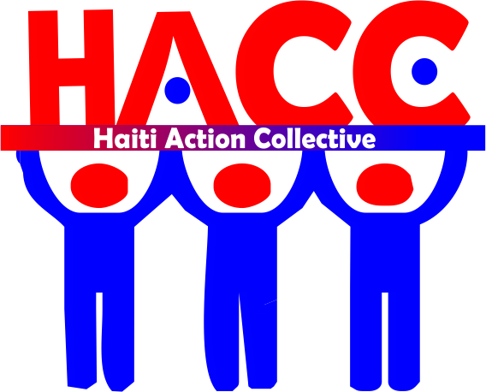

I. OVERVIEW OF HACC
Haiti Action Collective is a Haitian organization created in November 2013 and works legally according to Haitian law. After the earthquake of January 12th 2010 that changed many things in the running of the country, it was imperative for us even urgent civil society to ask ourselves what our role in that country. Despite, the efforts of humanitarian community and international partners, it is believed that the change must first come from within and that the country must now change course, to move towards sustainable development.
With this, it is important to improve the living conditions of the population in varying degrees; but the lack of state resources problem in order to respond in practical ways to the most urgent needs of the population. Many efforts have been made but problems deserve participates to a better future for Haiti.
Having done the analysis of this global context, we, responsible citizens informed, have taken the initiative to launch this structure called: Haiti Action Collective (HACC).
Like any organized structure, it will have a legitimate regulatory tool placed in a formal legal framework.

SCOPE AND OBJECTIVES
The organization works in the following areas:
1. Education / citizenship
2. Health / Nutrition
3. Agriculture / Livestock
4. Environmental protection
5. Risk Management and Disaster
6. Road infrastructure
7. Assistance to women and the elderly in difficulty
8. Water and sanitation
9. Community Action / microfinance
10. Social housing
Its main objectives are:
- Promote and encourage education, health, agriculture and environmental protection
- Working to promote and gender equity
- Assisting elderly people in difficult situations
- Assist in the development and improvement of road infrastructure
- Facilitate and encourage the establishment of a water system and acceptable sanitation.
- Strengthen community resilience capacity by facilitating loans for trade and entrepreneurship.
- Allowing malnourished children aged 0-59 months have access to medical care.

II. MISSION
HAITI ACTION COLLECTIVE whose acronym HACC is a national non-profit and apolitical Organization. It is in key, fundamental areas such as education, health, nutrition, agriculture, community development and the environment, by supporting the efforts of state institutions, humanitarian coordination, society Haitian civil and friends of Haiti. She advocacy, training, education, implementation of the actions / activities related to its objectives.

IV. ACTIVITIES CARRIED OUT BY THE ORGANIZATION
Sector | Projects | Geography | Partners | Impact
1. Education | Education of vulnerable children (2013-2014) | North West /Jean Rabel | Fondation FULL Action | This project has enabled 125 children aged 4 to 10 years to have access to a classroom for the first time by providing them all the teaching materials needed for learning.
2. Health / Nutrition | Mobile Clinic (2014-2015) | North-West/ Jean Rabel | --------- | malnutrition screening children aged 0-59 months in 2770/3345 Counseling for pregnant and lactating women / Distribution of vitamin A to 1400 children /
 | Mobile clinic (2013) | West/Cabaret | ------- | malnutrition screening in 1540 children aged 0-59 months / 18670 Counseling for pregnant and lactating women / Distribution of vitamin A to 800 children.
 | Mobile clinic (2013) | West / Delmas 2 | ……………. | Malnutrition screening 1,100 children aged 0-59 months / Counseling for 2000 pregnant & lactating / Distribution of vitamin A to 850 children.
 | Health caravan (2014) | North-West/ Jean Rabel | Fondation FULL Action | Prevention of certain diseases through community awareness on hygiene standards and distribution of hygiene kits to more than 500 people.
3. Community Action | Micro finance (2014-2015) | North West /Port-de-Paix | Fondation FULL Action | Improved socioeconomic conditions of 170 small businesses by providing loans at an interest rate of 5% a month.
4. Environmental protection | Distribution of plants ( May 1st 2014) | North West/ Jean Rabel | Fondation FULL Action | Increased vegetation cover by planting 10,000 seedlings of fruit and forest trees.

- ANNUAL PLAN 2016
The organization has an annual plan for 2016 and intends to concentrate its resources in the departments of North & West and the plan is as follows:
1.1 Nutrition
In The Northwest department, municipality of Port-de-Paix, we aim to Screen about 13,000 children aged 0-59 months and 9000 pregnant & lactating women, 1,900 children 0-59 months supported.
1.2 Health
In the department of Northwest town of Port-de-Paix, HACC will support 400 people affected by Zika virus, we aim vaccinated 1,500 people against cholera.
1.3 Community Development
In the Northwest department, municipality of Port-de-Paix, we intend to strengthen the capacity of people to this town via a micro-finance project, 50 groups of 30 people per group. These groups will submit micro finance projects and these projects will be analyzed and 20 of them will be sorted and funded. They aim to create wealth in the community.
1.4 Education
-In The west department (Commune of Cité Soleil) and Northwest (Commune of Port-de-Paix), we intend to work with 140 schools. This project will improve the quality of education, allowing each student to these schools to have access to books requested.
1.5 Environmental protection
In order to bring an answer to the degradation of natural resources, intends to ask HACC actions to the production and planting of 80,000 seedlings in the Communes of Jean Rabel and Port-de-Paix; Perform 10 environmental forums on raising awareness of the issue of natural resource degradation in the 10 municipalities of the North West department.
1.6 Agriculture
To address the food crisis in the Northwest, we intend develop watersheds in four (4) Communes (Bassin Bleu, Chansolme, Jean-Rabel, Port-de-Paix).
Distribute vegetable seeds (20,000 households) in 10 Communes for the establishment of vegetable gardens.
-To strengthen the capacity of farmers (10,000 farmers) through the distribution of agricultural seeds (but strain peas, beans, groundnuts, millet)
1.7 Assistance to the 3rd age
Given the situation in which people in the 3rd age in Haiti are living, we expect to provide assistance to the most needed. Give an allowance to 750 people in 5 towns (Mole St. Nicolas, Bombardopolis, Baie-de-Henne, Jean-Rabel, and Port-de-Paix).

