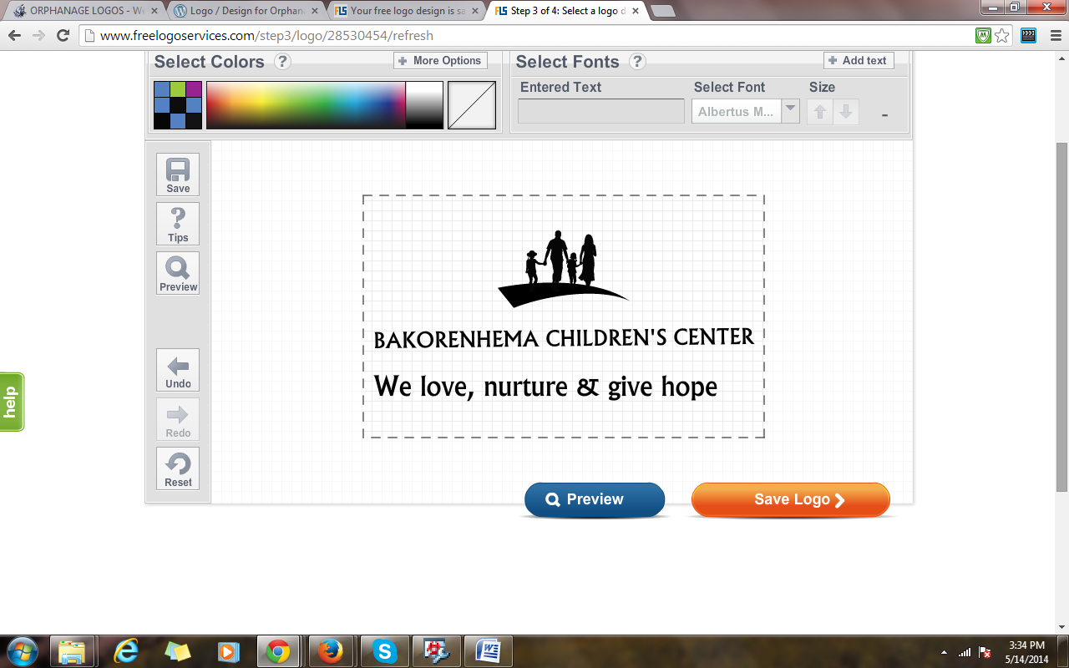

Full name of the organisation |  | BAKORENHEMA CHILDREN CENTRE
 |  | Physical: No. 11 Metheun Road,Mutare ,Zimbabwe
Postal: Bakorenhema Children Centre
11 Metheun Road,Murambi
Mutare
Zimbabwe
 |  | Website (if applicable): N/A
 |  | Social Network (face book): Type: Bakorenhema Children Centre
Name and title of the contact person. |  | Andrew Sadziwa
Phone number |  | +263 772880830
Fax number |  | NIL
Email address |  | weetzim@gmail.com
When was your organisation founded |  | Year:2001
How is your organisation formed? |  | e.g. company/trust it is a Private Voluntary Organisation (PVO).
Is your organisation registered? |  | Type of registration: It is registered as a PVO No. 397/68
Name of head of organisation (please included their title): |  | Andrew Sadziwa  International Coordinator/Administrator
Current Number of staff members |  | 2 staff members and 3 volunteers.
Do you have a Board? |  | YES
How often does your Board meet? |  | The BCC board meets on quarterly basis and when it is necessary.
What kind of support does your Board provide? |  | The board plays a pivotal role in creating linkages with keys stakeholders such as government departments and potential sponsors. It also provides policy direction for the organisation and promotes good corporate governance.
Do you keep records / minutes of your Board meetings? |  | Yes
- INFORMATION ABOUT YOUR ORGANISATION’S ACTIVITIES AND PROGRAMS
- Problem definition:
PROFILE | Mission: To work with all sectors of society in order to empower the vulnerable children and enable them to build a better life for them.  Vision : To give children help hope and opportunity in life  History of the Organization  Bakorenhema Children’s Centre (BCC) is registered private voluntary organization (P.V.O) Reg - W.O. 397/68. It was established in 2001. It is licensed to accommodate a maximum of 38 children, aged between 6 and 18years, but currently has 11 children, 4 girls and 7 boys.It was created as a result of the overwhelming population of orphans orphaned by either natural causes of parent’s death or death due to HIV-Aids scourge. The emergence of juvenile delinquency among the (OVC’s) in the country also prompted the creation of Bakorenhema Children’s Centre. Manicaland Province in Zimbabwe many cases of vulnerable children who have ended up on the streets or open places and abandoned by their parents
- Community/geographic areas of operation that the organisation serves? | Thus, the centre caters for children in difficult circumstances from Marange and its environs.  The specific target being the following:  - The abandoned  - Orphans  - Destitute  - Victims of cruelty,  - Neglected and those physically, psychologically and sexually abused  - Those unwanted by their biological parents among others
- The needs/challenges/issues of the people that the organisation addresses? | The organisation addresses the following issues:  The orphanage takes full responsibility of these children by providing medical care, food, education, clothing, bedding and shelter. Additional to that the orphanage centre also offers psychosocial support to reduce stigma associated with these children. Orphans living in utmost poverty, abandoned children, destitute, neglected children, victims of cruelty, physical, psychological and sexually abused are carefully selected and admitted to the centre. The department of Social Services brings in these children to the centre.  The centre respects and honors the children’s rights as outlined by the Social Services department, UNICEF and other Children’s rights conventions.  Bakorenhema Children’s Centre was established to protect and promote children’s rights in the province and Zimbabwe as a whole.
- How the organisation addresses the problem
Objective 1 – Education |  |  | To ensure the enrolment and retention of Orphans and other vulnerable children (OVC) in schools in Marange District.
 |  |  | - Provide direct education support including school fees, uniforms and stationery to children attending school in the formal schools.
 |  |  | - Identify children living with a disability for the out of school study groups learning.
 |  |  | - Facilitate birth registration to the learners in need of birth certificates in preparation for reintegration
Objective 2 – Children and Caregiver economic strengthening |  |  | To train OVC care givers to improve on the general standards of the orphans, vulnerable, needy children through promoting income generating activities with skills to assist households where such children are living
Activities – |  |  | - Train, with support OVC caregivers and children start income generating projects
 |  |  | - Identify mentors and attach to them children interested in plumbing, welding and other artisanship
 |  |  | - Source, and distribute start-up kits for Income generating projects (IGPs) for children, caregivers and the Matron trained in IGPs and entrepreneurship.
 |  |  | - Cary out projects (e.g. poultry, rabbits, gardening) at BCC to supplement nutrition programme, generate income and serve as demonstration to OVC and caregivers.
 |  |  | - Construct a slaughter house for the chickens (broiler) project
Objective 4 – Sexual Reproductive Health Education |  |  | To assist youth to make informed sexual, reproductive and health choices through providing relevant information on health (SRH), life skills, career guidance..
 |  |  | - Conduct talk sessions on health and sexual reproduction, life skills, career guidance conducted at Centre
 |  |  | - Commemoration of international youth, children and health days at Centre and in communities every year.
Objective 5 – Provisions of Health and Nutrition |  |  | To provide nutritional health food to the children living at the centre.
Activities – |  |  | - Conduct health assessments of children living at the centre.
 |  |  | - Conduct voluntary HIV Testing and Counselling for children
 |  |  | - Refer children to clinics for treatement
 |  |  | - Provide basic nutrition to children
 |  |  | - Conduct health talks for children and caregivers
Objective 6– Child Protection |  |  | To provide an expanded child protection programme for children living at the centre.
Activities |  |  | - Identify children in need of support at the centre.
 |  |  | - Provide counselling for children in distress at the centre.
 |  |  | - Handle child abuse cases through a case management approach
 |  |  | - Conduct child rights training sessions within the centre
 |  |  | - Conduct parenting sessions at community level
 |  |  | - Facilitate birth registration for children
Geographical Coverage and Reach |  |  | Country: Zimbabwe  Province(s) (where applicable):Marange and Buhera (but can operate in all the provinces)  District(s): Marange and Buhera District Harare, Zvimba  Community(ies): Shavambiri Village,Murwira,Magurasave Villages.

- SUCCESSES, STRENGTHS AND CHALLENGES
- Organisation’s key successes
Since its inception in 2001, BCC made the following key successes;

Holistic model: The holistic psychosocial support model that BCC model developed is a great success as evidenced by the quality of life of its beneficiaries and those who left the program. The ex-beneficiaries of the centre are known for their high self esteem, literacy and numeric skills, decision making skills and an entrepreneurial mindset. The model addresses both emotional and physical needs of children. Unlike, the traditional development models that saw the emotional needs of children being ignored.
- Organisation’s top three strengths
Below are BCC’s top strengths:

- Holistic model: BCC offers comprehensive home care services to children, thus meeting both their material and physical needs. The children access holistic care at one goal which promotes their holistic development. The services ranges from primary education, secondary education and skillsl training as well as meeting the health, nutritional, emotional and psychosocial needs of children.
- Family and community centred approach-The BCC model offers beneficiary family units and the community structures as key to the provision of support to children. This approach reinforces family cohesion significantly. Further, the centre has strong relations with community institutions such as schools, churches, community groups among others. The relationships were nurtured by the centre through its capacity development efforts aimed at strengthening the capacity of family units and community institutions to better care for children. These efforts make the programmes sustainable in a big way. The cordial relations make implementation of programmes easy whilst the centre’s visibility in communities is maintained.
- Collaboration with government departments-BCC enjoys cordial relations with government ministries and departments such as the Department of Social Services, Ministry of Women Affairs, City Health Department, Ministry of Health and Child Care, and Ministry of Primary and Secondary Education. The relations significantly improved by the centre’s culture of designing programmes that address policy gaps from time to time, thus complementing government efforts. Thus, BCC’s programmes are not parallel to those of the government.

- Main challenges faced by BCC
The following is a summary of BCC’s challenges;

1. Inadequate resources- the centre relies heavily on local and overseas volunteers for manpower, which sometimes compromise the quality of services rendered to beneficiaries. This also poses technical challenges especially when the confronted scenarios required technical expertise. The centre has mobility challenges due to lack of v ehicle for program support.

The centre serves children from Marange, where poverty and unemployment are rampant. Due to the burgeoning effects of poverty and the escalating problem of HIV and AIDS on children, demand for the centre services is overwhelming regardless of the fact that BCC is grappling resource constraints. It lacks financial resources to acquire various equipment and other material resources needed to support the needy children. The centre has since resorted to thorough screening of beneficiaries as part of efforts to select the most deserving. This however, has disadvantaged many other children in need of support.

- Success Story on how the centre has benefited children in your community
The restored smile.-Volunteer Program

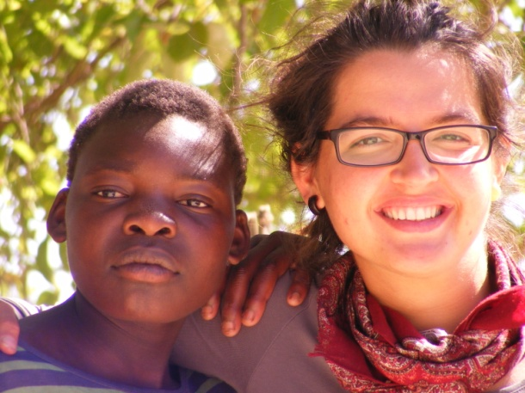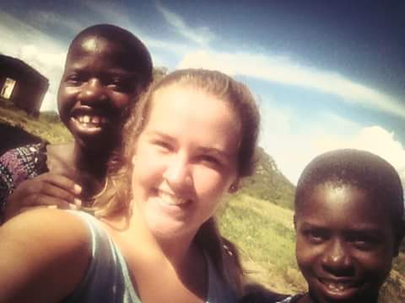
Caster shares a moment of laugher with Viera Barkilova(Slovakia ) Tracy and Jess Melrose(UK middle) and Brenda laughs
Had it not been of the volunteer program that our Administrator Andrew Sadziwa has not started most of our children would still has not improved academic in school. The volunteers came up with innovative ways of helping children to improve their school academic through conducting teaching sessions .Some of the children has lost hope in doing well at school and were considering dropping at school because of lack of self esteem, which was restored by the 14 volunteers from overseas who visited us in 2014.

“My hope of acquiring education has been restored and i am extremely happy to say the least”, said the smiling Caster on her first day at school study group site. The retired teachers who facilitate the study group sessions had a daunting task of moulding Caster’s behaviour because she was used to speaking foul language and all sorts of indiscipline. They counselled her until she understood the need to speak to others politely and also maintaining good behaviour.

Tracy’s life has never been the same, her character was moulded, she now behaves well. She now has friends at school and even in the community..

In the class, Tracy is a star; she has scooped several accolades and prizes.

