(AWCHSCWO)
Afghan Women and Children Humanitarian and Social Charity Welfare

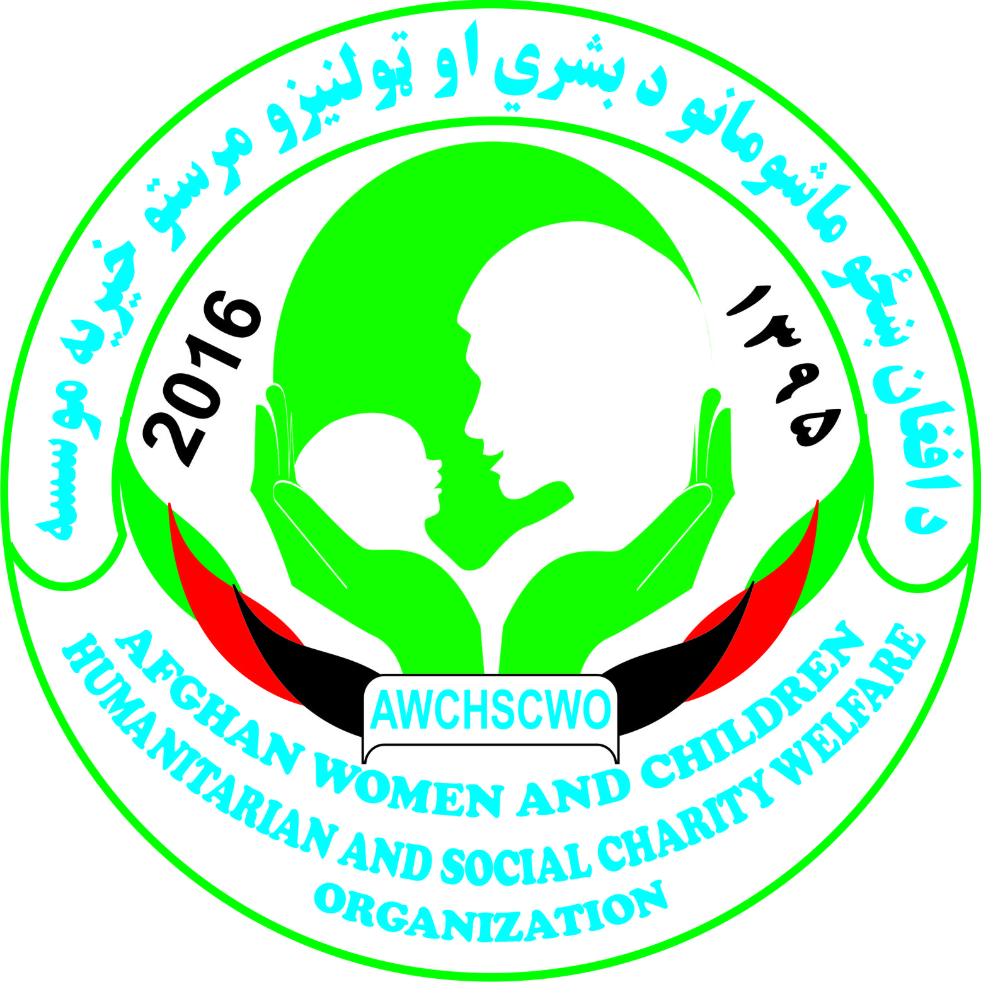

Organization Profile
2016

Address: # 09, 3rd floor Fayz Hidari Plaza, Jalalabad City
Phone: 0788467619, 0792362371
E-mail: womenchildren.org@gmail.com
P.O.Box #

Table of Contents
Preface
1. AWSHCWO Establishment 1
1.1 Thematic Areas 1
2. AWSHCWO Vision 1
3. AWSHCWO Mission 1
4. AWSHCWO Objectives 2
5. AWSHCWO Core Values 2
6. AWSHCWO Strategic Areas of Operation 3
7. Social Services 3
8. Education 3
9. Heath 4
10. Agriculture 4
11. Legal Section 5
12. AWSHCWO Structure 5
12.1 AWSHCWO Beneficiaries 6
12.2 AWSHCWO Competencies 6

Preface
Since 2001 Afghanistan has slowly been rebuilding, but the decades of war, administrative corruption, limited local capacities, extremism and instability have slow to fade, and some Afghans continue to suffer from the same types of oppression, shortages and deprivation. Today, insecurity, poverty, corruption, absence of rule of law, violence and high rates of mortality persist. Besides the lack of access to and quality of health services as well as other factors such as lack of adequate food, shelter and clean water, low marriage age, and lack of spacing of child births contribute to the extremely poor health of Afghan community.
Continuation of insecurity and conflict in Afghanistan has had severe repercussions on the situation of Afghan people, who have long suffered the consequences of civil war, drought, pervasive poverty and institutionalized discrimination. Besides, Afghanistan has the largest refugee repatriation in the world in the last 30 years. On the other hand, Afghanistan has one of the highest mortality rates in the world. one in five children dies before the age of five and one out of every eight Afghan women die from causes related to pregnancy and childbirth each year. Life expectancy is only 44 years for both men and women. 1 in 3 Afghan women experience physical or psychological violence. Bad security in the southern and eastern Afghanistan has interrupted access of humanitarian services including health and education services especially to war-affected, refugee and internally displaced Afghans.
Furthermore, The Sustainable Development Goals (SDGs) of the 2030 Agenda indicates that integrating all three dimensions of sustainable development (economic, social and environmental) recognizing that eradicating poverty and inequality, creating inclusive economic growth and preserving the planet are inextricably linked. Health is centrally positioned within the 2030 Agenda, with one comprehensive goal (SDG 3) and its 13 targets covering all major health priorities, and links to targets in many of the other goals. The 2030 Agenda has major implications for health monitoring. Monitoring will need to reflect the fact that the SDGs are relevant for all countries. In order to accommodate a much broader range of health and health-related issues, country, regional and global monitoring systems will have to adapt. This will mean, at the very least, undertaking health data collection, analysis and communication in an integrated manner. The SDG focus on leaving no one behind means that much greater attention will have to be given to disaggregated data. Health monitoring will have to look beyond the health sector and consider economic, social and environmental indicators, as well as inter-sectorial actions. The 2030 Agenda also puts strong emphasis on country follow-up and review processes as the basis for accountability. Strengthening country health information systems should therefore be a priority.

Available data show that in spite of the major progress during the Millennium Development Goal (MDG) era, major challenges remain in terms of reducing maternal and child mortality, improving nutrition, and achieving further progress in the battle against infectious diseases such as HIV/AIDS, tuberculosis, malaria, neglected tropical diseases and hepatitis. The situation analysis also provides evidence of the importance of addressing no communicable diseases and their risk factors such as tobacco use, mental health problems, road traffic injuries, and environmental health issues. Data on water and sanitation and air quality show that much more needs to be done to reduce risks to health.

Child abuse is one of the most important Issues that exist in Afghanistan. Unfortunately no major decision or initiative has been taken by the government in this regard. Everyday thousands of children throughout Afghanistan becomes victim of one or another form of child abuse. beating the children in schools, denial of education, force and early marriages, denial of proper food and cloths, denial of proper love by the parents, sexual abuse etc. are some of the abuses that the Afghan children are facing every day. The main issue is that most of the people do not know “what Child abuse is” and so willingly or by mistake they become the culprit of child abuse.

To contribute in the elimination of child abuse and making the people aware of what child abuse is; AWSHCWO with the help of its donors agency is working on preparing a child protection policy which after completion will be distributed to the partners, NGOs that work for the children and government authorities so that they could make use of it in their offices and work place. The first step taken in this regard will be providing training on types of child abuse that are happening in Afghanistan to the staff of the AWSHCWO and later will expand this to other constituencies. The staff it will help the target audience that how child rights are being violated in schools and other places. AWSHCWO will continue its trainings on Child abuse to different sections of the society and will do its best to make it a practice to understand and implement the child rights in their homes, workplace and other places.

Gender Mainstreaming

Afghan women have an important role to play in the struggle for stability in their communities, and need to feel supported that their needs and concerns are being addressed and are important. Developing a path to self-reliance, self-realization, and respect for themselves is critical if women are supported in taking measures to rebuild their lives and the social and economic fabric of their society. Training providers need to communicate to male members of the community the value of women’s participation in vocational training programs, such as these, and educate them on how to support women’s opportunities of seeking employment outside the household after graduation. Working through local leaders and institutions like the local shuras, CSOs, religious leaders, there will be consensus on the value that this type of program brings to families, as well as the overall community. AWSHCWO will focus on implementing long term children and women empowerment programs in close consultation of MoWA, Ministry of Hajj affairs, MoEC, and Human Rights Commission.

1. AWSHCWO Establishment

Afghan Women and Children Humanitarian and Social Charity Welfare Organization AWSHCWO” is a non for profit, non-political, non-sectarian and non-governmental organization registered with Ministry of Economy (MoE) at 28/5/2016 according to the final decision no. 3907 and is entitled to work in Afghanistan as an NGO. AWSHCWO is mandated to work for education/literacy, creating forms, creating poultry farms, health awareness elimination against violence and narcotics, advocacy and communication, and training and capacity building. AWSHCWO established by a group of committed, dedicated and professional volunteers to offer result-oriented services to rural, urban slums and urban areas of Afghanistan. AWSHCWO’s services will be delivered through utilization of easy adaptable, well-received and participatory community empowerment strategies, as per the key principles of result based management (RBM) approaches, and in line with Afghanistan national development priorities and national strategic plans.

1.1 Thematic Areas

AWSHCWO aims to consolidate its activities over the next coming years under the following four core pillars:
Social Services
Education
Health Awareness
Agriculture

2. AWSHCWO Vision

AWSHCWO envisions a healthy, educated, informed, peaceful and developed society, free from all kinds of, deprivation, discrimination, injustice, corruption, unemployment, disability and violence.

3. AWSHCWO Mission

AWSHCWO is a non for profit, non-political, non-sectarian and non-governmental organization mandated to conduct development services on social services, education, health awareness, and agriculture, advocacy and communication, and training and capacity building in rural, urban-slums and urban Afghanistan with special focus to the remote areas of Afghanistan.

AWSHCWO is committed to achieve its mission through participatory, result-oriented, transparent, accountable, professional, gender sensitive services with the consideration of following strategic principles:
- Community empowerment through decentralized bottom-up approaches and real participation
- Sustainable development
- Public-Private partnership and ownership
- Result-based management approaches
- Management efficiency
- Partnership development and coordination
- Creation of circumstances in which people can develop their potentialities and express their diverse qualities

4. AWSHCWO Objectives

To contribute towards its strategic goal, AWSHCWO pursues following specific objectives:
1. To empower local communities through building their awareness about social developments in the country through conducting awareness rising programs on public services, national policies and plans.
2. To improve health condition of the Afghan men and women through provision of quality health care services and trainings with special focus to marginalized, remote underserved areas.
3. To voice up about national policies by conducting participatory rights based advocacy and public communication campaigns on national issues with special focus on heath and development.
4. To advance knowledge and update information of the citizens and policy makers through conducting qualitative and quantitative researches and evaluations i.e. on health and social development issues.
5. To build the capacities of communities, institutions and service providers of both governmental and nongovernmental organizations through short-term training and organization development interventions and implementation of community development projects.
6. To contest against drugs and women and children abuses through conducting public awareness programs and trainings.
7. To support and provide humanitarian assistance to war affected, displaces families and vulnerable local communities.

5. AWSHCWO Core Values

- Commitment and industriousness
- Integrity and respect
- Inclusiveness and participation
- Gender equity and human rights
- Effectiveness and efficiency
- Innovation and creativity
- Transparency
- Accountability
- Volunteerism and activism
- Impartiality

6. AWSHCWO Strategic Areas of Operation

In light of organization values and in direction of achieving its objectives AWSHCWO will deliver its services in following strategic areas of operations:

7. Social Services

With envisioning informed citizens and access to information for all Afghans AWSHCWO provides awareness programs to marginalized and underserved local populations through its well-trained trainers.

8. Education

Education in every sense is one of the fundamental factors of development. No country can achieve sustainable economic development without substantial investment in human capital. Education enriches people’s understanding of themselves and world. It improves the quality of their lives and leads to broad social benefits to individuals and society. Education raises people’s productivity and creativity and promotes entrepreneurship and technological advances. In addition it plays a very crucial role in securing economic and social progress and improving income distribution.

To this end, Remarkable progress has been made in education in Afghanistan in terms of students’ enrolment since the fall of the Taliban in 2001. Students’ enrolment has increased tremendously for both boys and girls from just 900,000 in 2001 to around 8.3 million in 2011 of which 39 per cent are females (EMIS, 2012) with joint efforts of partners including UNICEF. However, the progress is viewed as “fragile, limited in reach, depth and uncertainty of sustainability” (UNICEF Education SitAn, 2013). The status of boys and girls in education in Afghanistan continues to be compromised in terms of access, quality and gender equality. Only 50 per cent of eligible children are enrolled in schools while approximately 3 million children, especially children in remote, mountainous and insecure areas remain out of school. This is also exacerbated by the estimated 15 per cent of students who remain on the books for up to 3 years, but are actually out of school as “permanent absentees”. The status of girls in education is considerably lower than boys with a Gender Parity Index (GPI) of 0.74.
The shortage of schools and insufficient infrastructure resulting in long walking distances to schools combined with the general insecurity is one of the biggest causes for low enrolment. There are currently about 14,000 schools of which only 15 per cent are for girls and 50 per cent are without usable buildings, safe water and sanitation facilities. Almost all schools operate on multiple shifts based on reduced instructional schedule which negatively impacts on quality. AWSHCWO will try to direct its activities in implementing the literacy programs both for boys and girls as well as literacy programs for the ages-15-30 in remote areas of the country. Furthermore, AWSHCWO will implement awareness raising programs regarding the importance of education in rural areas through radio plays, radio-call-in shows, and community events.

9. Heath

With envisioning “better health for all Afghans”, AWSHCWO provides primary health care services to poor and needy people of Afghanistan. AWSHCWO through its well-trained health service providers will outreach its services to remote and underserved areas of Afghanistan where the gaps for health services are still unfilled. The services will be aligned with MoPH priorities and strategies and coordinated with other national and international organization working in the same field. Currently, following are the key heath service priorities for AWSHCWO: Basic Package of Health Services (BPHS): AWSHCWO intends to implement BPHS programs in partnership with MoPH and other national and international organizations in different parts of the country. Moreover, AWSHCWO will enhance this area through Maternal and Newborn Health Provision of maternal and newborn health services through community awareness, research, health provider’s capacity building and motivation.

10. Agriculture

AWSHCWO believes that agricultural sector plays a strategic role in the process of economic development of a country. It has already made a significant contribution to the economic prosperity of advanced countries and its role in the economic development of less developed countries is of vital importance. AWSHCWO will improve this area through creating fruit farms, poultry farms, and vocational trainings.

AWSHCWO believes that real participatory development with bottom up approaches is a capacity-building process through which community individuals, groups, or organizations plan, carry out, and evaluate activities on a participatory and sustained basis to improve their economic needs, either on their own initiative or stimulated by others.

AWSHCWO strives to assist women to acquire equal access to education, resources and institutions and to transform social attitudes and behavior for a responsive and supportive social environment and to address women's concerns. Besides, AWSHCWO will use findings and conclusions of researches for advocacy and information campaigns. AWSHCWO will also try to ensure public-private partnership in both development and advocacy projects. AWSHCWO has already established interaction and reliable relations with actors in civil society both national and international organizations, public administration and private sector in order to implement integrated, acceptable and effective advocacy and communication campaigns. AWSHCWO will consider the principle of cultural sensitivity, confidentiality of information, ethics, and gender consideration throughout its advocacy campaigns, along with focus on:
- Rights and interests of people
- Achieving justice
- Achieving equity
- Minimizing conflicts of interest
- Accountability to the beneficiaries and supporters

11. Legal Section

The AWSHCWO’s goal is to improve citizen access to justice services based on Afghan law. Aims to increase the effectiveness and reach of the formal justice sector, strengthen linkages between the formal and traditional justice sectors, and increase citizen demand and access to quality legal services

12. AWSHCWO Structure

The main governance of AWSHCWO lies within a General Assembly, which consists of volunteers and committed members of AWSHCWO. The General Assembly is the supreme body of the organization and is responsible for the approval of organization’s charter, election of the chairperson and members of board of directors and Managing Director.
The Board Director (BoD) consists of no fewer than 5 and no more than 9 members, do not have to be staff of AWSHCWO, except Managing Director. The Board membership is decided by the General Assembly and includes intellectuals, development workers and experts. The BoDs develops and approves AWSHCWO priorities and long-term strategies and provides valuable advice and guidance to the organization from time to time. Board members also represent AWSHCWO in important and fundraising meetings. The sphere of responsibilities of the Board of Directors and its decision making authorities will be defined in specific document.
AWSHCWO has a very simple organization structure, to ensure democratic decision making and easy access to information. Operational level decisions are being made by management team led by Managing Director while the strategic and policy level decisions are subject to approval of Board of Directors who held bi-annual meetings.
AWSHCWO Organization Chart:

Board of Directors (BoDs)
Health Development Program Manager
Training and Capacity Building Program Manager
Agriculture/Livehoold Development Program Manager
Gender Manager
Admin and Finance Manager
Deputy Director
Managing Director
Health Program Manager

12.1 AWSHCWO Beneficiaries

AWSHCWO services will benefit both groups and individuals disregarding their racial, ethnic, geographic, linguistic, religious, sex and age differences. Following are the key categories of AWSHCWO beneficiaries:
Poor and remote communities and people (male and female) Community groups including community based organizations (CBOs), community development councils (CDCs), civil society organizations (CSOs) and non-governmental organizations (NGOs), Civil servants , Marginalized groups such as women, ethnic and religious minorities, nomads, internally displaced people (IDPs) and youth, Development and health professionals, Social workers, School students and, teachers, Orphans and Policy makers.

12.2 AWSHCWO Competencies

AWSHCWO has well- experienced team of professional staff in the areas of heath care, capacity building, agriculture, education, advocacy, community development and awareness building.
AWSHCWO professional staff members supported by Board of Directors (BoDs) have recently developed following important policy documents for the organization.
a) AWSHCWO finance policy
b) AWSHCWO procurement policy
c) AWSHCWO HR policy
d) AWSHCWO monitoring guideline
e) AWSHCWO volunteers role definition

AWSHCWO has computerized financial management system (Double Entry System) operated by competent staff. AWSHCWO operates its financial management through computerized software of QuickBooks. AWSHCWO financial affairs are governed by Financial Management Policy which meets maximum standards for a local organization. AWSHCWO maintains separate bank account for the entity, and keeping soft and hard copies of the financial documents.

AWSHCWO has foundations to maintain effective internal controls procedures which will ensure that all financial transactions are approved by an authorized individual and are consistent with organization policies. All organization’s assets are maintained safely and accounting records are complete, accurate and consistent. AWSHCWO official time includes 6 days of week and 8 hours per day.
AWSHCWO has a suitable office located in Kabul that provides enough facilities for the staff and easy access to the clients of the organization. AWSHCWO office is equipped with basic office equipment, and internet.

