TANZANIA YOUTH ENVIRONMENTAL NETWORK (TAYEN)
“Making an Environmentally Sustainable Tanzania”

OUR STORY
The story of TAYEN can be traced back to 2006 when its founder, Mr. Evodius Rutta while a student at University of Dar es Salaam in Tanzania initiated campus Youth Environmental Program in University of Dar es Salaam. A year later the campus youth environmental program was transformed into youth organization (TAYEN) with a mission to bring together youth, educate them about environmental conservation and enhance their engagement in conservation initiatives across Tanzania.

In 2008, TAYEN was formally registered as a non-profit youth led organization with registration number NGO/2396 under Tanzania Non-government Act of 2002. Between 2009 and 2010 TAYEN recorded its first milestone with establishment of its Advisory Board and initial pilot programs in and outside schools. This involved the initiation of Youth Environmental Networks in six secondary schools in the city of Dar es Salaam (Makongo, St. Mary’s, Tegeta, Wazo Hill, Mbezi Beach and Green Acres).

TAYEN grew from strength to strength and made considerable progress. About 12 Youth Environmental Clubs (Networks) have been established in 12 secondary schools reaching more than 3000 youths in both urban and rural Tanzania. TAYEN has also been very active at the University of Dar es Salaam (UDSM), Sokoine University of Agriculture (SUA), Ardhi University and St. Augustine University (SAUT) building more youth networks. TAYEN is now working with various partners including government institutions, schools, universities, civil society organizations, private sector and foundations in and outside Tanzania.

WHY YOUTH & ENVIRONMENT
Young people in Tanzania make the largest part of population in their communities. According to 2012 Tanzania National Population Census the total population is 44,928,923, under 15 age group represents 44.1 per cent of the population, with 35.5 per cent being in the 15–35 age group. Youth have both special concerns and special responsibilities in relation to the environment. It is very clear that youth have a big stake in protecting and conserving the environment for better future because the current environmental challenges left by their parents will affect their livelihood. Recognizing this, TAYEN not only engages youth in conservation initiatives but also implement programs that prepare youth to take lead in bringing sustainable development in Tanzania

OUR VISION
An environmentally sustainable Tanzania through youth-led conservation and development programs.
OUR MISSION
Inspiring youth to conserve and protect the environment for a better tomorrow.
OUR GOALS
- Impart knowledge, raise awareness and actively engage children and youth of Tanzania in environmental conservation initiatives.
- Empower youth through conservation initiatives focusing on achieving sustainable development.
- Address environmental degradation resulting from unsustainable utilization of environmental resources.

OUR END RESULT (OUTCOME)
A sustainable environment for the present and future generation.
OUR PROGRAMS
- Environmental Education and Conservation.
- Climate Change (Mitigation and Adaptation).
- Tree Planting.
- Social Entrepreneurship.
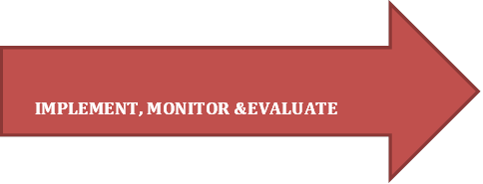
OUR APPROACH
Establish Youth Teams
A sustainable environment for present and future generation.
Recruit and Engage Youth
Visit and Identify Youth Groups

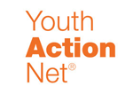
OUR PARTNERS
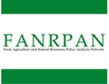

OUR ACHIEVEMENTS
- Reached out more than 3000 Tanzanian youth with environmental conservation and youth development programs across Tanzania.
- Successfully planted over 10,000 indigenous trees in tackling deforestation in Tanzania.
- 2012 Winner of African International Achievers Award (AfIA Awards) under Environmental Protection category.
- 2011 Winner of YouthActionet Global Fellow Award offered by International Youth Foundation.
- 2010n Winner of African Climate Change Fund competition organized by Global Green Grants Fund.

CONTACTS
TAYEN
P.O.BOX 34734
Dar es Salaam, Tanzania
Tel: +255 (0) 753 062 485
Cell: +255 (0) 717 569 513
Cell: +255 (0) 713 527 551
E-mail: info@tayen.or.tz
Website: www.tayen.or.tz

