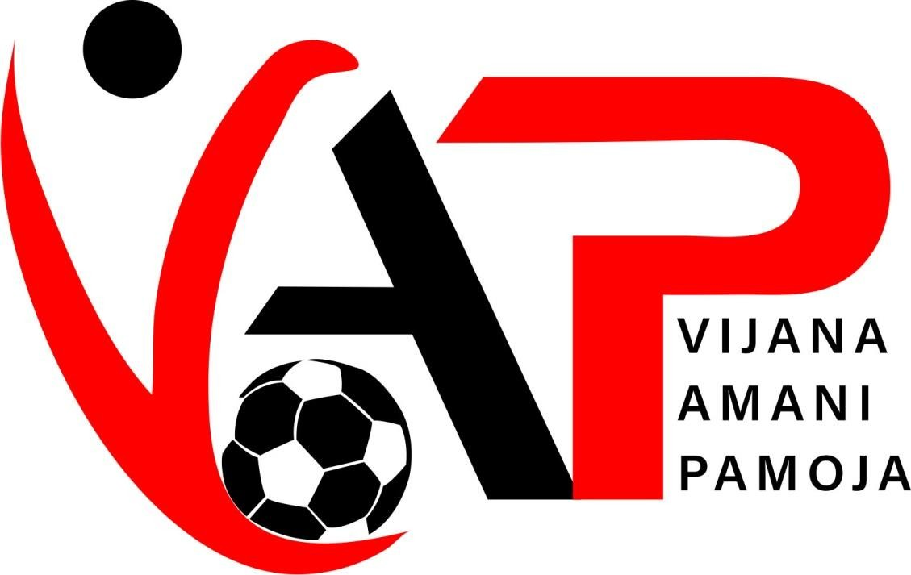

2021

ANNUAL IMPACT REPORT #MORETHANFOOTBALL

Thank You Our Partners:

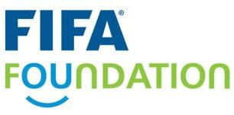
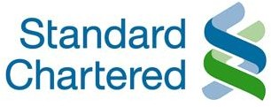

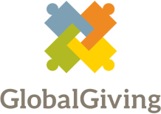

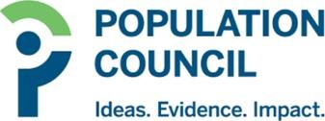
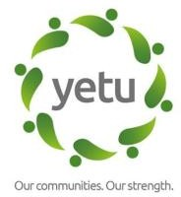
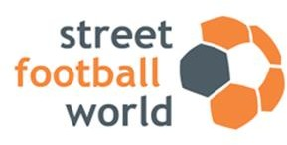

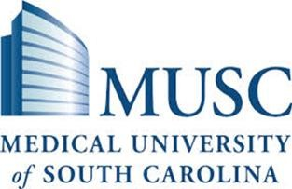

SKILLZ KENYA PROGRAM
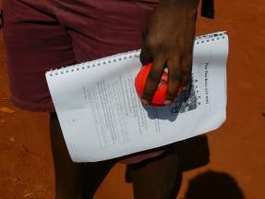
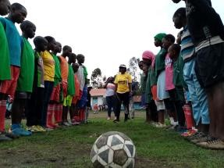
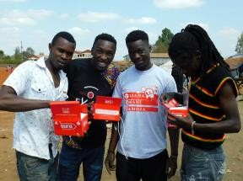

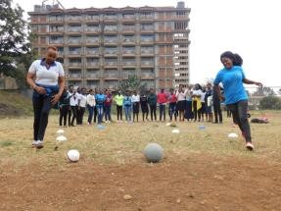
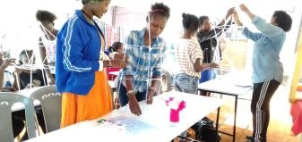
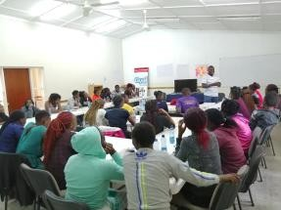
GOAL PROGRAM

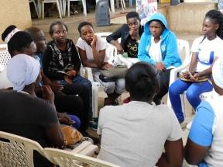
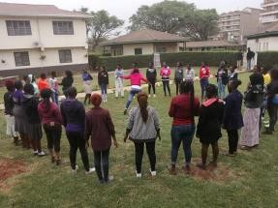
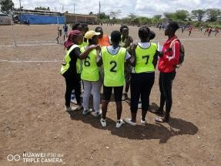
SECURE FUTURES

HESHIMA PROGRAM
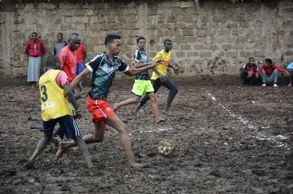
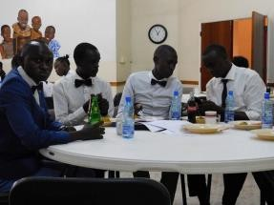
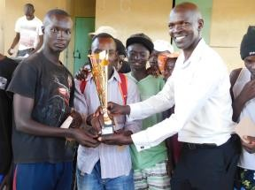

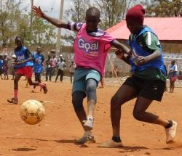
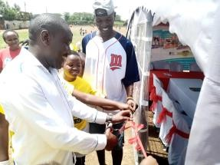
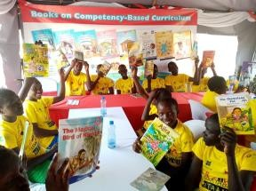
MAKTABA MTAANI

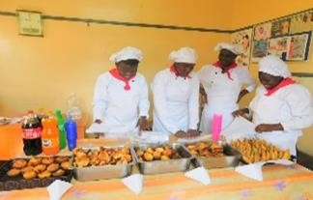
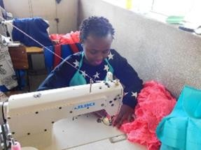
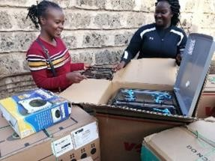
EE PROGRAM

KEY FEATURES:

- Introduction

- Strategy

- A year in Numbers

- Skillz Kenya

- Goal/Mrembo

- Employment + Entrepreneurship

- Young Mother and Pregnant Adolescent Girls

- Heshima

- Maktaba Mtaani

- Future Plans for 2021

INTRODUCTION
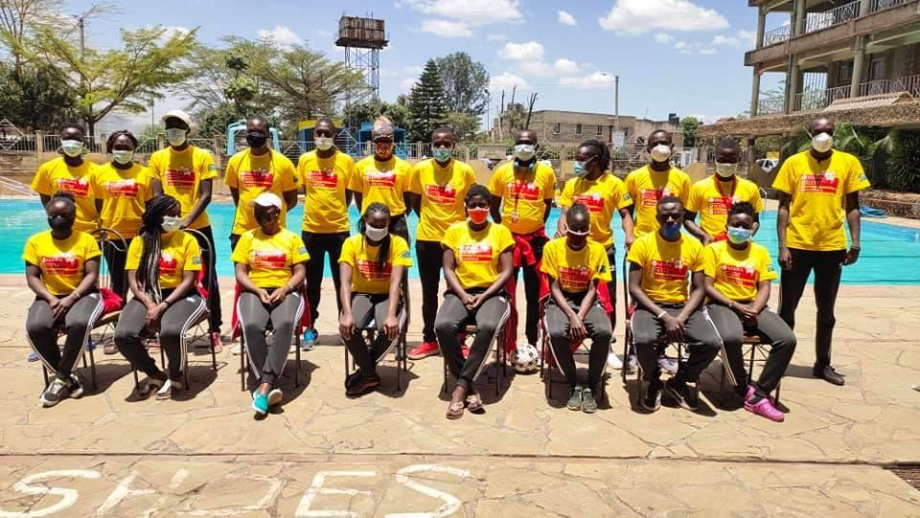
A message from Team Vijana Amani Pamoja
We are delighted to share our impact report for the year 2020 delivery with you all. You will see through the pages of this report the variety of programmes we deliver as a football based community scheme and the impact these have made throughout the course of the year.

We continue our journey as a sport for development organization serving the under privileged youth of Nairobi regardless of their: zip-code, color, race, religion and tribe seeking excellence in our provision to ensure the best possible experience for all our programme youth participants.

As a community scheme, we are totally committed to our mission of integrating social and economic values through football by creating a pro-active health environment fully subscribing into our vision of creating a society that is socially, economically and healthy empowered.

In this report, there are some very inspiring and powerful stories from the participants that highlight the positive changes the programmes have made to their lives and their achievement as a result of being part of Vijana Amani Pamoja.

We wish to offer our sincere thanks to our ever supportive: staff, our progressive coaches, and our passionate and dedicated volunteers who have worked tirelessly through the year to provide valuable opportunities for our communities.

Of course, our work would not have been possible without the ongoing support from our esteemed partners both local and international including well –wishers. These relationships help us create a tremendous amount of positive impact in our communities and for that, we are truly grateful.

Thank you to each and every one of you for choosing to support Vijana Amani Pamoja
for your investment of time, your words of encouragement, and for championing our cause across the city. We are extremely proud of our history, and hugely excited by our future!

Together we are #MoreThanFootball Team VAP

STRATEGY
MISSION
TO INTEGRATE SOCIAL AND ECONOMIC VALUES THROUGH SOCCER BY CREATING A
PRO-ACTIVE HEALTH ENVIRONMENT
VISION
A SOCIETY THAT IS SOCIALLY, ECONOMICALLY AND HEALTHY EMPOWERED

OUR VALUES
PASSIONATE
PROGRESSIVE
TRUSTWORTHY
CONSIDERATE
INTEGRITY
FLEXIBLE

A YEAR IN NUMBERS

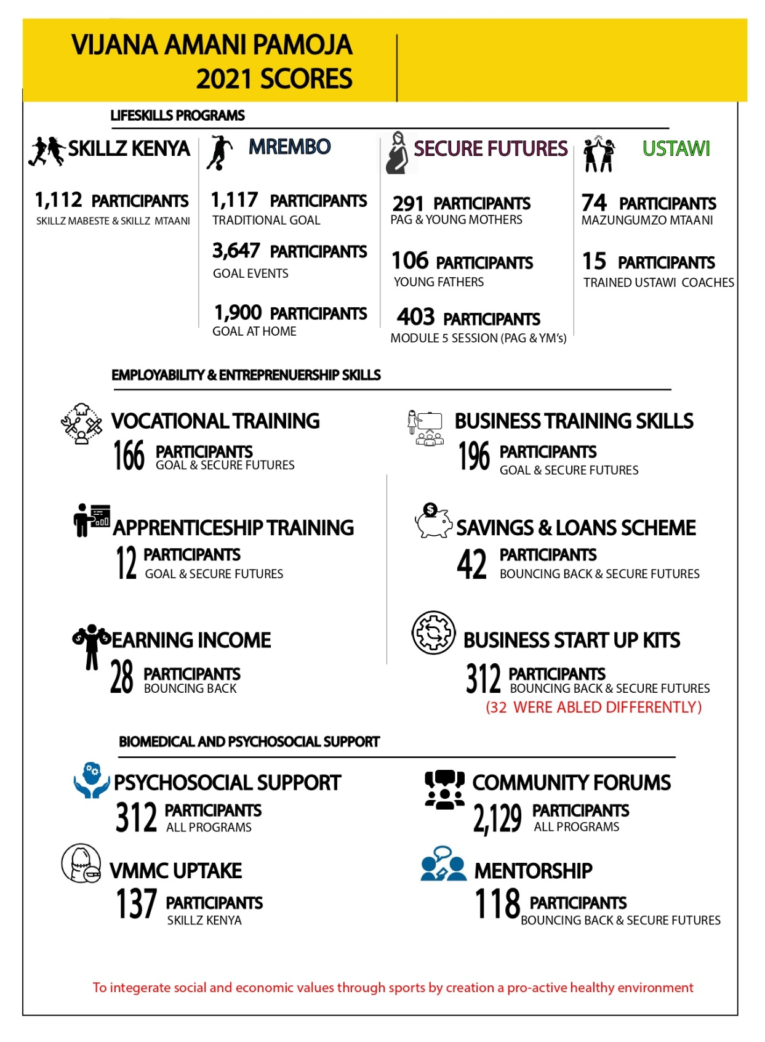

SKILLZ KENYA

Kenya is home to one of the world‟s harshest HIV and AIDS epidemics. An estimated 1.6 million people are living with HIV, around 1.1 million children have been orphaned by AIDS and in 2018 nearly 62,000 people died from AIDS-related illnesses (UNGASS 2019; UNAIDS 2019).
SKILLZ Program creates simple, but powerful connections between football and life, and helps young people take small steps to achieve their goals, stay strong when faced with challenges, and protect themselves and others from HIV and AIDS.
Numerous independent evaluations have proven that SKILLZ interventions are highly effective at building participants‟ knowledge and understanding of high-risk behaviours, changing harmful attitudes, as well as adopting health-seeking behaviours including increased uptake of health and psychosocial support services. Youth who complete the SKILLZ Kenya program are empowered – and supported – to make healthy decisions and begin changing their behaviors.
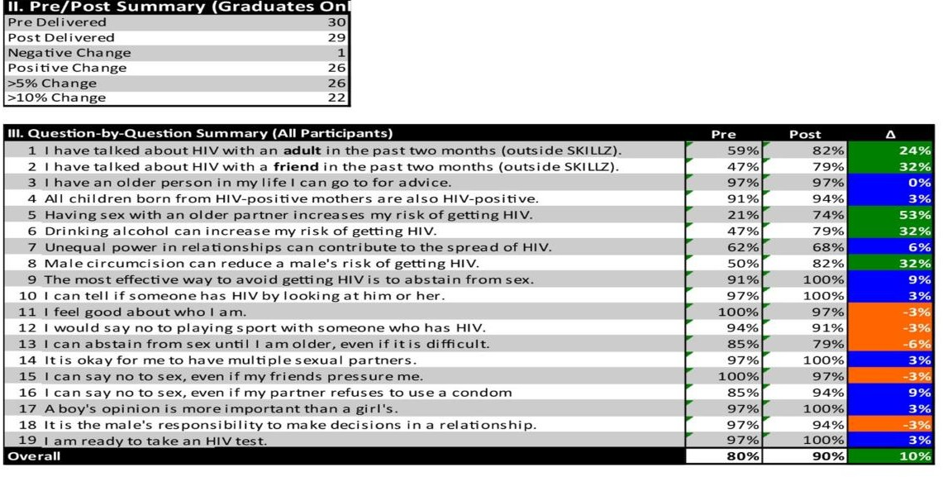
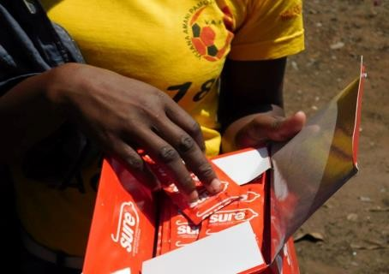
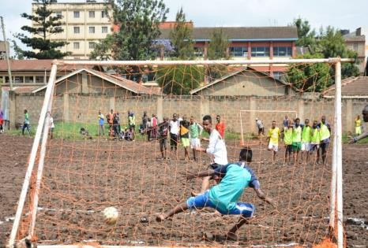
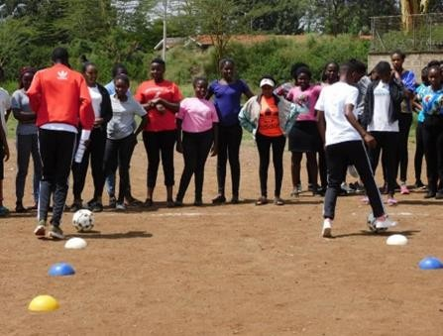

MREMBO/GOAL

“Mrembo” in Swahili means “beautiful”, normally reflecting the outer beauty of a person. However, outer beauty does not reflect what‟s on the inside. Mrembo program focuses on girls by building, unveiling and restoring the inner beauty of disadvantaged young women age 10-21 through a series of sports learning activities. The program objectives are:
- Empower young women and girls on issues related to their sexuality.
- Explore social challenges faced by girls as they are growing up.
- Encourage women to participate in sports.
- Offer counseling and guidance.
- Create a platform where young women can discuss their issues.
- Enable young women to make informed choices in their lives.
With an additional sub- project „Goal „created by standard chartered with the purposes of using sports as a tool for training and life skills education to empower adolescent girls. The two have been merged together to empower adolescent girls holistically both socially and economically focusing on addressing: health, communication, rights and managing their personal finances in order to help transform not just their own lives, but of their families, friends and future generations.

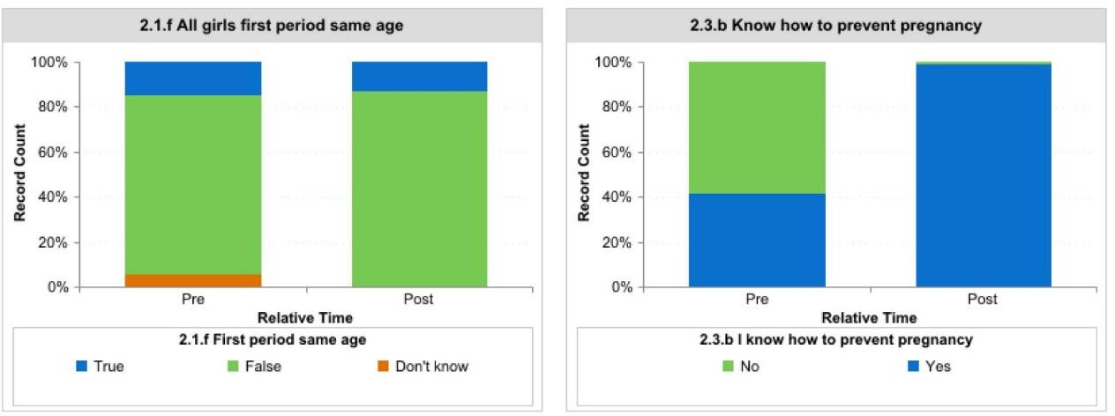

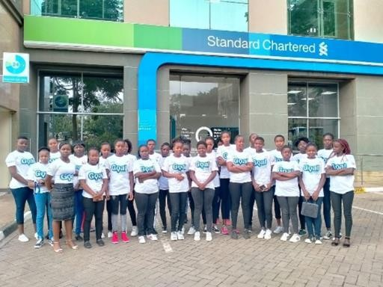
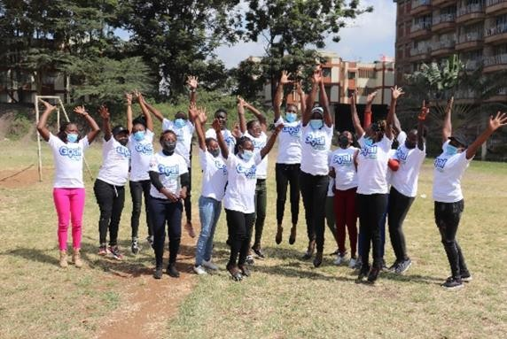

Employment +Entrepreneurship

Employment + Entrepreneurship (E+E) is the exit program of Vijana Amani Pamoja. The program integrates graduates of all other foundational programs including; skillz Kenya, Goal/Mrembo and Maktaba and provides them with vocational training courses of their own choices .E+E participants are attached with various partnering training colleges and institutions including: unity college of professional studies, YMCA, and Nairobi Industrial Institute for their vocational courses. Upon their graduation, they are attached to various partnering institutions and workplaces for either employment or internship opportunities with entrepreneurship participants supported with business skills and start-up support to pursue their careers.

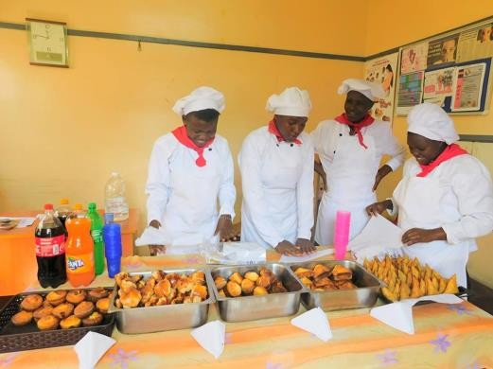
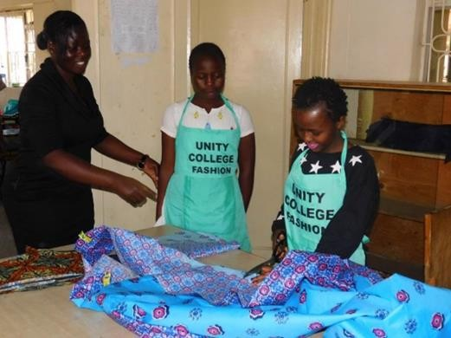

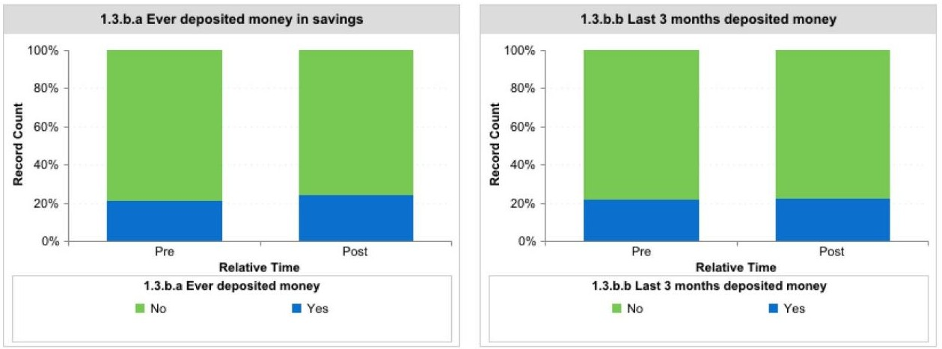

SECURE FUTURES

Secure Futures engages pregnant adolescent girls and young mothers from Nairobi slums without safe or secure places to live in a holistic sport-based programme. Secure Futures utilizes girl-centred approaches, design and implement activities in safe sport spaces to increase their social support, life skills and livelihoods opportunities.

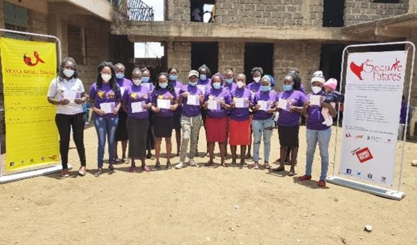
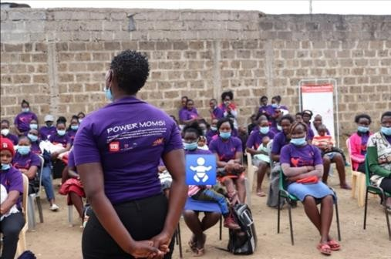

„S.F program gave me confidence as a mother to take care of my child and family. I know my roles as a mum, I used to often have fights and arguments with my husband but now I know to settle the conflicts and we live peacefully. I have realized we can be leaders even if we are young mums. My favorite session was violence. My coach Susan was the best. We were happy to receive cloth donations and the snack served on every session made us look forward to the next session‟‟

“If it were not for the counselor my marriage would not be in marriage today‟‟

„‟ I found a family in Secure Futures Program, my coach has mentored me. we were taken to
Bahati Health Centre where we registered for Linda Mama services. My prenatal clinic and delivery was free. When I got my baby my coach came to visit and it felt good to see her. The best thing I learned was how to breastfeed and wash my baby. It is my first baby and I did not have any experience on raising a child‟‟

HESHIMA

Heshima program is program targeting adolescent men and young fathers. The program creates a safe space for young men to share and learn how to be responsible; to inspire and motivate other youth in their community. The program also addresses issues to do with toxic masculinity, good parenthood, gender roles drugs & alcohol, money savvy and economic empowerment opportunity for the youth.

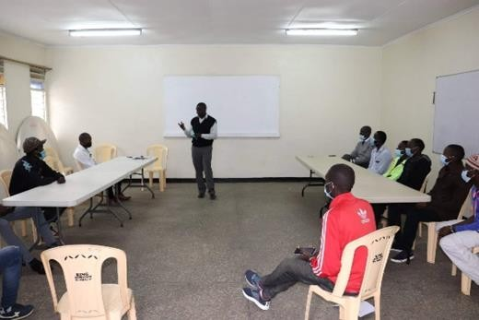
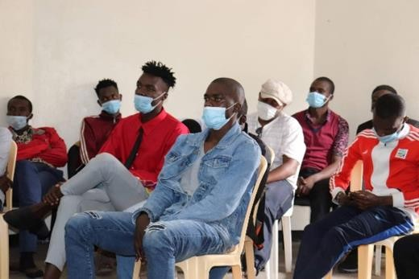

“Am grateful for Vijana Amani Pamoja for giving me the opportunity to further my studies by paying for my college education to do a course in catering. With the skills I gained during my course, period will really help me reach my goals. As a way of giving back to the organization am currently attached at
M-food where i assist in meals preparations. Thanks VAP for giving me this opportunity" Says Julius

MAKTABA MTAANI (STEM+Football)

Maktaba Mtaani uses football to provide quality education and promote lifelong learning opportunities for underprivileged youth living in the slum areas of Nairobi. Maktaba Mtaani creates a safe and conducive space away from already congested homes of these youth who live in the slum homes of Nairobi area to come and learn Science, Technology, English and Mathematics (STEM) while creating cognitive thinkers and developing deep introspection towards their future. Through mobile libraries tents are pitched on the sidelines of the football pitches. Further, youth participants have quiet and quality time of educational studies including reading, and doing revisions of their school work while engaging their tutors one on one while also having opportunities for periodical educational debate amongst themselves touching on various topics. Through Maktaba Mtaani, youth develop critical thinking, collaborative, creative problem-solving, and leadership skills that can be applied throughout their education and future careers. The program is designed to be youth-led and youth taught as participants are encouraged to explore on their own and continuously ask themselves why something is the way it is.

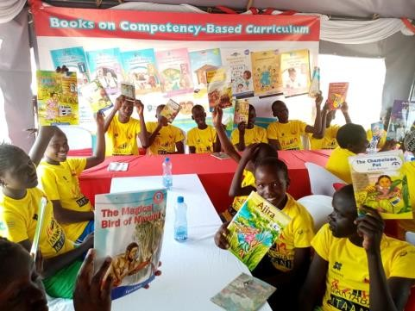
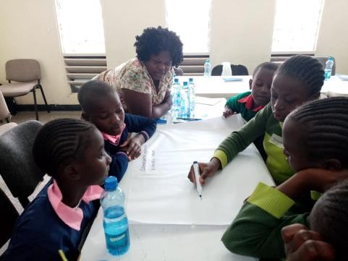

FUTURE PLANS FOR 2021

Based on VAP‟s strategic plan, the year 2021 promises to be the most chain breaker with lots of targets and aims both programmatically and organizationally.

