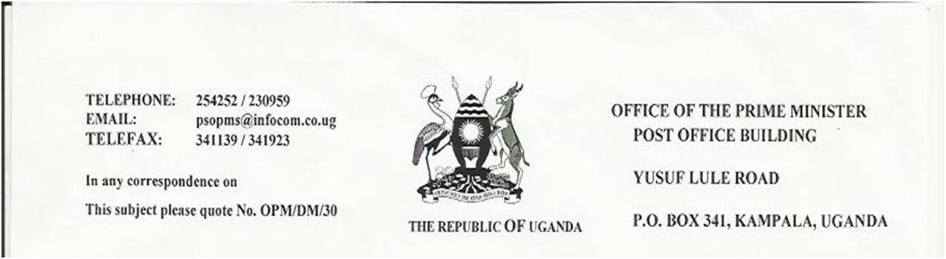

30 November 2011

TO WHOM IT MAY CONCERN
I ‘m writing to confirm the empowerment programs being provided to the HIV/AIDS orphans in Uganda by different Non- governmental organizations that include Divine Peace Ministries through vocational training in African Arts, crafts and dresses. In realization of there laudable projects and being a relief to one of our major disasters, the AIDS orphans and people living with AIDS/HIV are now producing these African products in commercial quantities not only to earn a living and be economically independent but also to help in their education and medication.
I hereby appeal and recommend these products for donation sales so as to help these unfortunate people in society.
Any assistance given to them is highly appreciated.
Yours,
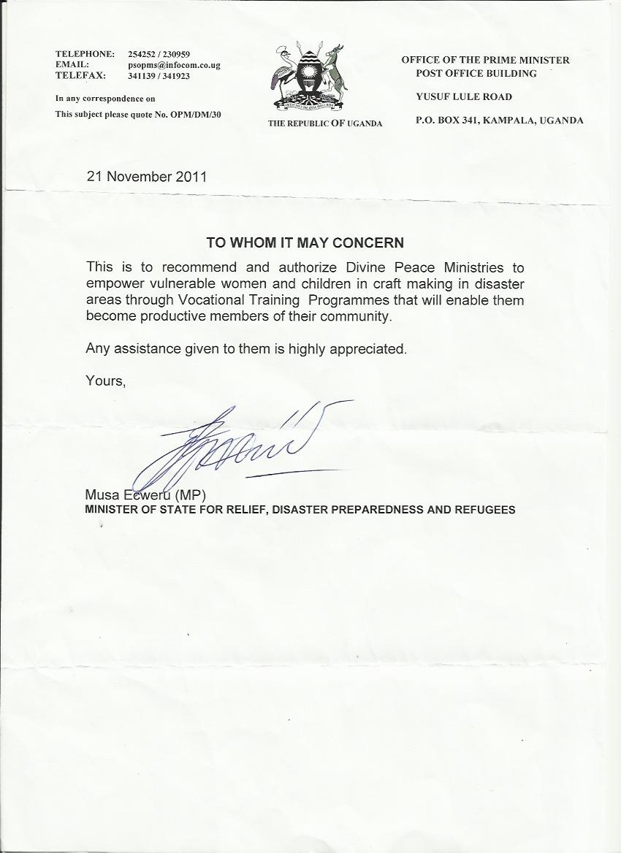

MINISTER OF STATE FOR RELIEF, DISASTER PREPAREDNESS AND REFUGEES

