TERRAMETER SAS 1000 FOR THE GEOPHYSICAL SURVEY (2 SETS)-Owned
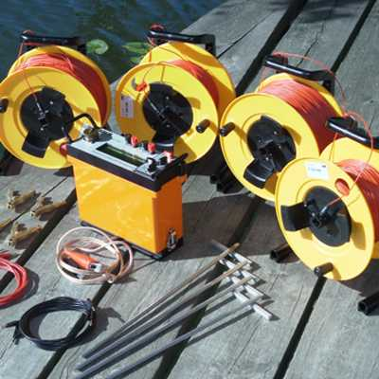
A HAND HELD GARMIN ETREX GPS FOR LOCATION CO-ORDINATES (5)-Owned
