Project

2013
E.D.I
Enyenge Development Initiative.

Water Project
Enyenge Communities
ENYENGE DEVELOPMENT INITIATIVE

Water Project- Enyenge Communities
© Enyenge Development Initiative
20 Makangai Street • P.O. Box 3 Limbe, South West Region, Cameroon
Telephone Numbers:
- EDI Central Office:……………….37 33 33 33 38•
- Fax:………………………………237 33 33 21 55•
- CEO: …………………………….237 95 400 510•
- Project Coordinator: ……………………71100791

Table of Contents

Introduction i
Chapter 1
Title of the project 2
Problem definition 3-8
Project plan 9-16
Outcomes 17-18
Finance 19-20
Annex 1 Community 21-25
Annex 2 Construction details 25-27
Annex 3 List of partners 27-31

Chapter
1

Project Title Description

The construction of one hand- dug well, fitted with hand pump for the supply of clean drinking water to the Enyenge Community.

- Introduction

Enyenge Development Initiative (EDI) is a Common Initiative Group founded in 2009, by a group of community members resident mainly in the south west region of Cameroon. EDI aims to improve the quality of life for people living in poverty-stricken communities in The South West and the rest of Cameroon. To achieve this goal, small-scale development projects are implemented in close cooperation with communities. The community is involved in the design, planning, activities and execution of each project. All EDI projects are strongly related to the Millennium Development Goals (MDGs) and are mainly focused on health and
Education. Where possible, projects are conducted in partnerships with local as well as international partners, each with their own expertise in their respective field, and who share similar objectives and goals. In order to ensure long-term continuity of each project, both ownership and responsibility are created at community level. To realize this, and to accentuate capacity building, EDI and partners train community members to monitor and maintain projects. However, EDI also strongly believes in preserving long-term relationships, jointly monitoring and evaluating the impact of each project by measuring outcomes based on predetermined indicators.
Enyenge¹ a community located in the Idenau Sub Division of the South West Region is presently the focus of EDI. For some years now, EDI has been working in Enyenge in the Agricultural sector of the community, planting economic trees to fight environmental degradation such as erosions and deforestation as well as providing employment and welfare during the transformation processes of these plants such as palm nuts into palmoil and soap.

Currently, the community of Enyenge (with an estimated 2.000 inhabitants) has no direct access to clean drinking water. The closest source of safe water is the town of Idenau, half an hour boat-drive away by the sea. The lack of clean and safe water causes many problems within the community.

This project proposal is focused on the realization of a safe water supply system for
Enyenge and the surrounding community of Enyenge. This project has identified Enyenge as crucial because the community is located along the Atlantic Ocean and is cut off from mainland by creeks and rainforest. Salinity and sandy soil make the existing wells not suitable for drinking and sustainably respectively. We examined the urgency as well as the feasibility of providing hand dug wells sealed with hand pumps to solve the problem of infected wells and insufficiency of potable water as well as its underlying consequences which include health depredations amongst others.

We have underscored the problematique and possible strategies to offer a sustainable solution to the water crisis. We also proffered how these would meet up with the stated goals and benefit the entire population of the region adequately. The project shall be economically viable and environmentally friendly and tailored within a convenient prescribed timeframe.

¹ See annex 1 for a more detailed description of the community.

- Problem definition

Water, the bigger picture

The provision of safe and clean drinking water is amongst the pressing challenges facing the developing world. The high demand for portable water is aggravated by a teaming population and environmental degradation. According to the United Nations human development index report (2012), Cameroon ranks 150th in the human development index, life expectancy at birth is 51.6 years. There is a high rate of infant and maternal mortalities. Multidimensional Poverty Index (MPI) is greater than or equal to 3%.Gender Inequality Index (GII), value is 0.668.Gross National Income (GNI) per capita is $2.031. These indicators show that Cameroon is amongst the poorest countries in the developing world. This is not unconnected to lack of safe and clean drinking water. Water and poverty are related, water and health are related, water and education are related, so also is water and hunger. Millennium Development Goal 7, Target 7c, calls on countries to "Halve, by 2015, the proportion of people without sustainable access to safe drinking water and basic sanitation". To achieve the MDG drinking water target for 2015, an additional 1.2 billion people will need access from 2004 to 2015.

Access to clean and safe water has an important impact on health. Each year 3.6 million people die from water-related disease, 98% of these deaths occur in the developing world. Of these water-related deaths, 84% are in children aged 0–14.² Diarrheal disease alone is responsible for the deaths of 1.8 million people every year, 90% of these victims are children under 5. Access to an improved water supply reduces diarrheal morbidity up to 25%. ³
²World Health Organization, 2008. Safer Water, Better Health: Costs, benefits, and sustainability of
interventions to protect and promote health

³World Health Organization, 2004

Water in Cameroon

As a member country of the United Nations (UN), Cameroon is in line with the policy of poverty reduction of which the provision of portable water to the poor is top on the agenda. The provision of water in Cameroon is the responsibility of the Ministry of Water and Energy. However, due to limited monetary resources of the government, external funding is very much needed to supplement efforts in order to meet the numerous demands from communities pleading the government to resolve their water crisis.

The United Nations Development Program says less than half of Cameroon's estimated 18 million inhabitants have access to safe drinking water. This is a striking statistic for a country rich in water resources; Cameroon has two rainy seasons and many sources of underground and surface water.

Water related problems in Enyenge

Currently, the community of Enyenge has no direct access to clean drinking water. The closest source of safe water is the town of Idenau, half an hour boat-drive away through the sea. Because people have no direct access to safe drinking water, they are forced to use rainwater or contaminated groundwater from unprotected wells found on certain compounds. Clean water is also available in bottles, but these are too expensive to use on a daily basis.

The lack of clean and safe water causes specific problems within the community. Because people have no direct access to safe drinking water, they are forced to use
rainwater or contaminated groundwater from unprotected wells. The incidence of cholera epidemics and other water related diseases such as typhoid, diarrheal disease, and dysentery have commonly been reported in the area by the care taker council.

In Enyenge, most available sources of water within settlements are affected by about 5% of saline water which is infiltrated into wells. Worthy of note is the fact that the existing wells are polluted. (According to survey by EDI)

Fig. 1 Shows the filth in contaminated wells.
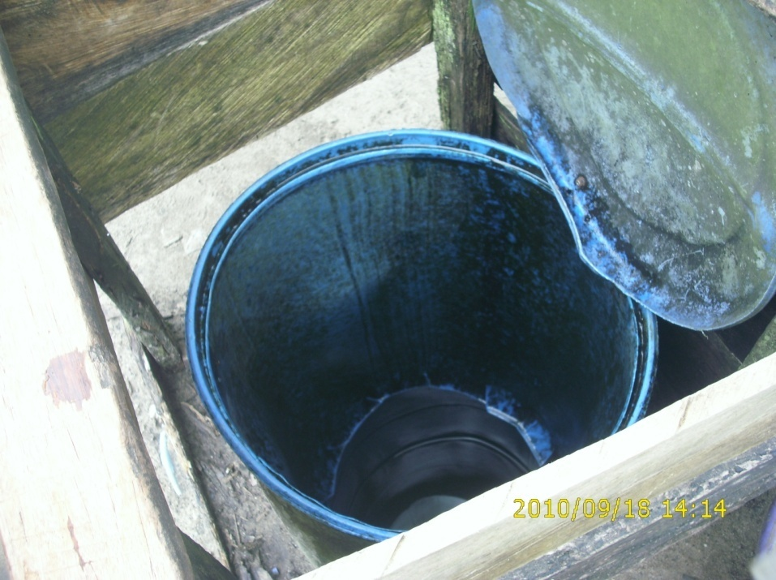

Attempts to treat the shallow wells have not succeeded largely due to the absence of an organized water management committee. The wells are susceptible to the infiltration of organic matters and bacteria as they are shallow and often left open. Consequently the over 2000 inhabitants have to walk miles away to streams and springs to fetch water which itself is not safe for drinking and are the cause of premature deaths in infants and acute health depredations harnessed by the fact that health centers are far away.

Fig 2. Shows that traditionally, it is the task of the children and women to collect water for the household. This heavy task consumes time that could have been spent on other activities, such as income generating activities. Traditionally, the girls help their mothers with collecting water. This chore often takes precedence over primary education.

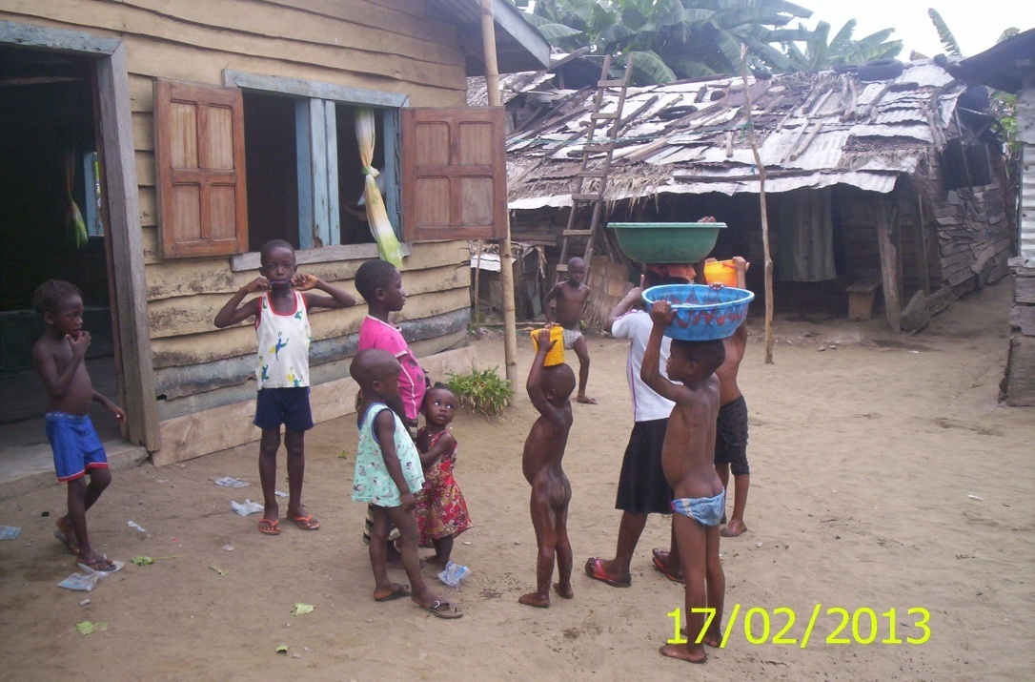

Fig 3. Shows how children are susceptible to falling into wells
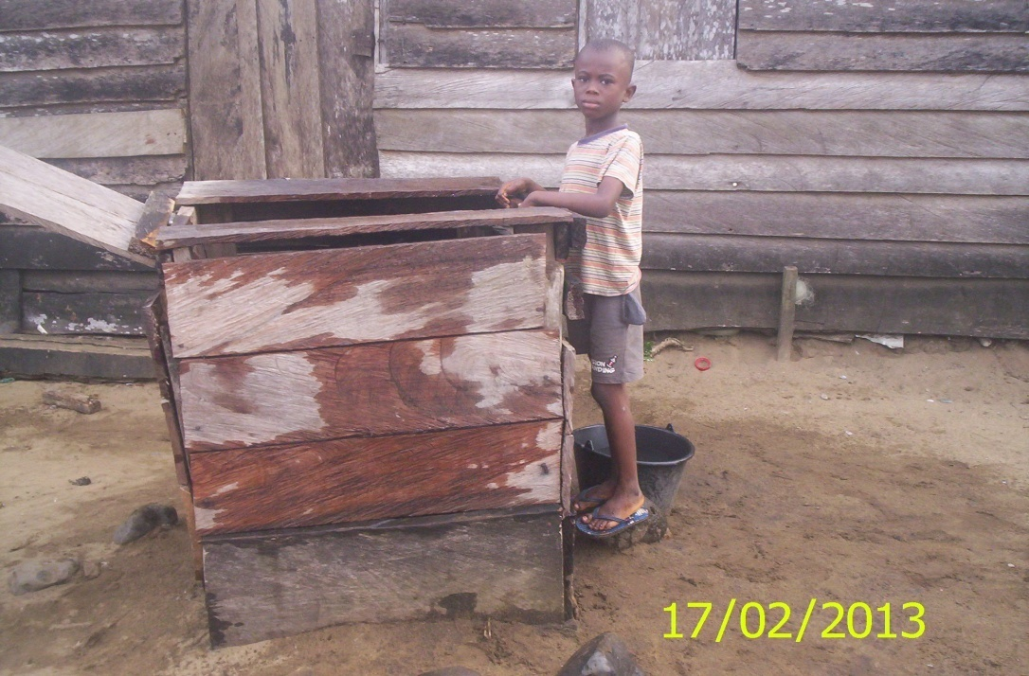

The streams, rivers, and poorly constructed wells are unprotected water sources because the wells are not drilled and do not have watertight casings that extends to a depth of at least six meters below ground level. This makes them susceptible for contaminants such as Bacteria, Total coliforms, E.coli, nitrates and pesticides, Salmonella, and Cryptosporidium species.

The safety of the well water is also influenced by the original water quality in the watershed or catchment which is partly saline and contaminated by poor sewerage system. These unprotected water sources are easily contaminated and unfit for drinking.

Fig 4. Shows the project coordinator identifying a well close-by a sewage outlet at a community member’s compound.

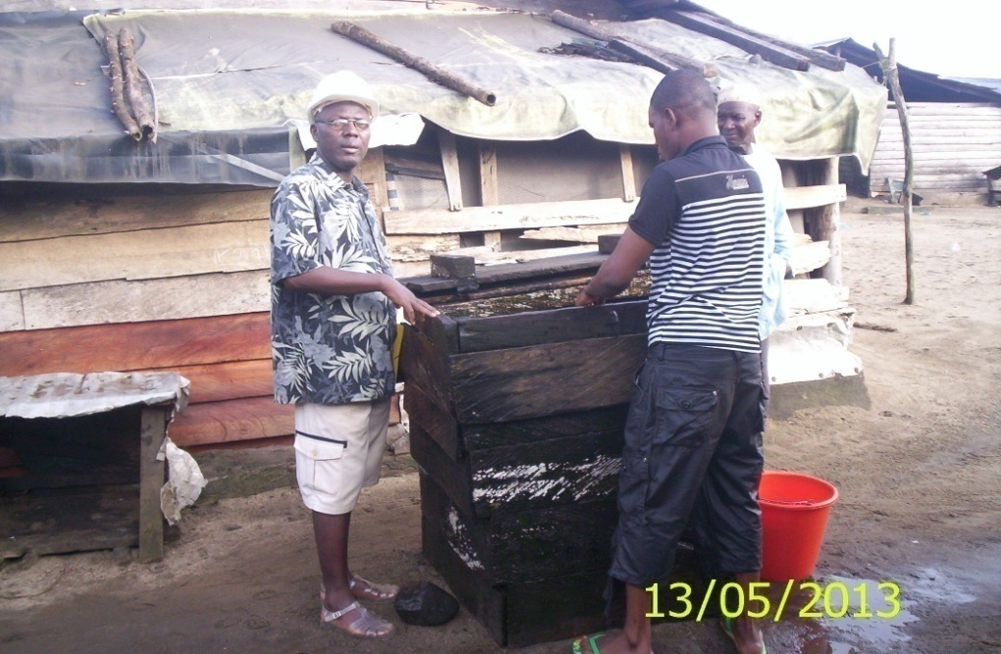

Health depredations from drinking contaminated water have become endemic in the communities the likes of gastrointestinal and stomach illnesses, cramps diarrhea, reproductive problems, and neurological disorders and even premature death. Infants, young children, pregnant women, the elderly, and immuno-compromised persons are especially at risk for becoming ill after drinking the contaminated water.

Lessons from the past

In the late 1980’s, Enyenge was provided with wells by the government of
Cameroon, which is currently non-functional. The system consists of a borehole 10m deep and uncovered. After completion, it proved to be too impractical for 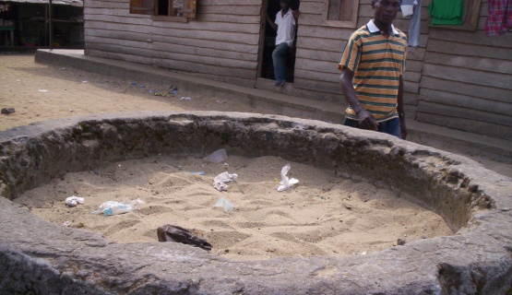the rural community to manage. The population was not involved in the implementation of the project and no proper training was given to manage the system. Eventually, mainly due to lack of maintenance, the system broke down andremains non-functional with sand filled up to the brim. Since then, the communi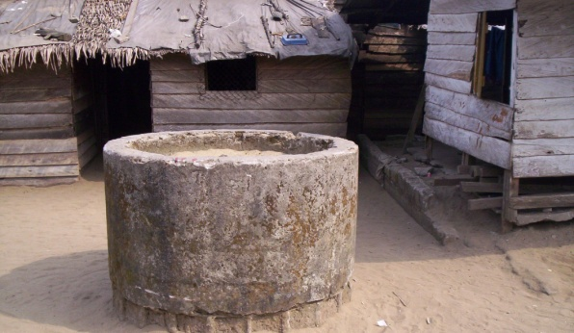ty members have gone back to fetching water from unimproved water sources. Due to the problems described above, the inhabitants have gone back to old traditional wells and polluted springs to fetch drinking water, with all related consequences. We have learned from these mistakes made in the past and emphasize the importance ensuring long-term continuity and community participation in this project plan.

- Project plan

Main goal

EDI wants to realize an easily accessible and sustainable supply of safe drinking water in sufficient amounts for Enyenge community and its neighbouring communities. Through this project, EDI aims to improve the quality of life for the
people in Enyenge , by reducing water-related diseases and deaths and providing economic and social benefits for the region.

Specific Objectives

- To supply safe and portable drinking water; without access to safe water for drinking, cooking and cleaning, people are more likely to suffer from water related diseases. These can be fatal, killing children, women and youths on a daily basis. This water related illnesses will be reduced to the barest minimum.
- To provide portable water which shall be easily accessible; the time and energy spent to fetch water will be used for more productive activities, such as education of the youths, farming and other house hold chores.
- To prevent the risk of children falling into wells or streams
- To prevent the access of organic matters to contaminate the wells such as: E. coli, total coli forms, bacteria, nitrates and herbicides or pesticides.
- To alleviate health depredations related to water borne diseases such as bilharzias etc.
- To facilitate the drawing of water by children and women.
- To alleviate poverty and an increase in economic growth.

Location of Pumps

The initial site of the hand pump well will be at Enyenge I (Bamboko). EDI aims to subsequently provide same to Enyenge II (Blackbush) and EnyengeIII (Over side).

Timeline

Phasing

The execution of the Enyenge water project will be divided into three separate phases. The first phase is the subject of this proposal and the two other phases shall be continued after the successful implementation of the current project. The whole project comprises of a manually dug borehole facility and an embedded manual pump or tap.

The phasing of the project will allow for better planning and a clear overview of the progress of the whole project. The first phase will be carefully monitored and evaluated after completion in order to learn from mistakes made and adapt the planning to these experiences, before initiation of the next phase. This will be the first community owned water project in Enyenge , so a strict monitoring and evaluation process will be necessary.

Phase 1

This phase will kick-start the first water project at Enyenge 1 area (Bamboko). It includes clearing the site, digging a borehole, installation of the pump, training and formation of the water management committee and caretakers.

Phase 2

This phase shall be started after the successful implementation of the first water project. It shall be located at the Enyenge 2 area (Black Bush). It shall have the same implantation strategies as was with phase 1. It shall be funded independently hopefully by the resources the water management committee shall gain from the first phase and further grant.

Phase 3

This phase shall be started following the second water project. It shall be located at the Enyenge 3 area (Overside). It shall have the same implantation strategies as phases 1 and 2. It shall also be funded independently hopefully by the resources the water management committee shall gain from the first and second phase and further grant.

Phase 1, 2 and 3 will connect all the quarters of Enyenge to the water network, so that the whole community can benefit from the project.

Project Schedule

Effective period of implementation is during the dry Season that is any period from November 2013 to June 2014. The effective duration for implementation is three weeks. Below is a simulation of a schedule that shall run from the 6 of November to the 11 of December 2013.

# | Tasks | Days | Start(M/D/Y) | Finish(M/D/Y) | %
1 | General assembly meeting on Donor approval. | 2 | 11/5/2013 | 11/6/2013 | 0
2 | Workshop for implementation | 2 | 11/5/2013 | 11/6/2013 | 0
3 | Site Preparation | 6 | 11/6/2013 | 11/13/2013 | 0
4 | Location of Well | 1 | 11/6/2013 | 11/6/2013 | 0
5 | Clearing of site | 1 | 11/11/2013 | 11/11/2013 | 0
6 | Mobilization of Material resources | 1 | 11/12/2013 | 11/12/2013 | 0
7 | Monitoring and Evaluation | 1 | 11/13/2013 | 11/13/2013 | 0
8 | Construction of Well | 12 | 11/14/2013 | 11/29/2013 | 0
9 | Procurement of Construction Materials | 1 | 11/14/2013 | 11/14/2013 | 0
10 | Excavation of Well | 3 | 11/15/2013 | 11/19/2013 | 0
11 | Fabrication of culvert rings | 4 | 11/20/2013 | 11/25/2013 | 0
12 | Sinking of precast culvert rings | 1 | 11/26/2013 | 11/26/2013 | 0
13 | Cleaning of the Well | 1 | 11/27/2013 | 11/27/2013 | 0
14 | Installation of the pump | 1 | 11/28/2013 | 11/28/2013 | 0
15 | Monitoring and Evaluation | 1 | 11/29/2013 | 11/29/2013 | 0
16 | Testing of Hand Pump Well | 1 | 11/29/2013 | 11/29/2013 | 0
17 | Testing of hand pump | 1 | 11/29/2013 | 11/29/2013 | 0
18 | Testing of water quality | 1 | 11/29/2013 | 11/29/2013 | 0
19 | Training and Capacity Building | 4 | 11/29/2013 | 12/4/2013 | 0
20 | Training of water management committee | 3 | 11/29/2013 | 12/3/2013 | 0
21 | Setting up of pump usage and management policy | 3 | 11/29/2013 | 12/3/2013 | 0
22 | Monitoring and Evaluation | 1 | 12/4/2013 | 12/4/2013 | 0
23 | Labeling | 1 | 11/29/2013 | 11/29/2013 | 0
24 | Placing of label of the funding body | 1 | 11/29/2013 | 11/29/2013 | 0
25 | Handing over ceremony | 1 | 12/6/2013 | 12/6/2013 | 0
26 | Showcasing of product to the Administration, community and donor | 1 | 12/6/2013 | 12/6/2013 | 0

Organization And Management

The project will be implemented by the Enyenge Development Initiative (EDI), under the auspices of its partners and the Enyenge Resource Center. There will be support and cooperation from the Enyenge caretaker council and water management committee. The main objective of the group is to enhance development and it is community driven. The group is gender sensitive, made up of men, women and youths. There is total membership of about 25. EDI, has sub groups that controls other developmental projects in the community.

EDI will also arrange the monitoring, evaluation and reporting at all levels of implementation of the project. EDI has shortlisted its partners⁴ (OSRI) for the construction of the hand dug wells, the community will assist in the mobilization of material resources such as sand, stones, gravel. EDI will represent the Donors at the community level and will be responsible for the coordination, disbursement and procurement of all project activities.

However EDI shall have one of its partners which is a local NGO having much experience in Cameroon with water and sanitation projects using a community-based approach to carry out major works on the project. The Organization for Sustainable Rural Infrastructure (OSRI) is specialized in the planning, monitoring and execution of community based infrastructure projects in rural communities in South West Cameroon. Its head office is in Kumba, a 2 hours drive from Enyenge .

During the execution of the project, OSRI will be responsible for the following activities:

- All technicalities concerning the construction.
- Providing on the job training to caretakers.
- Facilitating the formation of the water management committee.
- Training of the management committee to ensure the continuity of the project.
- Sensitize and mobilize the community to participate actively in all the stages of the project.

To ensure effective community participation the caretaker council of Enyenge and the water management committee will be closely involved with the following:

- Communal labour (i.e. digging and carrying of building material,)
- Mobilization of available local resources (financial, material and human) for the implementation of the project
- Communication with local municipality and government
- Ownership and Long Term Continuity

The lessons learned from past water projects in the region will be a starting point for the realization of this project. Special attention will be go to community involvement, local ownership and long-term continuity. The organization and financing of maintenance and caretaking will ensure the durability of the system.

⁴ See ANNEX 3 for a complete list of our partners and a detailed description of the most important ones.

To ensure that the project can run independently in the future, without constant support from western donors, the project will be locally owned and managed by the Enyenge Water Management Committee (EWMC ).
The EWMC will be extensively trained in various important aspects concerning the management of this project. Additionally, caretakers will be trained to maintain the water supply system after completion. OSRI, which has much experience in this area, will give these workshops and training. With future oversight from EDI, this will ensure the continuation of the project for many years.

Enyenge Water Management Committee (EWMC)

EDI is presently organizing the formation of the Enyenge water management committee to take on the local management of the project. The committee shall consists of representatives of the various caretaker council, the EDI, the different nationalities, trade unions, church unions, the health committee, women groups and youth groups

- The representative of the EDI shall be made up of the Chief Executive Officer, the project coordinator/secretary General
- The representative of the Caretaker council shall be made up of four members from the council
- The representative of the various nationalities shall be made up of four members each from the Nigerian, Ghanaian, and Togolese Unions
- The representative of the Cameroon Union shall be made up from four member from each of the various divisions of the regions such as, Fako, meme, etc from the South West region, and from the North West region
- The representative from the Church shall be the pastors or chairpersons of each church
- The representative from the Health committee shall be made up of two members from the committee
- The representative from the Women group shall be the chairpersons of each group
- The representative from the Youth group shall be the chairpersons of each group

Within the EWMC , one member will be chosen to act as a project manager. This project manager will have direct contact with the project manager of EDI . This local project manager should have sufficient knowledge of the English language and be able to communicate through phone and email.

The role of the EWMC is to act as a management board for the whole project. The EWMC has the following responsibilities:

- Together with the village council, will assist in sensitizing and mobilizing the population towards the realization of the project.
- To organize community labour during the execution of the project.
- After completion to organize the collection and management of funds for the upkeep of the project.
- Collect the monthly user fee (approximately 300 CFA) A legal status will be acquired from the divisional officer of the Idenau Sub division to give the legal rights to collect public funds during and after the completion of the project.
- Representing the wishes and demands of the community and administering the project at all levels.
- Maintenance and caretaking.
- To direct and appoint two local caretakers who are responsible for project
- Maintenance, repairs and security.
- To bridge the gap between EDI and the community.

Caretakers/technicians

EDI and OSRI will be responsible for the training and installment of three technicians. These caretakers are technicians who shall work along side other workers during the execution of the project and will assist in all technical problems when the project is completed. The caretakers will be trained in the handling of the pumps and the day to day running of the water project. Additionally, they will be trained to maintain
and repair water pipes, water points, pumps and all other aspects of the project’s hardware.

Training/workshops

EDI and OSRI will set up workshops and training sessions to teach the EWMC and the caretakers how to run the project in the long run. Management training for the EWMC will be determined by the technicians. This training includes management workshops, financial workshops, administrative workshops and some basic water theory workshops. The management committee will also be sensitized on water hygiene and sanitation practices.

Community contribution

One of the major aspects concerning the project is the contribution and participation of the local community, to promote ownership of the project and a sense of responsibility. This contribution will take on three different forms; local available materials, manual labour and financial resources. The EWMC , in collaboration with OSRI, caretaker council, and EDI , will be responsible for the sensitization and mobilization of the community.

Financial contribution

The Enyenge community will help finance the construction of the project in kind. This kind contribution is calculated to a monetary value of CFA 2,036,355. (3,104.403€). This is almost 29% of the local investment needed to complete the project. The details of this local kind contribution can be found below.

In meetings with EDI and the community members it was decided that a small financial contribution will be requested from all members of the community, paying monthly fees to save money for large repairs, replacements and maintenance. Currently, this fee is set upon 300 CFA (€ 0,45) a month;. To put this amount of CFA 300 in the right context, a boat fare from Enyenge to Idenau and back (to get clean water) is CFA 3.000. One bottle of water is priced around CFA 400, a large bottle of beer is CFA 500 (€ 0,76) and an average monthly wage in the community is between CFA 30.000 (€ 45,80) and CFA 50.000 (€ 76,36).
The collecting of this fee will be carried out by the heads of all respective quarters in Enyenge and will be overseen by the EWMC . The collecting of the fees will be a transparent and well-documented process. Such a process of requiring small amounts of money is determined to be an attractive place for corruption and self-enrichment. The EWMC will receive awareness and administration training from EDI and its partners to help prevent this from happening.

Labour contribution

During the phase of digging the borehole, the community will be mainly responsible for digging the well and getting the required sand and rocks to build the necessary constructions. This is part of their contribution in kind.

Material contribution

The community will contribute available local resources to the project. The material contribution from the village will include sand, stone and timber. These materials are abundant in the region.

Project Staff List.

Name  Qualification.  Address | Position  Years with Organization  Specialization
Mr. Akuru Joseph;  Technical Adviser. OSRI  Tel: 79435372.  Email: osri_sp@yahoo.co.uk | Team Leader of the Enyenge Water Project. Senior Technician at OSRI and also a civil engineer. Great experience in the planning and implementation to measures related to drinking water supply as water shed management, improvement of hygiene in villages.
Dr. Okolle Justin  PhD; Researcher/lecturer;  Tel: 745534786  Email: okollejustine@yahoo.com; agrovitalservice@yahoo.com | Assistant Team Leader of the Enyenge Water Project. A seasoned university don at the university of Buea and also a researcher with the Institute of Agricultural Research and developmet (IRAD), South West region.
Mr. Jerry Nambeke W.  (B.A.Linguistic, Dip.Marketing, PIP. A/C  Tel: +237 95 40 05 10.  Email: jerrybil222@yahoo.co.uk | C.E.O. of EDI. Since 5 Years. 6 years experience in the education business. Real Estate Owner. Extensive background in telecommunication and Marketing. 3 years experience in Customer Relations with MTN Cameroon.
Mr. Johnson Ndoa (Bsc (hons)  Chemistry, Dip computer studies.  Tel: +237 71 10 07 91.  Email: johnsonean2002@yahoo.com | Project coordinator of EDI. Over 6 years working experience in the rural and community development management. Great expertise on Quality control analysis, Community development, Project coordination and management, and Risk management. Extensive working experience with RUMPI PROJECT for 4 years.
Mr. Valentine Asong Tellen  (Bsc,Msc,PhD) Environmental chemistry, soil fertility.  Tel: +237 77 91 09 35.  Email: tvasong@yahoo.com | Water Management Technician/Consultant. University lecturer with the University of Buea and PAN AFRICAN INSTITUTE of DEVELOPMENT - WEST AFRICA. Extensive working experience in soil management, water quality control, Environmental management and natural resources. Founding Member of EDI.
Mr. Metuge Nzenze  (Dip, management,  Dip life science).  Tel: 74 76 93 67.  Email: mbineman@yahoo.com | Financial Secretary of EDI. Over 4 years working experience in rural community development. Extensive knowledge in Financial Data processing techniques, Project management and Environmental management.
Mr Ashu Elvis Avere.  Bsc( Management Sciences). Tel: 75712841/ 95041678; Email: ashunkap@yahoo.co.uk | Experience in Internal control (Internal audit), efficient and effective management skills in an enterprise.
Mr. Emmanuel Epie Ngoleson  (Dip,Management, - ACCA).  Tel: +237 79 23 58 86.  Email: epie.ngoleson@yahoo.com | Accountant. Extensive experience in management and Financial Accounting.
Mrs. Muki Margaret. | Field assistant with EDI. Computer skills.
Ms Ebua Mildred Seh  (Dip, Computer studies).  +237 78 55 10 94  Email: miloyette150@yahoo.com | Field assistant. Data processing Techniques. Social Secretary with EDI.

- Outcomes

Monitoring and Evaluation

The monitoring of the activities towards the provision of clean water for The communities of Enyenge will be executed in collaboration with EDI, its partners where applicable and the EWMC ,
.

After completion of the project, periodic reports will be made by the local project manager together with the EWMC and EDI concerning availability of water, safety of the water (regular water safety checks), status of the hardware, and financing, and sent to the donors . EDI will followup the project monthly, for a period of one year, to inspect all the components of the system. This will be done with the caretakers and the water management committee to repair any damage.

Projected Outcomes

After completion of this project we hope to realize an easily accessible supply of safe drinking water, in sufficient amounts, for the Enyenge . Through the realization of safe water, EDI hopes to provide economic and social benefits. In order to reach this goal after construction, we hope for outcomes that help reduce the problems
as described in the problem definition chapter.

- The sealed well fitted with hand pump will keep away germs and snails which cause water borne disease in the community.
- The manual pump will provide safe and clean water, prevent children from falling into wells, and also prevent the access of organic matter.
- Fetching water will be easy even for children.
- The casing enables the pump and pipe to be easily removed for services every fortnight thus rendering the water to be clean always.
- The population of Enyenge and beyond will have access to safe clean portable water.
- A regular supply of clean water means, health and the general well being of the people improves.
- Precious time will be used by children to go to school, women to attend to more productive activities, and men to be more active in farming, fishing, poverty is reduced and there will be increase in economic growth.
- By realizing an easily accessible and sustainable supply of safe drinking water in sufficient amounts for the whole of Enyenge we hope to improve public health by reducing the incidence of water borne diseases.
- Monitoring and evaluation of the impact of clean water towards improvement of public health will be implemented in collaboration with communities of Enyenge .
- The realization of easy access to safe drinking water will contribute to reducing time spent for obtaining water for household use. This reduction in time spent on fetching water will empower women by giving women more time to engage in income generating ventures, thus increasing their economic power.
- Customarily, children especially girls help their mothers with collecting water. This chore often takes precedence over (primary) education. Providing easy accessible safe water will now reduce the time spent by girls for obtaining drinking water for household use, providing more time to focus on education, thus increasing gender-equitable school attendance.

Target Population/ Beneficiaries

The project under the auspices of Enyenge resource center with the Enyenge Development initiative (EDI) as the principal coordinating agents will directly the entire population of;

- ENYENGE I ( Bamboko) about 1,500 persons,
- ENYENGE II( black bush) about 900 people,
- ENYENGE III (Overside), about 500 people.

Indirect beneficiaries include;
- Sanje, about 2000 persons
- Ghana Kope, about 800 persons
- Bammusso about 2000 persons

Initially we intend to construct One hand dug well fitted with a hand pump to serve the Enyenge 1 population. Our goal is to provide three wells fitted with hand pumps for the three quarters in Enyenge.

Impact

Poverty in the community is reduced through access to clean, safe water. This is the foundation of all developments. Poverty and water are related, water and health are related, water and Education are related, and water and hunger are also related. The United Nations estimates that sub- Saharan Africa alone losses 40 billion hours per year collecting water, that is a whole year’s worth of labor by France’s entire workforce. This is incredibly valuable time.

The community of Enyenge would be a place where safe, clean drinking water is available to all and sundry. This will be a step towards reduction of poverty and increase in Economic growth.

With sustainable water supply, the community of Enyenge and beyond will realize an increase in Agricultural productivity, and these will enable them to provide income, employment, and food, as well as raw materials for industry and exports.

Risks And Limitations

Natural disasters like flooding would be contained by raising the height of the hand pump vicinity.
The risk of contamination is reduced by increasing the depth of the well as earlier discussed.

An ongoing challenge facing the community is the lack of shops that retails water supply spare parts; EDI will work with small shop owners to establish supply chains in the nearby town of Limbe.

- Finance

Funding

EDI is hoping that this proposal shall be sponsored partly by one or more of the sponsors or donors contacted of one side of the coin, and in kind, the EDI and the Enyenge communities of the other side of the coin..

Total cost estimate

The following estimate gives an outlook of the costs of the project. In the attachment, a more detailed description of the costs can be found. The following exchange rate is used; €1/CFA655.

General Cost Of Constructing One Hand Pump Well
S/N | Description of work | Donor | Beneficiary and EDI | Total Amount.
1. | Lay out and Geophysical studies. | 400,000 | - | 400,000
2. | Site installation (transportation of materials, safe sign, project sign board, security fence around work area), clearing of site. | 360,000 | 90,000 | 450,000
3. | Excavation above water level using manual tools(dig axes, crow bars,hoes,spades shovels, buckets) | 89,600 | 22,400 | 112,000
4. | Pre-fabrication of culvert rings, with concrete dose at 350kg/m3 for culvert rings, form work, iron work. | 1,112,600 | 278,150. | 1,390,750.
5. | Excavation below water table (cutting culvert rings, pre-fabrication base slab. | 51,928. | 12,982. | 64,910.
6. | Sinking of pre-cast culvert rings (filtration and non- filtration culvert rings. | 418,708. | 104,675 | 523,379.
7. | Superstructure, slab on grade, with anti-shrinking rods, concreting of platform, fencing. | 994,147 | 248,536.6 | 1,242,683.
8. | Cleaning of well( quality control analysis) | 176,000 | 44,000 | 220,000
9. | Purchase and Installation of manual pump(Indian mark) | 680,000 | 170,000 | 850,000.
10. | Training and capacity building, supply of tool kit for maintenance. |  | 100,000 | 100,000.
11. | Supply and placing of the label of funding body. | . | 50,000 | 50,000.
12. | Reception and folding back.( all temporary structures, equipment removed from project site, cleaning of the site, report of work elaborated by the contracting parties. Handing over ceremony. |  | 250,000 | 250,000.
13. | EDI facilities (vehicles, stationery, project staff. | - | 400,000. | 400,000.
TOTAL |  | 4,282,983 | 1,770,743.6 | 6,053,726.6.
14. | Miscellaneous(5% of total) | 214,149.15 | 88,537.18 | 302,686.33.
15. | Management and supervision (10% of total). | 428,298.3 | 177,074.36 | 605,372.66.
GRANT TOTAL. |  | 4,925,430.45 | 2,036,355.14 | 6,961,785.59

- Donor amount: 4,925,430.45 = 7,508.770€
- Beneficiary and EDI: 2,036,355.14 = = 3,104.403€
- Total amount: 6,961,785.59= 10,613.174€
Exchange rate: 1€ = 655.957 CFA francs.

- Annex 1. Community

The community of Enyenge is located in the Idenau sub-division, Fako division, South West region, Republic of Cameroon. Enyenge is situated along the Gulf of Guinea, a coastal seaport, about a 30 minutes boatdrive away from Idenau (the Sub divisional head quarter of the Idenau Sub division) and a 45 minutes drive from Limbe, the Divisional Headquarters of the Fako Division. The community is divided into three parts; Enyenge 1 also called Bomboko, Enyenge 2 also called, BlackBush and Enyenge 3 also called Overside. In total, the whole community has around 2.000 inhabitants (the population statistics
is based on the questionnaire answered by the Caretaker Council representing the landlord).

The major source of income for the people in Enyenge is fishing. Other complementary occupation involves farm produce such as cassava to transform into garri and fufu. Other crops are produced in lesser quantities. These include oil palms, plantains, cocoyams, vegetables, pepper, and maize. Food crops are produced for local consumption and sold on local markets. In addition to farming, people earn money with small shops, selling phone credit, by running a bar, boat making, hauling of goods and persons through the boats and canoe and trucks etc. Livestock is produced in small quantity.

The community has a caretaker council headed by a caretaker, community development associations; common initiative groups (CIGs), churches, artisans and a primary schools. The community is multilingual, made up of several tribal groups, nationalities such Cameroonians, Nigerians, Togolese, Beninese and Ghanaians, political parties; the ruling Cameroon Peoples Democratic Movement (CPDM), and other dormant parties, indigenes and non indigenes. There is peaceful co-existence amongst the people.

Topography of the village

Enyenge village is situated on a flat terrain. The community has sandy and clay soil type, which is good for agriculture. EDI has assisted in the planting of trees and the management of the palm plantations and bush mango plantation.

Climate

Enyenge experiences dry and rainy seasons, as is the case with most parts of Cameroon. The dry season starts from mid November to mid March while the rainy season starts from mid March to mid November. Heavy rainfall in this area is witnessed in the months of August and September. But sometimes, it could be experienced also during July mindful of the proximity to Debundscha which has the highest rainfall in the whole of West Africa. The temperature has an average reading of 30oc, which is caused by the evergreen forest. Sand, stones and other local resources like wood are available in the surroundings of the community.

Population projections

Considering that Enyenge village is between 0 – 10m above sea level, it is assumed that a borehole of up to 30m deep will produce about 18m3 of water per hour or 432m3 of water per day
The studies of the borehole were carried out by the KEBICOM LTD
Company. (See appendeix for the attached Bill of quantity document)

Map of the region

Fig: Map of Cameroon showing South West Region fringed by the gulf of Guinea. (source www.mapofworld.com)
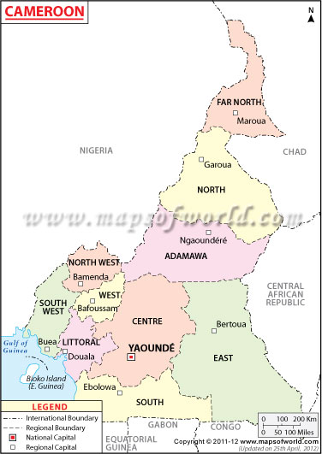

Fig: Map of South west Region showing the Idenau District (source Mor-Achankap Bakia, MINFOF GIS/MIS Unit RDFOF, Buea)
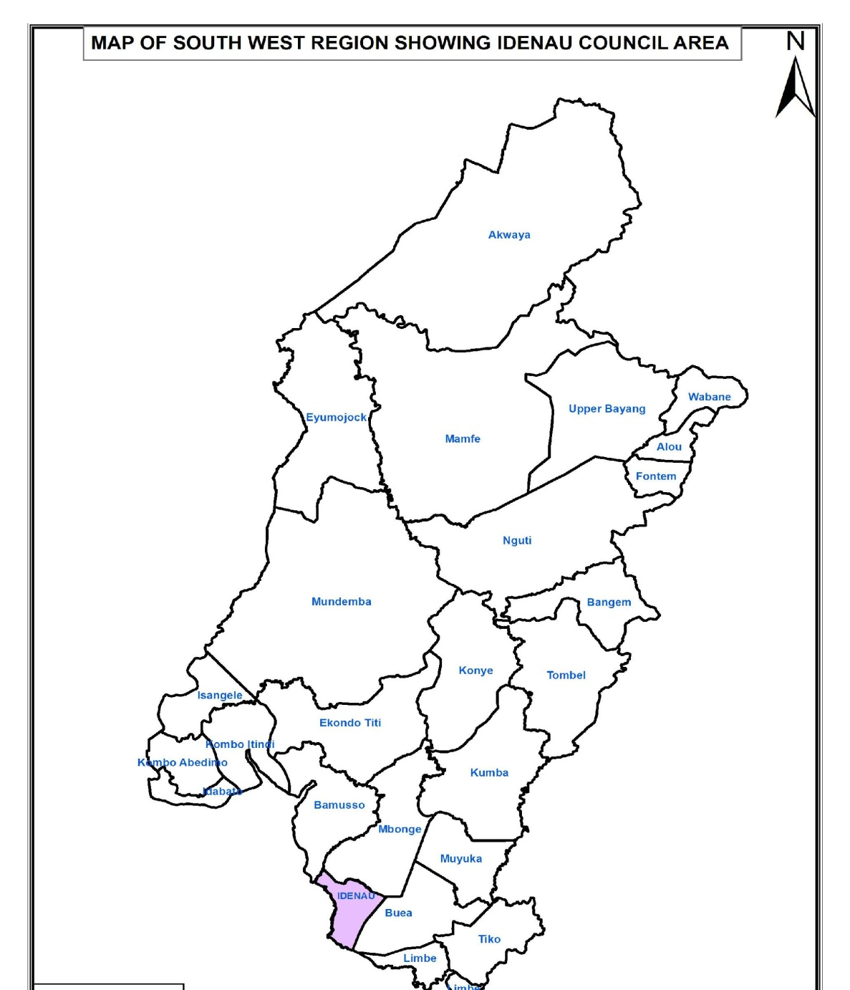

Fig: Map showing Enyenge in the Idenau District area (source Mor-Achankap Bakia, MINFOF GIS/MIS Unit RDFOF, Buea)
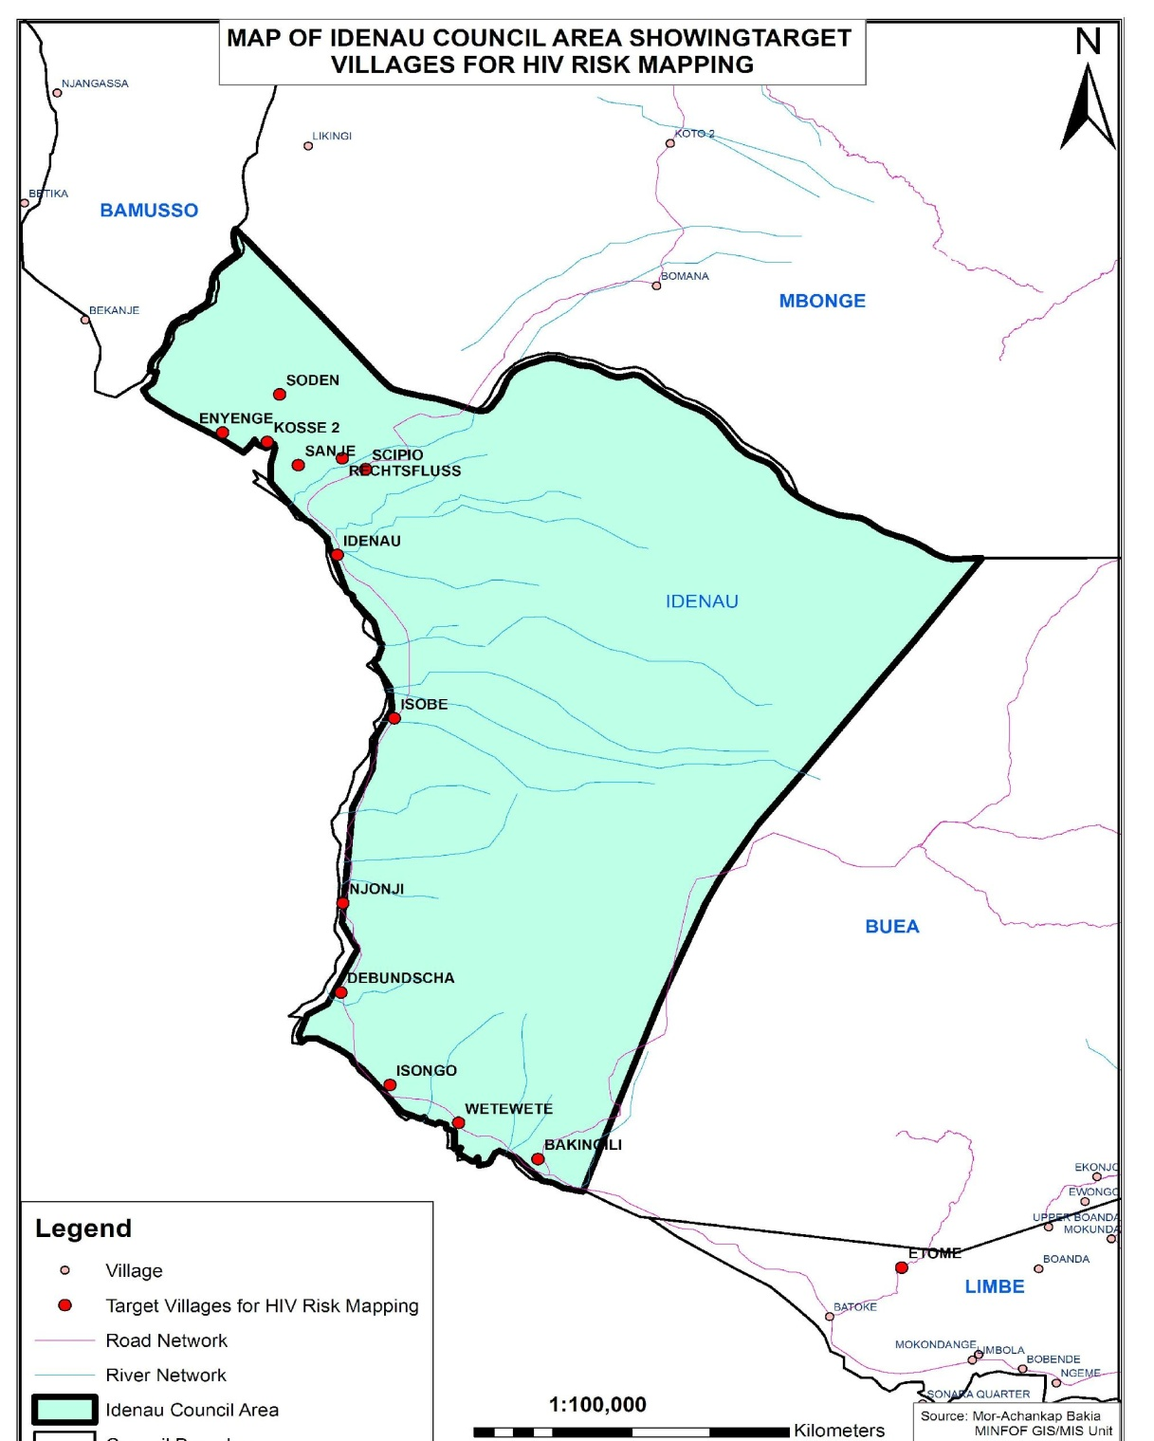

- Annex 2. Construction details

Digging a borehole

Considering that Enyenge village is between 0 – 10m above sea level, it is assumed that a borehole of up to 30m deep will be enough to produce approximately 18m3 of water per hour or 432m3 of water per day. For the population of 2.000 people, it is assumed that each person will consume 21lts/day.

Installing a Human propelled pump:
      - Formwork: The formwork of the prefabricated culvert rings shall be done in wood, made of Ayous with thickness of 25mm. The internal surfaces of the formwork shall be lined with ply wood of 4mm thick. The two different parts of the formwork shall be stabilized using threaded iron clamps.
      - Concrete: Cement CPJ 35 produced by Cimecam, Douala is the approved cement for this work. River siliceous sand of grade size 0/5( mungo sand preferable), crushed gravel with grain size 5/15, water, portable water or any source of water which will not impair the chemical process of hydration of cement.
      - Iron work: Iron work for the pre-cast culvert rings shall be reinforcement bars of HA8 and HA10.
      - Sinking of the culvert rings; It shall be done using a mechanical winch and marine ropes.
      - Masonry Block work: The protective dwarf wall of the superstructure shall be constructed in cement blocks of 15x 20x 40 and laid with mortar dosed at 400kg/m³( I bag of cement: 3 wheel barrows of sand).
Drawing of water: Water from the well shall be drawn using a manual propelled pump (Indian mark) as authorized by the Ministry of Energy, Mines and Water Resources.

Technical Specifications:
- Hand pump Installation,
  - Manual pump (1) camatel.
  - Pipe camatel( 07)
  - Iron rod camatel (07)
  - Cylinder (01)
  - Filter (01).
- Fabrication of culvert rings,
  - Concrete dose of 350kg/m³ for culvert rings
  - Traditional form work for rings ( m²)
  - Iron work for culvert rings (kg).
- Sinking of pre-cast culvert rings
  - Sinking of pre-cast filtration culvert rings
  - Sinking of pre-cast non-filtration culvert rings
  - Backfilling of Annulus with soil
  - Sealing joint of culvert rings
  - Putting in place of the base filtration bed.
  - Putting in place of the outer filtration beds (15/25)

- Annex 3. List of partners

Operational partners and Referees

- Ministry of Agriculture and Rural Development ( MINADER) South West Region of Cameroon
- Ministry of Mines, Energy and Water Resources. South West Region of Cameroon
- Organization for Sustainable Rural Infrastructure (OSRI). South West Region of Cameroon
- Organization for Gender, Civic and Youth Development (OGCEYOD). South West Region of Cameroon
- African Research Center for Banana and Plantains. South West Region of Cameroon
- South West Development Authority (SOWEDA) South West Region of Cameroon
- Ministry of Scientific Research and Innovation, South West Region of Cameroon

FUNDING PARTNERS

  - First Peoples’ World Wide, USA.
857 Leeland Road,
Fredericksburg, VA 22405,
Email: grants@firstpeoples.org
  - United States African Development Foundation( USADF)
1400 1 St NW no: 1000
Washington, DC, 2005, U.S.A.
Phone: + 202- 673- 3916.
Email: info@adf.gov

  - Civil Society Strengthening program( PASC),
Quarter Omnisport Avenue Foe,
P.O. Box 355577, Yaounde, Cameroon,
Tel: 22 20 85 80,
Email: info@pasc.org
  - Embassy of the Federal Republic of Germany,
Nouvell Route Bastos, Bastos Usine,
P.O. Box 1160, Yaounde , Cameroon.
Website: www.jaunde.diplo.de
  - The Australian High Commission,
Oakland Centre
40 Aguiyi Ironsi Street,
Maitama, Abuja, Nigeria.
Email: ahc.abuja@dfat.gov.au

Profile

- The Organization for Sustainable Rural Infrastructure(OSRI) (sourced from the Live Build document on the Banga Bakundu Water Project)

It is specialized in the planning, monitoring and execution of community based infrastructure projects in rural communities in South West Cameroon, providing technical support in the implementation of rural infrastructures, especially rural water supplies, roads, bridges, culverts etc. The management team is composed of trained and experienced personnel in the social, civil and water-engineering domain. Based on their capacity, various sustainable projects have been realized in the South West Region.
These include:

• 25 community water schemes
• 4 bridges
• 1 community hall
• 1 seminary (Lutheran seminary)
• 9 training courses for the management of rural infrastructure. OSRI has been offering these consultancy services since 1991. Its head office is in Kumba, a 2 hours minute drive from Enyenge . It operates under the 1990 law permitting the freedom of Association in Cameroon with authorization No G39/D14/5/1001 of 8thDecember1991.

In June 2013, the EDI team met with Dr. Klaus Flessner; the Coordinator cum Technical Adviser of GIZ, Tel: M+237 75 35 80 51, 33 32 28 36, Email: Klaus.flessner1@giz.de, website: www.giz.de, to solicit his indulgence to be a partner on the project; however, due to his tight schedule, he linked us with his colleague, Mr. John Tansah; the Infrastructural Development Officer GIZ,Tel: +237 77 40 83 37,Email: johntansah@tahoo.com, who is the OSRI founder. Mr Tansah and Mr Akuru of OSRI have agreed to work with the team to bring forth the successful implementation of this project.

The project will be implemented under the leadership of an elected water management committee, which will be assisted by EDI and other existing government institutions. The design of the project is in conformity with IRC publications on community water supplies. During execution of the project, OSRI will be responsible for the following activities:

• All technicalities concerning the construction.
• Providing on the job training to caretakers.
• Facilitating the formation of the water management committee.
• Training of the management committee to ensure the continuity of the project.
• Sensitize and mobilize the community to participate actively in all the stages of the project. To ensure effective community participation the village council and the water management committee will be closely involved with the following

o Community fund raising programs
o Communal labour (i.e. digging and carrying of material)
o Mobilization of available local resources (financial, material and human) for the
Implementation of the project

- Organization for Gender , Civic and Youth Development(OGCEYOD)

OGCEYOD is a Cameroonian based Non-governmental Organization that was created on the 17th of July 2005 with a vision to improve the standard of living of Youths and women from a variety of backgrounds and to mainstream sustainable development.

OGCEYOD is a joint venture with a corporate social vision, mission, goal and objectives to mainstream Sustainable Development through Education, capacity building, advocacy and lobbying, research, exchange visits, recreation, innovations, peace and dialogue.

Their activities are focused on education and research with five thematic areas of intervention; Education, Environment, Capacity Building/Economic Empowerment, HIV/AIDS, Agriculture and they use a right base approach in carrying out these activities.

They have also been very influential in gender based activities as well as human rights and development issues in the country. They have a work force of 3 permanent staff and a couple of local and international volunteers.

3. African Research Center for Banana and plantains (CARBAP) is headed by Dr. Justine Okolle in the South West Region. He is a researcher, Lecturer, community development officer with several years of working experience as outlined below.

- 2013 - : Chief of Anntena for the Southwest Region, African Research Center on Bananas and Plantains
- 2012 - : Research Entomologist, Laboratory of Entomology, Institute of Agricultural Research for Development
(IRAD Ekona, South West Region, Cameroon)
- 2007-2011: Research Entomologist (Research Officer), African Research Centre on Bananas and Plantains
(CARBAP), Cameroon.
- 2002-2003: Research Entomologist, African Research Centre on Bananas and Plantains (CARBAP), Cameroon
- 1999-2002: Chemistry/Biology/Human Biology lecturer/Head of Biology Department in Christ the King College
(CKC),Tiko, Cameroon.
(b) Part-Time Positions
- 2013: Lecturer (Plants Entomology, Principles of Crop Protection), University Institute of the Diocese of Buea,
Cameroon
- 2010-2012: Lecturer (Research Methodology & Report Writing & Presentation Skills). Higher Institute of
Business Management & Technology, Buea, Cameroon (www.hibmat.org)
- 2007-: Undergraduate/Graduate/Postgraduate lecturer (Principles of Pest Management, Invertebrate & Vertebrate
Zoology, Insect Systematics, Insect Physiology/Biochemistry, Plant Health Management, Applied Entomology,
Pests of Tropical Crops, Pesticide Chemistry, Toxicology & Application, Insect Ecology and Chemical Ecology of
Insects), Departments of Zoology & Animal Physiology, Botany & Plant Physiology and Agronomic & Applied
Molecular Sciences, University of Buea, Cameroon.
- 2004-2005: Research assistant (Monitoring and Management of insect pests and Fusarium disease on bananas) in
Synergy Farm Sdn.Bhd, Ara Kuda-Seberang Prai, Penang State, Malaysia

4. The South West Development Authority (SOWEDA) is determined to reinforce its engagement to foster its role as a catalyst of development in the South West Region.
, as well as the Livestock and Fisheries Development Project. The overall objective of SOWEDA is to the fight against poverty and food shortage. Also, the need to work in collaboration with the Ministry of Agriculture and (Common Initiative Groups) CIGs, for the production of seeds like maize, beans, plantain suckers, etc; and that of Public Works for the construction and rehabilitation of rural farm to market roads, led by RUMPI Rural area participatory development project ( RUMPI PROJECT).
5. The Ministry of Agriculture and Rural Development (MINADER) focuses on the following thematic areas to fight against poverty and rural development.
- Infrastructure; construction of farm to market roads, markets, community barns, water schemes, sanitation, education and health in synergy with Rumpi project and SOWEDA.
- Capacity building; Extension services to farmer organizations on modern farming practices, book keeping, savings and loans.
- Agriculture; provision of improved seeds to farmer organizations
- Funding of micro-projects on Agriculture, livestock and fisheries.
- Project coordination, through monitoring and evaluation.

DONE AT ENYENGE THIS ____________________ DAY OF _____________________ IN THE YEAR _______________

SIGNATURES

Secretary EDI Chairman EDI

