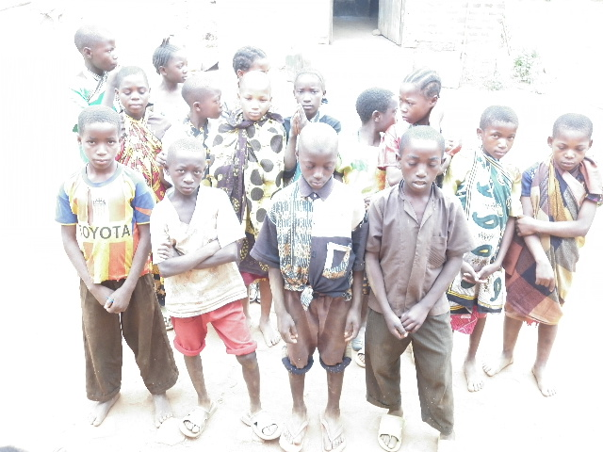
RURAL AND URBAN ORPHANS’ CARE .ORGANIZATION (RUUOCAO)

RURAL AND URBAN ORPHANS’ CARE ORGANIZATION (RUUOCAO)
ARTICLE: 7: Head Office, ADDRESS: P.O. Box197, SONGEA-RUVUMA, TANZANIA. E-mail: ruralorphanscare@gmail.com Phone nos; +255766595144, +255714686552, +255754439108, +255785990046, +255652906420.

RURAL AND URBAN ORPHANS’ CARE ORGANIZATION
[RUUOCAO]

- CONTACT INFORMATION:
- Postal Address: P.O. Box 197, Songea, Ruvuma-Tanzania
- Telephone: +255652906420+ 255 714686552
- E-mail: ruralorphanscare@gmail.com
- Contact Person: Mr. Jackson Mwingira

- THE ORGANIZATION:
1. The Purpose of the Organization:
- The aim is to see Orphan girls free of poverty and violence in the communities that value equality, respect, rights and participation in development.
- The mission statement is to strengthen orphans and vulnerable girls’ through training and fight against all violence, discrimination, stigmatization and oppression that increase marginalization and girls’ poverty in Songea district, Ruvuma region. Also the Association commits to advocate for girls’ rights to live free of violence.

- Organization beneficiaries/target groups:
- The target groups are girls especially orphans, barmaids, uneducated girls, homeless girls and house girls from and living in the poor and indigenous areas of Songea district, Ruvuma, TANZANIA.

- The key role playing by the beneficiaries in the organizational decision making process:
- The Association normally empower the community members particularly girls at the grass root level in the identification of their problems through meetings, workshops and various training sessions. Also, the Association always makes sure that the target group benefit equally through consultation and physical participation in the community outreach activities, monitoring, follow up/evaluation.

The Organization structure:
- Establishment period:
- The association was established in 2010 and legally registered in August 01st 2014 under Registration No. 00NGO/00007398. Registered under Non-Governmental Organization act, 2002 under section 12(2) of Act No.24 of 2002.

- Legal status:
- We are a local non-governmental organization (NGO), as a Community based non-profit business making based in Songea district, Ruvuma region, in the Southern of Tanzania. The Association is generally deals with special groups such as Orphans, Albinos, Old people, and women/girls.

- Governance/administration organizational system:
- All members of our Association members including direct beneficiaries participate in the decision making through approving planed programmes in the structure of the association, like General Meeting, Board of Advisors, Management Committee and Project coordination meetings: planning, implementation, monitoring and evaluation.

- Organizational structure:
The organizational structure of the group is: General Assembly, Board of Advisors, Chairperson and Executive Staff;
- The General Meeting is composed by all members who discuss participatory and resolve key matters of the organization programs;
- The Board of Advisors is a board who formulate policy that is to be approved by the General Meeting and before put into implementation. The Board of Advisors with 4 members make the follow-up of the execution of all activities of the group;
- The Chairperson is the key man in the association and daily office bear. She is responsible for planning and implementing the association activities;
- The Executive Staff is composed of all Head Project’s Activities coordination teams and support staff, like cleaners, security guards/gardeners, secretary and treasurer.

- THE PROJECT DESCRIPTION:
- Name of the project:
- Orphans and Vulnerable Girls Self-Reliance Empowerment Through Tailoring Project

- Project purpose:
- This project seeks to assist the unemployed and vulnerable girls especially in poor and peripheral wards in Songea district, Ruvuma region through vocational training and provision of sewing machines and related equipments to enable them access skills in tailoring, clothing, handcrafting and textiles for self-reliance and employment opportunities.

- Project problem statement and justification:
- Youths, especially girls are the most vulnerable population groups in Songea district, Ruvuma region.
- Since the district is one of the poorest in the country poverty, many communicable diseases further worsen the vulnerability of this population category, street girls, low education girls, juvenile mothers, girls homeless, house girls, sexual prostitutes and barmaids, etc.
- This bad situation is caused by poverty and lack of occupation; therefore these girls have actually no hope of life, occupation and no future life orientated. So, our Association have taken the initiative to assist and relieve suffering of our sisters who are actually in great danger of being affected by HIV and other related diseases, through community vocational training and girls’ self support community activities.

- Project inspected Out Puts:
- A Weaving Power Loom will be bought;
- Four Design Sewing Machines (Zigzag) will be bought;
- One Over-Lock Sewing machine will be bought;
- Two Singer High Speed Sewing machines will be bought;
- One small generator will be bought;
- One Singer Straight Knife Cloth Cutter will be obtained;
- The number of girls trainees will raise from 50 to 100 or more per in-take (Session of 6 months);
- There will be an average increase in production and sales; and customer orders will be completed on time;
- All activities implemented will be monitored, evaluated and reported monthly.

- Project Selected Beneficiaries:
In the first phase, the project target to empower 100 vulnerable girls, among them:
- 25 informal fostered orphan girls;
- 15 orphan homeless girls (street girls);
- 10 barmaids;
- 25 juvenile mothers;
- 5 older prostitutes;
- 20 drop-out-school girls due to economic family status.
But regarding to the sustainability of the project, other beneficiaries will be selected at the end of the first phase with 4 training sessions. All selected vulnerable children-girls age is ranged between 12-16 years.
- Project planned activities;
- Purchasing of materials and equipments,
- Enrolment and skills training of participants,
- Project supervision,
- Monitoring and evaluation etc.

- Project Management:
- The Project Development Officer will be responsible for the overall supervision for all activities. She will timely report to the Chairperson of the association.
- There will be a project coordination committee composed by the Treasurer, Logistic officer and 2 Trainers, all are volunteers.

- Project sustainability:
Since this project is initiated and fully accepted and desired by the beneficiaries, it will be integrated and all its imparting resources will be directed toward imparting the skills required and making the project cost effective for self sustenance and improvement over time. Thus, it will be self sustaining and on-going.

- Project duration:
As the project involves training, it will be completed in twelve (12) months after funding.

- Project monitoring and evaluation:
- The Association, through the Project coordination team will produce monthly reports that supply the numbers of current participants and achieved trainees in each vocational or income-generating trainee activities.
- On monthly and quarterly basis the Project Development Officer will provide a progress and financial report to the organization and to the Donor respectively. At the end of the project (EOP), The Association will conduct Workshop follow up to review the project whereby the Association will provide an annual project progress and an audited financial report.

- Project estimated budget:
S/N | Activity/ Items Description | Unit cost (Tshs) | Quantity | Total cost
1 | Electric Sewing Machines (Zigzag) | 200,000/- | 30 | 6,000,000
2 | Manual Sewing machines | 150,000/- | 10 | 1,500,000
3 | Knitting Machines | 600,000/- | 10 | 6,000,000
4 | Over-Lock Sewing machine | 350,000/- | 7 | 2,450,000
5 | Bicycles | 200,000/- | 15 | 3,000,000
6 | Small generator | 800,000/- | 2 | 1,600,000
7 | Singer Straight Knife Cloth Cutter | 200,000/- | 3 | 600,000
8 | Treadle Machines | 400,000/- | 7 | 2,800,000
9 | Computers | 600,000/- | 5 | 3,000,000
10 | Scanner machines | 150,000/- | 3 | 450,000
11 | Training materials and facilities | - | Lump sum | 1,100,000
12 | Motor cycles | 1,800,000 | 3 | 5,400,000
13 | Carpentry and Joinery tools | 500,000 | 10 | 5,000,000
 | TOTAL: |  |  | 38,900,000
- The Project Total cost : Tzshs. 38,900,000
- The Contribution of our Association and members :Tzshs. 3,900,000
- The Requested Amount :Tzshs. 35,000,000
NOTE: (*) is our local contribution.

OSMUND KAWONGA AGNELA KOMBA JACKSON MWINGIRA
President Board Chairman Coordinator
The Rural and Urban
Orphans’ care Organization (RUUOCAO)

