CHILDHOPE -UNICEF QUARTTERLY PROGRESS REPORT
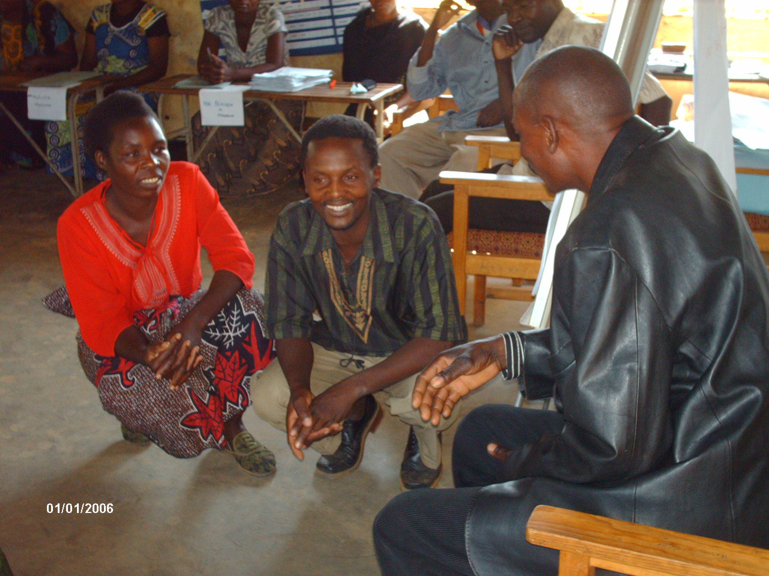
Figure 1.Showing some of the trained ECCD caregivers during role play (2009)

Report Submitted to: The United Nations Children’s Fund (UNICEF)
Prepared by: CHILDHOPE Secretariat, Lotti house, 4th floor suite “M”
P.O.BOX 39481, LUSAKA, ZAMBIA
Phone: 097-7773243/0955765671
E-mail:childhopezambia@zambian.com
E-mail:childhope_project@yahoo.com

UNICEF Quarterly progress report
1. General Information:
1.1 Name of the Organization: CHILDHOPE-ZAMBIA
1.2 Project Title: CHILDHOPE EARLY CHILDHOOD CARE, DEVELOPMENT SUPPORT PROGRAMME AND COMMUNITY CAPACITY BUILDING (CHECCDSPCCB)

1.3 PCA no: | 1.4 Period covered by the report: May –July,2009
1.5 Date of Submission: 15th June,2009 | 1.6 Author of the report: Mr.Chim Mvula (Co-ordinator)

2. Background Information

CHILDHOPE-Zambia is a non government non-profit making NGO working towards attaining rural child survival, alleviating poverty and reducing the escalating transmission of HIV/AIDS pandemic and supporting education of children. The organisation was formed and registered under the societies Act in June, 1999. CHILDHOPE operates in chief Mwanachingwala `s area of Magoye/Mazabuka in the Southern Province of Zambia, approximately 168km from Lusaka where its secretariat is based.

The initial goal of CHILDHOPE was to improve the living standards of the rural children and to reduce poverty among them. However, due to the continuous increase in the number of orphaned children due to their parents dying of HIV/AIDS and other related diseases; CHILDHOPE embarked on other activities. CHILDHOPE was in June 2009 awarded a grant amounting to US$61,940.00 equivalent to K344, 391,600.00. A total programme cost of K144, 942,600 was awarded to CHILDHOPE.

Of the total programme cost, an amount of K79, 786,000 was released as the first installment for CHILDHOPE to conduct 3(three) trainings and purchase training materials .A balance of K47, 100,000 was left with UNICEF in order for CHILDHOPE to request after conducting the other three trainings so that the organization would conduct a training of parents in parenting education on ECCD. An amount of K144, 000,000 was left with UNICEF to provide clean water and sanitation to the ECCD centres while K55, 499,000 was left with UNICEF to purchase supplies for the ECCD centres and administration.

The released grant supported 4(four) villages of chief Mwanachingwala in the Southern Province of Zambia in Magoye (Mazabuka district). Through the quarter under review, CHILDHOPE trained community ECCD caregivers, parent management committee and the pre-school teachers. Among the communities trained were Mabanga, Upper Chalimbana, Makangala and Habulembe.

3. Project progress:
3.1
Activities planned as per the proposal | When planned Indicate quarter planned? | Status of implement-action? | More detailed description of the status?
- Training of Parent Management Committees | First quarter(June) | Training conducted. | 40 community members were trained in parent management. This helped them know how to manage the ECCD centres for the benefit of the children. Of the trained, 21 were women while 19 were men. Each centre came up with an activity plan on how they would manage the ECCD centers. The trained were drawn from the 4(four) newly established ECCD centres which included Mabanga, upper Chalimbana, Makangala and Habulembe communities.
- Training of Pre-school teachers | First quarter(June) | Training conducted. | 20 pre-school teachers were trained. Of the trained, 12 were women while 8 were men. During the training, the importance of the linkage between the basic schools and the ECCD centers was emphasized. The teachers were also trained in health/ nutrition/ HIV/AIDS and sexual reproductive health which was an important part when dealing with children and their parents. Among the communities trained were Mabanga, upper Chalimbana, Makangala and Habulembe.
- Training of ECCD Caregivers | First quarter(June) | Training conducted. | 32 community members were trained as ECCD Caregivers. Of the trained, 21 were women while 11 were men .Participants were trained on how they could work parents for the development of a child. Each center came up with an activity plan on how they were going to work with parents in their respective communities. This training covered 4(four) communities in the newly established ECCD centres. Communities covered were Mabanga, Upper Chalimbana, Makangala and Habulembe.

3.2: How and why have changes occurred in planned activities?

- Changes have occurred in planned activities in that, all the people that were trained under CHILDHOPE through the support of UNICEF have come up with work plans on how they could support ECCD activities in their respective communities. Not only have these people come up with work plans but have also started implementing and educating other community members on the importance of ECCD and what they were trained on.

- In the newly established centres, ECCD has become the talk of the day due to the knowledge the trained are imparting the communities members. These changes have drawn the attention of other surrounding villages who would like to have similar programmes.
- ECCD has opened most eyes in the newly established centres as to how they should take care of their children in order for them to grow into responsible citizens. Due to the trainings, communities would want to do a lot of things for the development of a child. The trained have gone out into the communities to educate others why ECCD should be the top of the agenda for the development of a child.

- Changes have occurred in the planned activities because communities trained were willing and keen to learn so that they could contribute to their development and that of their children.

- The other reason why changes occurred was that communities believed that poverty would only be fought if education of the child started at an early age.

- In the newly established centres, communities believed that giving them the knowledge and skills on how to look after their children was a greater gift because they would continue passing on this knowledge and skills to the children as one way of developing their children.

3.3: What progress has been made towards project’s outcomes and objectives?

- Progress that has been made towards project’s outcome and objectives is that, under objectives 32 ECCD Caregivers has been trained, trained on how they could work parents for the development of a child, 20 pre-school teachers have been trained on the importance of the linkage between the basic schools and the ECCD centers. The teachers were also trained in health/ nutrition/ HIV/AIDS and sexual reproductive health which was an important part when dealing with children and their parents. Also, 40 parent management committees were trained .This helped them know how to manage the ECCD centres for the benefit of the children.

- Under outcomes, due to the commitment of those that were trained, response from the communities and the strategy used, it is evident that there will be strengthened system of child development and increased family /community knowledge levels and capacities in supporting ECCD which will have effective and sustainable systems of community participation in supporting ECCD activities in the newly established ECCD centres.

- There was an increase in the number of mothers and fathers involved in the programme. This was also evident by the number of community members who have taken keen interest in ECCD activities so far. For example in the newly established centres, more parents want to be part and parcel of what is happening in terms of child development.

3.4: Have any unanticipated changes (positive or negative) in beneficiary status occurred or been influenced through the project?

- Yes, there has been unanticipated change positively in beneficiary status influenced through the project. After the trained went back to their respective communities and educated other community members on the importance of ECCD, many community members were seen wanting to be actively involved in ECCD activities unlike the previous situation .it is anticipated that once all the trainings are done and more community members are sensitized on the importance of ECCD, the numbers of men and women involved will swell.

3.5: What are the status of risks and assumptions mentioned in the proposal?

- The status of the risks and assumptions mentioned in the proposal are low for the activities that have been done so far.

4. Lessons learned / any changes required:

- CHILDHOPE has had lessons learned from its project implementation.However, the organization does not have any changes required apart from increasing its funding base and training more community members and scaling up its programmes in order for more children to benefit.

4.1: Any lessons learned:

CHILDHOPE has had lessons learned through this project and these have been:

- Imparted with enough knowledge and skills, rural communities can learn from their past mistakes on how to look after their children.

- Rural communities if fully supported can contribute to their development and that of their children.
- ECCD activities can help parents bring up bring up their children in a good manner.

- Training communities in ECCD inculcates knowledge and skills which could be used for continuous child development activities among the rural areas.

- Community trainings particularly ECCD encourages other surrounding villages/communities to start up something on their own without being pushed.

4.2: Any changes proposed (including budgetary adjustments) to overcome the identified new realities:

There is need for UNICEF to support CHILDHOPE trainings as budgeted for since CHILDHOPE budgets are made according to the experience gotten from the other trainings.

Position of the author: Co-ordinator

Signature and the date:

