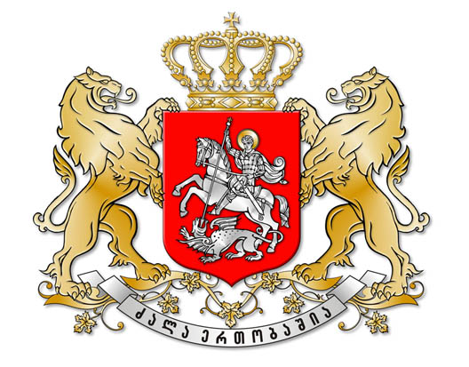
Sps dasavleT saqarTvelos neiroreabilitaciis centri “Temida-97”

LTD NEIROREABILITATION CENTER OF WEST GEORGIA “TEMIDA – 97”

4600, q. quTaisi, buxaiZis q. #9, t: 593 31 17 91, 599 27 60 11
9 Bukhaidze Street, Kutaisi, 4600, Republic of Georgia, Phone: 995 593 31 17 91, 995 599 27 60 11, E-mail: temida97@rambler.ru

Reg. № 5/83
22/07/2016
Letter of Support

Our cooperation with Federation of the Women of Georgia "QOLGA" lasts already some years.
This Organization is sharply allocated on a background others with the activity, enthusiasm and innovation. Non-standard approaches to the decision of problems. She under the right is one of the leaders among the best not governmental Organization of Georgia.
By our joint efforts 30 disabled women 2 weeks had a rest on balneologycal resorts of Georgia. At active participation of Organization, Neiroreabilitation Centre of Western Georgia "TEMIDA - 97", were selected armchairs and some massager for children with cerebral palsy. Have carried out some training of seminars on medical subjects.
The Director of the Project the Dr. David Pruidze is one of the founders of this Organization, and also Main Coordinator and Project Manager. Besides he has the large practical experience managing, organizing and economic job. Actively is engaged in public activity. I can say with the complete responsibility, that his organizing abilities allow him with success to lead up the begun businesses to the end.
I give the recommendation for partnerships with Federation of the Women of Georgia "QOLGA".

Director of the Neiroreabilitation Centre of
Western Georgia "TEMIDA - 97": Dr. Zaza Pataridze

