AFRICAN NETWORK FOR PREVENTION AND PROTECTION AGAINST CHILD ABUSE AND NEGLECT

Baseline survey report on SGBV stakeholder’s
(August 2011)
TABLE OF CONTENTS
Abbreviations and Acronyms ............................................................................. 2
Acknowledgements ........................................................................................ 3
Executive Summary ....................................................................................... 4
SECTION ONE: Introduction ............................................................................. 7
1.0 Background and rationale of the baseline study............................ 7
1.1 Objectives of the baseline survey.................................................. 7
1.2 Locale and scope of the study....................................................... 7
1.3 Research Methodology ................................................................. 8
1.4 Data analysis ................................................................................. 9
1.5 Limitations of the study ................................................................. 9
SECTION TWO: Review of related literature ................................................. 10
2.0 Introduction ................................................................................. 10
2.1 Preventing Violence ..................................................................... 10
2.2 Sexual Gender Based Violence: Nationwide Initiatives and
Coordinated Responses (Liberia)......................................................... 11
2.3 Overview of the referral pathway ................................................. 13
SECTION THREE: Presentation of findings ............................................... 14
3.0 Introduction ................................................................................. 14
3.1 Background information of respondents ....................................... 14
3.2 Respondent’s knowledge about SGBV ......................................... 17
3.3 Responsibilities of stakeholders in addressing SGBV ................... 19
3.4 Effectiveness of the SGBV referral pathway ................................ . 21
SECTION FOUR: Challenges, recommendations and conclusion ............... 25
4.1 Challenges in addressing SGBV ................................................... 25
4.2 Recommendations ........................................................................ 25
4.3 Conclusion .................................................................................. 26
Bibliography ................................................................................................. 27
Appendix ....................................................................................................... 28

ABBREVIATIONS AND ACRONYMS
ANPPCAN - African Network for the Prevention and Protection Against Child Abuse and Neglect.
DEA - Drug Enforcement Commission
GBV - Gender Based Violence
LNP - Liberia National Police
MoGD - Ministry of Gender and Development
NGO - Non Governmental Organization
SEA - Sexual Exploitation and Abuse
SGBV - Sexual and Gender Based Violence
SPSS - Statistical Package for Social Scientists
UN -United Nations
UNICEF - United Nations Children’s Fund
UNMIL - United Nations Mission in Liberia
WCPU - Women and Children Protection Unit

Acknowledgements
The African Network for the Prevention and Protection Against Child Abuse and Neglect (ANPPCAN) Liberia chapter would like to take this opportunity to thank and acknowledge organizations and individuals who made it possible to conduct a comprehensive baseline survey in Gbarpolu and Grand Cape Mount counties in Liberia.
ANPPCAN Liberia wishes to acknowledge with appreciation the district commissioners, Governors, Paramount chiefs, Town Chiefs and the Dean of Elders of Gbarma, Bopulu and Bokomo districts in Yomo, Gokallah, Gbangay and Nyeamah towns in Gbarpolu county and Bamballah and Tahn communities in Porkpa District, Tienii and Bo Waterside communities in Tewor District and Robertsport and Gbah Foboi of the Commonwealth and Garwula districts respectively in Grand Cape Mount county.
Appreciation is also extended to the various youth and women groups in the above mentioned localities for being helpful in providing us with information on SGBV in their communities and their roles in addressing it as it occurs. I wish to further thank the Liberian National Police officers (LNP) at the various stations and from the Women and Child Protection Units (WCPU) in the above localities for their support and positive responses during the survey. Further gratitude goes to the other security personnel such as the Immigration, Drug enforcement agency (DEA) that took part in the survey, your corporation is highly appreciated.
Special thanks also go to the teachers, nurses, the staff at the SGBV unit at the ministry of Gender and Development and all those that in one way or the other contributed morally to the successful conduct of the study. The information you provided is invaluable, we hope that it will guide us to improve our strategies in addressing SGBV issues.

EXECUTIVE SUMMARY
This report presents the findings of the baseline survey that was conducted in Gbarpolu and Grand Cape Mount counties in August 2011. The objectives of the survey were to review activities and responsibilities of stakeholders in addressing SGBV, asses capacities of the stakeholders identified in the referral pathway, identify gaps in SGBV service provision and make recommendations for necessary improvements that are needed in designing programs and activities aimed at addressing SGBV at the community level. Descriptive survey was used in which a total of 200 respondents participated. Data was collected through self administered questionnaires and document analysis was effective in collecting secondary data. The Statistical Package for Social Scientists was used to compute and analyze the data.

SUMMARY OF FINDINGS

Background information
The findings revealed that 80% of the respondents were male and 20% female. This clearly indicated that women are underrepresented in addressing SGBV. Binding this with the fact that, most of the SGBV victims are women, there is need for an increased representation of women among stakeholders who address SGBV. Similarly, the age groups of the respondents showed that young adults (25-30) were only represented by 10% of the respondents compared to older age groups (36-40) 19%; (31-35, 46-50) 18% and (51-55) 12%. An incorporative approach to get young adults involved in addressing SGBV would also work as an early intervention among them to prevent violence among young adults in the future. Further, the findings revealed that 47% of the stakeholders have not schooled beyond Junior high school of which 27% have not been to school at all and given the fact that they are a much older population there is need to take a more educative approach that will not involve writing or reading when conducting SGBV trainings.

Knowledge about SGBV
A substantial number of research participants showed reasonable knowledge on SGBV i.e. 93.3% while only 6.7% did not. The majority of them (47.69 %) attributed NGOs as being instrumental in disseminating knowledge about SGBV. On the other hand, (25.64%) alleged that they acquired it from Radios, (11.79%) from friends while (8.21%) derived knowledge from other sources.

Responsibilities of stakeholders in addressing SGBV
The findings revealed that stakeholders consolidate each other’s roles in addressing SGBV. Thus, each of the stakeholders complements the other’s roles (counselling, providing access to medical facilities, investigate and forward cases for prosecution and report cases) in addressing SGBV. The only exceptions were that security personnel and religious leaders did not play any role in providing access to medical facilities, private citizens and religious leaders also did not carry out any investigations before forwarding cases for prosecution or reporting them. It was also noted that investigating and forwarding cases for prosecution is mainly the police’s role but other stakeholders identified themselves as carrying out preliminary investigation. The study however identified a leap on prosecution of SGBV cases, Magistrate courts are far apart and respondents alluded that cases take long to be settled hence some victims are demoralised to carry on cases.

Prevalence of SGBV cases that stakeholders have handled in the last 12 months
The study revealed that 61% of the stakeholders had not handled any SGBV cases in the last 12 months, 27% of them had only handled below five (5) cases, 4% handled case between 6 and 10 while 8% had eleven or more cases in the last 12 months. The fact that the highest number of stakeholders (61%) indicated not having handled any SGBV cases in the last twelve months is a cause for concern because it is either people do not report SGBV cases or they do not know who to report cases to or they settle cases on their own.

Effectiveness of the SGBV referral pathway
A reveal of the actions that the respondents take when SGBV cases occur showed that 73.98 % of them report to the police whereas 22.96 % report to the town chief. 2.55 % of the respondents resort to sorting cases the family way while 0.51% do nothing at all. A further analysis showed that 70% of the respondents know and use the referral pathway while 30 % do not. Out of the 70% of respondents who know and use the referral pathway 61% see the referral pathway as an effective means of addressing SGBV while 9% see it as ineffective. From the findings one can conclude that the majority of the respondents use the referral pathway and see it effective. However, a significant number of the respondents (22.96%) report SGBV cases to the Town administrators (Town chief) hence there might be need to include the town administrators in the recommended SGBV referral pathway especially that most of the challenges that respondents identified were that not all communities have Police stations making it difficult to report cases to them.

Conclusion
Based on the findings of the study, it was clear that there is need to take an incorporative approach to enable more women and young adults to participate in addressing SGBV. The majority of the respondents showed considerable knowledge on SGBV issues. However, trainings on SGBV also need to take diverse approaches considering that almost half of the identified respondents had not attended senior high school. Further, the study revealed that stakeholders consolidate each other’s roles (counselling, providing access to medical facilities, investigate and forward cases for prosecution and report cases) in addressing SGBV. Concern was raised on the number of cases each stakeholder had handled in the last 12 months. More than half of them had not handled any case, implying that cases are not dealt with in the recommended manner. This problem can however be attributed to the general public since most of the stakeholders agree that the SGBV referral pathway is effective. On the other hand, Town administrators outstandingly came out as another preferred channel of reporting SGBV cases since the Police are not present in all the communities.

SECTION ONE: INTRODUCTION

1.0 Background and rationale of the Baseline Study
Sexual and Gender Based Violence (SGBV) has for long been a social menace that has broken marriages, torn families apart and disgruntled communities leaving women and young girls and children who are considered the most vulnerable groups in society at a disadvantage in fending for themselves. They experience unimaginable forms of violence such as; rape, domestic violence, sexual exploitation and other abuses that at most times go unreported due to ignorance and traditional and cultural beliefs. In the past few years, Government bodies, International and local NGO’s and various community groups have made coordinated efforts to salvage this problem. However, there is still need to strengthen these efforts to come up with a comprehensive approach.
It is against this background that ANPPCAN Liberia conducted a baseline survey to identify the activities and responsibilities that stakeholders are undertaking in addressing SGBV, review the activity line and identify gaps for possible interventions. The survey also assessed the capacity of the key actors in addressing SGBV identified through the SGBV referral pathway. The recommendations from the study will enable us to make improvements in our future interventions through designing of programs and activities on this social menace that is consuming the social fibre of Liberia.

1.1 Objectives of the Baseline Survey
The main objectives of the survey were:
- To review activities and responsibilities of stakeholders in addressing SGBV.
- Asses capacities of the stakeholders identified in the referral pathway.
- Identify the gaps in SGBV service provision.
- Make recommendations for necessary improvements that are needed in designing programs and activities aimed at addressing SGBV.

1.2 Locale and scope of the study
The study was conducted in four (4) Towns within three (3) districts in Gbarpolu and six (6) communities under four (4) districts in Grand Cape Mount County. The respondents were stakeholders/duty bearers identified in the SGBV referral pathway such as the Police, Judicial personnel, health practitioners and Teachers. Others included; Local leaders, personnel from local women/youth groups, other security personnel and the general public.
Gbarpolu and Grand Cape Mount counties share similar customs and cultural identity of their respective people partly because they share a border. Cultural aspects that are shared include; language, religion and traditional cultural practices.
Gbarpolu
The study in Gbarpolu county was conducted in Gbarma, Bopulu and Bokomo districts specifically in Yomo, Gokallah, Gbangay and Nyeamah towns. Inhabitants of these towns are predominantly of the Kpelle speaking people. Other tribes include; vai, Gola and Lorma. The main economic activities of residents in these towns range from petty trading, farming and pit sawing.
Grand Cape Mount
Grand Cape Mount county is situated on the North-Western sphere of Liberia that borders with Sierra Leone. The study was conducted in Bamballah and Tahn communities in Porkpa District, Tienii and Bo Waterside communities in Tewor District and Robertsport and Gbah Foboi of Commonwealth and Garwula districts respectively. The people of this region are predominantly Vai, Gola, Mende. However the Kpelle, Kru and Fanti speaking people are also found. The main economic activities of people in these localities are Fishing, logging, pit sawing, diamond/gold mining and trading.

1.3 Research Methodology
1.3.1 Sampling technique, frame and size
The study targeted 80 respondents from the four towns mentioned above in Gbarpolu county and 120 respondents from the six study communities also identified above in Grand Cape Mount county.
Both purposive and Random sampling was used in the study. Purposive sampling was used to target key people in the communities such as Local leaders (Town Chiefs), Identified stakeholders in the referral pathway such as the Police, Judicial personnel and Health practitioners. Random sampling was used to collect data from community associations and the general public.
1.3.2 Data collection
Self-administered questionnaires were used to collect both quantitative and qualitative primary data. The questionnaires consisted of close-ended questions to facilitate easy comparison of responses. In cases where the respondents were illiterate, the same questions on the questionnaire were translated verbally by the researcher. Secondary data was also collected to review other studies carried out and current measures being undertaken to address SGBV.

1.4 Data analysis
The Statistical Package for Social Scientists (SPSS) was used to facilitate the analysis of data that was collected. The data collected using questionnaires was first checked for uniformity, accuracy and consistency. Thereafter, the responses were coded and entered into the code sheets to facilitate computation. This helped in establishing, analyzing and interpreting the various relationships between variables. Open ended questions were also used to derive challenges in addressing SGBV issues and recommendations from the stakeholders.

1.5 Limitations of the study
- Illiteracy among the residents made the researchers spend more time with the respondents explaining the contents of the questionnaire.
- Long and unpredictable rains slowed down the process of data collection.

SECTION TWO: REVIEW OF THE RELATED LITERATURE

2.0 Introduction
This section reviews literature from related studies that have been carried out on measures of preventing violence of which SGBV is one of the forms. It also reviews some of Liberia’s Nationwide initiatives and approaches that have been used to address SGBV which include the review of the Referral pathway currently being used to address SGBV.

2.1 Preventing Violence
The World Health Organization’s guide to implementing the recommendations of the world report on violence and health (2004:35 & 38) acknowledged the importance of support and care services for victims in mitigating the physical and psychological consequences of interpersonal violence and reducing individual vulnerability. It however emphasised that considerable attention needs to be given to preventing the development and perpetration of violent behaviour. The guide came up with several approaches in preventing violence. Among them are: Investing in early interventions-Violence prevention programs targeted at children or those who influence them during early development show greater promise than those that target adults. Early interventions have the potential to shape the attitudes, knowledge and behaviour of children while they are more open to positive influences, and to affect their lifelong behaviours.
Increasing adult involvement: Evidence has shown that a warm, supportive relationship between a child and parents or other elders is protective against anti social and violent behaviour in youths. Given these factors, youth violence would be expected to increase where family structures have been disintegrated because of wars, epidemics and rapid social change.
Strengthening communities: The community is the environment in which individuals and families interact, and the extent to which it condones violence and its associated risk behaviours will be an important consideration in prevention efforts. For instance, increasing the availability and quality of childcare facilities may help promote healthy development and facilitate success in school, while the creation of safe routes for children on their way to and from school and to other activities in the community can prevent victimization.
Changing cultural norms: The cultural context plays an important role in violent behaviour. Cultural tradition and social norms are sometimes used to justify practices such as female genital Mutilation (FGM) abuse of women, the severe physical punishment of children and physical violence as a means of conflict resolution among young males. Cultural norms can also be a source of protection against violence, as in the case of long-held traditions that promote equality for women or respect for the elderly. For the prevention of violence it is particularly important to address norms that associate violent behaviour with masculinity and norms that foster racism, classism and sexism. Similarly, norms that protect against violence must be promoted.
Reducing income inequality: Although poverty itself does not appear to be consistently associated with violence, the juxtaposition of extreme poverty with extreme wealth appears to be universally associated with interpersonal and collective violence. Programs or policies that reduce or minimize the impact of income inequality may therefore be highly relevant to violence prevention.
Improving the criminal justice and social welfare systems: Cross-national studies show that the efficiency and reliability of criminal justice institutions and the existence of programs that provide economic safety nets are associated with lower rates of homicide. From the perspective of the primary prevention of violence, maintaining a fair and efficient criminal justice system contributes to the general deterrence of violence. Similarly, social welfare institutions that provide basic support for individuals and families in dire economic circumstances may serve to mitigate the effects of income inequality. Improvements and reforms in these systems should be considered as potentially important dimensions of national violence prevention policies and programs.

2.2 Sexual Gender Based Violence: Nationwide Initiatives and Coordinated Responses (Liberia)
Liberia has a National Task Force on Gender Based Violence led by the Ministry of Gender and Development (MoGD). A National Plan of Action on GBV, developed in 2006 by the government serves as a guiding document for the Government’s response and donor support to address this practice across the 15 counties. The United Nations Mission in Liberia (UNMIL) through the joint Government/ United Nations (UN) program on SGBV during the period 2006-2008 introduced two major sensitization campaigns: The campaign against Sexual Exploitation and Abuse (SEA) and the Anti-Rape Campaign. These campaigns served as the primary vehicle for organizing, developing and disseminating important messages about the rights of women and girls in Liberian society. These campaigns have been cited by several partners as key to addressing SGBV through improved knowledge and information sharing.
Non Governmental Organization (NGO) partners held sensitization events such as comedy shows, community drama performances, anti-rape soccer games, concerts and dissemination of messages and information through radio stations, posters, T-shirts and billboards. Together, these campaigns are responsible for improvements in knowledge about SGBV and options for redress. These coordinated efforts brought to the fore, reporting systems and how to respond to rape/ SEA and Gender Based Violence (GBV), improved understanding about what constitutes GBV and SEA to the general public.
Another step that was taken to prevent SGBV was the creation of women and children protection units at the Liberian National Police (LNP). According to the best practices report on Gender mainstreaming in peace keeping operations in Liberia 2003-2009 “To enhance law enforcement response, the LNP women and children protection units (WCPU) established from 2005, have provided a resource for women and children who had been left particularly vulnerable by years of conflict. UNMIL and UNICEF assisted in training 15 trainers ; since then, over 235 police officers have been trained as women and children protection officers and spread throughout the fifteen counties” (2010:34). The recruits at the police academy also receive training on gender and SGBV, preparing them in how to protect women and girls from these crimes. According to some partners, women and children protection units have been effective at securing the environment for some women who feel safe and secure reporting to the units and are aware of their presence.
A second Programming element is focused on redress and judicial Posturing. The ministry of Justice’s SGBV crimes unit was established in 2007 to consolidate and speed up the process of prosecuting SGBV cases as well as ensure their appropriate response. The unit is responsible for coordinating the judicial response to SGBV cases from around the country. The unit conducts public education, including training for respondents on integrative and collaborative assistance on SGBV, and has created a handbook on provider response. Additionally, a newly renovated criminal court “E” has been set up; and it focuses on the prosecution of sexual offences and responds to the backlog of SGBV cases in Montserrado county. (Best Practices Report: Gender Mainstreaming In peacekeeping Operations In Liberia 2003-2009, 2010:32-35)

Overview of the referral pathway
According to the MoGD, the referral pathway is a set of centres recommended for reporting SGBV cases in all the fifteen counties in Liberia. The recommended institutions with qualified personnel to respond to SGBV cases include the Police stations for protection of victims, investigation and forward cases for prosecution and apprehension of perpetrators of such cases. Health centres are another constituent of the referral pathway. They are useful in addressing SGBV cases through providing medical assistance and counselling to victims of such violence. They also provide medical reports for victims in order to provide the police with valid evidence of the extent or type of the violence that the victim endured. Emphasis has been laid by health practitioners on victims of violence to report all SGBV cases within seventy-two hours before evidence is destroyed. Other institutions include the Court for prosecution of cases and Counselling centres to provide psychosocial support to victims of SGBV cases.

SECTION THREE: PRESENTATION OF FINDINGS

3.0 Introduction
This section presents the findings of the survey. It has been divided into background information, respondent’s knowledge about SGBV, stakeholder’s responsibilities in addressing SGBV, Prevalence of SGBV cases that respondents have encountered in the last year and the effectiveness of the referral pathway.

3.1 Background Information

3.1.1 Gender
A total of 200 respondents participated in the study out of which 80% were male and only 20% female. This is a clear indication of less women representation among stakeholders in addressing SGBV.
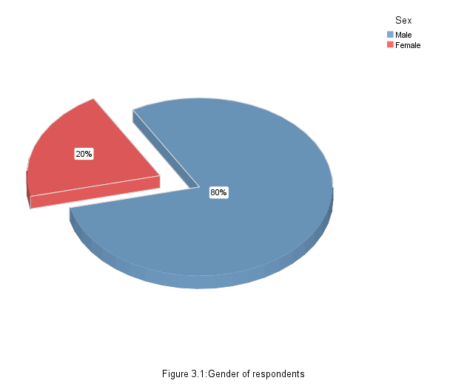

3.1.2 AGE
Most of the respondents (19%) were in the age range of 36-40, seconded by those in the age range 46-50 and 31-35 with 18% each; 41-45 (15%); 51-55 (12%); 25-30 (10%) and the least were 56 years and above (8%). This has been summarized in figure 3.2 below.
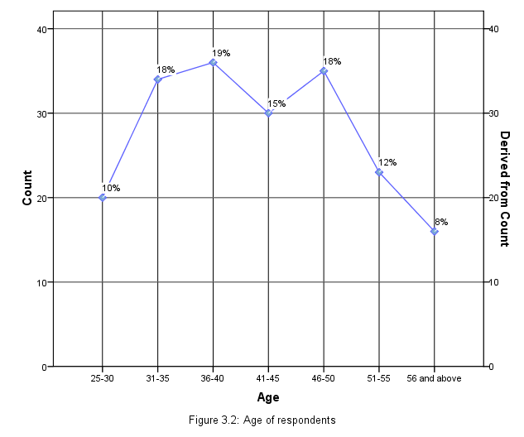

3.1.3 Education Level
Figure 3.3 below illustrates the demographic characteristics of the study population’s level of education. The majority of them (39%) attended senior high school whereas those who never attended school were second with (24%). Those who attended college and elementary education had (14%) each while those who attended Junior high school had the least number of persons (9%). Provided the above results we can conclude that at least 53% of the respondents attained senior high school education or more hence can adequately read and write compared to 47% who never went to school or schooled only up to junior high school.
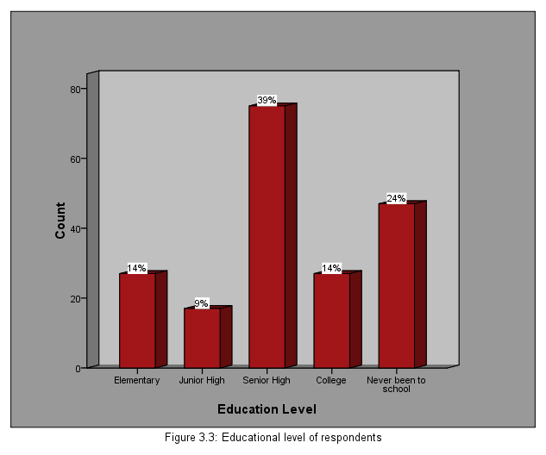

3.2 Knowledge about SGBV

3.2.1 Knowledge about SGBV per county
The findings reveal that out of 195 stakeholders that gave their view on whether they know SGBV or not, 182 (93.3%) acknowledged being aware of SGBV i.e. 112 (96.6%) in Grand Cape Mount and 70 (88.6%) in Gbarpolu. The interpretation is that Grand Cape Mount county has 8% more people who know about SGBV compared to Gbarpolu and only 13 (6.7%) of the respondents do not know about SGBV. With regard to these findings, one can conclude that there is relatively an equal awareness on SGBV among respondents from both counties The figure below illustrates this information clearly.
County * knowing about SGBV Crosstabulation
 |  |  | knowing about SGBV |  | Total
 |  |  | yes | No | Total
County | Gbarpolu | Count | 70 | 9 | 79
County | Gbarpolu | % within County | 88.6% | 11.4% | 100.0%
County | Grand Cape Mount | Count | 112 | 4 | 116
County | Grand Cape Mount | % within County | 96.6% | 3.4% | 100.0%
Total |  | Count | 182 | 13 | 195
 |  | % within County | 93.3% | 6.7% | 100.0%

Figure 3.4: Knowledge about SGBV per county.

3.2.2 Where Knowledge about SGBV was acquired
Figure 3.5 below shows that the majority of the respondents acquired knowledge on SGBV from NGOs (47.69%) while others acquired it from Radio (25.64%); friends (11.79%) and other sources (8.21%). The respondents represented by Non applicable (N/A) 6.67% represents those that were not aware of GBV.
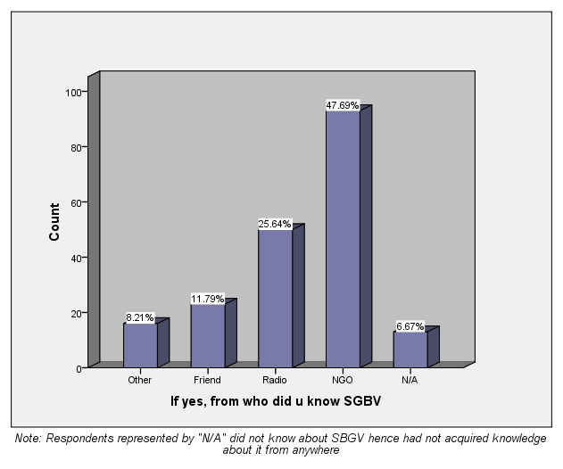
Figure 3.5 where knowledge about SGBV was acquired

3.3 Responsibilities of stakeholders in addressing SGBV
3.3.1 Roles of stakeholders in addressing SGBV
Stakeholders have various roles in addressing SGBV. The figure 3.6 below depicts the various stakeholders and their identified roles in addressing SGBV.
Access to medical facilities - Service providers (nurses, teachers) had the highest percentage of respondents who render access to medical facilities as a means to addressing SGBV followed by community associations (women / youth groups); while private citizens and Town administrators (Town chiefs, Clan chiefs) had minute percentages. However, access to medical facilities does not form part of the roles of Security personnel (LNP, DEA. Immigration Officers) and religious leaders (pastors, Imams) in addressing SGBV.
Counselling – All stakeholders reached in the survey have counselling as part of their responsibilities in addressing SGBV. Religious leaders identified themselves with the highest percentage of stakeholders who provide counselling as a service in addressing SGBV compared to the other groups of stakeholders. Town administrators, security personnel and community associations also identified themselves as contributing significantly to counselling in addressing SGBV. Service providers and private citizens had the least identity in this area of focus.
Investigate and forward cases for prosecution - It is also encouraging to find out that, apart from the police whose core responsibility is to investigate and forward cases for prosecution, Town administrators, service providers and community associations also carry out preliminary investigations while Religious leaders and private citizens do not.
Report cases – The findings of the study reveal that reporting cases to relevant authorities is a collective responsibility for all stakeholders. Town administrators had the highest number of respondents who report cases to the police, community association, security personnel, private citizens, service providers and religious leaders also report cases of SGBV in that order. In conclusion, stakeholders consolidate each other’s roles in addressing SGBV through interceding responsibilities.
Note: There were no stakeholders from the judiciary such as judges who prosecute SGBV cases that were reached in the study areas. However In Gbarma distric (Gbarpolu county) there is a newly constructed Magistrate court which is not yet operational while in Robertsport (Grand Cape Mount county) such facility does exist but at the time of the data collector’s visit Judges could not be reached.

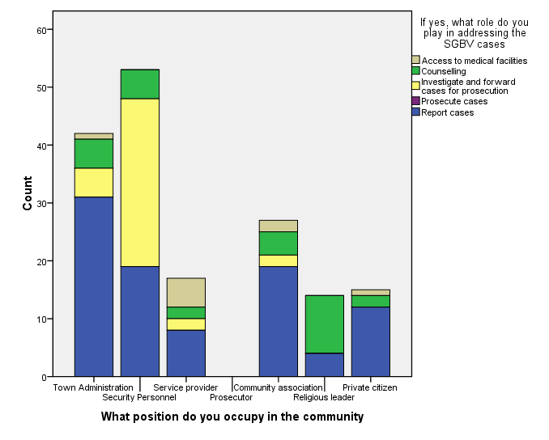
Figure 3.6: Roles of stakeholders in addressing SGBV

3.3.2 Prevalence of SGBV cases that stakeholders have handled in the last 12 months
Figure 3.7 below represents the number of cases handled by the various stakeholders in the study area. Sixty-one percent (61%) of the stakeholders have not handled any SGBV case in the last 12 months; (27%) of the stakeholders however had handled not more than five (5) cases. Four percent (4%) of stakeholders handled Cases between 6 and 10 while eight percent (8%) of them handled eleven or more cases of SGBV. The fact that the highest number of respondents (61%) indicated not having handled any SGBV cases in the last twelve months is a cause for concern because it is either people do not report SGBV cases or they do not know who to report cases to or they settle cases on their own.
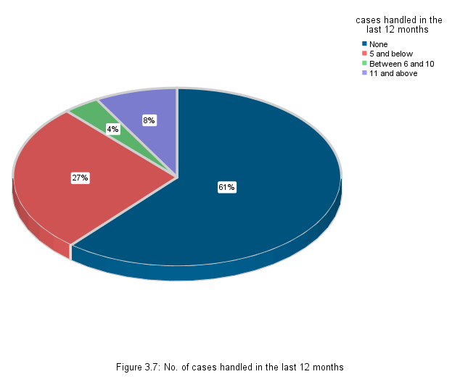

3.4 Effectiveness of the SGBV referral pathway

3.4.1 Action taken by people when SGBV cases occur
The findings indicated that 73.98% of the respondents report SGBV cases to the police whereas 22.96% report SGBV cases to the Town chief. The lesser percentages were for those that report SGBV cases to the family (2.55%) while (0.51%) do nothing at all. (See figure 3.8 for the illustration). The implication is that the majority of the respondents (73.98%) follow the recommended SGBV pathway in reporting SGBV cases i.e. reporting to the police. Those that report to the Town Chiefs (22.96%) do not follow the recommended referral pathway but one can arguably say they form part of the right channel since the findings of the roles that stakeholders play in addressing SGBV (see figure 3.6 above) shows that the majority of the people in the Town administration (Town Chiefs inclusive) report cases to the police. The others that report to the family (2.55%) do not use the proposed SGBV referral pathway and those that do not take any action form a very minute percentage (0.51%) of respondents.
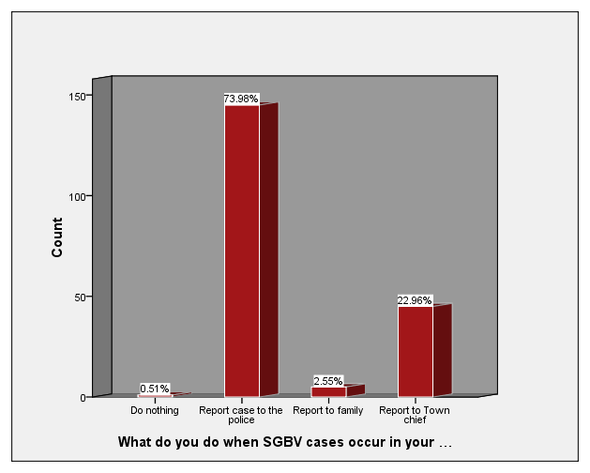
Figure 3.7: Actions taken by stakeholders to address SGBV

3.4.2 use of the referral pathway when reporting SGBV cases
Figure 3.8 below shows the findings on the respondent’s use of the SGBV referral pathway. Seventy percent (70%) of the respondents acknowledged the use of the SGBV referral pathway while thirty percent (30%) did not. From the findings a conclusion can be drawn that most of the stakeholders know and use the referral pathway in addressing SGBV while 30% of them either do not know it or do not find it as an effective means of addressing SGBV. This implies that there is need to carry out more awareness on the referral pathway since some of the stakeholders (30%) do not use it. This puts a significant numbers of SGBV cases at risk of not being addressed in the right manner, a phenomenon we are striving to avoid.
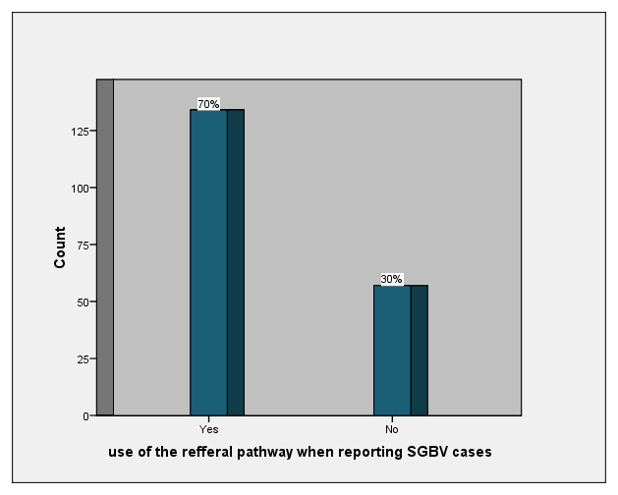
Figure 3.8: Use of the referral pathway when reporting SGBV

3.4.3 Effectiveness of the referral pathway
Having identified that 70% of the stakeholders use the referral pathway (see figure 3,8 above) it was worth identifying those that felt that it was effective. Figure 3.9 below shows that 61% of the respondents who use the referral pathway see it as an effective means of addressing SGBV cases while 9% do not see it as effective in addressing SGBV. The rest of the respondents (30%) either do not use the referral pathway or do not know it.
Note: The percentage of respondents who either do not use the referral pathway or do not know about it (30%) is also reflected in figure 3.8 above as respondents who do not use the SGBV referral pathway.
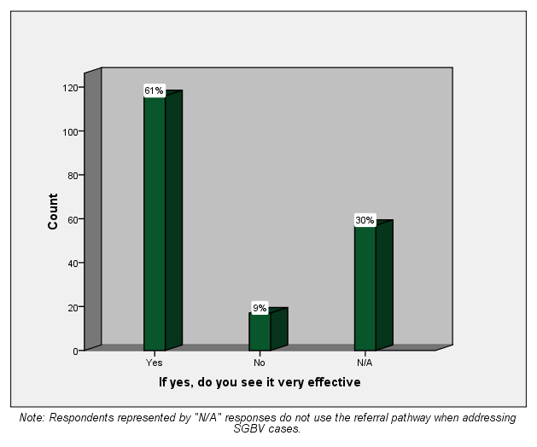
Figure 3.9: Effectiveness of the SGBV referral pathway.

4.0 SECTION FOUR: CHALLENGES, RECOMMENDATIONS AND CONCLUSION

4.1 Challenges in addressing SGBV
The following are the most outstanding challenges that stakeholders face in addressing SGBV.
- The Police identified logistical problems such as transportation, few staff, and lack of cells to lock up perpetrators as the core problems in addressing SGBV cases.
- Lack of mobile phone network (signal) to effectively communicate when reporting SGBV cases.
- Despite victims fearing to report SGBV cases due to stigmatization, most of the communities do not have police stations hence the distance to the nearest Police station is far.
- The court for prosecuting cases is far hence victims tend to withdraw cases when it is time for prosecution which at most times delays.
- Since most SGBV cases occur within the family, most cases are rather settled secretly the family way
- Cultural beliefs hinder people from speaking about SGBV.

4.2 Recommendations
Some of the recommendations made by the stakeholders include;
- There is need for more awareness (sensitization) on SGBV, the measures to take and where to report cases.
- The police need to be strengthened in terms of logistical support and infrastructure.
- To take a holistic approach by strengthening relations of community members and Police (stakeholders)
- Medical practitioners and police (stakeholders) should work in close collaboration to address SGBV cases
- Counseling should be given to both victim and close relatives/spouse
- Emphasis should be laid on transferring cases further to the court and stiff punishments be introduced for perpetrators.
- Need for a permanent person in each community to report cases to police/ court and empowering Town chiefs and other local authorities to engage in solving SGBV cases.

4.3 Conclusion
Based on the findings of the study, it was clear there is need to take an incorporative approach to enable more women and young adults to participate in addressing SGBV. The majority of the respondents showed considerable knowledge on SGBV. However, trainings on SGBV also need to take diverse approaches considering that almost half of the identified respondents had not attended senior high school. Further, the study revealed that stakeholders consolidate each other’s roles (counselling, providing access to medical facilities, investigate and forward cases for prosecution and report cases) in addressing SGBV. Concern was raised on the number of cases each stakeholder had handled in the last 12 months. More than half of them had not handled any case, implying that cases are not dealt with in the recommended manner. This problem can however be attributed to the general public since most of the stakeholders confer that the SGBV referral pathway is effective. On the other hand, Town administrators outstandingly came out as another preferred channel of reporting SGBV cases since the Police are not present in all the communities.

Bibliography
World Health Organization (WHO) (2010) Preventing violence :a guide to implementing the Recommendations of the World report on violence and health, Geneva, Switzerland.
United Nations Mission in Liberia (UNMIL) Office of the Gender Adviser (OGA): Best Practices Report: Gender Mainstreaming in peacekeeping operations in Liberia 2003-2009. UNMIL, Kofi Annan International Peace keeping Training Centre (KAIPTC), German Development cooperation, Accra, Ghana. September 2010.

APPENDIX
SGBV BASELINE SURVEY QUESTIONNAIRE FOR STAKEHOLDERS
Location:
County………………..….……... District: …….…….…….….….
Community: ................................. Date: …….………………........
Respondent’s Background Information
Instructions: Please put a check mark ( ) in the parenthesis that best answers the question.
- Sex: Male [ ] Female [ ]

- Age: (a) 25-30 [ ] (b) 31-35 [ ] (c) 36-40 [ ] (d) 41-45 [ ] (e) 46-50 [ ] (f) 51-55 [ ] (g) 56 and above [ ]

- Education level: (a)Elementary [ ] (b)Junior High [ ] (c)Senior High [ ] (d)College [ ] (d) Never been to school [ ]

Knowledge of SGBV
- What does gender mean to you? (a) only men [ ] (b) only women [ ] (c) Both men and women [ ]

- What is your understanding of the word violence? (a) Fighting [ ] (b) Loving [ ] (c) Caring [ ]

- Have you heard about Sexual and Gender Based Violence (SGBV) before? (a)Yes [ ] (b) No [ ]

- If yes, from whom did you hear it? (a) N/A [ ] (b) Friend [ ] (c) Radio [ ] (d) NGO [ ] (e) Other [ ]

- Would you define SGBV as any harm done to a person that creates a negative impact on the physical and psychological wellbeing of the person? (a) Yes [ ] (b) No [ ]

- What do you do when SGBV cases occur in your community? (a)Do nothing [ ] (b) Report case to the Police [ ] (c) Report case to Family member [ ] (d) Report case to Town Chief [ ] (e) Others, specify ……………………………………………………

Sector of work

- Which position do you occupy in the community? (a) Security personnel i.e. Police, immigration, customs, Drug enforcement agent etc [ ]
(b) Community associations / groups i.e. women group, youth group etc [ ]
(c) Service providers i.e. Teachers, Nurses, etc [ ]
(d) Prosecutor i.e. Judge, Lawyer, etc [ ]
(e) Town Administration i.e. Town Chief, Clan chief etc [ ]
(f) Private citizen [ ]

- In your area of work, do you address cases of SGBV? (a) Yes [ ] (b) No [ ]

- If yes, what role do you play in addressing the SGBV cases? (a) Report cases [ ] (b) Counseling [ ] (c) Access to medical facilities [ ] (d) Prosecute cases [ ] (e)Investigate and forward cases for prosecution [ ] (f) N/A [ ] (g) Others specify ……………………………………………………………………………………….

- How many cases have you handled and made follow up on in the last 12 months? (a) none [ ] (b) 5 and below [ ] (c) Between 6 and 10 [ ] (d) 11 and above [ ]

- Do you use the referral pathway when reporting SGBV cases? (a) Yes [ ] (b) No [ ]

- If yes, do you see it very effective? (a) Yes [ ] (b) No [ ] (c) N/A [ ]

- If no to question 14 above, what other means do you use to report SGBV cases? Please specify ……………………………………………………………………

- What are the challenges faced in addressing SGBV cases? Please specify ………………………………………………………………………………………………………………………………………………………………………………………………………………………………………………………………………………

- What suggestions would you recommend that will appropriately address SGBV issues?
(a)………………………………………………………………………………………
(b) ………………………………………………………………………………………
(c) ………………………………………………………………………………………

