ANNAI THERESA SOCIAL WELFARE ACTION TRUST (ATSWA)
SHORT HISTORY OF ORGANIZATION:
Annai Theresa Social Welfare Action Trust (ATSWA) is a registered in Indian Trust established in 2005 at 8.M.P.A.Chruch Road Thirumullaivoyal Chennai-600 062 with a secular and humanitarian outlook and led by established principles of social service. It has been in service to the poor, downtrodden and excluded communities for the past twenty two years. ATSWA primarily works in North Tamil Nadu Eastern & East and West Chittoor District in Andhra Pradesh that borders and reach out to any area where need arises at any time. ATSWA works for the rural poor, orphans children & women, people with disabilities, senior citizens, commercial sex workers, and people living with HIV/AIDS and empowers them with human dignity.

VISION
"To alleviate poverty and bring about Economic Empowerment and Social Justice and healing to the less privileged in all areas of life and help them live with Human Dignity."

MISSION
"To empower the downtrodden, with activities and support to overcome their limitations".

PROGRAMS OF ATSWA:
Developmental Programs for Children.
- Residential Child Care programme for children at risk.
- Education and Rehabilitation of physically challenged Children.
- Day care Centres for the Physically Challenged Children
- Residential Child care for HIV infected and affected children
- Community based child Care

Developmental Programs for Women:
- Formation of women Groups
- Women Leadership
- Micro Entrepreneur Developmental Programs
- Human Rights awareness and capacity building programs
- Environmental Protection
- Comprehensive programs for Senior Citizen and destitute.
Target Population:
- Poor, Orphan and semi orphan children
- Children with Physical and Mental Disability
- Poor women, widows, aged and destitute

ACTIVITIES FOR THE PHYSICALLY CHALLANGED PEOPLE
Disabilities are very common in the rural areas due to poverty, illiteracy, unemployment and also traditional customs and this aids the continuance and even the increase of people with disabilities in this district. The differently abled people are identified through surveys and the degree of disability is medically assessed in order to help them to get: a) Government facilities such as medical certificate, pension, and bus pass etc and b) required rehabilitation processes and C) Educational support with home based care for differently abled children.

Community based rehabilitation services are provided to;
1. Visually impaired,
2. Speech and Hearing impaired
3. Mentally Challenged,
4. Locomotive (orthopedically) impaired
5. Those with multiple disabilities.
6. Leprosy affected people

PROGRAMS FOR DIFFERENTLY ABLED PERSONS:
Immediate Relief:
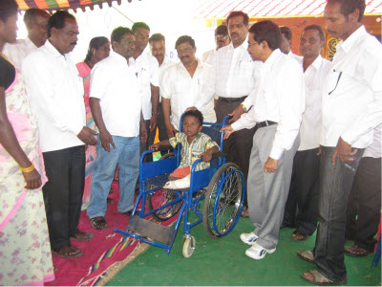
ATSWA focuses on immediate intervention to bring relief to those affected with disability and then works for the total rehabilitation of the affected. After the initial interaction the family members are provided with required counseling and training to help the differently abled person to be able to take care of oneself. In most cases the affected person is provided with assistive devices such as, Try Cycles, Crutches, and Callipers, Hearing aid or any device that would help in improving the condition of the differently-abled person.

Home Based Care and Support:
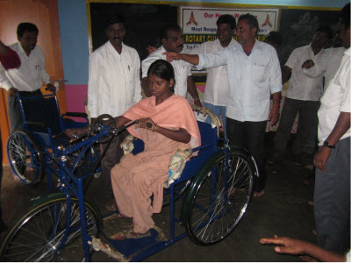
Home Based Care and Supports are provided for the differently-abled to enable them to lead a dignified life. Totally, 38 physically challenged children are under the care of the ATSWA. ATSWA provides care and support to physically and mentally challenged children. Once in three months, medical camp for the children is organized in order to identify their health problems and give them a special care and proper treatment. Children are given admission in nearby schools. Very special attention and safety measures are provided to keep them sage and secured at the home.

Educational Support:
Special care is provided for the differently abled children in the 6 day care centres where they are provided preschool education day care and rehabilitation. The early care helps the children to get rehabilitated faster than others. After proper care and training the differently abled children are admitted in the regular mainstream schools including mentally retarded children under integrated education programme. This inclusion helps the children recover faster than other methods and they are able to learn better.

Vocational skill Trainings:
The affected person is provided with required skill training and support to start a self employment venture. The differently abled people are also brought together to form self help groups and helped to get government grant and then group loans to help them either start their small businesses or expand it.
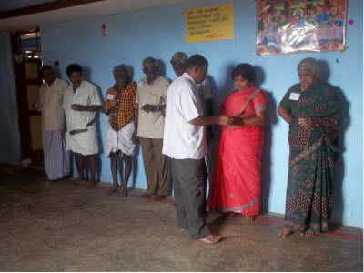
Community Health Awareness Program:
On a preventive note regular awareness programmes are conducted for the parents and community about the causes for disabilities and the ways to reduce them. Regular pre and post natal care programmes are also conducted for reducing disabilities at birth and /or to carry out an early intervention to help the differently abled children attain near normal life.

Medical Camp:
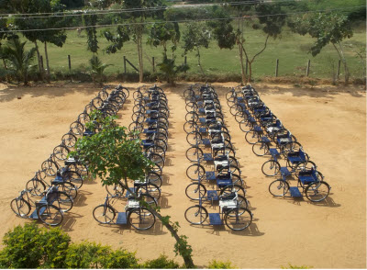
Eye care camp is a regular feature since 1999 and it has touched the lives of 5000 old people in and around Sathyavedu area. Due to this work Cataract has been eradicated in 4 blocks. In this mission we are assisted by Sankara Nethralaya – Chennai.

The Need for the Differently Abled children in Home:
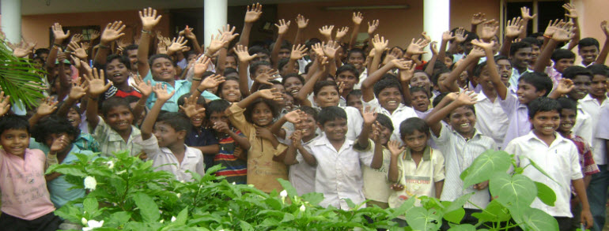
Annai Theresa Social Welfare Action Trust (ATSWA) runs a home for poor, orphans, and differently abled children from the target area of East Andra Pradesh and North Tamil Nadu.
There are 85 children are accommodated in the home called “Happy Children Home” for their studies and development. Among 85 children 38 are differently abled children who are given special attentions and care for their health, mobility, education and developments. These special children are studying from 5th STD to 12th standards in Government and in private schools which are 5 and 7 kilometres away from home.
They are taken to the schools by share Autos which very risky yet we do not have any other option. We are not able to pay for the hiring of a van or Tempo Traveller to take these differently abled children to their schools and bring them back to Home. The roads are muddy and uneven and most of the time differently abled children are not able to travel by this road comfortably. If a vehicle with 25 seats would help these children to take them to schools and bring them back to home. Since the number of children is 38, we could even take double trip to schools.
THE URGENT NEEDS OF THE CHILDREN IN OUR HOME:
- Carrying differently abled children to schools and bring them back.
- Taking them to Hospitals and dispensaries for regular/ monthly check up and treatments and at the time of emergency.
- Taking them to picnic spots, outings.
- Organise medical camps in target villages

Outcome:
- Differently abled Children have easy access and mobility to schools and reach on time.
- A safe mode of travel for the children
- All emergency needs of the children at the home are attended.
- Children have the peaceful atmosphere in the home
- Children are taken out for picnics and short tours.
- Health needs are attended on time and treated at hospitals.
- Community people are given mobile health facilities and treatments.

Conclusion:
Children must enjoy their childhood. Their rights and duties are respected. ATSWA is committed to provide them with all avenues for their psycho motor and social development in Happy Children’s Home. We no approach you with a tire need which would help these differently abled children and many others both in children’s home and villages. We hope that you would support us in serving these special children in a better way.

Photo Gallery of Happy Children’s Home
