To
The Global Hand.

Greetings to you!
It my privilege to be a member of Global Hand.
The request the I have made for the leh Laddak. This is very vital need of the people living on snow mountain.
The main earning was Yak tending and sheep and sale wool for daily living .
But many of the have lost their everything.

Therefore Serve India Team would like to stand in the gap those still suffering.

I have put information on the website of yours. In you need any other detail project proposal please let me know

Organization profile!

“Serve India” is a registered non-profit making, voluntary non –Governmental Charitable Organization working in the urban and rural areas in Delhi. Our organization is mainly working in the priorities of Relief during natural disasters, Education, health care HIV /AIDS, tuberculosis, Micro Enterprises Development (MED), Income generation program, Vocational Training program for the community developments in the slums in Delhi. Also projects running like Health Education on Tuberculosis and HIV Aids, Mobil medical clinic, Adult Education Centre Vocational tailoring training, basic computer programme have been initiated and being implemented successfully.

We have a team of dedicated grassroots volunteers, experienced and qualified skilled education counselors, thus enabling us to implement our program effectively with an eye to results.

Our contact person, the Chairman Rajender Singh is a veteran in this field of social work and has received acclaim from various organizations on several occasions for implementing the programs. He and the Board of the Trustees will be responsible for proper implementation, monitoring and evaluation of the projects.

Legal Statutes
“Serve India" is a non-governmental non-profit making Charitable Trust, established for community developments and transformation. “Serve India” and its board of Trustees meet regularly for board meetings to ensure the smooth running of the projects and its activities, and we have several advisors who are well experienced in different mission fields. “Serve India” also has 12A income tax exemption and 80G tax deduction.
“Serve India” also having permission from Ministry of home affairs to get foreign contribution. FCRA Registration No : 231660933
At the end of the financial year we submit our financial audit statements to the Government of India and donor agencies involved.

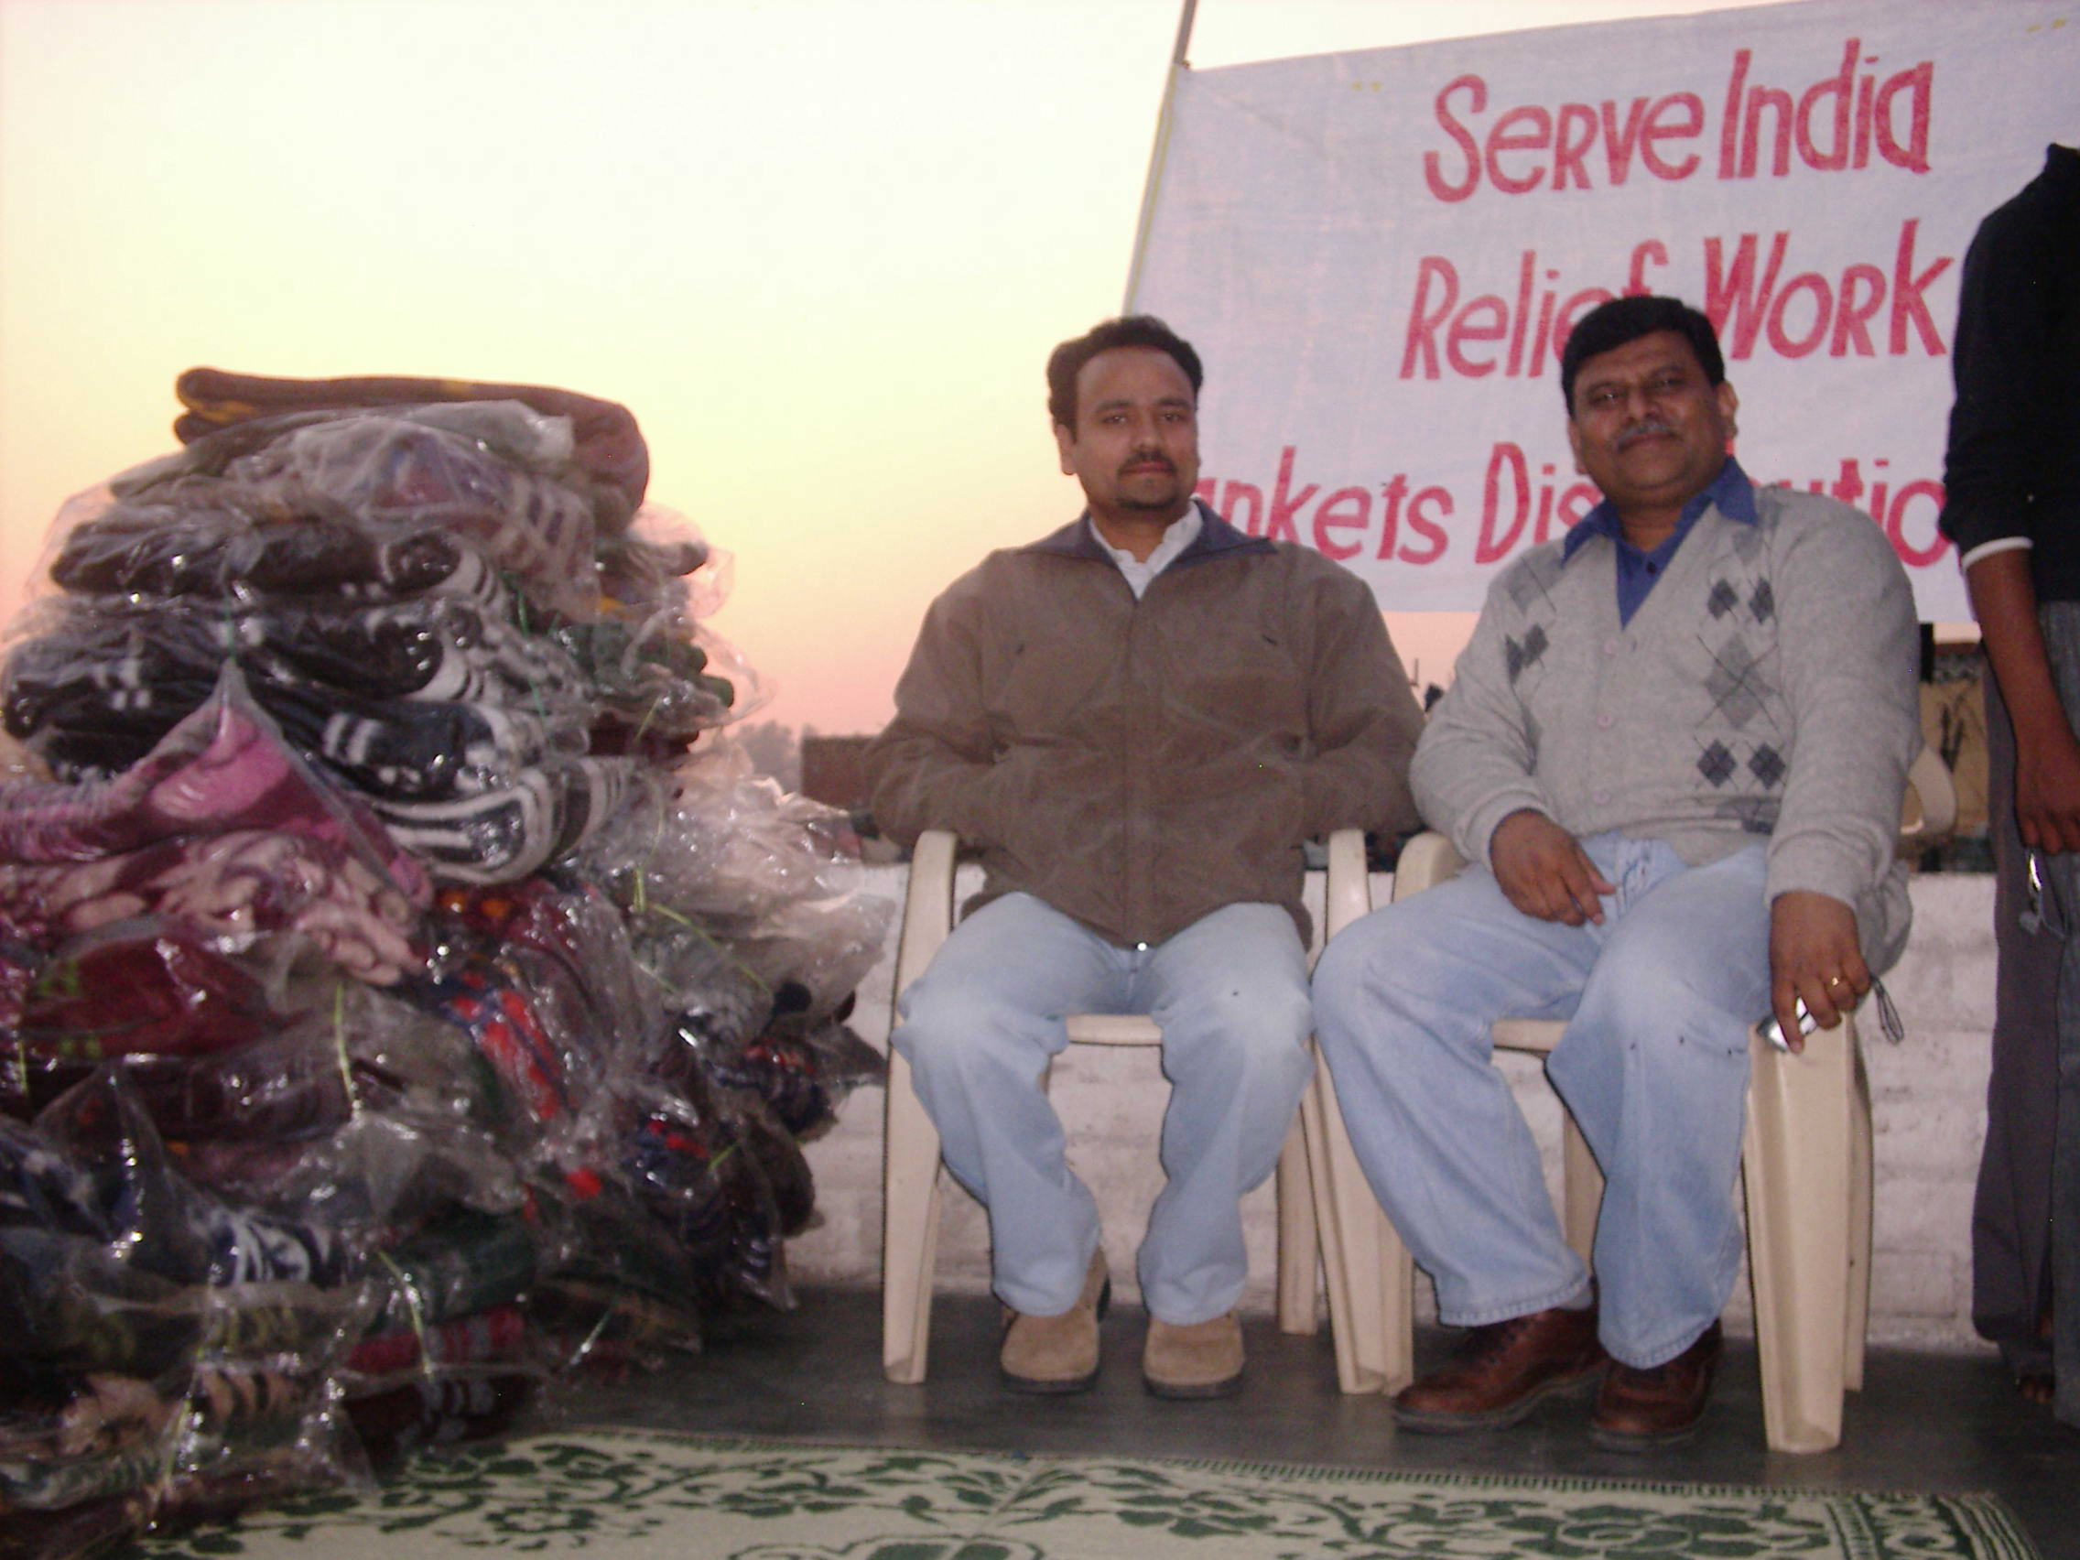

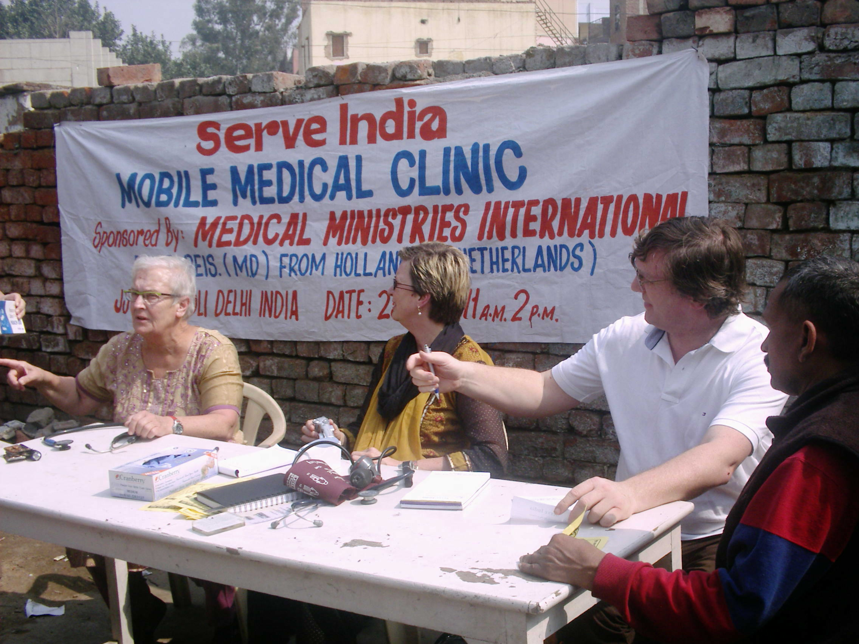

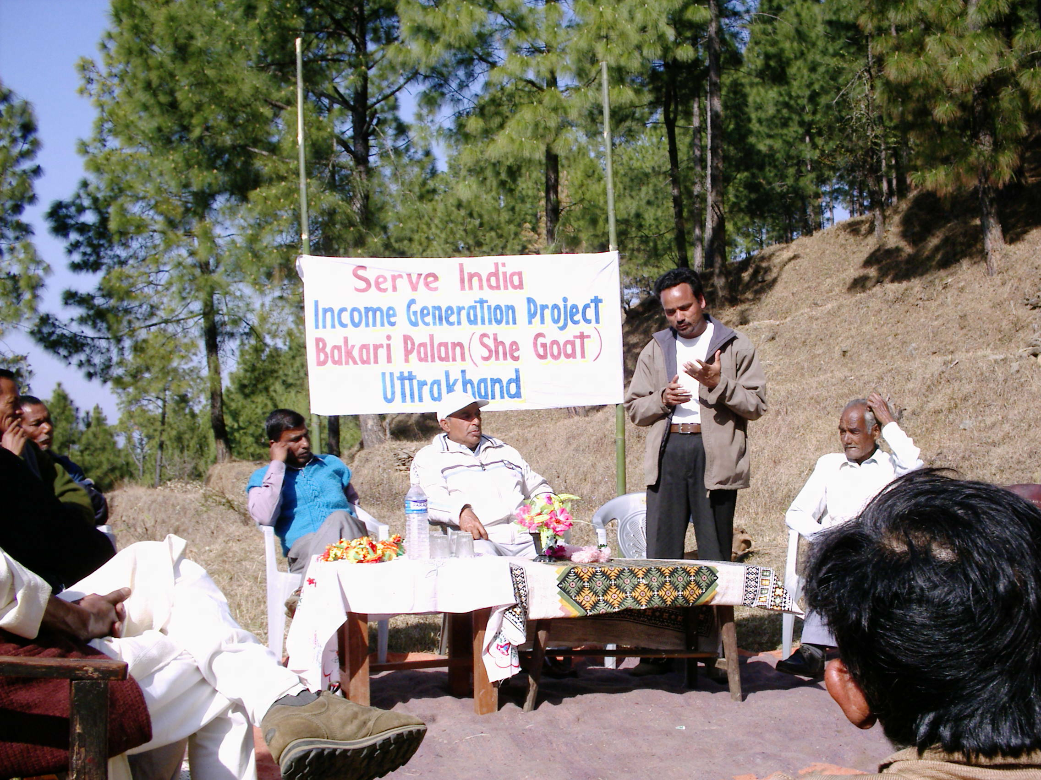

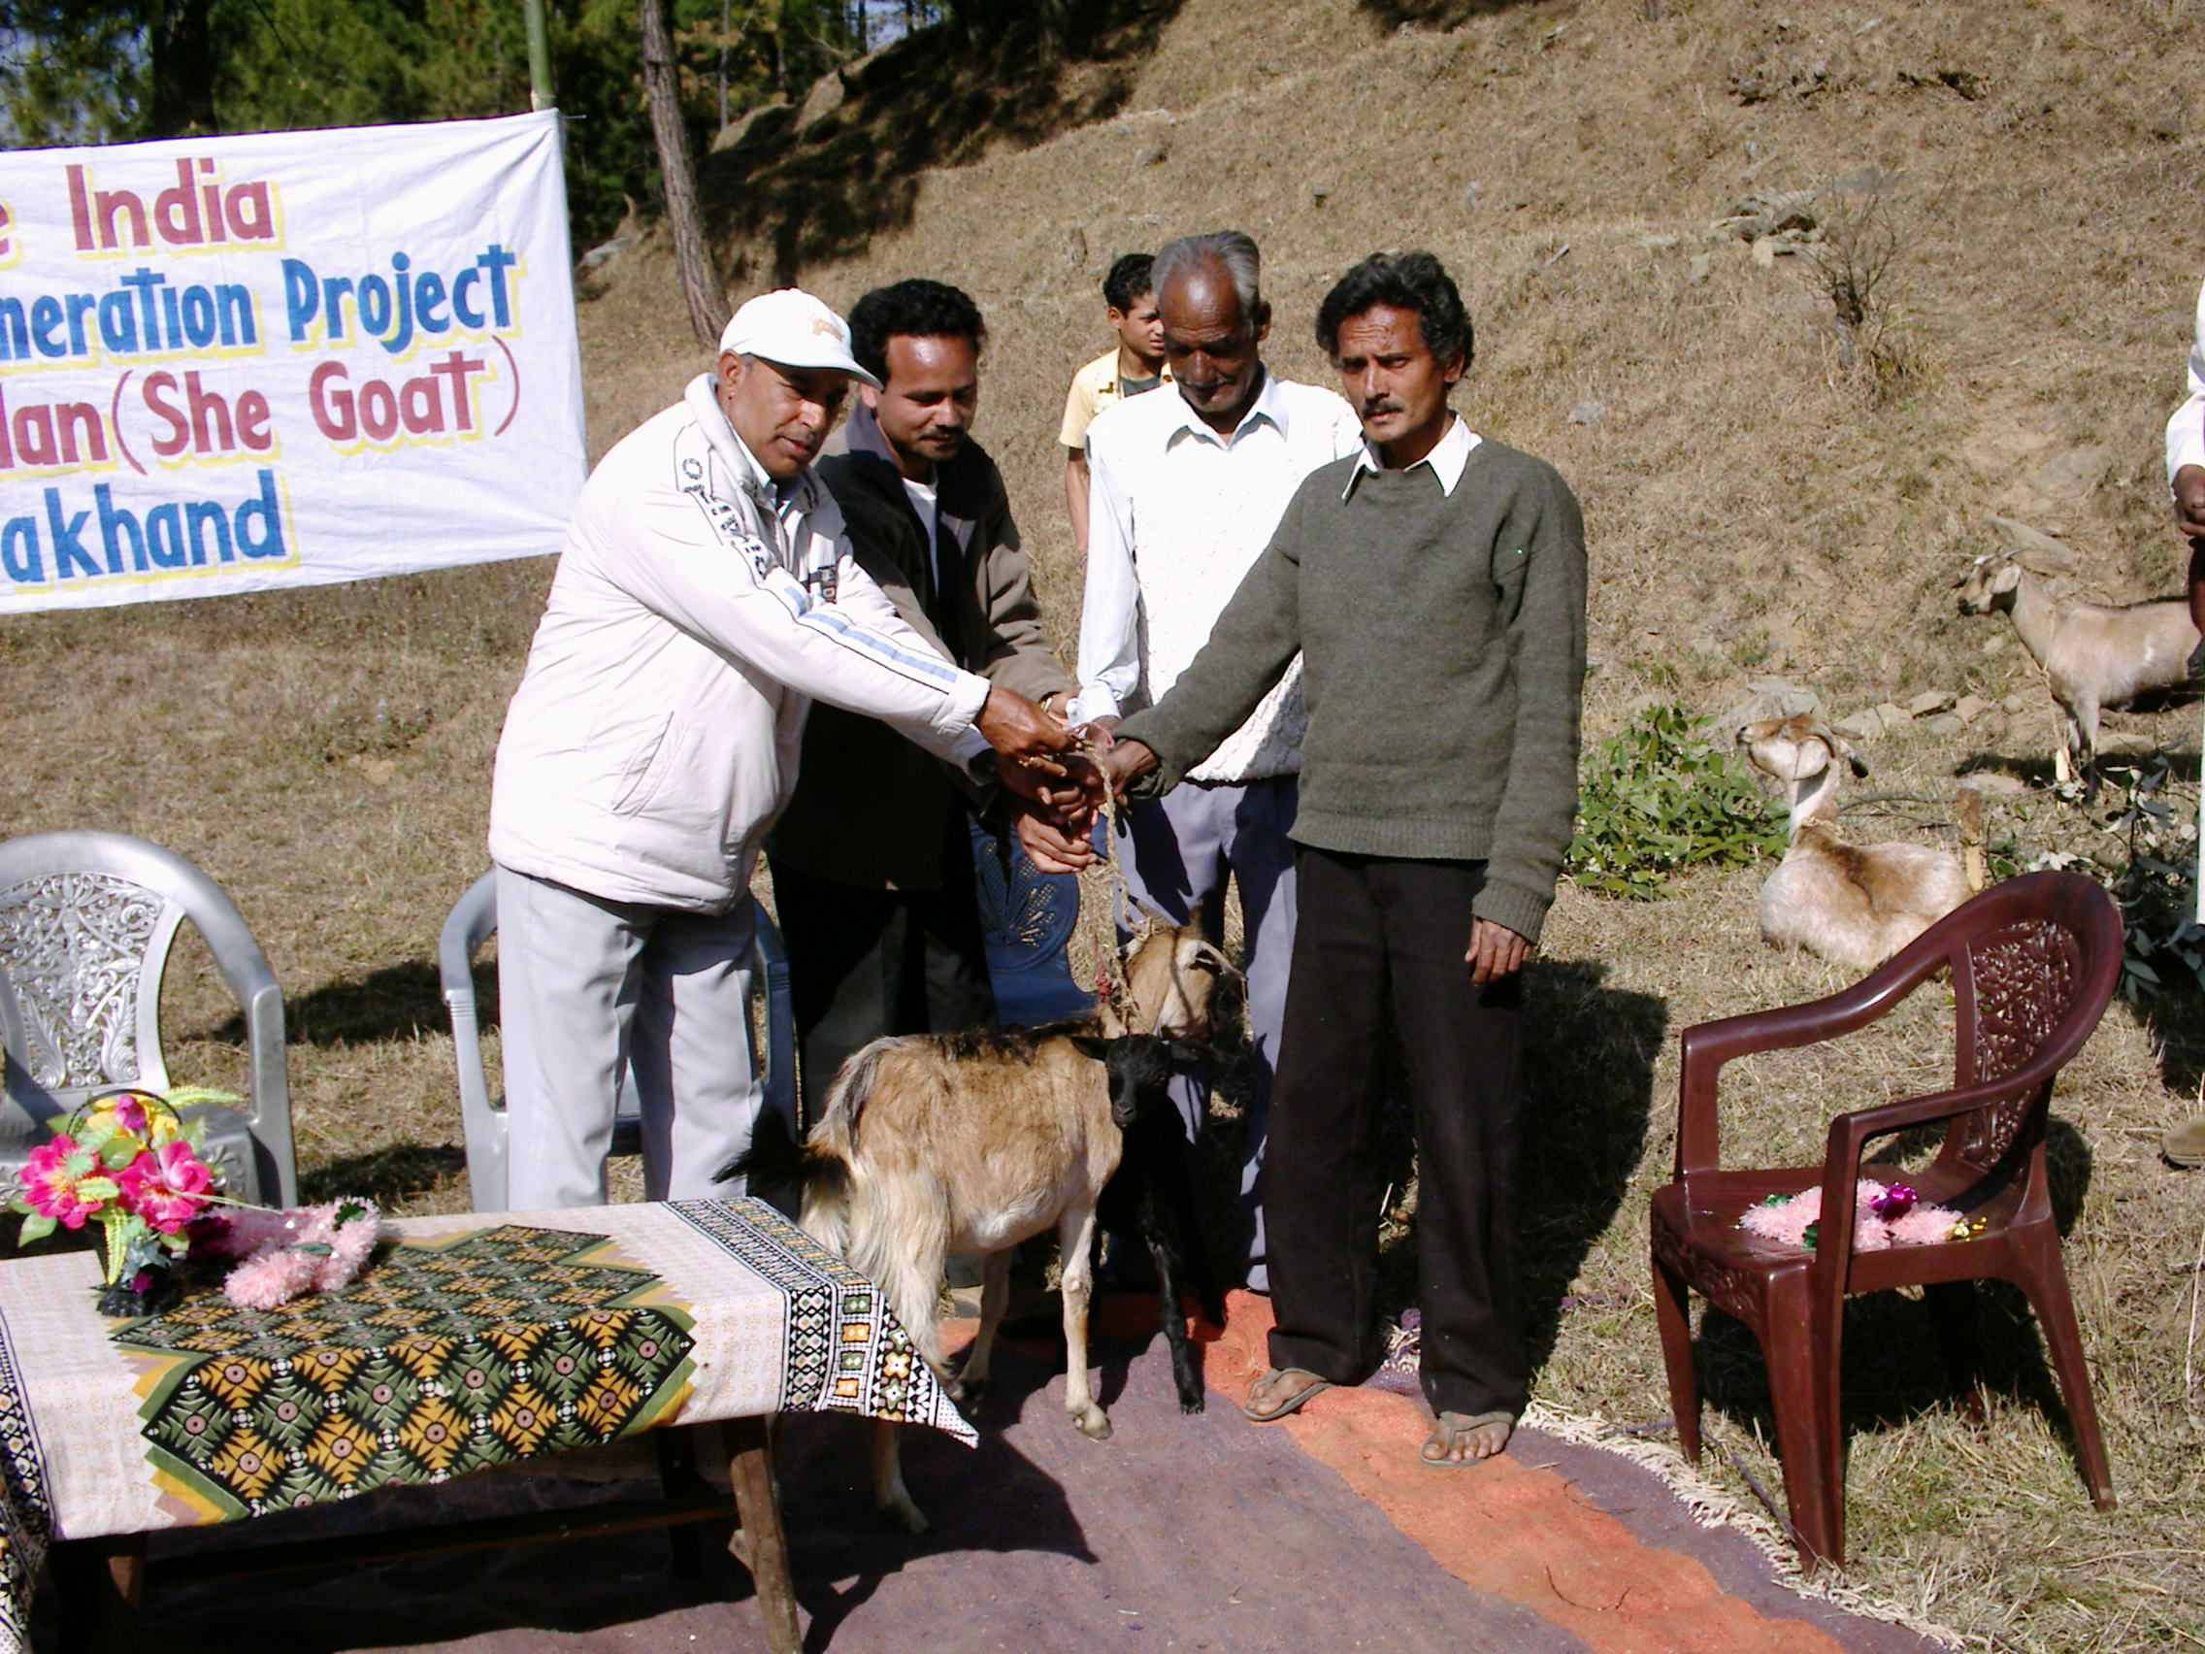

Organization profile and Bank Details

Name : Serve India
Registration No : 28492 Charitable Trust
Place of Registration : Delhi India
Date of Registration : 08/08/2005
FCRA Registration No : 231660933 (Foreign contribution registration act)
Income tax 12A exempt : S.44441504
Income Tax 80G : S4444/3045
Account No : 14740100014807

Bank Details
Account Name : Serve India
Account No : 14740100014807
Bank Code : 110049015
Swift Code : FDRL IN BB IBD
Branch Code : NDLM

Bank Address.
The Federal Bank LTD
1st floor SGL Plaza Plot No.10
Community Centre Sector, 9
New Delhi
Pin 110085
Tel 011 27556500

Office Address.
Serve India
B-5/63 Sector 18
Rohini Delhi India
Pin 110089
Tel 011 27859055/ 9911256654/ 9213105286
Nature of work : Cultural, Educational, Social, and Medical
Main Object : For medical, Educational orphanages, and relief

SERVE INDIA
Governing body of Serve India 2010

S.No | NAME | NAME OF FATHER/HUSBAND | NATIONALIY | OCCUPATION | OFFICE HELD IN THE ASSOCIATION | RELATIONSHIP WITH OFFICE BEARERS | ADDRESS
1 | 2 | 3 | 4 | 5 | 6 | 7 | 8
1 | Mr. Rajender Singh | Mr. Kunwar Singh | Indian | Social Worker | Chairman | N.A | House No B-5/63 Sector 18 Rohini Delhi –89  Cell 9213105286
2 | Dr. Harich. C. Lamba | Late. Mr. B. R. Lamba | Indian | Doctor M.B.B.S | Secretary | N.A | B-3/16 Sector 18 Rohini Delhi -89  Tel 27855786
3 | Mr. Sudhir Yadav | Mr. M. P. Singh | Indian | Chemist | Treasurer | N.A | CC Block, 38-A  Shalimar Bag  Delhi
4 | Mr. Monoj Mohanty | Late. Mr. E. S Mohanty | Indian | Consultant | Member | N.A | B-53, Rohit Appt  Plot No 30, Sector 10 Dwarka  Delhi  Cell 9910678848
5 | Mr. Anurag Joab | Late. Mr. Joab | Indian | Program Director  FEBA Radio | Member | N.A | 1109, 2nd floor  Dr. Mukherjee Nagar  Delhi 09  Cell 9968269095

