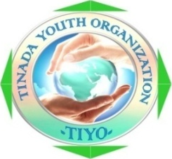

Introduction
Tinada Youth Organization (TIYO) is a Youth and Child focused Nonprofit Community Based Organization registered in 2001 in working within the Lake Vitoria Region, Western part of Kenya. Tinada is a Family Driven Integrated Initiatives believed in using the family to family and youth to youth focused interventions to demonstrate and attain sustainable Health and economic power of the family households.

Our Vision:

Healthy and Empowered Youth actively participating in community development

Our Mission:
TINADA exist to promote Health seeking behaviour, integrity, glory of productive work and economically productive life among Youth within the Lake Victoria Region of Kenya through Capacity Building, support services, Mentorship, Demonstrated good practices and strategic networking

OUR STRATEGIC Program Focus
- Promote children and youth Health, productive education, Rights and Career Development
- Promote Effective Reproductive Health practices among the youth and young women
- Promote Enterprise among Youth, Young Women and the vulnerable population Exhibiting best Entrepreneurial and agriculture Practice
- Strengthen wise management of economic, environmental and human resources within the Lake Victoria Region
- Promote Public Governance, human rights, equity and justice

Our Programs

Adolescent Sexual And Reproductive Health (ASRH) -.

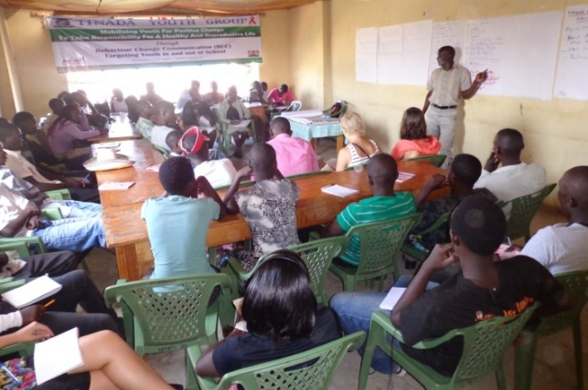
Tinada implement adolescent development programme that worked to model and remodel adolescent behaviour by enhancing their capacity to make informed choices on issues of sexuality to ensure the full enjoyment of reproductive lives.

The program is promoting:

Comprehensive sexuality education, Combating sexual and gender-based violence, and Freedom of expression of sexual diversity and gender identity.

The Project Objectives include:
- Increase utilization and quality of comprehensive Sexual and Reproductive Health (SRH) services
- Increase quality and delivery of Comprehensive Sexuality Education (CSE)
- Reduction of Sexual and Gender Based Violence (SGBV)
- Increase acceptance of Sexual Diversity and Gender Identity
- Improve sexual and reproductive health services
We have reached 16200 in and out of school youth in clubs, local school and children’s ministries, academies institutions as the direct beneficiaries.

Early Childhood Development
This is a child development program in child growth and development with much attention to Education, health and Environment through Community Health Volunteers., learn and reason. For this to happen, they need to grow in a supportive environment. Early Childhood Mentorship program, gives the children a head start at subsequent education levels. The programmes also promote their smooth and successful transition to primary school and other advanced levels of education. The program work with community health workers and cares givers through community health strategy (Government implementation model). The program target public and private schools, child development centers, nursery schools and churches.

Education Sponsorship
According to the statistics (Kenya 2009 census), only 20% of young people who enroll for primary education manage to go to Secondary school, while only about 6% proceed to university. The pressure of life is forcing more and more school leavers into drugs, alcoholism, increased in spread of diseases, unplanned pregnancy and marriages, rape, ignorance, unemployment, stealing and robbing from their neighbors presumably for survival. So some children and youth are poor not because of inability but for lack of support to excel in specific areas of their talents. The program aims at giving such needy cases a second chances through increasing quality and access to affordable education for poor children, and skills training for poor youth and young women, this program give a concrete possibility of social and economic empowerment to the adults of tomorrow and to all their families

Youth Soccer and HIV Integration program
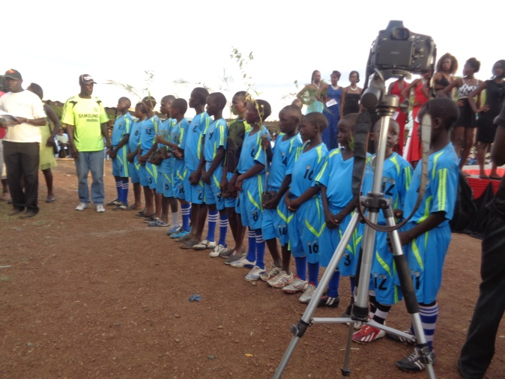
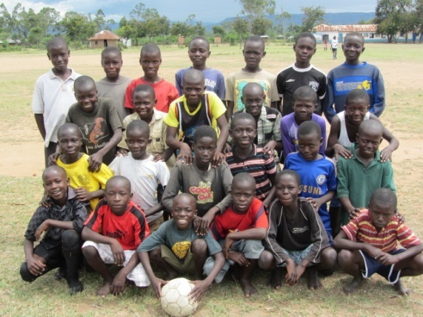
This program is targeting kids and youth in identifying talent to achieve sporting and art excellence. There are many soccer clubs within the communities but they luck support, mentorship, motivation and linkages. We promote social justice within youth both boys and girls within the communities to enhance their standard of living. The program is founded with an aim to equip, mentor, instill, educate and mould the talented and less talented boys and girls up to their standard of achieving sporting excellence within the local and international fields. We have trained 30 coaches from 30 local clubs and schools who intern train kids and youth through integration of HIV/AIDS

Democracy & Public Governance
The program promotes advocacy for a strong institutional framework and enhancing the capacity of the citizenry in democracy and good governance. The programme seeks to:
- Rebuild the democratic culture among young people and general community in Kenya by enhancing their civic awareness around the ideals of nationhood, patriotism and constitutionalism;
- Increase the level and quality of participation by young people in public policy, engaged governance and national development and improve the responsiveness of public policy to the development priorities of young people;
- Enhance the participation of Kenyan youth and women in national development by enhancing their leadership competencies to enable their full participation in the political, social and economic development
- advance access to justice for disadvantaged and marginalized children and young people in Kenya
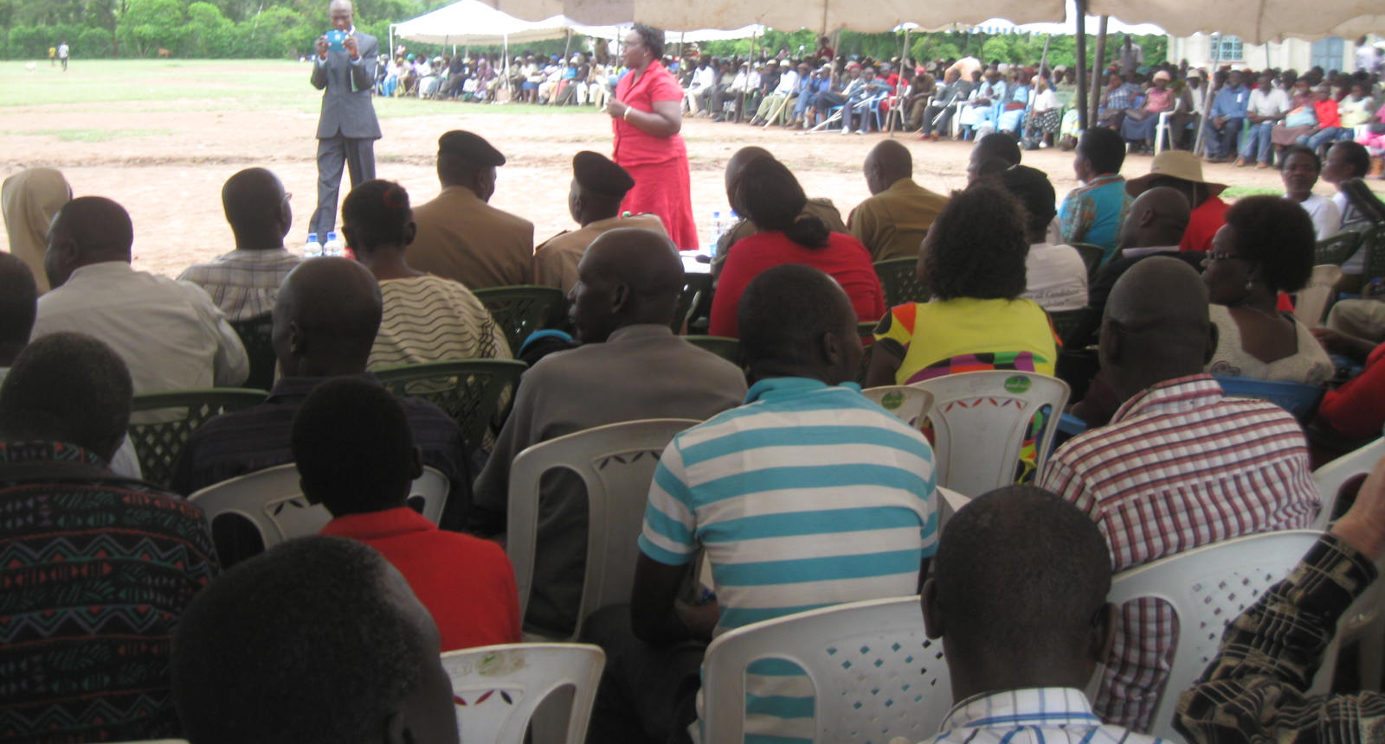

ARTS AND CULTURE :
Arts and Culture programme focused on building new audiences for the arts and the creation of employment in on job training and authentic communities work. Tinada strives to offer alternatives to Art and artwork youth career both creative and performing arts. Tinada continue to roll out various activities under Mentors Arts Centre and Inuka Tinada Theatres aimed at recruiting youth volunteers to participate in Art and design work, theatres, photography, music audio and visual artwork as means to address cultural and socio-economic issues in Kenya. We provide and extend our services in the area of art and design include; painting, coding, portraits, rubber stamps, banners, photography, computer services, ceremony badges, sign writing, physical drawing and among others

Environment Conservation Project
This program focuses on environmental conservation towards involving youth to actively participate in community sanitation and global climate change. The program involve: Climate Change Advocacy, sponsoring and participation in massive tree planting campaigns, establishment of woodlots, construction, water pans and gabions, sanitation improvement, Soil erosion/Gulley Control and Tree nursery Establishment and management

NYAKATICH Poultry Farmers Cooperative Initiative
Is a Youth-To-Youth Entrepreneurship Program Supported By Ustadi Foundation Through An Initiative.The Africa Commission, and The International Labor Organization (ILO).The main purpose of the project is strengthen capacity of youth and provide adequate services to upscale and commercialize poultry farming among the unemployed youth out of school and and teenage mothers aged 18 to 35. The project is running two incubator eggs machine with capacity of over 2200 eggs

GlobNet Volunteers and Internship Program
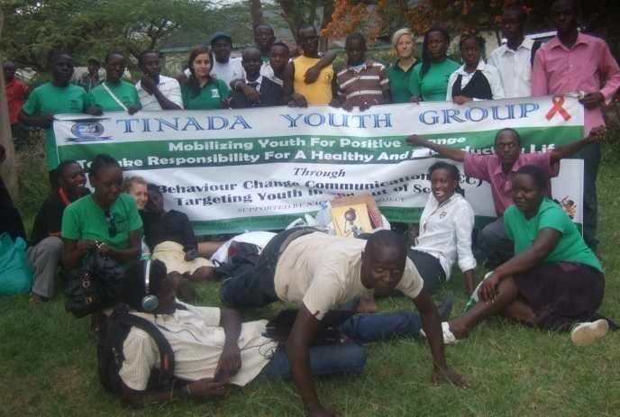
This program gives both local and international volunteers / intens opportunity to volunteer various projects. The program search work placement for volunteers within the organization and our partners in kenya. We recruit volunteers globally to various projects according to their area interest/skills and taste.

Tinada Youth team with Interns from Humak University from Finland, during outreach activity

Mental Health Program
In partnership with ON THE MOVE (German Based NGO),we promote mental health and preventing mental disorders; reducing stigmatization, discrimination and human rights violations. We also promote comprehensive, integrated and responsive Child mental health and social care services in community-based settings through implementation of promotion and prevention of Child mental health. Health systems have not yet adequately responded to the burden of mental disorders; as a consequence, the gap between the need for treatment and its provision is large all over the world.
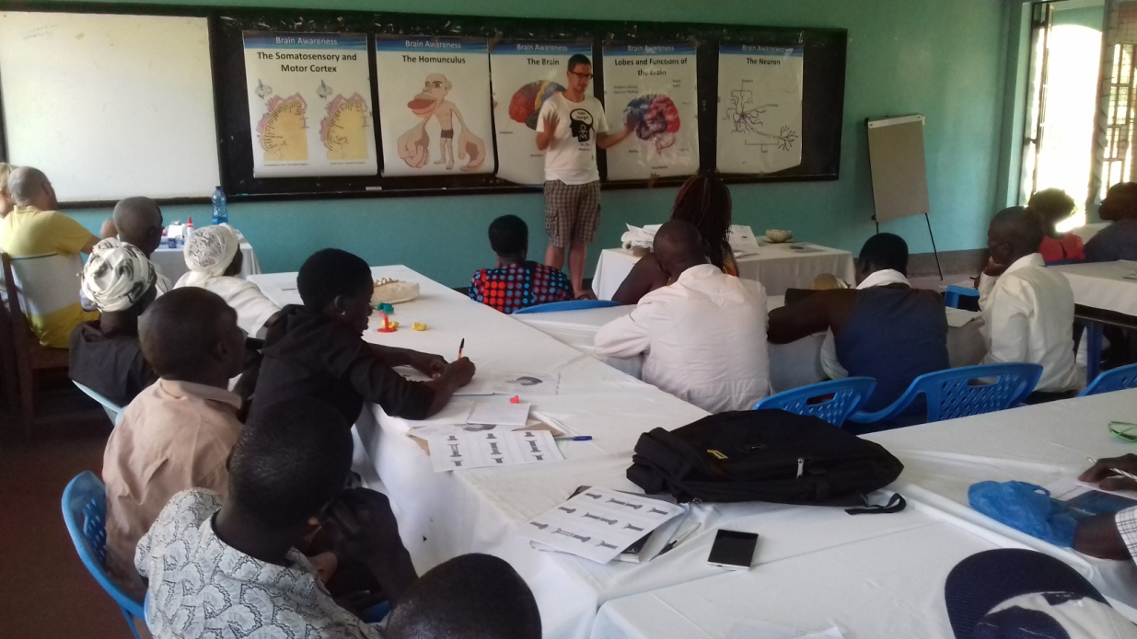

Community Health workers Mental Training Class
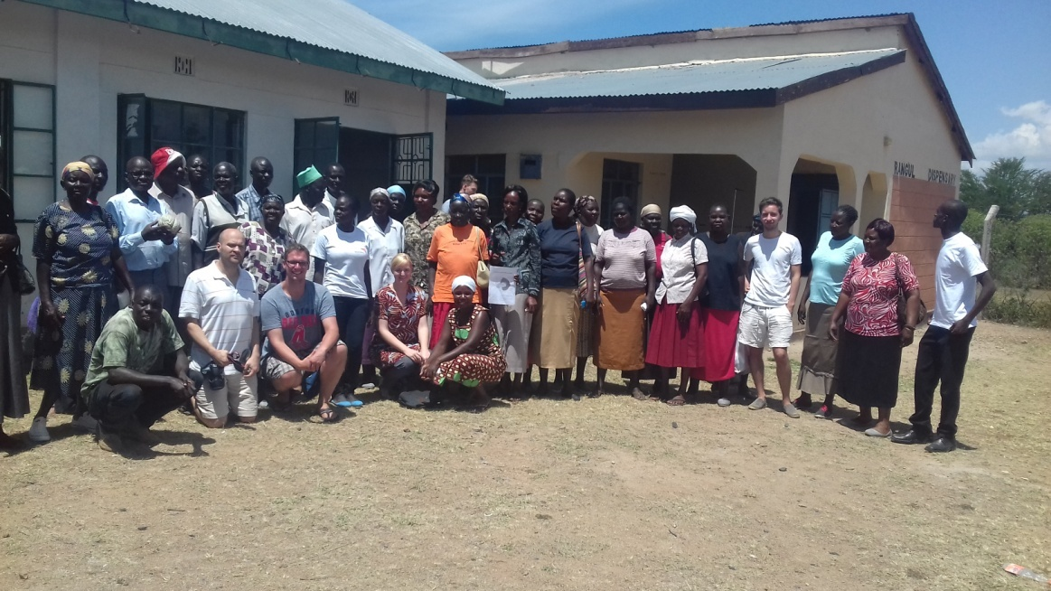

Facebook all our activities photos, visit:

- https://web.facebook.com/tinada.youthgroup/photos

- https://web.facebook.com/Tinada-Youth-Project-272309992822765/photos_stream

TOWARDS TOTAL TRANSFORMATION OF OUR COMMUNITIES
FOR EFFECTIVE & SUSTAINABLE DEVELOPMENT
Building on community strengths and exploiting existing / emerging opportunities and reversing challenges and threats to achieve Kenya Vision 2030 & Sustainable Development Sustainable Development Goals within the devolved Government
- Existing community partnership programmes
- Youth potential
- Existing asset base at community level
- Available natural resources
- Leadership:
Mobilization, coordination & networking, planning, M & E, feedback & dialogue at community level (HRD Gaps)
- Information & Communication Technology gaps at grassroot level.
- Income.

- Intellectual, Professional Asset
E.g. Participating Universities
- Enabling policies and systems
Policy documents e.g.;
- Community strategy
- The new constitution
- The County Government
- Kisumu International Airport
- Global Partnerships Vision 2030 and MDGs Programing.
MDGs

- Insecurity
- In increasing environmental degradation, natural resources loss and climate change (Reducing carrying capacity)
SCOT ANALYSIS
- Existing community partnership programmes
- Youth potential
- Existing asset base at community level
- Available natural resources
- Leadership:
Mobilization, coordination & networking, planning, M & E, feedback & dialogue at community level (HRD Gaps)
- Information & Communication Technology gaps at grassroot level.
- Income.

- Intellectual, Professional Asset
E.g. Participating Universities
- Enabling policies and systems
Policy documents e.g.;
- Community strategy
- The new constitution
- The County Government
- Kisumu International Airport
- Global Partnerships Vision 2030 and MDGs Programing.
MDGs

- Insecurity
- In increasing environmental degradation, natural resources loss and climate change (Reducing carrying capacity)

Strengths Challenges

Opportunities Threats

- WORKING WAYS FORWARD
- Tightening loose nuts to strengthen Community strategy
- DEVELOPING EFFECTIVE THINK TANKS / ENGINES / CHAMPIONS AT ALL LEVELS.
(Identify, recruit, equip, engage, motivate, network monitor, evaluate and feedback, & plough back lessons for continuous improvement towards excellence).
- ENHANCING A GOOD MIX OF PROFFESSIONAL & TECHNICAL INTELECTUAL KNOWLEDGE AND INDIGENOUS / LOCAL WISDOM & EXPERIENCE FOR EFFECTIVE “HOWS” OF DEVELOPMENT AGENDA.
- REGULARIZING FORUMS FOR PLANNING DIALOGUE, FOLLOW-UPS, AND ACTION TOWARDS SET TARGETS OBJECTIVES & GOALS AT ALL LEVELS.
- PROVIDING ESSENTIAL FINANCIAL RESOURCES INCLUDING AND MORAL SUPPORT (Budget allocations and goodwill).

