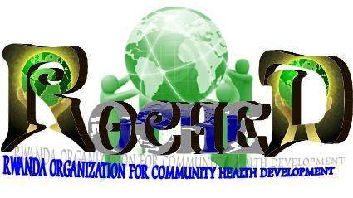

Rwanda Organization for Community Health Development
Tel : (+250) 788604536 / 0788308121/0788500140
E-mail : info@roched.org
Web site : www.roched.org

REPORT OF COMMUNITY DIALOGUE ON CONDOM USE IN NYAGATARE DISTRICT BY RWANDA ORGANIZATION FOR COMMUNITY HEALTH DEVELOPMENT (ROCHED)

Kigali, MARCH, 2014

TABLE OF CONTENT TENT
TABLE OF CONTENT 0
ABBREVEIATION AND ACRONYMS 1
1. INTRODUCTION 1
1.1. Context 1
1.2 Collaboration between SFH/RWANDA: Society for Family Health / Rwanda and ROCHED 2
1.3. Knowledge on Condom Use, HIV/AIDS status in NYAGATARE District 2
2.1. COMMUNITY DIALOGUE ON CONDOM USE 4
2.2. COMMUNITY DIALOGUE IN MIMURI SECTOR 6
3. POSITIVITY 7
4. CHALLENGES 8
5. RECOMMENDATIONS 8
6. GENERAL CONCLUSION 9

ABBREVEIATION AND ACRONYMS

AIDS: Acquired Immunodeficiency Syndrome
CBO: Community Based Organization
HIV: Human Immunodeficiency Virus
MoH: Ministry of Health
ROCHED: Rwanda Organization for Community Health Development
SFH/RWANDA: Society for Family Health/Rwanda

1. INTRODUCTION

1.1. Context

HIV is infection is a major public health concern in Rwanda, where it is a primary cause of mortality with negative social and economic consequences that affect everyone in the country.
Condom use is one of the most effective strategies for combating the spread of HIV. However, educating youth about condoms is sometimes controversial because some people believe it promotes early sexual initiation.

According to Government Research, there is an increase of use of condom at last sexual intercourse in the youth aged 15-24,Unfortenatly it’s very difficult to get these Condoms in rural areas and in this Area even if the Youth want to use Condoms they are not civilized until they can ask or buy them in public.
ROCHED is a community based organization, its office is located in Nyagatare District, Mimuri and Rukomo sector. ROCHED contribute to the sustainable development of our country; it provides Social behavior change communications that empower the world's most vulnerable populations to lead healthier lives.
ROCHED implements and shall continue to diverse public health interventions on HIV/AIDS, Malaria, Reproductive Health, Antenatal Care, malnutrition and family planning.

1.2 Collaboration between ROCHED and SFH/Rwanda
The collaboration between ROCHED and Society for Family Health / Rwanda started in 2013. Different activities have been carried out with the support from Society for Family Health / Rwanda; this support helped us to achieve some of our objectives. The collaboration was focused to different programs including HIV/Prevention, Malaria prevention, malnutrition and family planning and using Safe water by using P&G product.

1.3. Knowledge on Condom Use, HIV/AIDS status in NYAGATARE District

In NYAGATARE District, The population in general they have no sufficient Knowledge on Condoms use, based on Community Dialogue that we have done they still confusing the thing.
In fact, in a bid to reduce the incidence of HIV as stipulated in its development policy documents, Rwanda invested a lot of effort in the promotion of condom use which resulted to remarkable increase knowledge, reduction in stigma attached to condom use and increase in the distribution of condoms.
The major objective of Rapid Promotion Event in NYAGATARE District, in MIMURI and RUKOMO Sectors was to sensitize NYAGATARE population to fight against HIV/AIDS using condoms through Community Dialogue. In that way, ROCHED, SHF/Rwanda in partnership with Ministry of Health (MoH) and NYAGATRE District have prepared a Promotion Event of Condom Use in order to raise the awareness of strategies of combating the spread of HIV and understand the use of condoms in general population, especially the youth.
2. ACTIVITIES AND IMPLEMENTATION
The rapid promotion of condom use is seen as a behavioral strategy to combat the spread of HIV and will lead to the increased use of condoms and this promotion makes people ensure that there is access to condom to all groups at-risk in all health Centers, Commercial centers (shops, bars and hotels), higher learning institutions (Universities and Institutes). The group to target includes youth, women and men.

On 14 MARCH 2014, these following activities were undertaken and consisted of:
- Orientation of activity meeting with Community Based Organizations (CBOs), SFH/Rwanda Representative in Eastern Region : Mr. BUYINZA Alex;
- Preparation of letters for official approval and assistance in the District, Police, executive secretaries of MIMURI and RUKOMO Sectors with objective of providing information about the event and to support the event;
- Meeting with the ROCHED members to prepare the activity: Meeting, Script Preparation on HIV prevention and Condom use, Rehearsal.
- Launching of the activity or the event on Promotion of Condom Use in MIMURI and RUKOMO Sectors on 20 and 25 February 2014.
The population was already invited by ROCHED in partnership with local authorities. They attended the event in which ROCHED started by animating and welcoming the guest , explaining the objective of the event by ROCHED Representative, Community Dialogue , Demonstration of condom use, asking questions and giving answers related to HIV and Condom Use and giving of awards and farewell.
Table: the population attended in Event of Condom use Promotion
Nº | Date | Name of Sector | Target | NUMBER REACHED |  |  | %
 |  |  |  | M | F | TOTAL
1 | 20/03/2014 | MIMURI | 150 | 70 | 90 | 160 | 106.6
2 | 25/03/2014 | RUKOMO | 100 | 47 | 56 | 103 | 103
Total |  |  | 250 | 117 | 146 | 263 | 105.2

During the event, ROCHED distributed to the attendees the promotional materials such as: Condoms and flyers.
The target group was all kind of Population in general. Youth need to be taught on condom use because they are ones exposed to HIV infection as they are attaining the adult state. Boys and girls also are at risk to get HIV infections because their reproductive cycle or period and change and sexuality. Adult women and men also were targeted because some of them are unable to hold or sustain the fidelity after their marriage.

2.1. COMMUNITY DIALOGUE ON CONDOM USE

As our major Objective was to teach the population on HIV/AIDS and Condom Use through Community Dialogue, The Population was so interested where ROCHED emphasized on the abstinence as a way of HIV prevention and the effective use of condoms in case a person fails to abstain. The population was mobilized to reducing chances of getting HIV/AIDS infection. The Dialogue was done by ROCHED members in friendly way.
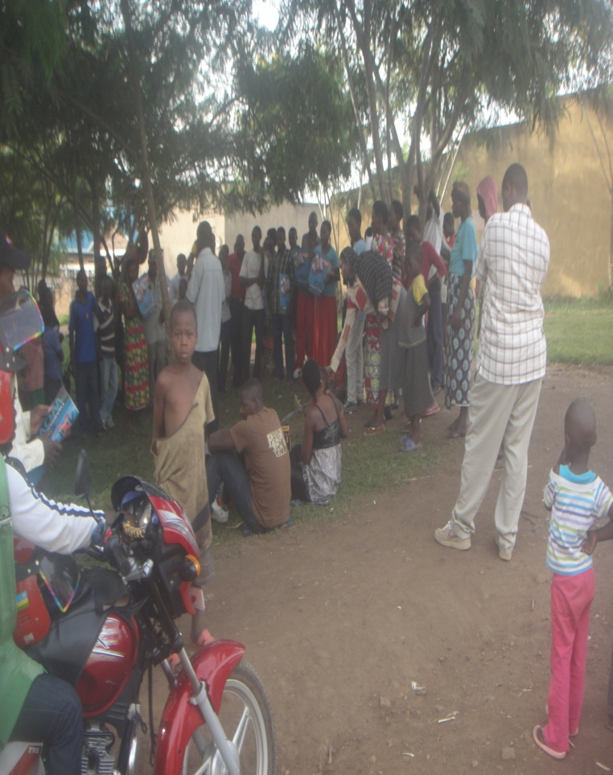
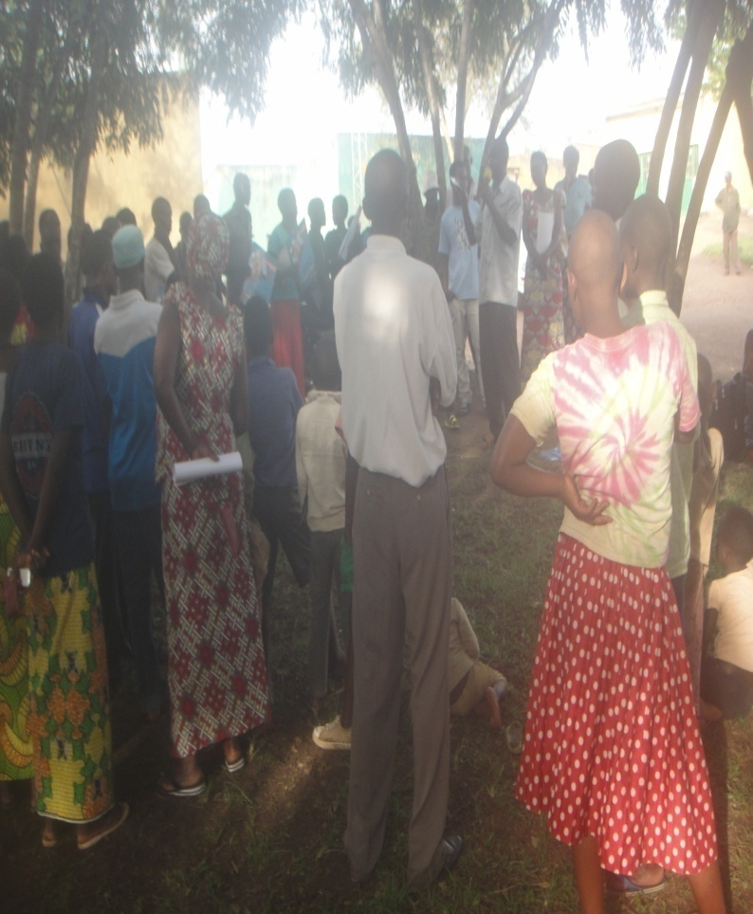

Population was so interested while Dialogue on HIV/AIDS and Condom use was done in Community

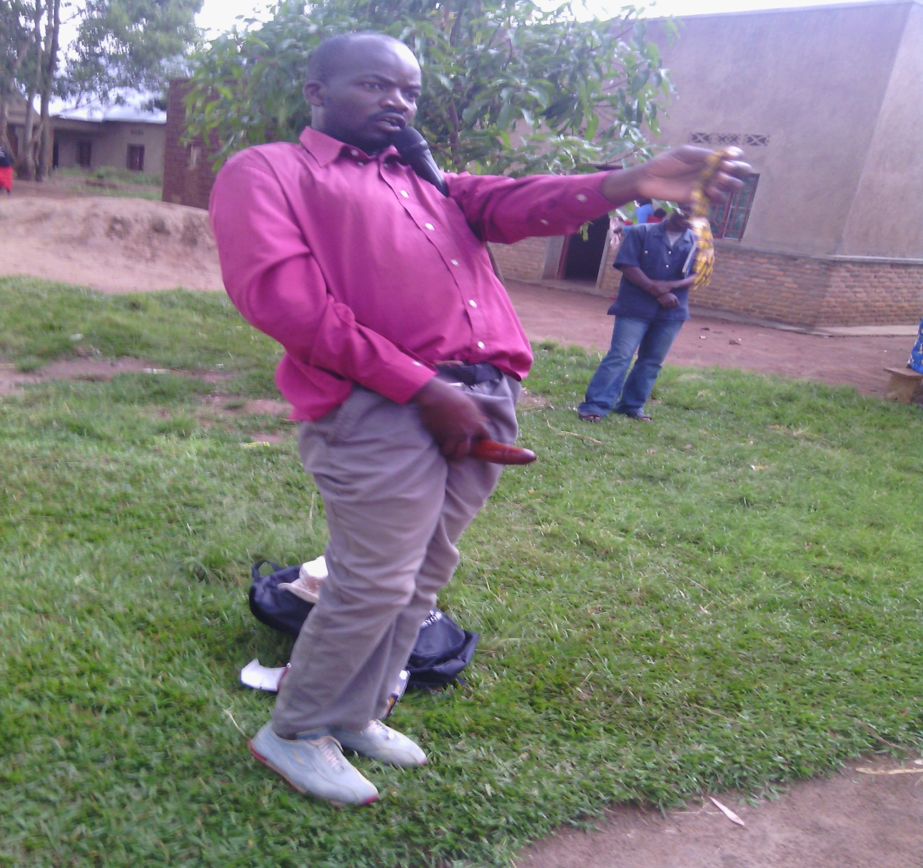

KIVIRI ALPHONSE is demonstrating how Condom is used

2.2. COMMUNITY DIALOGUE IN MIMURI SECTOR

Here was in MIMURI Sector where People was so interested

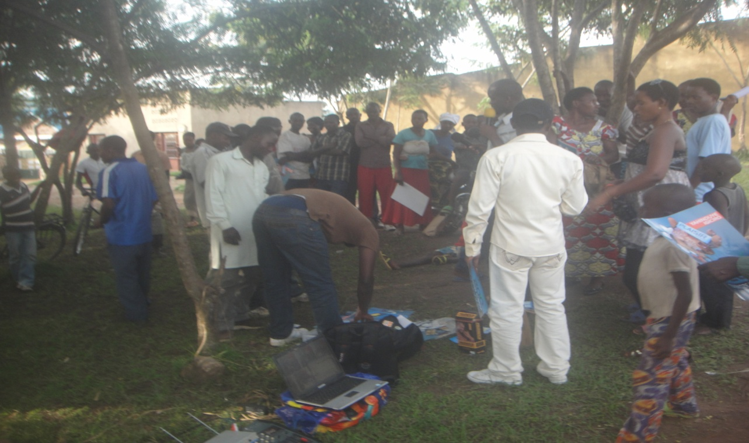

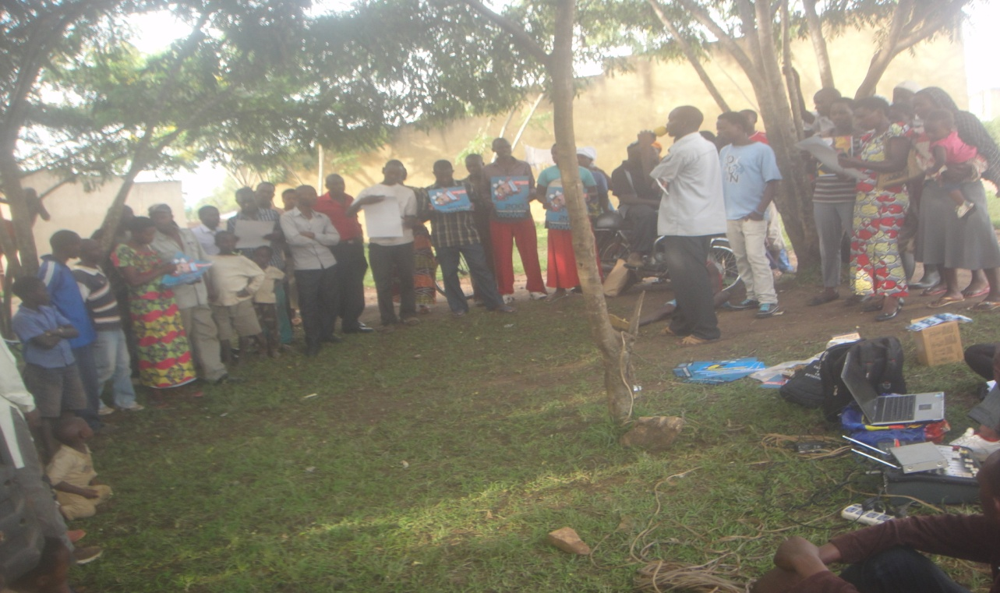

People asked many questions on Condom Use

2.3. CONDOM PROMOTION IN RUKOMO SECTOR
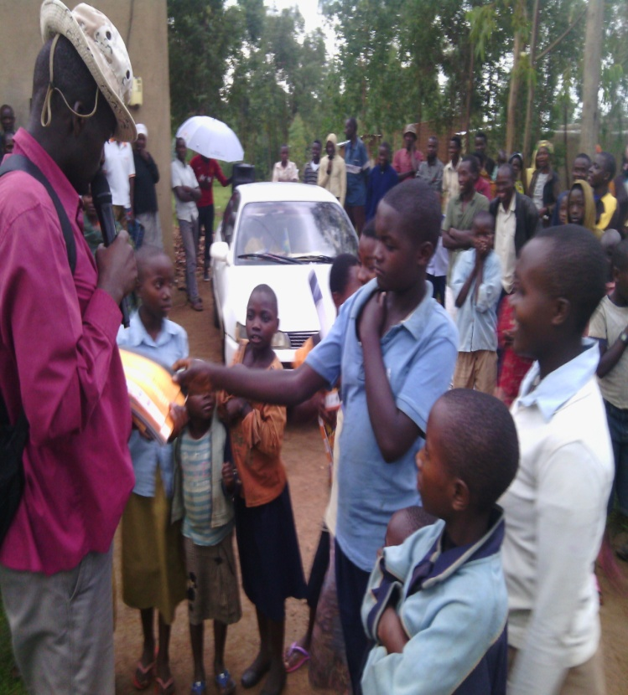
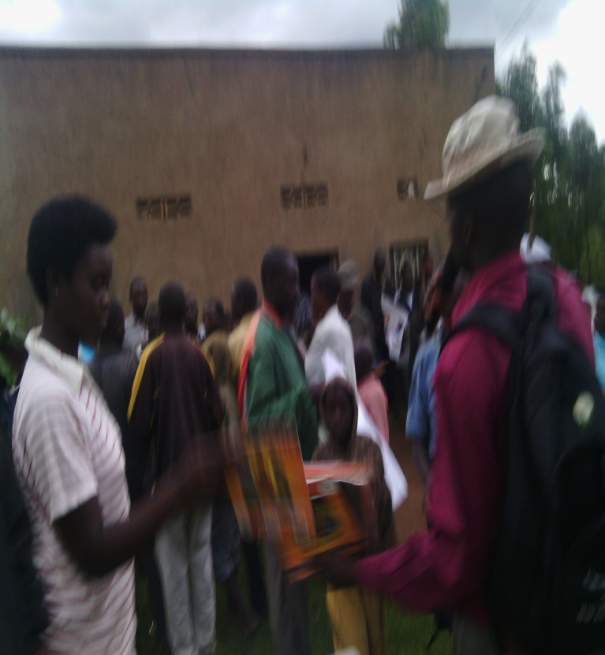

Youth wanted to get Condoms

3. POSITIVITY
In general, the population of NYAGATARE District were interested in the event and participated in greater number. In the launching of event, the population was ready for the event as a result of effort put in sensitization by SFH/Rwanda in Eastern region and local authorities to inform the initiative to be undertaken.
- The event was launched in a secured climate and there was a good collaborative environment between local authorities, ROCHED Team and SFH/Rwanda in Eastern region;
- Institutional agreement of the event was successfully approved by signing official documents;
- People showed the interactive spirit and willingness at deeper manner to understand the use of condoms;
- The youth at risk showed the willingness to adopt the use of condoms;
- The population raised the questions to know the current HIV prevention strategies and methods;

4. CHALLENGES

However, there is always a confrontation of challenges resulting from coordination strategies at institutional bodies responsible for facilitating the implementation of the initiative and in the livelihoods of population. Here is outlined some important challenges:
- Poor knowledge on condom use in the youth and on protective behaviors (prevention methods), especially in adult people after the marriage;
- Insufficient Promotional materials ;

5. RECOMMENDATIONS

Based on the challenges confronted during the promotional event on condom use, ROCHED gave recommendations:
- Strengthening coordination between implementing institution: SFH/Rwanda in Eastern region, District and Community Based Organization (ROCHED);
- Reviewing the initiatives aiming at stopping HIV spread among the youth: sensitizations, promotional events or campaigns;
- Monitoring and evaluation of the activities to measure the goals of the action plan of the activities or promotional events of condom use;
- Updating and organizing condom use rapid promotional events with a major objective of ceasing the spread of HIV infections;
- Massively distribution of take home materials on HIV/AIDS and increase the investment in promotion of condom.

6. GENERAL CONCLUSION

The Community Dialogue on Condom Use is one good of ways to teach or to mobilize any Population on HIV/AIDS and can be one of the effective tools that help cease the spread of HIV infections and combat HIV/AIDS in rural areas. The promotion of condom use is a key strategy to decease the transmission of HIV and the event undertaken in NYAGATARE District raised the awareness that the condom can be used a dual protection and helps demystifying the taboos around condom use.

Done at NYAGATARE, February 2014
Done by:
J. Pierre RUKEMA
Eastern Region Team Leader

Approved by:
Mercy KAMUKAMA
Health Programs Senior Manager

