****

P.O. BOX 5026 Bukedea-Kidongole Sub County

Tel: +256 782 596860 / +256 756 102303

Email: [ugandayouthtraining@gmail.com](mailto:ugandayouthtraining@gmail.com)

A critical mass of change leaders who have competencies to develop enterprising rural homes and the desire to empower other youth and women to develop prosperity, peace, freedom, health and happiness for all.

**ANNUAL REPORT 2016**

**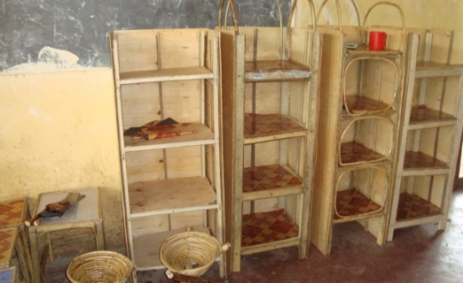** 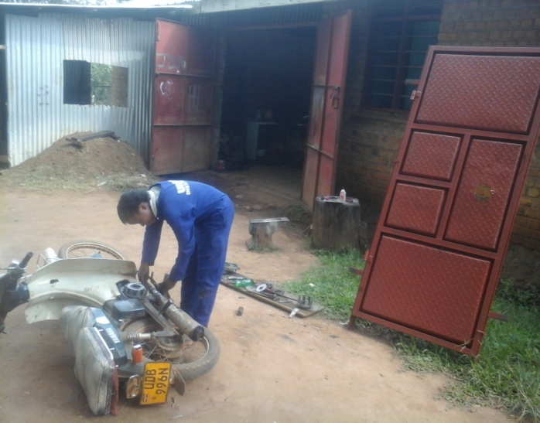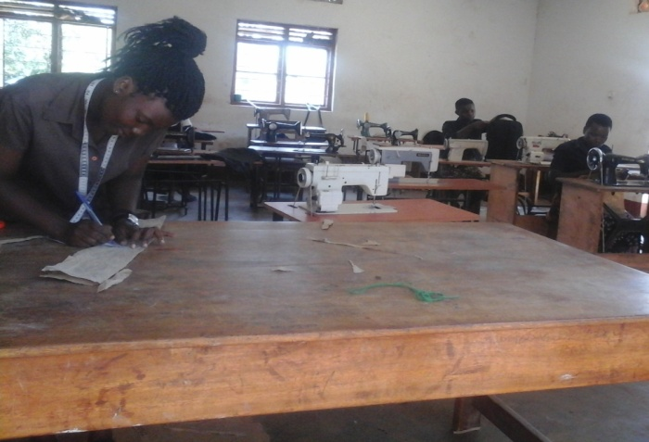

***Prepared by***

***Programme Administrator***

Table of Contents

[List of Acronyms 3](#_Toc494148597)

[INTRODUCTION 4](#_Toc494148598)

[1.1 Background of UYDT 4](#_Toc494148599)

[1.2 Vision 5](#_Toc494148600)

[1.3 Mission 5](#_Toc494148601)

[2 ACHIEVEMENTS 5](#_Toc494148602)

[2.1 HUMAN AND SOCIAL CAPITAL INCREASED 5](#_Toc494148603)

[2.1.1 Partnership and life skills strengthened 5](#_Toc494148604)

[2.1.2 Agribusiness knowledge and skills enhanced 6](#_Toc494148605)

[2.1.3 Competencies in fine arts and crafts improved 6](#_Toc494148606)

[2.1.4 Competencies in use of communication technologies improved 6](#_Toc494148607)

[2.1.5 SUSTAINABLE INCOME INCREASED. 7](#_Toc494148608)

[3 DEMOCRATIC PRACTICES AND GOOD GOVERNANCE INCREASED 7](#_Toc494148609)

[3.1 Participation in leadership positions 7](#_Toc494148610)

[3.2 Consciousness on the importance of girl child education and health increased 8](#_Toc494148611)

[4 conclusions and RECOMMENDATIONS 9](#_Toc494148612)

# 

# List of Acronyms

UYDT - Uganda Youth Development and Training Programme

UYDTI - Uganda Youth Development and Training institute

YSP - Youth Sustainable Skill and Empowerment Program

HIV - Human Immune-defiance Virus

AIDS - Acquired Immune Deficiency Syndrome

OVC - Orphan Vulnerable Children

CBV - Community Based Volunteer

CBO - Community Based Origination

# INTRODUCTION

UYDT programme aims at developing a pool of value driven, educated youth and women leaders who are committed to take up transformational roles. They learn to become socio-economic change makers in their homes and communities and get prepared for leadership in their communities. UYDT programme continued to implement its activities through-out the year of 2016.

The youth and women have enhanced their skills in: leadership, communication, agribusiness art and crafts besides vocational skills. At home level, there has been improved income, nutrition and team work. The youth have also influenced the communities through the youth venture programme, radio programs, Girls Education Movement outreaches among others.

We acknowledge the moral, technical and financial support from our students (youth and women), parents and local leaders and the community members that have enabled the programme to reach 226 students and their homes to create results achieved. Below the highlights of achievements in 2016;

This report highlights results at student, home and community levels. It also gives an update about how UYDT programme functions as a learning organization and partnerships. It has appendices with relevant photos, testimonies, list of staff and board members. We hope you will enjoy the report and give us feedback.

## Background of UYDT

Uganda Youth Development and Training Programme (UYDT) started in 2014 and is operating as a community based organization and is registered with the District local government. The program is working in Bukedea District and focusing on Business, media and Vocational training, agriculture, Agro-forestry, Health, Gender, Water and sanitation and small and micro enterprises for peace, health, happiness and freedom.

UYDT proprietors recognize that training and education are very crucial ingredients in sustainable development; as such, a vocational and business training Institute (UYDTI, was initiated as part of the long term strategy of the organization that is targeting youth creating job opportunities for their self reliance.

The UYDT was formed in response to the Youth unemployment that has become a major challenge in the 21st Century. Uganda is one of the countries highly affected by youth unemployment. It is estimated to be more than 83% among the youth (Source: Uganda Youth Forum).

While contending that the current economic growth in Uganda will not cope with the growing number of unemployed youth, alternative strategies needed to be developed before the situation gets out of control.

Interestingly only 1.5% of the unemployed youth have formal education beyond secondary school level and the remaining over 92% have no vocational or professional skills training and the majorities are found in the rural areas (ministry of Gender, Labour and Social Development, Youth Livelihood Programme document 2013).

Due to inadequate employment and livelihood opportunities in rural areas the tendency is that the youth migrate to urban centers to look for such opportunities. A strategy of rolling back rural –urban migration by investing in skills training would have a positive effect on the ability of the youth to become self reliant.

It is against this background that Uganda Youth development and Training programme sought for an opportunity fit in and to enable itself to train the youth in skills for sustainable development and self reliance**.**

## Vision

A centre for transformation excellence and development that integrates skills and knowledge to enhance sustainable development and self reliance among youth and women.

## Mission

To provide rural people with mental tools and practical skills needed to become productive members of their communities and fulfill their aspirations and become self reliant.

# ACHIEVEMENTS

## HUMAN AND SOCIAL CAPITAL INCREASED

### Partnership and life skills strengthened

In 2016, 250 students training in life skills and vocational studies (youth and women) where they gained skills in art and crafts, computer studies, hair dressing, metal works and metal fabrications etc.

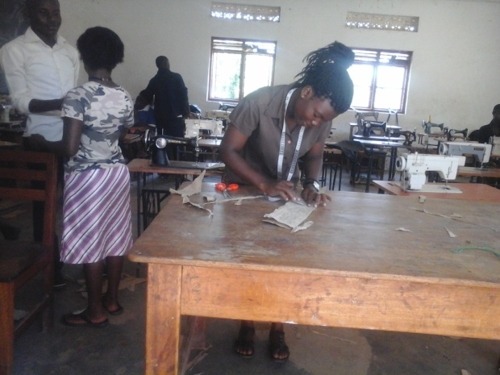 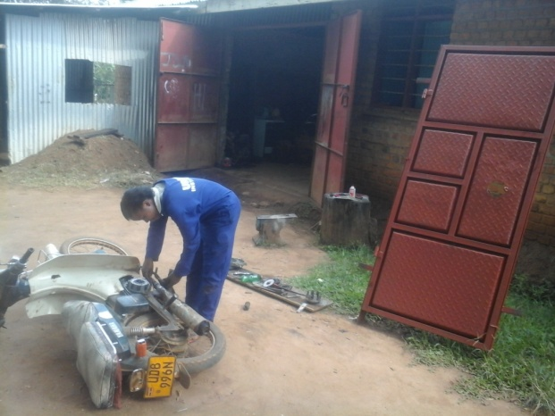

### Agribusiness knowledge and skills enhanced

At least 32% of the trainees have income generating activities and own business and 45% are employed by other business proprietors in the region.

### *D:\PHOTOS 2016\PHOTOS\FARM\DSC05206.JPG*Competencies in fine arts and crafts improved

|  |
| --- |
| D:\PHOTOS 2016\PHOTOS\FARM\DSC05200.JPG |

*students trained in art and crafts during the programme out reaches*

119 pupils and students trained and have competencies and skills in making bags, flowers, stools, trays, shelves and stools. These were made using threads, sacks, sheets of paper, food color, wood and carpets. All the products were bought by parents and other people around the locality. The monthly fine art and handcraft outreaches conducted in respective schools enabled the students make craft items in their homes using the locally available materials. Some items were for sale and others for home use to improve on health and sanitation.

### 

### Competencies in use of communication technologies improved

37 students in secondary section have computer skills in MS word, MS excel and power point. Students were trained in the named areas and introduced to internet through attending and participating in weekly information and communication technology lessons in the UYDT institute.

### SUSTAINABLE INCOME INCREASED.

#### Food and nutritional security

A healthy mind and body is very productive and therefore health is one of the key areas of attention in a transforming people’s lives. Focus has been put on hygiene, sanitation and good nutrition. The families are sensitised to have adequate sanitary facilities like a permanent house, kitchen, drying rack, animal house, clean & safe water, clean compound, two rubbish pits for plastics and another one for degradable materials and store food in granaries. In order to have good nutrition the families are empowered to have a balanced diet with qualitative & quantitative food and be in position to have breakfast, lunch and supper. They are also encouraged to put in place kitchen garden to supplement on the food staffs. The training was done by the UYDT demonstration farm where students and farmers around come to learn and replicated the good agronomic practices their homes for better and improved health

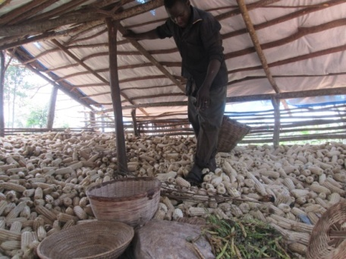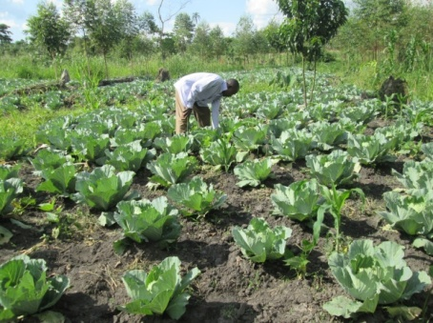

***Cabbages in UYDT Demo farm***  ***maize in one of the farmer’s granary***

# DEMOCRATIC PRACTICES AND GOOD GOVERNANCE INCREASED

### 3.1 Participation in leadership and peace workshop

The students participated freely in the student’s guild elections by democratically electing their leaders. Student leaders played different roles in organizing their fellow students and ensuring that all institutional programmes are implemented and other routine work done. Other students also endeavored to take up situational leadership when need arose and participated in the peace building and conflict resolution workshop that targeted 60 youth in the region. Similarly, the parents played their leadership roles under group formation in different communities as per sub-county/zone.

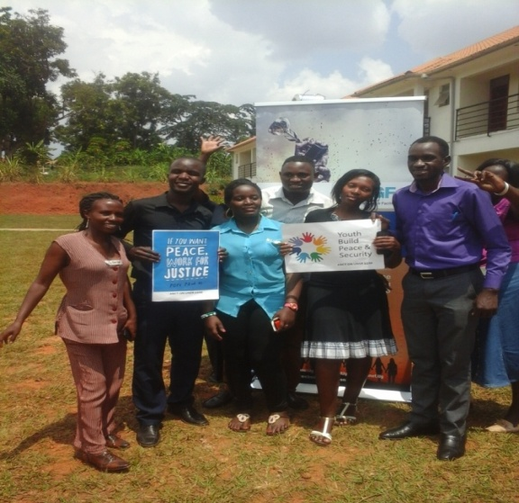 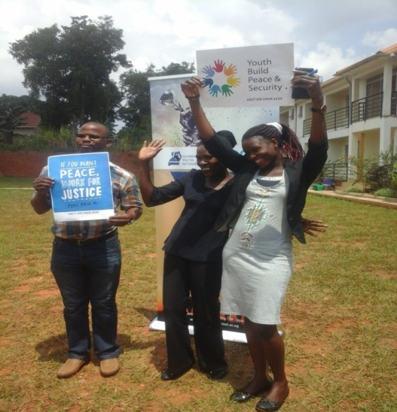

***Youth who attended a workshop on peace building In the middle is the founder of UYDT***

### 

### 3.2 Consciousness on the importance of life , vocational skill education and health increased

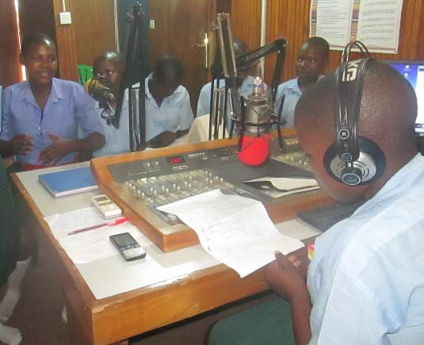The institution organized 22 radio programs through partnership with a community radio station to educate the rural listeners on a broad range of topics tailored on youth and women empowerment and girl child education. The listeners who called in appreciated the importance of life skill and vocational training and also the relationship between Health and home development, how to prevent HIV and AIDS. Also as a result, the participating students developed confidence and ability to generate ideas and related actions concerning the different topics to over 1.5 million listeners.. Also it enabled students and listeners to gain knowledge and skills on how to identify and handle different forms of sickness especially where there is no doctor.

### 

***Students of different schools sensitize the communities on radio on girl child education***

The achievements sofar realized reveals that there is a shift in the mind set change among the youth and women especially to recognize that they are the key to their own development and the choices they make can either build or brake their lives. Many youth and women now are for focused to the future than before.

# conclusions and RECOMMENDATIONS

The year 2016 has been productive as the institution achieved more than 50% of the planned results. The students performed well in all training and good progress has been registered in their practical work. They gained more confidence and ably express their views and can articulate the kind of life they want to lead after the training.

URDT programme appreciates all individual friends and partners who have contributed towards the results achieved in the year 2016 and special thanks go to the founder members who have always put resources to ensure the implementation of different activities.

However 2016 was a challenging year because of increase in prices of goods due to inflation which increased the expenditure yet funds are very scarce.

The management requests URDT proprietors to seek support for the following:

* Construction of classes to create more space for learning
* The programme also has a vision for constructing a center whole for workshops to enable it accommodate numbers and also rent it out to generate income for the sustainability of the programme activities.
* There are plans to increase its own sources to generate income from, vegetables and fruits which farm enterprises double as training ground for students, parents and farmers to boost farming in the region.
* The institution plans to upgrade the ICT lab with more computers to have a capacity of thirty students, a lap top for the trainer. More financial support is also needed in this department for more computers to enable students have adequate practice.

URDT programme looks forward to a productive 2017 and invite our partners to continue supporting us to achieve our goals

# Pictorial documentation.

|  |  |
| --- | --- |
| C:\Users\acer\AppData\Local\Microsoft\Windows\Temporary Internet Files\Content.Word\20170812_133644.jpg  **The youth who attended the workshop on peace building and conflict resolution** | C:\Users\acer\AppData\Local\Microsoft\Windows\Temporary Internet Files\Content.Word\20170812_133800.jpg |
| C:\Users\acer\AppData\Local\Microsoft\Windows\Temporary Internet Files\Content.Word\20170812_133812.jpg  **In the middle, the founder of UYDT pose for a photo during the workshop on peace building and conflict resolution that targeted 60 youth** | C:\Users\acer\AppData\Local\Microsoft\Windows\Temporary Internet Files\Content.Word\20170819_124209.jpg  **The staff of UYDT conducting a focused group discussion with the community on peace and conflict resolution.** |
| C:\Users\acer\AppData\Local\Microsoft\Windows\Temporary Internet Files\Content.Word\20170819_130939.jpg  **The staff administer a questionnaire (one on one) to collect data on the young people’s understanding on peace building so as to form a bench mark for the trainings** | C:\Users\acer\AppData\Local\Microsoft\Windows\Temporary Internet Files\Content.Word\20170818_144924.jpg  **The staff of UYDT conduct a land conflict resolution meeting with the community with the invited technical staff of the district** |
| D:\uydt docs edited\tfsr\20170919_140631.jpg  *Students practicing during the tailoring sessions* | C:\Users\acer\AppData\Local\Microsoft\Windows\Temporary Internet Files\Content.Word\LA17 2353.jpg  *Youth participate in the peacebuilding and conflict resolution workshop (60 youth)* |
| D:\uydt docs edited\tfsr\20170919_155958.jpg  *A female student learning motrtor mechanical work* | C:\Users\Head Teacher\Desktop\photo\DCIM\102MSDCF\DSC06267.JPGStudents attend computer lessons |

APPENDIX 2: LIST OF STAFF AND BOARD MEMBERS

LIST OF BOARD MEMBERS

|  |  |
| --- | --- |
| Name | Designation |
| Odere Emmanuel | Chairman |
| Anyait Joseline Vivian | Treasurer |
| Agwang Martha | Secretary |
| Angeki Simon Peter | Member |
| Amoding Harriet | Member |
| Adeke Anna Gorret | Member |

**List of staff members**

|  |  |
| --- | --- |
| **Name of staff member** | **Job Title** |
| Agwang Catherine Martha | Executive Director |
| Amoding Harriet | Programme Coordinator |
| Angeki Simon | Field officer |
| Asimo Debora | Trainer |
| Okello Emma | Trainer |
| Okalang Samuel | Trainer |
| Akwii Lucky Eunice | Trainer |
| Opio Enock | Trainer |
| Apolot Sarah | Support staff |