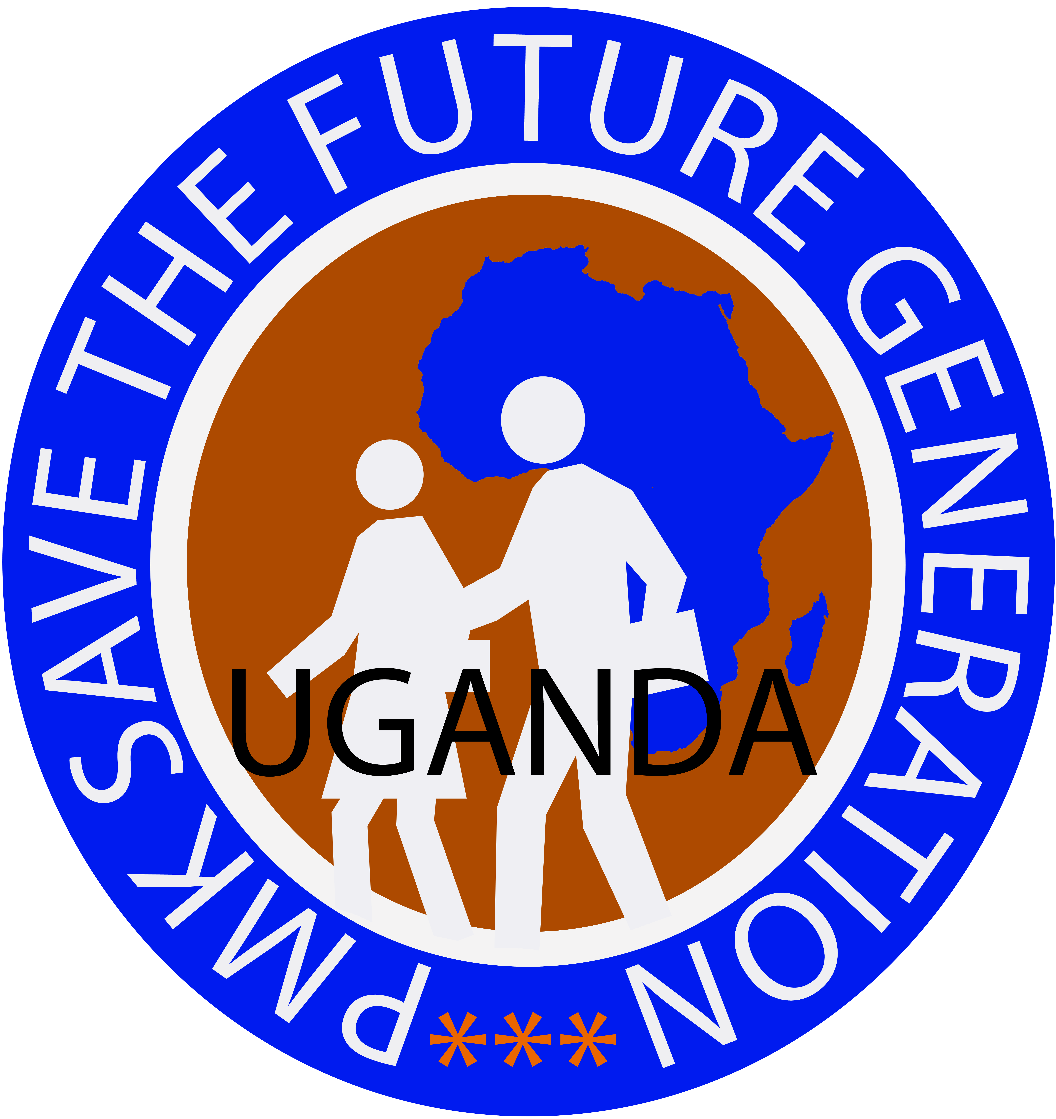
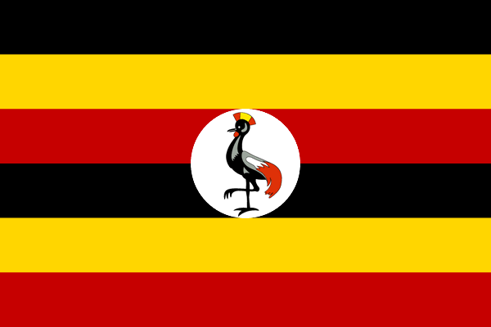
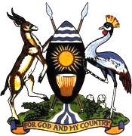
PMKSFG UGANDA
TOGETHER WE CAN CHANGE THE FUTURE
P.O.Box: 34514 Kampala (UG) C/o KICVOP UGANDA. www.saveug.org E-mail: info@saveug.org
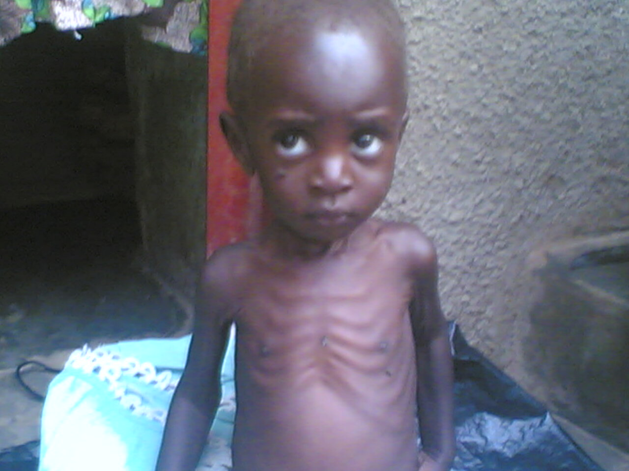
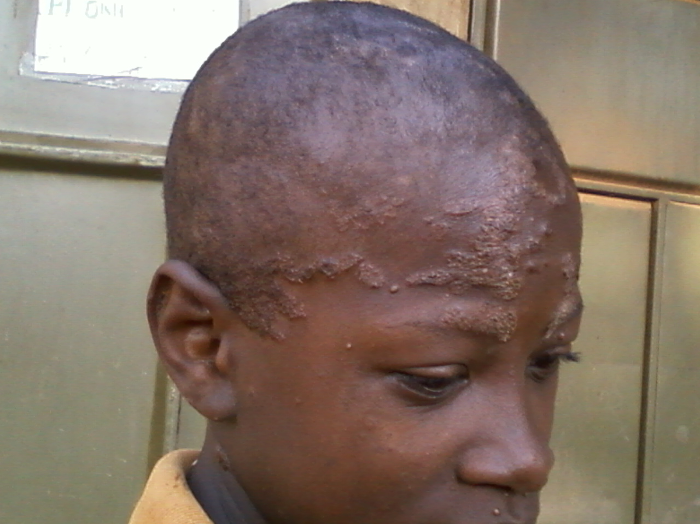

Ssenfuma Isa 12 Years he is HIV positive Ssentongo Ismail 5 Years, was abandoned by parents

PMK SAVE THE FUTURE GENERATION UGANDA

TOGETHER WE CAN CHANGE THE FUTURE

PMK SAVE THE FUTURE GENERATION UGANDA
(PMKSFG UGANDA)
PROFILE

FOR THE YEAR

2010-2014

______________________

LUCKY LUGGYA PETER
Program Director
Mob: +256 (0) 701 939282
E-mail: info@saveug.org
: peter@saveug.org
Web : www.saveug.org
BACK GROUND:
PMK Save the Future Generation Uganda (SAVE UGANDA) is a registered (WCBO/859/10) community based organization that provides physical and psychosocial support to marginalized and at-risk Orphans and Vulnerable Children, women, youth and the elderly living in the Wakiso district. The organization seeks to empower these groups of people through economic development, which it achieves through education programs, vocational training, and the provision of health care. SAVE UGANDA also campaigns for HIV/AIDS, Poverty and human rights awareness and provides direct support to children who have been orphaned as a result of the Poverty, HIV/AIDS and Violence.
We have a belief that everybody is a unique individual and that we all have a right to good health and basic needs and should access means to a comfortable life in one way or another.
LOCATION:
The organization is located in Kazo Central Zone Nabweru Sub-county Nansana Town Council Wakiso district Uganda-East Africa 1Mile off Bombo Road just near Kazo Parents School.
AREAS OF OPERATION:
Our area of operation is generally Wakiso district at large, though we operate in Kazo Ward only as of current due to less or/and limited resources to the organization. Kazo Ward was selected fit for the operations of the organization because it is one of the largest wards in Wakiso and it is densely populated estimated to have over 150,000 people but having the weakest points in the fields that we do operate in compared to other wards and centers.
CORE VALUES:
- God fearing
- Transparency
- Team work
- Heard work
- Empowerment
ORGANIZATION DETAILS:
MISSION:
To have an empowered and sensitized community that reacts positively to the prevention of HIV/AIDS, take action to the needs of Orphans, Vulnerable children (OVCs) and to have a violent free community.
MOTTO:
“Together we can Change the Future”

OBJECTIVES:
- To sensitize and raise awareness of HIV/AIDS to communities.
- To assist the HIV positive orphans and disadvantaged/vulnerable children academically.
- To improve on people’s stands of living through promoting income generating activities/projects for the communities.
- To provide variable treatment option to the HIV positive people in communities.
- To network with other organizations and institutions with similar objectives and in the same line of action.
- To lobby for the formulation and implementation of projects that aims at helping all needy groups of people in the country.
- To safeguard HIV/AIDS affected and infected children and families against stigma and discrimination.
- To establish income generating activities for the health and wealth of the organization.
- To provide HIV/AIDS peer groups, counseling and sensitization to the affected and infected persons and families.
ACTIVITES:
- Conducting baseline survey and needs assessment.
- Conduct sensitization and awareness programmes on HIV/AIDS.
- Networking with other related organizations.
- Community mobilization.
- Conducting meetings and organizational self assessment for proper evaluation.
- Distribution of Condoms.
- Providing material support to the OVCS.
- Promoting music, dance, and drama in the children and youths.
- Supporting the HIV positive OVCS’ quality education.
- Comforting and counseling the HIV/AIDS affected and infected children and families.
- Home visits
FUTURE PLANS:
- Turning PMK Save the Future Generation Uganda into an international organization.
- Joining and partnering with different organization with the same vision, mission, goal and objectives in Uganda, East Africa, and the entire world.
- Building up health centers in different parts of Uganda for proper provision of testing, treatment and Medicare to children and other people who may need it.
- Building schools and vocational institutions for the orphans, vulnerable and street children.
- Establishing orphanage home for the provision of shelter to the orphans, vulnerable, helpless, homeless and street children.
- Starting up other development projects like bakery, tailoring project, catering services, computer training, cattle, goals and poultry farms.
- Introducing other offices to several parts of the country; districts, divisions, town councils and sub-counties which will be co-ordinating with the main office.
- Promoting music, dance, drama and culture among the children and youths.
- Owning a land for the construction of organization headquarters, other structures and for the farm.
- Establishing adult education programme in every district of Uganda.
ACIEVEMENTS:
- Drafting and printing the organization constitution.
- Registering the organization to the district.
- Introducing our organization to local leaders e.g.; Chairman LC.1 Kazo Central Zone and others.
- Building strong relationships with other organizations, individuals and ministries of Uganda and outside Uganda.
NOTE: Organizations, ministries and institutions that have confirmed their partnership with PMK Save the Future generation Uganda include;
- Endtime Youth Empowerment; In the United States of America.
- Healing Hands World Mission Church; In the United States of America.
- Nurture Africa
- Kiyita Family Alliance for Development; In the Republic of Uganda.
- PMK Film Production International; In the Republic of Uganda.
- Uganda Pioneers’ Association; In the Republic of Uganda
- Mengo Youth Development Link; In the Republic of Uganda
Networks were we are members;
- Nansana Civil Society Network (In this network we are the publicity)
- Uganda Adult Education Network
Together we can change the future through;
  - Better planning.
  - Learning from each other.
  - Improving resource mobilization.
  - Improving the standards of living of OVCS and people living with HIV/AIDS.
  - Achieving more.
OUR APPEAL:
This is our appeal to the local and international communities to support PMKSFG UGANDA.
You can support through the following ways;
- Financially, technically, or materially to any of our projects/activities.
- Visit and work with us on any of the projects/activities.
- Networking and information sharing.
- Giving donations and grants.
- Capacity building of our teams respectively.

