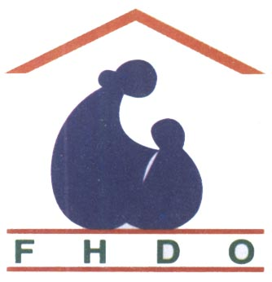
``Healthy Mother, Healthy Child. Happy Family, Prosperous Country ’’
Family Health Development Organization (FHDO)
B. A. College Road. Sirajgonj
Bangladesh

Shohagi’s pregnancy was developed

Shohagi Rani Aged about 24 years is an illiterate inhabitant of village Hat-Pangashi under Royganj sub district on Bangladesh. Her first pregnancy ended in tragedy .She saw her new born child die in child birth. She became pregnant again .The difficult labor ended with still birth.

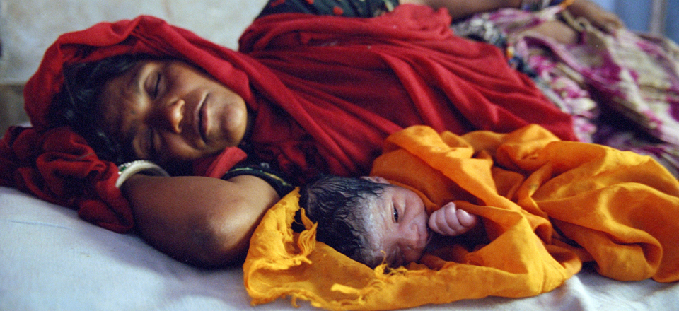
Shohagi & her Child

Shohagi Rani was recruited by the health care provider of FHDO. Who correctly identified the problems. She was treated with Folic Acid. Vitamin E&C plus, Calcium etc. She conceived and her pregnancy developed with due care. She was given awareness therapy to take balanced diet, proper nutrition, take rest and live in a hygienic environment. Her Body Mass Index (BMI) was monitored regularly. She was immunized. She was delivered under Safe Vaginal Delivery (SVD) method at Kohinoor Nursing Home on March 30/2012 by a Skilled Birth Attendant. She gave birth to a full term male child having weight 3.1 k.g with APGAR score 10. She was given post natal care the mother was given Antibiotic coverage the child was given k-1 oral injection and was taken under exclusive breast feeding. Shohagi now smiles as she is happy with her new family.

Phone : +88075162638 E-mail : fhdo_2bd@yahoo.com Web : www.fhdo.webs.com

``Healthy Mother, Healthy Child. Happy Family, Prosperous Country ’’
Family Health Development Organization (FHDO)
B. A. College Road. Sirajgonj
Bangladesh

Rekha’s was survived by curing pregnancy tuberculosis

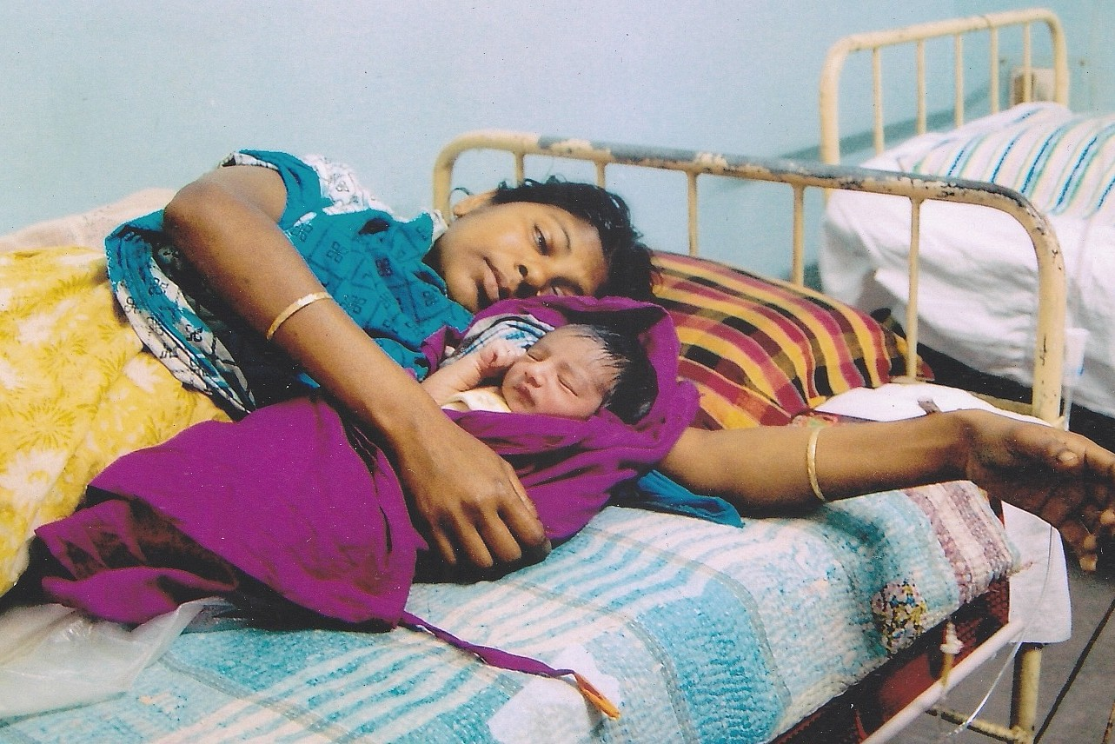
Rekha Khatoon & her preterm
with low weight child

Rekha Khatoon aged about 21 years of village Narinda under Sirajganj sub district was brought by FHDO’s village health provider Latifa Khatoon to FHDO’s affiliated facility Kohinoor Nursing Home in a critical condition at about 12 pm on February 29 /2012 She was admitted in emergency ward. Her pulse bit could not be counted. She was swatting. The physician on duty rushed her to labor room. Per vaginal (PV) examination revealed that she was a patient of placenta retained accompanied with profuse bleeding. She was anemic. The retained placenta was remove. It was gathered that she gave birth to a female preterm with low weight child at home where an untrained birth attendant attended. The physician suspected that Rekha has been suffering from pregnancy tuberculosis. She and her baby ware referred to T.B clinic. Examinations confirmed her pregnancy tuberculosis and she was given low cost Medicare Her child was also examined. FHDO and its affiliated facility Kohonoor Nursing Home delivered the service to Rekha Khatoon. She is living a happy life.

Phone : +88075162638 E-mail : fhdo_2bd@yahoo.com Web : www.fhdo.webs.com

``Healthy Mother, Healthy Child. Happy Family, Prosperous Country ’’
Family Health Development Organization (FHDO)
B. A. College Road. Sirajgonj
Bangladesh

Mina’s infertility was developed and she gave birth to a preterm baby
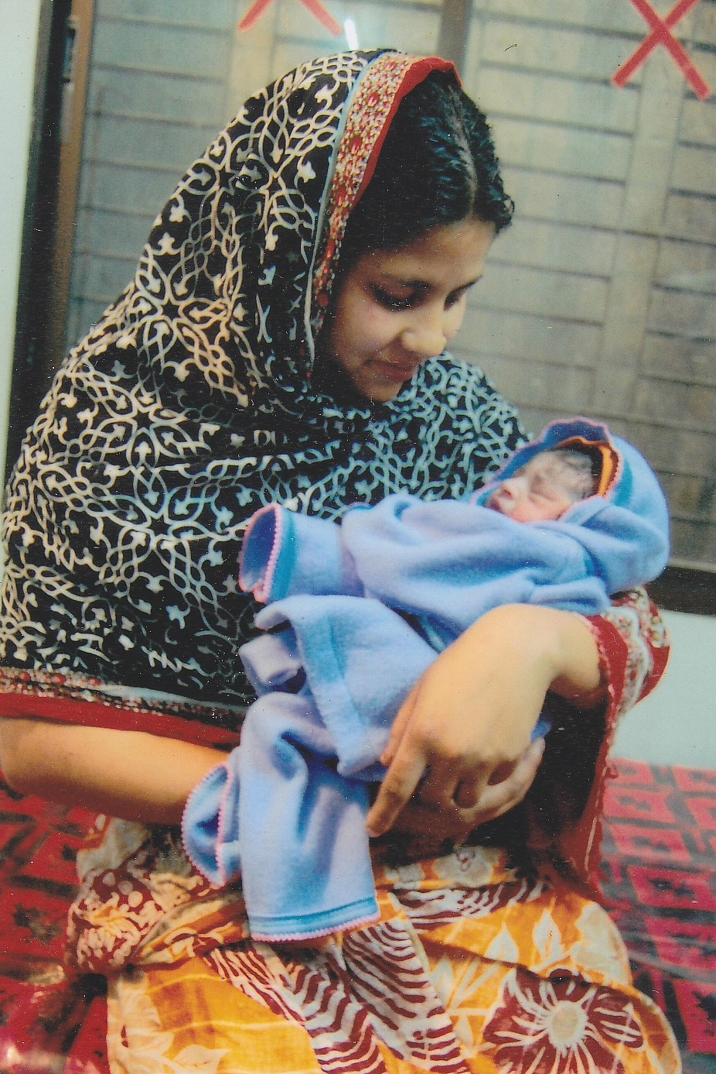
Mina & Her Preterm Baby

Mina (28) of Dhanbandi sub-urban moholla of Sirajganj town by FHDO field workers. She got married six years ago but could not become mother. Investigation revealed that she was infertile. She was treated by a Gyne & Obs expert physician. She conceived her pregnancy was taken under exclusive observation. Unfortunately at 30 week’s gestation, her membrane was ruptured. She was delivered under Safe Vaginal Delivery (SVD) method on May 18/2011. And she gave birth to a male child. Having (-) 2 kg weight. The baby was a low birth pre term baby. Immediately dryness care was taken. The baby was warmed by following skin-to-skin care (Kangaroo Care method) and was kept in a room raising temperature by high power electric bulb for one month. The child was kept in the observation of a pediatric physician. The baby was fed breast feeding by tube system. Mina is much happy as she became mother.

Phone : +88075162638 E-mail : fhdo_2bd@yahoo.com Web : www.fhdo.webs.com

