Kilele Junior School – Two examples of impact of its efforts..

Katrina Alek is 8 years old

She was born in Southern Sudan. When Katrina was very little, her parents died in war. She was brought to Kenya to live with refugee relatives but they too could not afford taking her to school. Feeding was a challenge. We enrolled her in school and in our feeding program. Katrina came to Kilele when she was 4 years old to start Baby class. Now the girl is in 2nd class. Her education and food has been sponsored by an online sponsor, courtesy of Nabuur online network organization. “I have friends who don’t go to school. They just stay at home. I like school. My favourite subject is English. I want to go to University and become a nurse. I want to help people”.

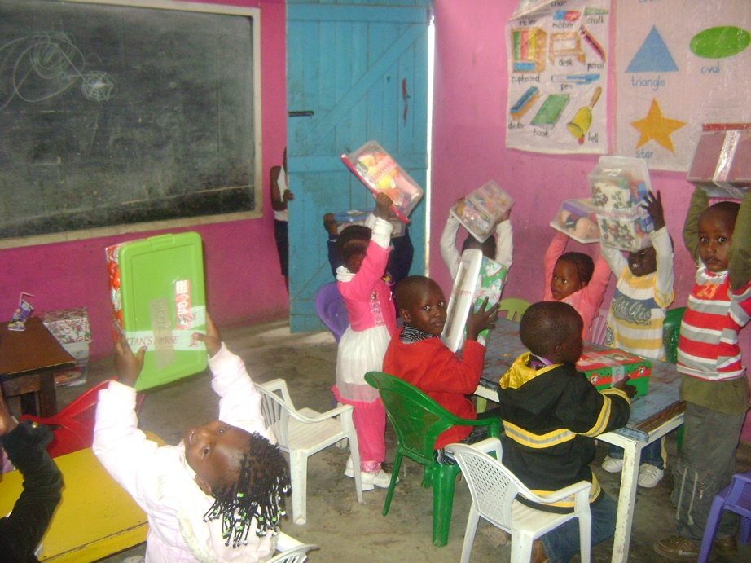
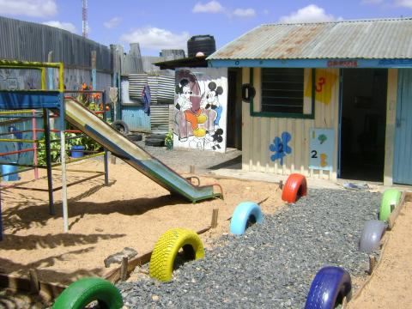
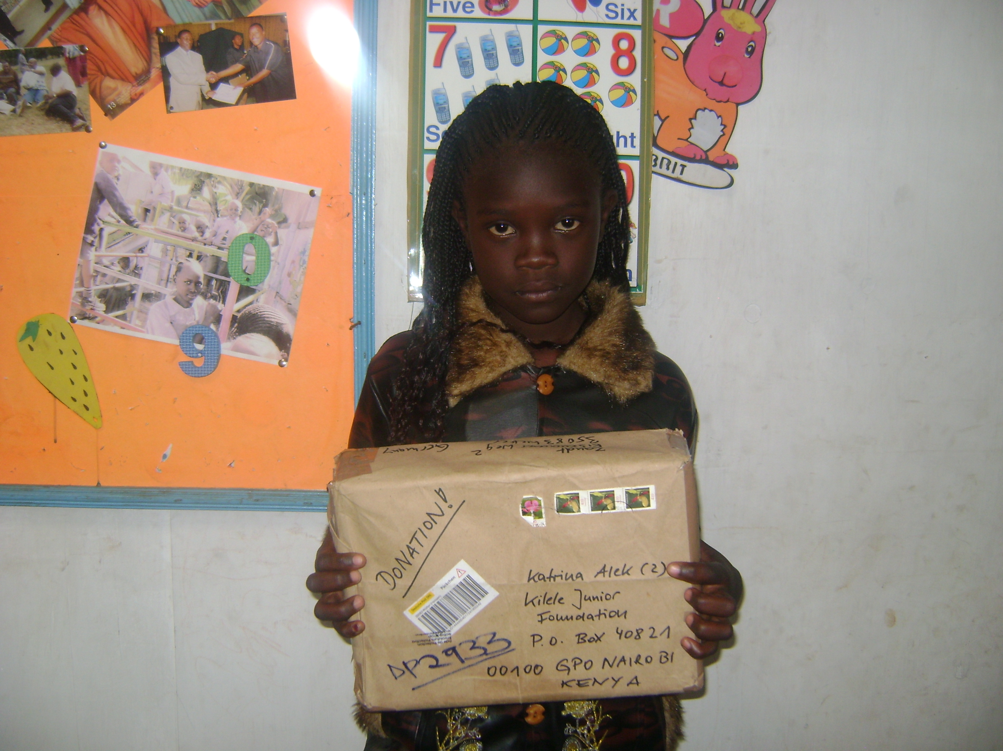

Prescilla Apajok Dout is 9 years old
Prescilla is Sudanese, she comes from Kakuma, a refugee camp on the North of Kenya. When she was 5 years old, Prescilla came to Nairobi to stay with her aunt and cousins. When she was 7, she joined Kilele Junior School, but because her family could not afford paying any school fees, she had to stop studying for almost a year. Kilele then took care of the situation and provided education and food to the girl. Now Prescilla is in the 3rd class. “I like school because I like to learn. My favourite subject is Math. I want to finish secondary school and University. And after University I want to become a lawyer because I want to help my family with money.”
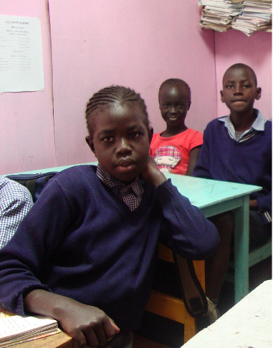

We continue to endeavour nurturing the young minds aimed at realization of their dreams as our mission for inter – generational equity.

Best Wishes
from
Kilele School Management, its Mentors & Volunteers

