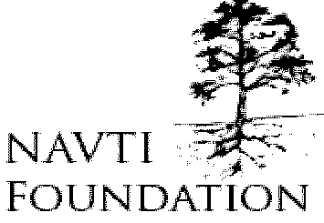 WE BUILD OUR COMMUNITIES OURSELVES
OUR REF: 23/2010/Rec-12 DATE: 15 October 20109

To: Global Hand
Hong Kong

Sir/Madam,
Letter of Reference in Favour of Social Development International (SDI)
I am writing this reference letter for SDI and Mr. Sulaiman Turay its Director. I have know Sulaiman Turay for the past 13 years in the University of Buea-Cameroon, in AIESEC Cameroon national executive team and in Cameroon NGO networks as a trust worthy and reliable partner. We believe SDI and its Director lives development, by mere reason of contributing to the society and making the world realize the importance of world peace, security, and sustainable development.

We have the opportunity to get to know SDI and its Director by constant sharing and communication between our communities, exchanging ideas through relevant discussions, and seeing the efforts that SDI team puts to partnership in its activities.
SDI has demonstrated and communicated principles of leadership, client focus, looking forward, cooperation, capacity building and accountability in its role and functions as an agent of change for the underprivileged and their communities with little or no discrimination.

As a current Global hand member, we strongly recommend SDI and Mr. Sulaiman TURAY for Global Hand Networking and partnership.

Sincerely yours

SHUDZEKA Jean Louis
PRESIDENT, NAVTI Foundation NGO, Cameroon
Email: president@navtifoundation.org

NAVTI Foundation (NGO) Cameroon, Canada and Hong Kong
Address: HEAD OFFICE: LYUNGA STREET TOBIN P.O.B 151 KUMBO, N.W.PROVINCE, CAMEROON AFRICA
Tel: (237) 3348 15 90, 7764 16 47, 7791 3792 Email: info@navtifoundation.org www.navtifoundation.org

