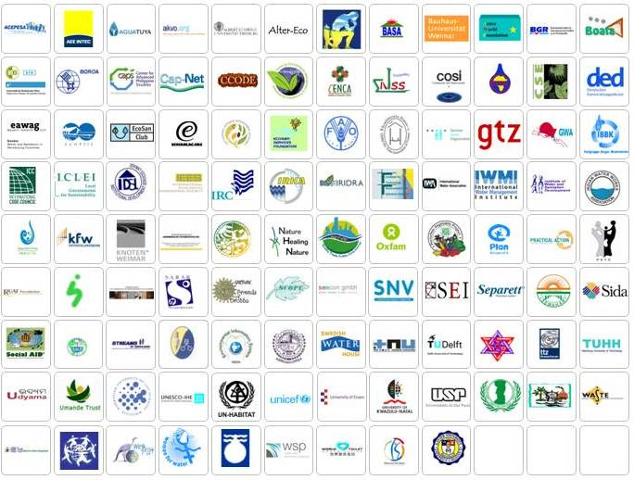
Partners all together http://www.susana.org/lang-en/partners/all-together

