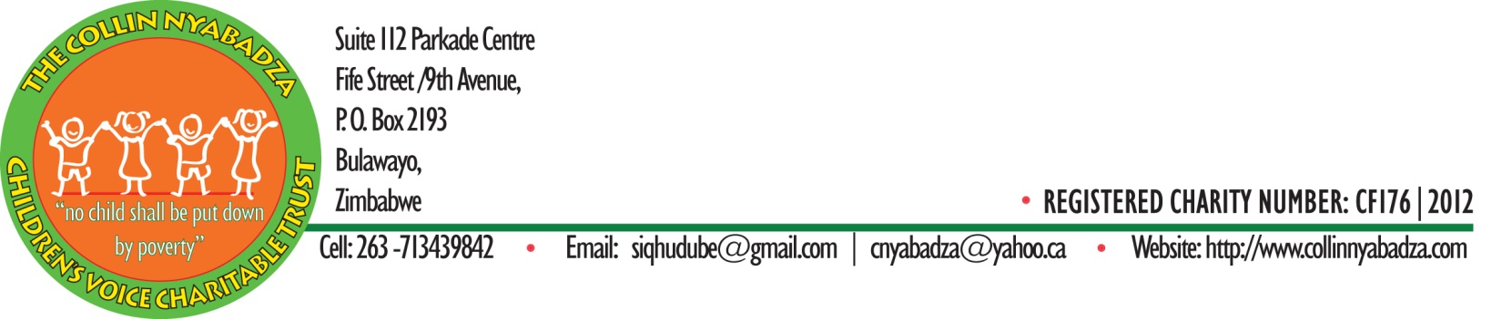
Our Board
Mr. Siqhubumthetho Dube – Chairman- Diploma In Education, United College of Education (UCE), Bachelor of Education, Administration, Planning and Policy Studies, University of Zimbabwe.
- A strong educational leader who never gives up where children are concerned. Has taught for over 15 years at both primary and secondary schools. At primary school he has taught all grades. He also served as headmaster in several dilapidated rural schools in Lupane but later turned them into an oasis. He has sourced a lot of funds to develop those schools and has a lot of knowledge in donor work.
Mr. Malaki Ndlovu- Donor Relations- Certificate in Education and Diploma In Special Needs Education, UCE, Bachelor of Education Honours, Administration, Planning and Policy Studies, University of Zimbabwe.
- just like the chairman, he has a vast knowledge of donor operations. Has been headmaster of several dilapidated rural schools which he turned them into polished diamonds. Currently heading a poor rural school. He is a man who has dedicated his entire professional life fighting for children’s rights to an education.
Mr. Sipho Ncube- Certificate In Education, Gwanda Teachers’ College, Bed, Educational Admin, Planning and Policy Studies, University of Zimbabwe.
- currently heading a poor rural school in Tsholostho District where his work in developing his school has inspired other school heads in the vicinity to follow suit. He has developed every school that he has headed. Lots of experience in donor relations and school administration.
Ms. S. Sibanda- Board Secretary, Bachelor of Water and Civil Engineering, National University of Science and Technology. A very intelligent young woman whom we want to develop and mentor into a fine leader. A former student of Mr. Nyabadza, our founder. Got an education through a scholarship sourced for her by Mr. C. Nyabadza. She therefore wishes to give back to the community by donating her time to this organisation. Currently she is paying for the education of a brilliant orphaned girl as a way of giving back.
Mr. Ronald Ncube- Bachelor of Engineering, National University of Science and Technology. Another of Mr. Nyabadza’s products. A very intelligent young man whom we are also developing and mentoring into a fine future community leader. Wants to give back something to his community by donating his time into this organisation.
Mr. Collin Nyabadza- Executive Director and Founder, Diploma In Education, Diploma In Special Needs Education, United College of Education, Bachelor of Community Studies (currently pursuing).
-a man who has been working with disadvantaged children for the past twenty years. Ten years of that were directly in the classroom. A man who is fearless in tackling child abuse, poverty and in protecting their rights. Has sourced scholarships for over 300 brilliant but needy children to enable them go to high school. Has also sourced funds to build classrooms and teachers cottages, to buy school furniture, drill boreholes, buy sports equipment, etc. Has vast experience in donor relations, advocacy, administration, counselling, resource mobilization, team building, teaching, community work, etc.
Mr. Exson N. Nyathi- Advisor to the Board, Diploma In Education, United College of Education.
- a retired school head. A man with lots of experience in developing dilapidated schools. He is a natural leader who respects his subordinates but gets the job done. A very honest, principled and transparent man who fears public funds. He is a visionary man who believes in working hard.

