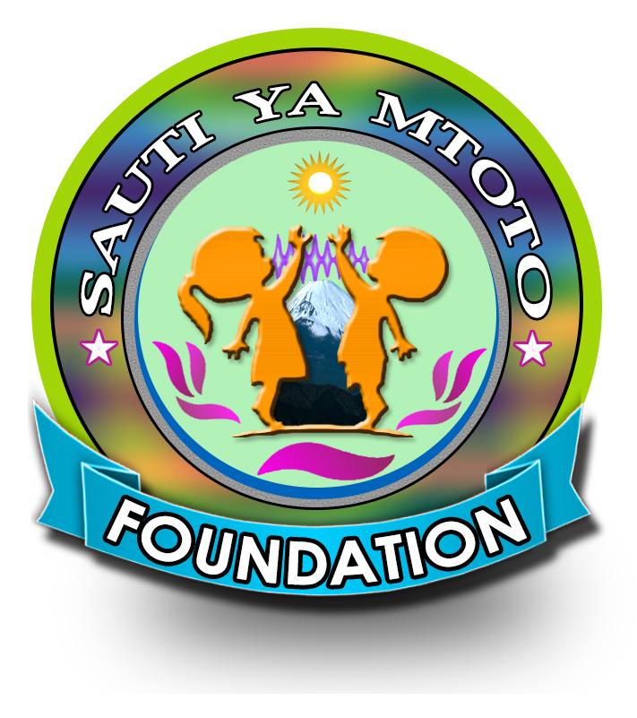
Who We Are ?
Sauti ya Mtoto Foundation(SMF) is a non -profit organization which was founded in 2017.It become legally registered under the Non-governmental organization Act,2002 of the Laws of Tanzania in the Ministry of Community, Development, Gender and Children in 2018 with registration number No.0009450.Sauti ya Mtoto is a Swahili word which means ``Child Voice.’ Sauti ya Foundation (SMF) operates both grassroots and national level specific Tanzania Mainland. Currently it has its head office located in Dar es salaam.
Thematic Areas
Sauti ya Mtoto Foundation(SMF) works on eight thematic areas :
- Awareness creation,
- Advocacy,
- Cross cutting issues,
- Environmental conservation and natural resources management,
- Education and Illiteracy,
- Cleaning and safe domestic water ,
- Capacity building, grants and technical expertise.

Vision and Mission
Vision
To have a community where children welfare is priority in development endeavors.
Mission
To promote and enhance children welfare through community awareness creation, capacity building, economic empowerment, advocacy, and support in areas of education and health services.
Our core values
Accountability
We take personal responsibility for using our resources effectively ,archiving measurable results, and being accountable to supporters, partners and most of all children.
Ambition
We are demanding of ourselves and our colleagues, set high goals and are committed to improving the quality of everything we do for the children.
collaboration
We respect and value each other thrive on our diversity and work with partners to leverage our global strength in making a difference for children.

Creativity
We are opening new ideas, embracing changes and taking disciplined risks to develop sustainable solution for and with children.
Integrity
We aspire to live to the highest standard of personal honesty and behaviour,we never compromise our reputation and always act in the best interests of children.
Governance structure
Sauti ya Mtoto Foundation(SMF) is a member based organization with its supreme decision makers vested to its members. Members meets once annually during Annual General Meeting (AGM) along with AGM, Sauti ya Mtoto foundation(SMF) is managed and advised by a team of Nine Board Members who conduct four meeting s in the year, but do meet at any time when need arises.
Reporting to the Board is the executive director who is heading the secretariat by overseeing daily activities of the organization.
Additionally, Sauti ya Mtoto Foundation has a team of 3 multi disciplinary experts who forms Technical Advisory Committee that advice the secretariat on all technical matters regularly. Its programs manager who manages all programs of the organization in collaboration with project assistant manager(s) and Training assistant(s) and consultant and field staff(S).
The organization has the Finance and Administration Manager(FAM) Who manages all finance and administration matters in collaboration with project accountant(S) and other officers. The organization has also Communication and Dissemination manager(s) who manage all communication web/social media in collaboration with public relation manager(S) and membership coordinator.

Our Staff
Currently ,Sauti ya Mtoto Foundation ( SMF) has a Total of 10 staff dedicated Members and volunteers to implement project activities in the areas of Children protection ,environmental conservation and natural resource management, education and health. (please visit our website for reference)

Address and Contacts
Head Office : Mwananyamala,Msisiri B,
House : No 346, Alongside Bakule Road,
P.O.BOX 21165, Dar Es Salaam
TEL: MOBILE : +255 758 992 376/ + 255 759 065 249

Other Contacts
Email : info@sautiyamtototz.org
Face book : www.facebook.com/sautiyamtotofoundation
Instagram : @sautiyamtotofoundation
twitter : @sautiyamtotofoundation

OUR CURRENT PROJECTS
1. Young Reporters Network
2. Education and Creating Awareness to Albinism Killing
3. Water and Environmental Sanitation for Disabled School Children
4. Celebrities and Artists Fund Raising Concerts

