**KSHEK JUNIOR SCHOOL AND RESOURCE CENTRE**

P.O. Box 11 Kapchorwa, Uganda****Email[Kshekjrsch@gmail.com](mailto:Kshekjrsch@gmail.com)

**KSHEK JUNIOR SCHOOL**

**Physical Address:** Kawowo Cell, Kirwoko ward, Eastern Division Kapchorwa Municipality

4 Kilometers along Kapchorwa – Suam Road

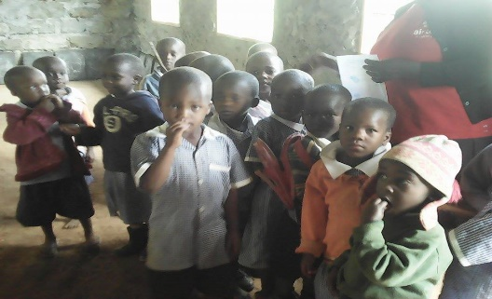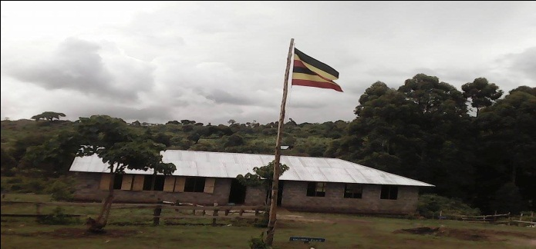

**PROJECT TITTLE: A CLASSROOM BLOCK AND TEACHER’ RESOURCE CENTREFOR KSHEK JUNIOR SCHOOL**.

**CONTACT PERSONS:**

|  |  |  |  |
| --- | --- | --- | --- |
| Name | Title | Email | TEL |
| Mr. Chepsikor Simon Peter | Director Kshek Junior School | [chepsikorsp@gmail.com](mailto:chepsikorsp@gmail.com) | +256 772956303  +256 704 456303 |
| Rev. David Siwa Sebei Diocese | Member School Management Committee | davidsiwarev@gmail.com | +256 774283280 |
| Ms. Martha Cheptoyek | Director Kshek Junior School | kshekjrsch@gmail.com | +256 776 848156 |

**HISTORICAL BACK GROUND.**

Kshek Junior School was started in 2016 as an initiative of Rev. Canon E.K. Chepkweshek a retired Anglican priest with the aim of bringing social, economic transformation by educating the less fortunate children in the communities of Kapchorwa, Kween and Bukwo Districts in eastern Uganda.

Currently the numbers of less fortunate children in Uganda are facing high levels of poverty and immense sufferings that continues to increase. Uganda is a country that depends on subsistence agriculture (farming) which occasionally suffers intensive drought that destroys most of the crops causing most of the less fortunate groups of people which includes, the elderly, widows, the sick and children to go with only one meal a day. Most families are unable to support themselves and keep their children in school throughout the year

We realized that there were many disadvantaged children who’s parents could not afford good education within the community, some of whom are orphans and destitute who cannot raise school fees and do not even have homes where to stay. Consequently most of the children were dropping out and creating problems for their families and the community.

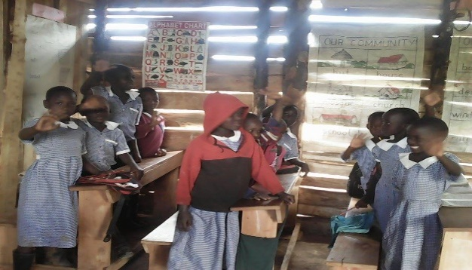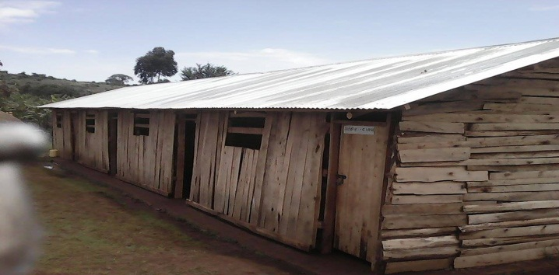

Considering the challenges the community is facing, some members of the community of kawowo and Kapchesiy mobilized themselves and decided to use their meager resources to start a Model Nursery and a primary school to cater for such children, the school started in February, 2016 with 93children, from Baby class, Nursery up to primary six.

The districts of Kween, Bukwoand Bulambuli which are neighboring Kapchorwa were also severely affected by cattle rustling and HIV/AIDS in the region resulting in high levels of poverty and therefore the communities are faced with the problems lack of sustainable incomes to pay for ever increasing cost of education and solve the problem of food insecurity resulting from internal displacement and overpopulation

In an effort to help the many needy and disadvantaged children, we made our community contribution to start this school. We have a number of needy and disadvantaged children who should urgently be accommodated at the school but we are unable to do so due limited resources thus the need for this project.

**PRESENT STATUS OF THE SCHOOL**

The school was established on a 5 acre piece of land in Kawowow village provided by the family of Rev. Chepkweshek with support from his son Mr. Chepsikor Simon Peter and daughter Cheptoyek Martha who constructed a four temporary structures out of timber off-cuts and other local materials which is currently serves classrooms for nursery section and Primary

The school currently has an enrolment of 174 children most of whom would have wished to be accommodated in the school but due to scarcity of resources it operates as a day school. It is maintained by 12 teachers, 5 non- teaching staff and a management committee of nine members.

With guidance from the concerned parents, guardians and community members we decided to organize a school management committee of nine members who help the school to mobilize for resources which will enable the development of the school

[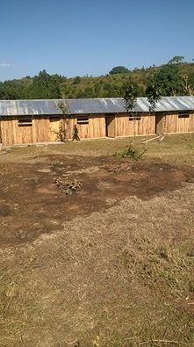](https://web.facebook.com/photo.php?fbid=990142401093381&set=p.990142401093381&type=3)[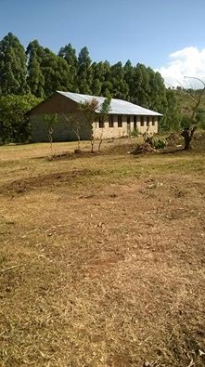](https://web.facebook.com/photo.php?fbid=990142091093412&set=p.990142091093412&type=3)[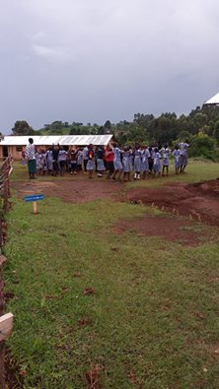](https://web.facebook.com/photo.php?fbid=990151854425769&set=p.990151854425769&type=3)

Given the economic predicament of the community the school is facing a major challenge of inability by parents and guardians to pay school fees for their children, feeding, clothing and treating them when sick. Special thanks to the community members for their support in to the school and the parents and guardians who have contributed the school fees, maize and beans that has enabled us to support the children.

**STUDENT ENROLMENT.**

The school opened in February 2016 but now it has a total population of 174 pupils

NUMBER OF PUPILS

|  |  |  |  |
| --- | --- | --- | --- |
| NUMBER OF PUPILS |  |  |  |
| CLASS | Boys | Girls | TOTAL |
| Baby | 19 | 12 | 31 |
| Middle | 11 | 10 | 21 |
| TOP | 12 | 9 | 21 |
| P.1 | 9 | 8 | 17 |
| P.2 | 7 | 8 | 15 |
| P.3 | 15 | 12 | 27 |
| P.4 | 9 | 4 | 13 |
| P.5 | 9 | 11 | 20 |
| P.6 | 5 | 4 | 9 |
| **TOTAL** | **96** | **78** | **174** |
|  |  |  |  |
| **TEACHERS AND SUPPORT STAFF.** | | | |
|  | TEACHERS | SUPPORT STAFF | TOTAL |
| FEMALE | 8 | 2 | 10 |
| MALE | 4 | 3 | 7 |
| TOTAL | **12** | **5** | **17** |

The school provides quality, practical and relevant education based on Christian values, promoting gender opportunities and we hope that in two years’ time, the school will operate as a full day and Boarding primary school and we hope to enroll up to three hundred pupils.

The Administrative Structure of the school;

• Chairperson of the management committee.

• Director.

• Head teacher

 Management with the support of the founder have mobilized a few resources and are currently putting up a two classroom block which will subsequently be used as a dormitory when we find resources to construct enough classrooms. Most of the parents and guardians want their children to stay at the school so as to get quality education and moral guidance.

**PROBLEM STATEMENT.**

The high poverty levels in the area due to, less food production, unemployment, lack of entrepreneurship skills and poor health among the working age group together with HIV&AIDS have knit out the vulnerability web mainly among women and youth, resulting in broken families, early marriages, rape and defilement, drug addiction and abuse and increased crime toll.

Children have suffered as a result of poverty, food insecurity, diseases, death of parents and single parent either due to HIV& AIDS, cattle rustling and other natural calamities. The situation has left most children with little or without any hope and they live in fear, not sure of a day meal and are uncertain of their future.

All these factors collectively result in causes of early deaths or imprisonment of parents, consequently making the children vulnerable. The poor yield as a result of the subsistence traditional farming. The aggravated problem therefore is the vulnerability of children rendering them unable to access their rightful basics of health care, education, good nutrition and psychosocial uplifting; that really need to be molded and empowered by them accessing basic education, treatment, with vocational skills that can make them happy, useful and resourceful citizens in society.

Although the school was mainly started to help the needy, we charge a minimal fee of 60,000 Shillings ($18) per term to cover scholastic material and Teacher welfare. We have some parents and guardians who have been able to pay but still they come from poor families who can’t pay much money and in time. Therefore the school cannot use these fees for construction of the necessary infrastructures needed at school.

The school is currently faced with the problem of lack of Classrooms due to lack resources to put up classrooms, a library, computers Laboratory, a dispensary, and transport.

The purpose of this proposal therefore is to request for assistance in the construction of a Classroom Block and Teachers Resource Centre that will enable the school to effective support the education of disadvantaged children.

**JUSTIFICATION:**

There is no care center for disadvantaged children in the districts of Kapchorwa, Kween and Bukwo and this renders the less fortunate children more vulnerable because they cannot access basic Education, no one cares or guides them and hence they are left on their own ending up in peer groups that are characterized by drug abuse that leads to juvenile delinquency.

Secondly due to rural peripheral location from the industrial centers the economic activity of subsistence peasantry farming making it far below the international poverty line resulting in people failing to afford basic education, health care and feeding. This has created tremendous vulnerability of children resulting in high level of prostitution, child labor and child neglect.

Thirdly there are few schools in the area that can provide good educational services, they are usually congested with high children – to- teacher ratio; they are of low academic standards, and not suitably deliverable to the vulnerable children. Kapchorwa and Kween districts have in the recent past been among the worst performing district in the education in Uganda.

Therefore schools with a highly enriched education and vocational skills center can have both short and a long term solution. Being aware that children are Uganda’s greatest future resource, the project intends to support and ensure the child’s complete development, mentally, physically, socially, spiritually and economically.

Therefore this project is intended to demonstrate true love and quality education for the less fortunate children and hence committed to delivering services to the needy and most vulnerable.

**MISSION STATEMENT:**

To provide quality education that will nurture, guide and train children to be God fearing mature, responsible and successful future Adults.

**PROJECT GOALS**

* To provide quality education to disadvantaged children so as to nurture, guide and train them to be God fearing mature, responsible and successful members of the community
* The main goal of this project is to have a good and permanent classroom Block to enable us improve on the classroom environment
* To enable increased enrollment and to add on number of the needy and orphan children.
* To save young pupils from walking long distance in search for school with good education standards.
* To improve on classroom control with manageable numberfor improve on the Academic performance of the pupils.
* To enable increased enrollment of girls and address issues of gender inequality in education
* To increase on the income to enable the school to cater for the needy children.

**PROJECT OUTPUT:**

* Increased number of needy, disadvantaged children and orphans attending school.
* Support Less fortunate children especially girls to attend school with enough supplies and clean uniforms
* Improved education, accommodation and living conditions among these children.
* Improved nutritional status and reduced physical ailments for a productive population.
* Enhanced enlightened community on child care thus creating a viable sound future.

**STRATEGIES:**

**The objectives will be realized through:**

* Train and nature children with strong Christian foundations.
* Improve on the nutritional status of the children at school and home.
* Sensitization of communities on the need to educate the girl child and encourage women initiatives.
* Create community awareness of support programs in health, sanitation and hygiene.
* Conduct home visit to needy children homes and conduct family counseling services.
* Conduct HIV/AIDS sensitization meetings with families of the community.

**PROJECTACTIVITIES:**

* Construction of classrooms and create a conducive learning environment.
* Supply and establishment of library, computers and dormitory for the children.
* Provision of tuition fees, school uniforms and scholastic materials for the less fortunate.
* Provide quality nutrition, hot meal to children at school and train women livelihood skills
* Identification and registering needy, orphan and vulnerable children.
* Construction of children’s chapel together with good sanitation facilities and pit latrines.
* Initiating and supporting income generating projects at family level.
* Conducting counseling and guidance to children and their guardians.

**TARGET BENEFICIARIES:**

The beneficiaries will be 300 needy children and orphans together with disadvantaged children from families of low income and those with large number of children but cannot afford their education, destitute, homeless and other forms of vulnerable children.

 It will directly benefit pupils of Kshek Junior School since they will have enough space in their classroom. The country will benefit as these needy and orphan children are very dangerous to the country if they do not attain education.

Those children from needy families and poorest of the poor families will be considered as priority amongst the beneficiaries of this project. The immediate families of these children will also in turn benefit by lifting/ raising their general welfare through building up their capacities in child care issues, skills development, support their livelihood projects. The community especially will in turn benefit through activities like counseling, Health education and income generating projects extended to them and general guidance in family positive progress.

**PROJECT COVERAGE AREA:**

This project is intended to cover the whole country (Uganda) because needy children are all over. However we are currently receiving children from the Districts of Kapchorwa and Kween due to limited financial resources.

**SUSTAINABILITY/ VIALABILITY OF THE PROJECT.**

The parents of Kshek Junior School have been facing the challenge of raising school fees for their children. With the creation of the School, they are realizing some savings which are being used for feeding and upkeep of the children.

Although the school receives some little school fees from pupils who can afford to pay, the founder and management contributed some resources that are being used to construct a two classroom block which is incomplete but is being utilized as a classroom.

The nature of Kshek Junior School and pupils in the school has attracted some friends and well-wishers who have contributed what is existing now and there is hope that they will continue to lend a hand to the School. Despite the fact that our parents are poor and obtain their small income through substance farming, they have been very vital to the establishment of what exists at the school now through payment of small school fees which demonstrate their commitment and interested in the success and continuity of the School.

The school has been entrusted to School Management committee and the community will work hand in hand with the school administration in case of any challenges. Such a background gives a guarantee for the success and continuity of the School

**IMPLEMENTATION SCHEDULE**

When Funds for realization of this project are availed, the Construction completed within a period of six months under the supervision of the School Management committee. The construction works will be executed by a competent local construction company which shall be selected by the school management committee.

**REQUEST**

We are therefore humbly submitting to you the enclosed proposal for your kind consideration to enable us construct a four classroom Block and resource Centre for Kshek Junior School.

The total cost of the Classroom Block will be Uganda shillings 167,165,200which is $49,900, out which we are requesting from you is Uganda Shillings 127,300,000 which is$38,000, upon which Shs39, 865,200 ($11,900)will be added as local contribution to realize this project.

|  |  |  |  |  |  |
| --- | --- | --- | --- | --- | --- |
| **Description** |  |  |  | **Total (UShs)** | **Total (US$)** |
| Community Contribution |  |  |  | 39,865,200 | 11,900 |
| Donor Support |  |  |  | 127,300,000 | 38,000 |
| **Total cost** |  |  |  | **167,165,200** | **49,900** |

**For information on how to donate please contact:**

**Mr. Chepsikor Simon Peter,** [**chepsikorsp@gmail.com**](mailto:chepsikorsp@gmail.com) **Tell: +256 772956303 / 704 456303**

**MANAGEMENT COMMITTEE MEMBERS**

|  |  |  |  |
| --- | --- | --- | --- |
|  | **Name** | **Title** | **Remarks** |
| 1 | Moses Lowoh | Chairperson | Local council representative |
| 2 | Malinga Francis | Vice Chairperson | Community representative |
| 3 | Mangusho Michael | Secretary | Community representative |
| 4 | Chebet Agnes | Treasurer | Founders representative |
| 5 | Rev. Siwa David | Chaplain | Church leader-Sebei Diocese |
| 6 | Sukuku Patricia | Member | Teacher representing Kween District |
| 7 | Chebet Hassan | Member | Parents representative |
| 8 | Cheptoyek Martha | Member | Director |
| 9 | Chepsikor Simon Peter | Member | Director |
|  | Others |  |  |
|  | Rev Canon E. Chepkweshek | Founder | Overseer and spiritual advisor |