EMPOWERING COMMUNITIES SINCE 1991



WZ-33A, DAYAL SAR ROAD, UTTAM NAGAR
NEW DELHI-110059

Website: www.uridango.org
E-mail: urida1992@yahoo.com
PH-01125333206, FAX: 01125337449

OVERVIEW
URIDA (Urbo Rural Integrated Development Association) an NGO registered Under SOCIETIES REGISTRATION ACT 1860 came into existence on 1ST JULY 1991. The establishment of URIDA was the outcome of long term efforts and vision of a committed team, passionate towards social work. Mrs. Sneh Lata Sharma, who is the founder of URIDA, had been working for the cause of women and children many years prior to its legal existence. The founder member, joined hands with likeminded friends and acquaintances who being technocrats, educationists and professional took up this noble task for the cause of people living in urban slums and rural areas of India where development process has slowed down due to poverty, ignorance and illiteracy.
URIDA’s major focus areas are Education, Health, Women Empowerment, Capacity Building of artisans, and Disaster management.

URIDA covers approximately population 15 lakhs, under various development programmes, in various states. Major developmental programmes undertaken by URIDA in the last 20 years include:

- Gender Resource centre- a women empowerment initiative by Department of Women & Child development, Govt of Delhi,
- TI (HIV/AIDS)Project to prevent and control of HIV among high risk groups (Female Sex workers, MSMs, IDUs) and bridge population(Migrant workers) supported by DSACS
- Reproductive and Child Health (RCH) programme (AS MOTHER NGO)

- Education programmes – (REACH INDIA, USAID sponsored education programme for slum children (2005-2007), UEE Mission, Kasturba Gandhi Balika Vidyalaya and Kishori Shakti Yojana.
- Ambedkar Hastshilp Vikas Yojna
- Rural Development programmes in Haryana sponsored by CAPART -2002-2005
- Disaster Management programmes and Awareness Campaigns: programmes on capacity building of poor and vulnerable communities for mitigation of losses.
- Pulse polio eradication programme (CGPP) supported by ADRA India - CORE Group, in Baghpat region. (2008-2010).

VISION: “Enlightened communities free from the evils of poverty, illiteracy and ignorance”
MISSION: “Upliftment of the disadvantaged communities through integrated social economic and infrastructure development”.

RECOGNITIONS
- Accredited member organization of ‘Credibility Alliance’ (a national network established to upgrade programme standards of NGOs on account of the norms for Good Governance, transparency and accountability.)

- Awarded for ‘best consistent performance’ by Mission Convergence, Ministry of women and Child Development.

- Mother NGO for RCH-II programme in south west Delhi.
GEOGRAPHICAL COVERAGE
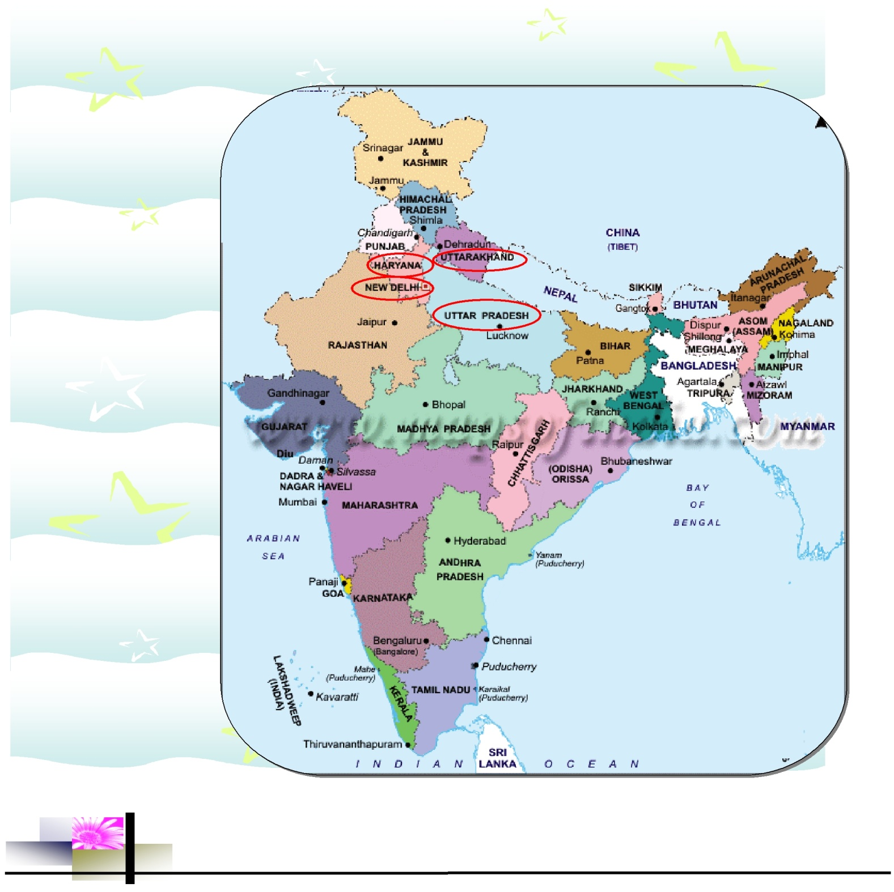
- Delhi

Distt. West

Distt. Southwest

Distt. North

Distt. Central

- Haryana

Sonipat

Mahendragarh

Karnal

- Uttarakhand

HARIDWAR

- Uttar Pradesh

SAHARANPUR

GHAZIABAD

- Himachal Pradesh

- Madhya Pradesh

TARGET BENEFICIARIES
- Women (Poor, needy & destitute)
- SC/ST and Vulnerable category
- Children/Juveniles
- Adolescents
- Aged and Senior citizens
- Drop out children
- Disaster victims
- HIV/AIDS victims
- Drug addicted victims
- Accident victims

FUNDING PARTNERS
CENTRAL GOVT:
Ministry of Health & Family Welfare
Ministry of HRD
Ministry of Road Transport & Highways
Ministry of Rural Development CAPART
Ministry of Environmental & Forests
Ministry of Home affairs

STATE GOVT:
Education (UEE Mission, Delhi)
Department of Social Welfare
Directorate of Family Welfare
State Transport Authority (Road Safety Cell), Delhi
MCD (JJ & Slum), Delhi
State Govt. of Haryana
Municipal Committee of Haridwar, Uttarakhand
Education Dept. Uttar Pradesh

AUTONOMOUS BODIES:
- DSACS
- CAPART
FOREIGN ORGNISATIONS:
- REACH INDIA (US AID)
- EDUCATION TRUST OF USA
- CORE GROUP –ADRA INDIA

PERSONNEL
Total No. of staff:
Male – 14
Female – 26
Volunteers – 200

ONGOING ACTIVITIES

- EDUCATION:

- NON FORMAL EDUCATION (NFE) CENTRE: Being run at JJ colony, Sector-16, Kakrola. The main aim is Identifying, enrolling, educating and mainstreaming children at risk; out of school and dropouts in the age group of 6-16. Remedial Classes are run for school drop-out children and Learning classes are given for School going children.
- Apart from this, women of all ages are given education through adult Literacy programme.
- HEALTH :

- SAHAJ SAMBHAV (DRUG DE ADDICTION CENTRE)
SAHAJ SAMBHAV aims to build up a drug free society, focusing the youth through anti drug campaigns, rehabilitation, treatment and counseling for de addiction. SAHAJ SAMBHAV provides a drug free environment which helps to develop a sense of discipline, commitment, responsibility and self confidence, Improve relationship with family members and others, and provide vocational guidance. Healthy food habits, yoga, meditation etc are also being practiced under strict supervision of experts/doctors.

- FOOD AND NUTRITION CAMPS:
With the objective of spreading awareness on better eating habits and prevention of diseases related to vitamin deficiencies among women and children, Food and Nutrition awareness and demonstration camps are conducted every month. Camps are theme based and the Nutrition expert demonstrates the preparation of high value food with low cost ingredients which are easily available and affordable to the vulnerable categories.

- OPD CLINIC:
Ailing women and children are provided free check up as well as medicines. Family Planning; counseling and free distribution of contraceptives is also done by the gynecologist to the eligible couples and other beneficiaries. Issues of reproductive and maternal health, adolescent health and concerns of women of different ages are addressed at the clinic. A pharmacist assists the doctor for distribution of medicines at the clinics.

- HEALTH CAMPS AND FREE SUPPLY OF MEDICINES
Health camps are conducted every alternate month covering most vulnerable sections of the target areas. Health services are offered to the poor & needy women, Children and men, at their door steps, free of cost. Service of three doctors (General Physician, Pediatrician & Gynecologist) is made available in each camp.

- HEALTH AND SANITATION CAMPAIGNS
With the support of volunteers and Self Help Group members, URIDA conducts Health and sanitation campaigns in urban slums. The campaigns include community meetings, door-to-door visits and observation of hygiene weeks

- CAMPAIGNS ON MENSTRUAL HYGIENE AND

DISTRIBUTION OF SANITARY NAPKINS.
The above activity exclusively covers adolescents and women. Awareness on menstrual hygiene is provided through individual/group counseling
AMBEDKAR HASTSHILP VIKAS YOJANA :
AHVY is a unique program initiated by the Min. of Textiles (GOI), for identification of potential artisans, special focus on their skills and mainstream them to the world of exposures and gainful self employment. The program takes account of formation of Self-Help Groups, trainings/workshops in various crafts, exhibitions and/or sale of artifacts in major craft bazaars.

3. PROMOTION OF HANDICRAFTS & WELFARE OF ARTISANS

The major clusters for interventions are Tikri Khurd (Narela), Hastsal, Kakrola and Madhu Vihar with artisans on different crafts like Art Jewellery, Embroidery, Painting, Soft Toys etc.

Trainings are conducted by consulting empanelled Resource Persons (designers) from NIIT. 27 Self Help Groups are presently functioning successfully under URIDA.

- WISE FEDERATION
For empowerment of all the Self Help Groups, artisans of URIDA jointly formed a federation – WISE (Women Integrated Society of Entrepreneurs) with 15 leading artisans as its founder members. The federation has been registered under societies registration act. 1860 as on 7th Dec 2009.

- WOMEN EMPOWERMENT

URIDA GIRLS HOSTEL
URIDA has recently started a girl’s hostel to provide safe, comfortable -homely stay for students/working women at cheaper cost. We offer well equipped rooms with air condition, food and recreational facilities. URIDA only charges a nominal amount from the occupants, against maintenance of the hostel. Presently the hostel is 12 bedded and in due course of time, with the support of our entrusted donors, we expect to serve more than 50 girls at a time.
- GENDER RESOURCE CENTRE/SAMAJIK SUVIDHA KENDRA:
URIDA’s Gender Resource Centre Has been functioning from the year 2006 at Kakrola, with the support of Dept. of Women and Child Development-GOI, where vocational training in four courses is being provided to the women beneficiaries of economically poor and backward classes free of cost. Each batch of six months trains approx. 200 women beneficiaries.

GRC also acts as an information/ facilitation Centre for the information seekers as well as needy women beneficiaries. Other important aspects are, free health checkups/free provisioning of medicines; legal counseling, health/ food & nutrition camps and formation of Self Help Groups for the economic development of the beneficiaries. Till date more than 1000 families have been covered under this program and approx 80% women are self employed or placed in commercial house nearly.

In addition to the Gender Specific Intervention through GRCS, the mission also aims at better reach of benefits of various schemes meant for the development of slum and rural poor. Financial Assistance Schemes like Widow/ Old age/ Disabled Pensions, Ladli and Construction workers welfare programmes are being covered for the benefit of more than one lakh households in the catchment areas of GRC.

