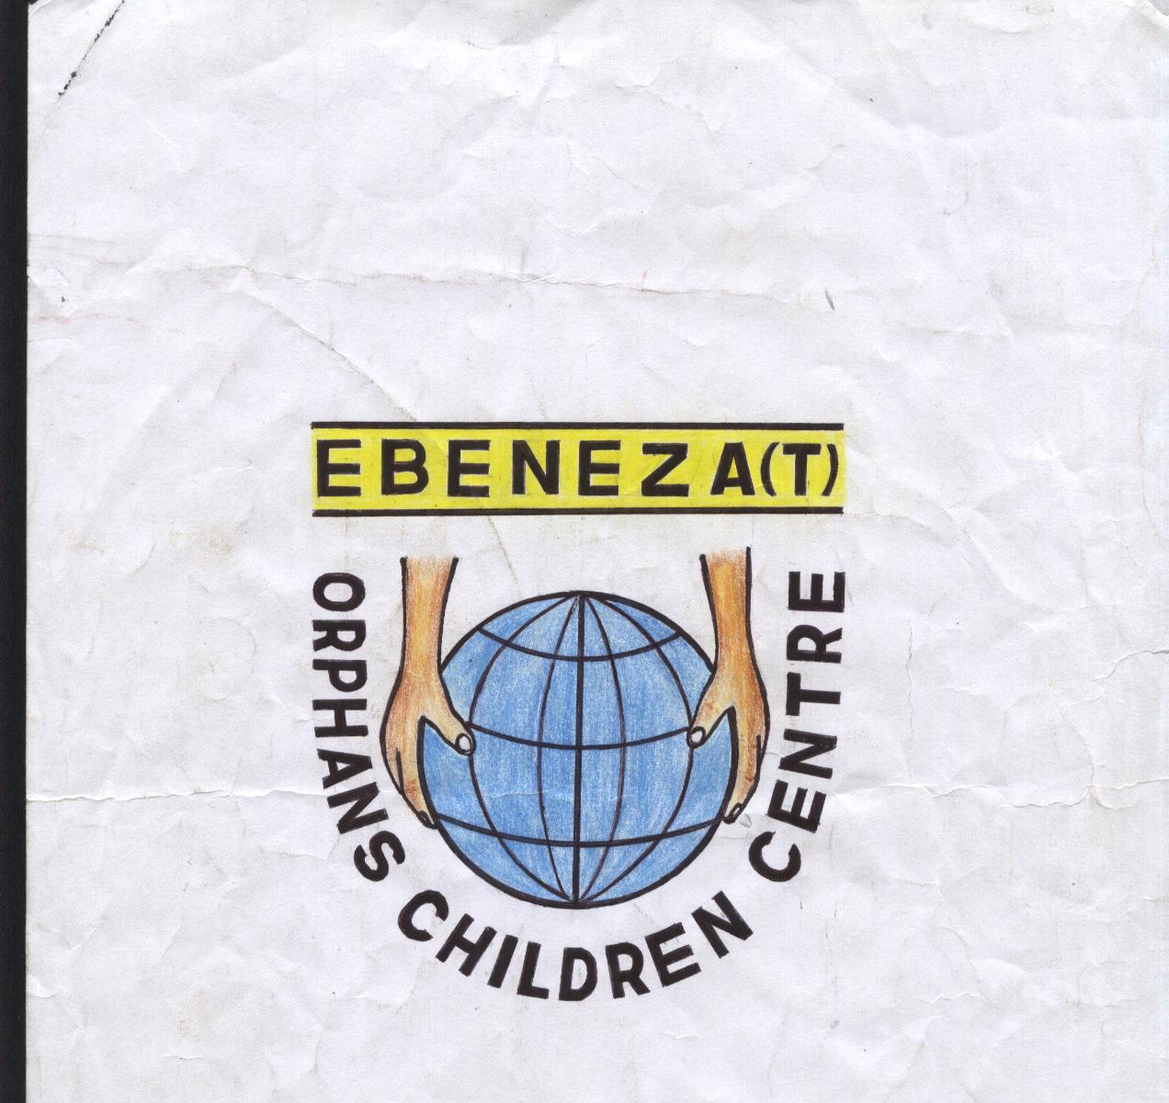
EBENEZA ORPHANS CHIRDLEN CENTRE
(EOCC)
P.O.BOX 67 SHY, MOBILE 0754-245206
Email-ebenezagroup@yahoo.com

1. PROJECT NAME: EXPATION DAIRY CATTLE AND POULTRY PRODUCTION

2. LOCATION: SHINYANGA MUNICIPALITY, SHINYANGA, TANZANIA.

3. GOAL: HELP AND ASSIST ORPHANS

4. PURPOSE: IS TO HELP THE ORPHANS TO HAVE BETTER LIFE

5. OBJECTIVE: TO HELP ORPHANS

6. SPECIFIC OBJECTIVES: TO ENSURE THAT EBENEZA ORPHANS CENTRE PROVIDE EDUCATION WHICH WILL ENABLE THESE ORPHANS TO BE INDEPENDENT IN FUTURE.

7. ESTIMATED BUDGET (REQUESTED FUNDING): TAS 18,236,000.00 (US $) 11,550.

8. CONTRIBUTION FROM EBENEZA: TSHS 1,000,000.00

1.0 PROJECT OVERVIEW

Dairy Cattle and Poultry Production Project intends to carter for supply of animal protein in terms of milk and meet to select both day care orphan and in-house orphan children whom are cared by EBENEZA ORPHANS CHILDREN CENTER in Shinyanga Municipality, South of Lake Victoria, Tanzania. This project is expected to have two components, namely, (1) dairy cattle and (2) Poultry layers and indigenous chicken project. Surplus production in terms of milk, eggs and chicken meat would be sold so as to generate income that would assist to meet other expenses for the center.

- Dairy Project is expected to constitute four (4) in-calf heifers (possibly Friesian crosses) that would be bought from a national livestock breeding unit. These dairy cattle crosses are well adapted to the local environment. Feeds will be obtained from a pasture farm that we have already.

- Poultry Project will constitute improved chicken layers and indigenous chicken. The commercial chicken layers will assist in egg production. Depending on financial availability, this project has planned to commence with 400 commercial chicken layers (i.e., we will purchase 400 chicks), and 60 local chicken pullets. Local chicken would assist in supply of a first class meat protein to the children. This 60 local chicken will at first act as a breeding stock. After they have bred say for example, after 2 years, few chickens will be slaughtered occasionally. Bred pullets from these superior local chicken strains will be distributed to less privileged families for breeding.

- The requested funding would run the project for two years. We also expect to obtain partial funding from other sources. EBENEZA members will also contribute basically in kind, including labour and other resources.

2.0 JUSTIFICATIONS AND IMPORTANCE OF THE PROJECT:

- Ebeneza members and friends are very committed. Ideas on this project were jointly developed among members.
- Among Ebeneza members we have one livestock specialist whom will be full responsible in daily management of this project.
- This livestock project will be easily supported by other agencies, for example, the Local Government Authority.
- Very rarely orphans have access to dairy and dairy- products and eggs that are essential animal protein for fundamental body and mental development.
- There is a promising market to sale surplus products in terms of milk, eggs, and even local poultry meat, which is currently in high demand. Local chickens’ eggs also sell at a premium price.

3.0 EXPECTED EXPENSES AND TENTATIVE BUDGET

- A total sum of 18,236,000/= Tanzania shillings (TAS) equivalent to US $ 11,550/= is proposed as shown in Table 1. Expected expenses include: purchase of dairy cattle, construction of animal houses and related structures, purchase of animal feeds and veterinary drugs and services, and transportation costs as detailed below:

3.1 Purchase of dairy cattle:

3.2 Construction of animal houses and related structures:

3.3 Purchase of animal feeds and veterinary drugs and services:

3.4 Transportation facilities:

4.0 EXPECTED INCOME AND VIABILITY OF THE PROJECT
DAIRY CATTLE
We need to start with 4 dairy cattle @900,000.00= 3,600,000.00
4 cattle can generate 40 litres daily (a dairy cattle well fed can generate 10 litres of milk per day)
1 ltre of milk is sold for 1000.00

Therefore if we succeed to have 4 dairy cattle we can get 40 litres per day, in which 10 litres will be used by the orphans as a source of protein and 30 litres will be sold.
30 litres x 1000.00 is equal to 3000.00

From the above figure it means that, for 1 month our group will be able to get Tshs 900,000.00

With the income of 900,000.00 per month the amount will be used as follows
- 25% x 900,000.00 equal to 225,000.00 will be banked
- 35% x 900,000.00 equal to 315,000.00 will cover direct costs to orphans
- 25% x 900,000.00 equal to 225,000.00 will cover administrative costs
- 15% x 900,000.00 equal to 135,000.00 will cover extension of the school

POULTRY
We need to start with layers (chicks) 400 @2,500.00 = 1,000,000.00
The chicks will be cared for 24 weeks to be cable to produce eggs.
We do estimate 400 Poultry can produce at least 300 daily, which means that 300 eggs will be obtained.
1 egg is sold for 200.00
Therefore if we succeed to get 300 eggs daily, 30 eggs will be used by orphans as a source of protein and 270 eggs will be sold.

From the above figure our group will be able to get 1,620,000.00 per month. This income will be used as follows.

With the income of 1,620,000.00 per month the amount will be used as follows
- 25% x 1,620,000.00 equal to 405,000.00 will be banked
- 35% x 1,620,000.00 equal to 567,000.00 will cover direct costs to orphans
- 25% x 1,620,000.00 equal to 405,000.00 will cover administrative costs
- 15% x 1,620,000.00 equal to 243,000.00 will cover extension of the school

5.0 RISK AND UNCERTAINITIES
The group have prepared for any risk and uncertainties which may occurs. Cattle and poultry will be cared accordingly.

6.0 ENVIRONMENTAL IMPACT ASSESSMENT AND ETHICS

Our project is free from environmental pollution. The environmental auditing have been taken into considerations, also no any unethical behavior which will be entertained.

TABLE 1. TENTATIVE BUDGET FOR LIVESTOCK PROJECT, SHINYANGA, TANZANIA

 | ITEM DESCRIPTION | UNITS | UNIT COST (TAS§) | COST (TAS)
 | Purchase of Livestock & Transportation Costs
1 | Dairy cattle | 4 | 900,000.00 | 3,600,000.00
2 | Layers (Chicks) | 400 | 2,500.00 | 1,000,000.00
3 | Indigenous chicken | 60 | 10,000.00 | 600,000.00
4 | Transportation of cattle | 1 | 200,000.00 | 200,000.00
 | Sub-Total 1 |  |  | 5,400,000.00
 | Animal Houses & Structures
1 | Cow house | 2 | 500,000.00 | 1,000,000.00
2 | Calf house | 2 | 200,000.00 | 400,000.00
3 | Troughs | 6 | 45,000.00 | 270,000.00
4 | Milking parlor | 2 | 200,000.00 | 400,000.00
5 | Clash | 2 | 35,000.00 | 70,000.00
6 | Poultry layers house | 1 | 400,000.00 | 400,000.00
7 | Brooder house | 2 | 150,000.00 | 300,000.00
8 | Indigenous poultry house | 1 | 500,000.00 | 500,000.00
 | Sub-Total 2 |  |  | 3,340,000.00
 | Animal feeds and Veterinary Drugs
1 | Pasture farm (Acres) | 4 | 300,000.00 | 1,200,000.00
2 | Cultivation | 8 | 15,000.00 | 120,000.00
3 | Grass pasture seeds | 8 | 6,000.00 | 48,000.00
4 | Legume pasture | 4 | 12,000.00 | 48,000.00
5 | Tree fodder | 4 | 15,000.00 | 60,000.00
7 | Chicks' mash | 30 | 45,000.00 | 1,350,000.00
8 | Growers' Mash | 40 | 50,000.00 | 2,000,000.00
8 | Layers' Mash | 60 | 50,000.00 | 3,000,000.00
9 | Sprayers | 1 | 80,000.00 | 80,000.00
10 | Veterinary drugs | 12 | 15,000.00 | 180,000.00
11 | Cattle dip | 14 | 15,000.00 | 210,000.00
 | Sub-Total 3 |  |  | 8,296,000.00
 | Transportation Costs and other Facilities and Services
1 | Bicycle | 2 | 150,000.00 | 300,000.00
2 | Wheel barrow | 1 | 300,000.00 | 300,000.00
3 | Consultation Fees | 12 | 50,000.00 | 600,000.00
 | Sub-Total 4 |  |  | 1,200,000.00
 | GRAND TOTAL |  | TAS | 18,236,000.00
 | GRAND TOTAL |  | US $ | 11,500
TAS = Tanzania Shillings

