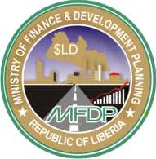**MINISTRY OF FINANCE AND DEVELOPMENT PLANNING (MFDP)**

**P.O. BOX 9016**

**MONROVIA, LIBERIA**

|  |  |  |  |  |  |  |  |  |  |  |  |  |  |  |  |  |  |  |  |  |  |  |  |  |  |  |  |  |  |  |  |  |  |  |  |  |  |
| --- | --- | --- | --- | --- | --- | --- | --- | --- | --- | --- | --- | --- | --- | --- | --- | --- | --- | --- | --- | --- | --- | --- | --- | --- | --- | --- | --- | --- | --- | --- | --- | --- | --- | --- | --- | --- | --- |
| **APPLICATION FORM** | | | | | | | | | | | | | | | | | | | | | | | | | | | | | | | | | | | | | |
| **NGO ACCREDITATION/REACCRDDITATION** | | | | | | | | | | | | | | | | | | | | | | | | | | | | | | | | | | | | | |
| **GENERAL INSTRUCTIONS:** | | | | | | | | | |  | |  | |  | |  |  | | | |  | | |  | |  |  |  | |  | |  | |  |  | |  | |
| *This form must be completed by an authorized representative. Solicited information herein are intended to enhance improved database, facilitate coordination and information sharing, as well as, monitor and evaluate performance. Therefore, please make sure that information provided are true and correct.* | | | | | | | | | | | | | | | | | | | | | | | | | | | | | | | | | | | | | | |
| **I- Background Information:** | | | | | | | | | | | | | | | | | | | | | | | | | | | | | | | | | | | | | | |
|  | | Name of NGO: **BASKET OF HOPE CHARITY ORGAINZATION FOR CHILDREN AND WOMEN IN LIBERIA** | | | | | | | | | | | | | | | | | | | | | | | | | | Acronym: **BASKET OF HOPE- LIBERIA** | | | | | | | | | | |
|  | | Year founded: 2014 | | | | | | | | | | | | | | | | | | | | | | | | | | | | | | | | | | | | |
|  | | Head Office Address: | | | | | | | *Voinjama* | | | | | | | | | | |  | | | | | | | | |  | | | | | | | | | |
|  | |  | | | | | | | *Street/Community Solomon* | | | | | | | | | | | *City/Town Voinjama* | | | | | | | | | *County*  *Lofa* | | | | | | | | | |
|  | | Current Head of Organization: | | | | | | | | | | | *Kelleh* | | | | | | | | | | *Mohammed* | | | | | | | | | | *Moiphilip* | | | | | |
|  | |  | | | | | | | | | | | *Surname* | | | | | | | | | | *First Name* | | | | | | | | | | *Middle Name* | | | | | |
|  | | Telephone/Cell Number: | | | | | | | | | *0886-531-644, 0777-531-644* | | | | | | | | | | | | | | | | | | | | | | | | | | | |
|  | | Email Address: | | | *Basketofhope.lib@gmail.com* | | | | | | | | | | | | | | | | | | | | | | | | | | | | | | | | | |
|  | | NGO type: | | *National* | | | | | | | | | | | | | | | | | | | | |  | | | | | | | | | | | | | |
|  | | *National* | | | | | | | | | | | | | | | | | | | | | *International* | | | | | | | | | | | | | |
|  | | If International NGO, Country of origin: | | | | | | | | | | | | | | | | | | | | | | |  | | | | | | | | | | | | | |
|  | | Application type: | | | | | *Accreditation* | | | | | | | | | | | | | | | | | | *Reaccreditation* | | | | | | | | | | | | | |
|  | | *Accreditation* | | | | | | | | | | | | | | | | | | *Reaccreditation* | | | | | | | | | | | | | |
|  | | If application is reaccreditation, year first accredited in Liberia | | | | | | | | | | | | | | | | | | | | | | | | | | | | | *2014* | | | | | | | |
|  | | Does your organization have a Logo? (X)Yes ( )No | | | | | | | | | | | | | | | | | | | | | | | | | | | | | | | | | | | | |
| If yes, please describe: *Our Logo is round with the name going round and a male with two school children both girl and boy; and a female along with a girl with animal in her hand in the middle of the cycle. Also the middle has Child protection is the major concern of Cafocwof* | | | | | | | | | | | | | | | | | | | | | | | | | | | | | | | | | | | | |
|  | | Vision/Mission Statement: ***For all children and women to live without fear of not having food to eat, to have shelter and protection, End FGC, end child marriage, to have access to clean water and medical care whenever it is needed.*** | | | | | | | | | | | | | | | | | | | | | | | | | | | | | | | | | | | | |
| **II- Board Members Information** | | | | | | | | | | | | | | | | | | | | | | | | | | | | | | | | | | | | | | |
|  | | 1) Name: | | | | | | | | | *Hon. Soko V. Sackor* | | | | | | | | | | | | | | | | | | | | | | | | | | | |
|  | | Occupation: | | | | | | | | | *Administrator* | | | | | | | | | | | | | | | | | | | | | | | | | | | |
|  | | Address: | | | | | | | | | *Old Road Sinkor* | | | | | | | | | | | | | | | | | | | | | | | | | | | |
|  | | Telephone/Cell #: | | | | | | | | | *0886-533-575* | | | | | | | | | | | | | | | | | | | | | | | | | | | |
|  | | Email: | | | | | | | | | *Sokov1@yahoo.com* | | | | | | | | | | | | | | | | | | | | | | | | | | | |
|  | |  | | | | | | | | | *Fatuma Fofana-Kamara* | | | | | | | | | | | | | | | | | | | | | | | | | | | |
|  | |  | | | | | | | | | *Manager* | | | | | | | | | | | | | | | | | | | | | | | | | | | |
|  | |  | | | | | | | | | *United State of America* | | | | | | | | | | | | | | | | | | | | | | | | | | | |
|  | |  | | | | | | | | | *+16123230841* | | | | | | | | | | | | | | | | | | | | | | | | | | | |
|  | |  | | | | | | | | | *fkfofana@gmail.com* | | | | | | | | | | | | | | | | | | | | | | | | | | | |
|  | |  | | | | | | | | |  | | | | | | | | | | | | | | | | | | | | | | | | | | | |
|  | | 3) Name:  Occupation:  Address:  Telephone/Cell #:    Email: | | | | | | | | | *Mariamu B. Fofana* | | | | | | | | | | | | | | | | | | | | | | | | | | | |
|  | | *Representative District# 4 Lofa County* | | | | | | | | | | | | | | | | | | | | | | | | | | | |
|  | | *Robert Field High-way Monrovia* | | | | | | | | | | | | | | | | | | | | | | | | | | | |
|  | | *0770306132* | | | | | | | | | | | | | | | | | | | | | | | | | | | |
|  | |  | | | | | | | | | | | | | | | | | | | | | | | | | | | |
|  | | Name:  Occupation:  Address:  Telephone/Cell #:    Email: | | | | | | | | | *Musa Kamara* | | | | | | | | | | | | | | | | | | | | | | | | | | | |
|  | | *Business-man* | | | | | | | | | | | | | | | | | | | | | | | | | | | |
|  | | *Barkedu Quardu-Gboni District* | | | | | | | | | | | | | | | | | | | | | | | | | | | |
|  | | *0880593345* | | | | | | | | | | | | | | | | | | | | | | | | | | | |
|  | |  | | | | | | | | | | | | | | | | | | | | | | | | | | | |
|  | |  | | | | | | | | | | | | | | | | | | | | | | | | | | | |
|  | | Name:  Occupation:  Address:  Telephone/Cell #:    Email: | | | | | | | | | *Mohammed M. Kelleh* | | | | | | | | | | | | | | | | | | | | | | | | | | | |
|  | | *Executive Director & Vice president Basket of Hope Liberia* | | | | | | | | | | | | | | | | | | | | | | | | | | | |
|  | | *Solomon Street Voinjama Lofa County* | | | | | | | | | | | | | | | | | | | | | | | | | | | |
|  | | *0886-531-644* | | | | | | | | | | | | | | | | | | | | | | | | | | | |
|  | | [*mohammedjkelleh@gmail.com*](mailto:mohammedjkelleh@gmail.com)*,* [*mmohammed.basketofhope.lib@gmail.com*](mailto:mmohammed.basketofhope.lib@gmail.com) | | | | | | | | | | | | | | | | | | | | | | | | | | | |
|  | |  | | | | | | | | | | | | | | | | | | | | | | | | | | | | | | | | | | | | |
| **III- Program Information** | | | | | | | | | | | | | | | | | | | | | | | | | | | | | | | | | | | | | | |
|  | Program intervention area and Sector Ministry/Agency/Commission priorities (Check applicable priority and sector | | | | | | | | | | | | | | | | | | | | | | | | | | | | | | | | | | | | | |
|  | **Program Priority** | | | | | | | | | | | | | | | | | **Sector Ministry/Agency/Commission responsible** | | | | | | | | | | | | | | | | | | **Check** | | |
|  | 1. Agriculture & Food Security | | | | | | | | | | | | | | | | | Ministry of Agriculture | | | | | | | | | | | | | | | | | |  | | |
|  | 1. Education and Training | | | | | | | | | | | | | | | | | Ministry of Education | | | | | | | | | | | | | | | | | | x | | |
|  | 1. Energy | | | | | | | | | | | | | | | | | Ministry of Lands, Mines & Energy | | | | | | | | | | | | | | | | | |  | | |
|  | 1. Environment and Natural Resources | | | | | | | | | | | | | | | | | Environmental Protection Agency | | | | | | | | | | | | | | | | | | x | | |
|  | 1. Gender and Child Protection | | | | | | | | | | | | | | | | | Ministry of Gender, Children and Social Protection | | | | | | | | | | | | | | | | | | x | | |
|  | 1. Health care/ HIV/AIDS | | | | | | | | | | | | | | | | | Ministry of Health | | | | | | | | | | | | | | | | | | x | | |
|  | 1. Human Rights and Rule of Law | | | | | | | | | | | | | | | | | National Human Rights Commission | | | | | | | | | | | | | | | | | | x | | |
|  | 1. Infrastructure/Water & Sanitation | | | | | | | | | | | | | | | | | Ministry of Public Works | | | | | | | | | | | | | | | | | | x | | |
|  | 1. Micro Finance | | | | | | | | | | | | | | | | | Central Bank of Liberia | | | | | | | | | | | | | | | | | |  | | |
|  | 1. Crisis Prevention/Recovery, Emergency Aid & Peace Building & Conflict Resolution | | | | | | | | | | | | | | | | | Ministry of Internal Affairs | | | | | | | | | | | | | | | | | | x | | |
|  | 1. Poverty eradication & Economic Development | | | | | | | | | | | | | | | | | Ministry of Finance and Development Planning | | | | | | | | | | | | | | | | | |  | | |
|  | 1. Youth Development | | | | | | | | | | | | | | | | | Ministry of Youth & Sports | | | | | | | | | | | | | | | | | |  | | |
|  | 1. Urban Development (Slum Communities) | | | | | | | | | | | | | | | | | Ministry of Internal Affairs | | | | | | | | | | | | | | | | | |  | | |
|  | 1. Employment and decent labor, job creation, anti-child labor, migration | | | | | | | | | | | | | | | | | Ministry of Labor | | | | | | | | | | | | | | | | | |  | | |
|  | 1. Persons with disabilities | | | | | | | | | | | | | | | | | Ministry of Gender, Children and Social Protection | | | | | | | | | | | | | | | | | | x | | |
|  | 1. Arts and Culture | | | | | | | | | | | | | | | | | Ministry of Information, Culture and Tourism | | | | | | | | | | | | | | | | | |  | | |
| 2 | County(ies) of operation | | | | | | | | | | | | | | | | | Lofa County | | | | | | | | | | | | | | | | | | | | |
| 3 | County(ies) with field offices | | | | | | | | | | | | | | | | | Barkedu Quardu-Gboni district | | | | | | | | | | | | | | | | | | | | |
| 4 | Mode of program implementation: ( )Direct implementation () implementation through Implementing Partners (IPs) (x) Both | | | | | | | | | | | | | | | | | | | | | | | | | | | | | | | | | | | | | |
| 5 | Name of Implementing Partners (IPs) Organizations: | | | | | | | | | | | | | | | | | | | | | | | | | | | | | | | | | | | | | |
| **National Organizations:** | | | | | | | | | | | | | | | | | | **International Organizations:** | | | | | | | | | | | | | | | | | | | |
| a. *Lofa County Peace Network* | | | | | | | | | | | | | | | | | | a. *Plan International* | | | | | | | | | | | | | | | | | | | |
| b. | | | | | | | | | | | | | | | | | | b. *Girls Not Brides* | | | | | | | | | | | | | | | | | | | |
| c. | | | | | | | | | | | | | | | | | | c. *A.U. Campaign to End Child Marriage* | | | | | | | | | | | | | | | | | | | |
| 6 | Target Beneficiaries: | | | | | | |  | | | | | | | | | | | | | | | | | | | | | | | | | | | | | | |
| 7 | Current Donors: | | | | |  | | | | | | | | | | | | | | | | | | | | | | | | | | | | | | | | |
| **8** | **Current Portfolio Amount per donor:** | | | | | | | | | | | | | | | | | | | | | | | | | | | | | | | | | | | | | |
| **Name of Donor/Sponsor** | | | | | | | | | | | | | | | | | | **Contributions** | | | | | | | | | | | | | | | | | | | |
|  | | Basket of Hope Charity Organization for Children and Women in Africa | | | | | | | | | | | | | | | |  | | | Financial & Materials | | | | | | | | | | | | | | | | |
|  | |  | | | | | | | | | | | | | | | |  | | |  | | | | | | | | | | | | | | | | |
|  | |  | | | | | | | | | | | | | | | |  | | |  | | | | | | | | | | | | | | | | |
|  | |  | | | | | | | | | | | | | | | |  | | |  | | | | | | | | | | | | | | | | |
| **IV- Banking information** | | | | | | | | | | | | | | | | | | | | | | | | | | | | | | | | | | | | | | |
|  | | Name of Banking institution: | | | | | | | | | | | | | *LBDI and Ecobank* | | | | | | | | | | | | | | | | | | | | | | | |
|  | | Address: | | | | | | | | | | | | | *Lofa County and Monrovia* | | | | | | | | | | | | | | | | | | | | | | | |

**Declaration:**

On behalf of (*Name of NGO)* **BASKET OF HOPE CHARITY ORGANIZATION FOR CHILDREN AND WOMEN IN LIBERIA***,* I hereby certify that the information contained herein is true and accurate to the best of my belief and knowledge. I understand that any misleading/inaccurate information may lead to a denial of accreditation/reaccreditation.

Name: __ _Mohammed M. Kelleh___________________________

*(Authorized Representative)*

Position: __ Executive Director ________________________

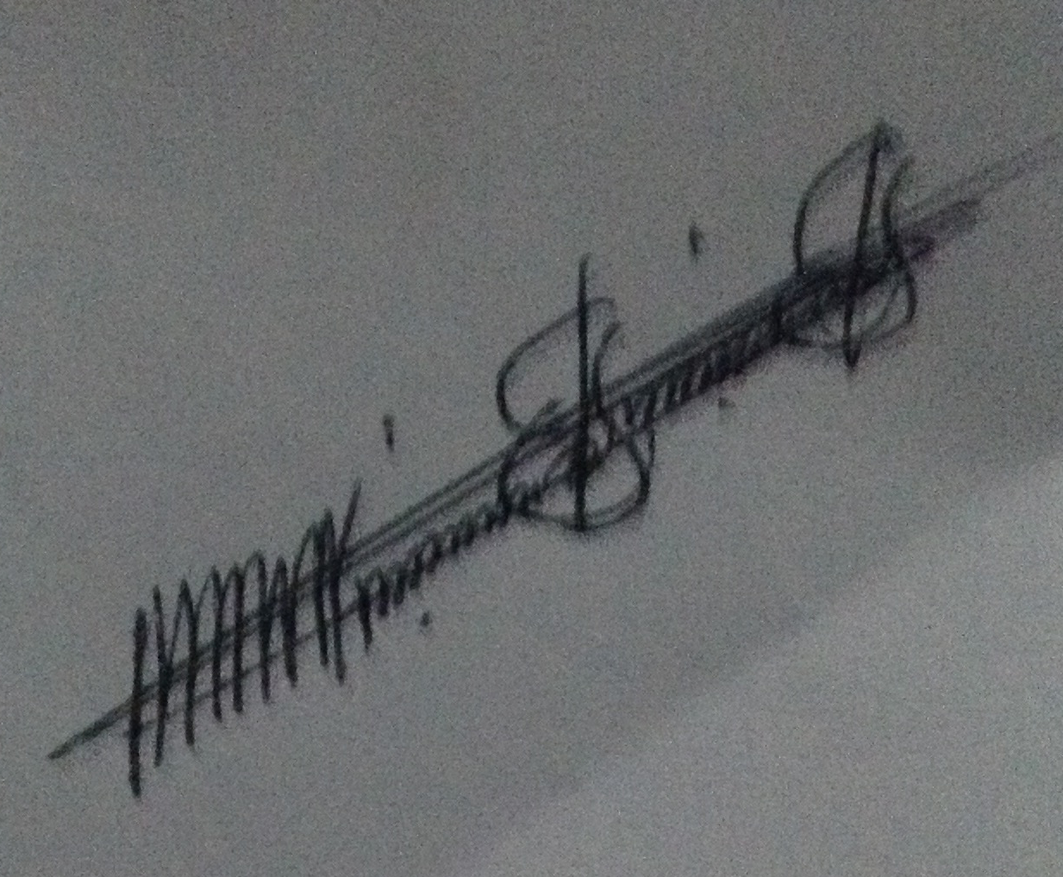Signature: ____________________________________________________

Date: ___________________5/28/16_______________________________

**Attachment:**

|  |  |  |  |  |
| --- | --- | --- | --- | --- |
| **S/N** | **Accreditation** | | **S/N** | **Reaccreditation** |
|  | Notarized by-laws and constitution | | 1. | Completed Annual Project/Program Report template |
|  | Article of Incorporation with attached corporate filing receipt | | 2. | Current Non-for-Profit Business Registration certificate/receipt (LBR) |
|  | Non-for-Profit Business Registration certificate/receipt (LBR) | | 3. | Sector Appraisal Report |
|  | Sector clearance/reference letter | | 4. | Audited financial report for the reporting period |
|  | Bank confirmation letter referencing active account holding | |  |  |
|  | List of staffs members, position and nationality | | 5. | List of permanent staffs, position, nationality and salary |
|  | List of capital assets and office equipment | | 6. | List of capital assets and office equipment |
|  | Annual Work Plan | | 7. | Annual Work Plan |
|  | |

**List of Staffs, Position, National and Salary**

|  |  |  |  |  |
| --- | --- | --- | --- | --- |
| **No.** | **Name** | **Position** | **Nationality** | **Salary** |
| 1. | Mohammed M. Kelleh | Executive Director | Liberian | $150USD |
| 2. | Sowah V. Verney | Adm/Finance | Liberian | $125USD |
| 3. | Losene A. Dukuly | Monitoring & Evaluation officer | Liberian | $100USD |
| 4 | Mary Sumo | Office Attendant | Liberia | $75.00 |

**List of capital assets and office equipment**

|  |  |  |
| --- | --- | --- |
| **No** | **Items** | **Qty** |
| 1 | Desktop Computer legal Affairs | 2 |
| 2 | Laptop Computer | 3 |
| 3 | Generator (3.5KVA) | 2 |
| 4 | Office Desks | 4 |
| 5 | Mini Ice Box | 1 |
| 6 | Printer | 3 |
| 7 | Chairs for office used | 8 |
| 8 | Conference Table | 1 |
| 9 | Conference Chairs | 8 |
| 10 | Min Speaker | 5 |
| 11 | P. A System | 1 set |
| 12 | Motorbike | 2 |

**Annual Work Plan**

|  |  |  |  |  |  |
| --- | --- | --- | --- | --- | --- |
| No. | Activity | Objective | Venue | Duration | Responsible person |
| 1. | Radio Talk-show Awareness | Creating awareness on the fundamental rights of Liberians Citizens under chapter three (3) of the Liberian Constitution | Radio Kintoma | July 2015-July 2016  Every Sunday for the period of one years | Mohammed M. Kelleh Executive Director |
| 2. | Radio Talk-show Awareness | Creating awareness through radio talk-show on Ending Child Marriage | Radio Kintoma | July 2015-July 2016  Every Sunday for the period of one years | Mohammed M. Kelleh Executive Director |
| Note  Since last year March 2015, The Concern Care for Children and Women Foundation inc (NOW) **BASKET OF HOPE CHARITY ORGANIZATION FOR CHILDREN AND WOMEN IN LIBERIA**. project ended with Plan International Liberia in Lofa County Republic of Liberia, our institution have not had any other project yet for implementation from donor partner/s. Base on this, we have been creating more awareness on the role of citizens and the Liberia National Police building confident between through community policing partnership and the role of law of Liberia as UNMIL drawdown continue. | | | | | |