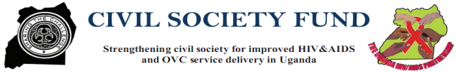

WOSO 2015 ANNUAL REPORT
Funded by: Civil Society Fund(CSF)-USAID
Sub-Granted by: Joint Clinical Research Centre (JCRC)


Implemented by:
Widows and Orphans Support Organization (WOSO)
Email: woso.org@gmail.com
Tel:: +256 0777-485948 / 0792-331587
“Desperate to Prosper”

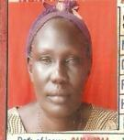  Ms.Laker K Ogena  Chairperson  Board of Directors  indebt about SCIPHA Welcome to project  2015 Annual report | I am very happy to welcome you to this wonderful WOSO-SCIPHA project Annual Report. 2015  This annual report is acting as a means where we can share our ideas, what we do and experiences in the fights against HIV/AIDS and its burden in our communities  Strengthening Civil Society for Improved HIV/AIDS and OVC service Delivery in Uganda (SCIPHA) project is being implemented by WOSO from Oct. 2012-2015 with funding from Civil Society Fund (CSF) through Joint Clinical Research Centre (JCRC).  WOSO-SCIPHA project implemented;  - HIV/AIDS prevention services  - HIV/AIDS Care, treatment and support services  Activity in HIV Prevention services provided includes; HIV prevention awareness creation, Sexual and reproductive Health care education, elimination of mother to child transmission of HIV awareness creation, HIV counseling and testing(HCT), Correct and consistence condom use education, Behavioral Change Communication(BCC) messages, exposed infant Diagnosis (EID) services, Condoms education, Family Planning education, Antenatal Care Referral services, Sexual and reproductive health services education.  Activity in HIV/AIDS care and treatment includes: enrolment and referral for HIV/ AIDS care, treatment and support services, Cotrimoxazole Prophylaxis (CTX) services, , |  | Sexual transmitted Infections(STIs) screening and treatment services, TB screening and treatment services, Opportunistic infection(OIs) screening and treatment services, CD4 testing and laboratory monitoring services, ART referral, ART awareness creation, Social support, Home based care support, family planning and Sexual and reproductive health services, risk reduction counseling and support., Referral services, follow-up support,  All these activities are being implemented in partnership with government health facilities.  SCIPHA project in Agago district implemented in Patongo, Adilang, Omot and Lirapalwo sub-counties.  SCIPHA project implemented in phases. SCIPHA I,II,III and IV  WOSO-SCIPHA project employed holistic and sustainable approaches to increase access and utilization of HIV/AIDS prevention, care, treatment and support services among the MARPs and PLHIVS.  Some of the approaches includes; Four Tent Model out-reaches, Moon light testing, Formation of mentors clubs:- Mama mentors, Baba Mentors, | Young positive Mentors, Yellow mentor’s clubs dialogues, Home based care, referral and follow-up, Working through existing structures like VHTs, health facilities, PHA Networks MARPS coordinators, leaders.  Some of the project remarkable achievements are; Partnership where WOSO-SCIPHA project enjoys collaboration with Agago district leaderships, Health facilities and community members to create HIV/AIDS services demand and increased access and utilization.  The Mama clubs has enabled us mentor elimination of Mother- To- Child Transmission (eMTCT) where HIV-ve mothers and their partners are mobilized for HIV services including HIV Counseling and Testing, Antenatal Care and Family Planning and EID services, also the Baba mentors clubs established and instrumental in the community, they are active in mobilization of men to support their partners in accessing HIV/AIDS and it related services and creation of HIV/AIDS services demand among men in their community.  Through working with the existing structures approaches, WOSO-SCIPHA project continues to address and mitigate the HIV/AIDS Scourge at the grass root level where HIV/AIDS services are most needed.
WOSO-SCIPHA Project teams’
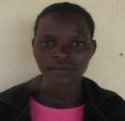

Ms. Adong G. Julia Ms.Adanga Babra Mr. Adonga Thomas
Project Coordinator Finance & Administrator Project officer
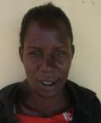

Ms. Amwony .N. Ogena Mr. Okello James Ms. Aceng Jane
Project Coordinator Programme Coordinator Project officer
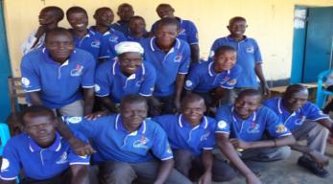

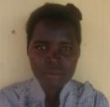
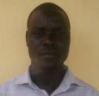
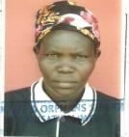
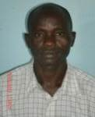
Village Health Teams(VHTs)

Project Goal: To contribute to the reduction of HIV incident by 30% and improve the quality of life of PLHIVS within Agago district by Dec.2015

Project objectives:
- To increase access and utilization of HIV prevention services to most at risk key population (MARPs) in Agago district by Dec.2015.
- To increase access and utilization of HIV/AIDS care, treatment and support services among HIV positive children ,adults and adolescent in Agago district by Dec.2015
- To strengthen coordination, linkages, referral and partnerships for improved HIV/AIDS services delivery in Agago district by Dec. 2015
- To create a sustainable enabling environment that mitigate the underlying socio-cultural, gender based and structural drivers of HIV epidemic in Agago district by Dec.2015

Project achievements’
Project outputs | Project annual targets/ indicators | Achievements | Remarks
HIV Prevention services.
Output 1.1: 6768 MARPS reached with Behavioral Change communication (BCC) messages | 8768 | 7,488 MARPS reached | VHT activeness in mobilization
Output 1.2: 1836 IEC materials on HIV/AIDS services disseminated and distributed | 1836 | 288 IEC materials distributed
Output 1.3: 2486 MARPS accessed HIV Counseling and Testing (HCT) services | 6212 | 6761 MARPS provided with HCT
Output 1.4: 18,497 Condoms distributed | 18,497 | 49,020 Condoms distributed to MARPS
Output 1.5: 163 Pregnant mothers mobilized for HCT,FP, eMTCT and ANC services | 163 | 196 pregnant mothers reached | Active MaMa mentors clubs in mobilization of pregnant mothers
Output 1.6: 47 Exposed infants mobilized and provided with Exposed Infants Diagnosis(EID) services | 47 | 53 Exposed Infants Reached with EID services | Active MaMa mentors clubs in mobilization of HIV positive pregnant mothers
Output 1.7: 20 discordance couple provided with risk reduction counseling support | 20 | 15 Discordance couples reached
HIV/AIDS care, treatment and support services
Output 2.1: 491 new PLHIVS enrolled and referred for HIV/AIDS care, treatment and support services | 491 | 526 new PLHIVS enrolled and referred | Active clubs in mobilization of PLHIVS
Output 2.2: 491 new PLHIVS accessed Cotrimoxazole Prophylaxis(CTX) services | 491 | 526 new PLHIVS accessed CTX services
Output 2.3: 503 adults PLHIVS reached with HIV/AIDS care services at community levels | 503 | 421 adults PLHIVS reached
Output 2.4:492 Adults and adolescent reached with STIs services at community levels | 492 | 351 Adults and adolescent reached
Output 2.5: 487 Children and adolescent accessed clinical monitoring and management of opportunistic infection s (OIs). | 487 | 505 Children and adolescent accessed | Active Young Star mentors clubs
Output 2.6: 168 PLHIVS supported and accessed CD4 services at community levels. | 168 | 179 PLHIVS supported and accessed CD4 services | Active clubs in mobilization of PLHIVS
Output 2.7:385 PLHIVS supported and accessed TB screening and treatment services | 385 | 526 accessed TB screening
Output 2.8:257 adults PLHIVS supported and accessed OIs screening and treatment services | 257 | 321 accessed OIs screening and treatment services
Output 2.9: 8 TB patients supported and accessed HCT services | 8 | 7 TB patients and accessed HCT services
Output 2.10:152 PLHIVS accessed home based care support | 152 | 192 PLHIVS accessed home based care support
Output 2.11:321 PLHIVS provided with FP and SRH education | 321 | 421 PLHIVS provided with FP and SRH education
Output 2.12:247 Eligible PLHIVS referred for ART services | 247 | 207 ART eligible referred for ART services
Output 2.13:491 PLHIVS provided with minimum package for positive health dignity(PHDP) services | 391 | 432 PLHIVS provided with (PHDP) services
Output 3.1: 16 referral meeting conducted at sub-counties levels | 16 | 16 Referral meetings conducted successfully at sub-counties levels | Active referral network at sub-counties levels
Output 4.1: 16 community dialogue to plan intervention to address harmful socio-cultural, gender based and structural drives of epidemic, | 16 | 16 Community dialogue successfully conducted
Output 4.2: 16 dialogue meetings with Person with disabilities (PWDs) to plan intervention to address harmful socio-cultural, gender based and structural drives of epidemic | 16 | 16 PWD Dialogue meetings successfully conducted | Active mobilization of PWDs by PWDs mentors clubs
Output 4.3: 16 dialogue meetings with cultural leaders, and heads of institutions to plan intervention to address harmful socio-cultural, gender based and structural drives of epidemic | 16 | 16 dialogue meetings with cultural leaders and head of institutions successfully conducted
WOSO best practices/success
- Partnerships with the health facilities (health centre II, III & ART clinic), NGOs partners, and Local government have improved HIV/AIDS services delivery in the district.
- Working with the existing community structures like VHTs, PLHIVS networks, PHA coordinators,
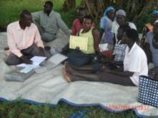
- 10 clubs legally registered with their respective sub-county authority and out of which 5 clubs open their A/C with Bank of Africa Patongo branch.
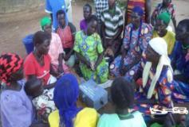

Gum-Pat-pat PHA Mama club-Omot Nena-Anyim Young PHA club-Patongo
During weekly SACCO/ VSLA meeting During their SACCO/VSLA Meeting

Working with the PLHIVS clubs like MAMA,BABA,YOUTH PHA CLUBs has strengthen the mobilization, referral ,linkages and advocacy at community levels (12 active clubs in 4 SCIPHA project sub-counties formed, supported and functional)
- Forming and supporting clubs with sustainable IGAs (SACCO) has created culture of saving, borrowing and IGAs to fights poverty at their households levels (12 clubs supported with sustainable IGAs inform of SACOO)

Other activity clubs engaged in:
- Income generating business
- Home based care support to PLHIVs
- Mobilization and referral of pregnant
Mothers for PMTCT,FP,ANC etc
- Community drama on HIV/AIDS
- Advocacy on PLHIVS rights

- Giving life testimonies (HIV+ living clients) and community drama on HIV care services.
- 4-tent modal outreaches(Prevention and care services at one stop point)

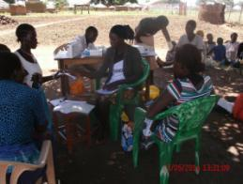
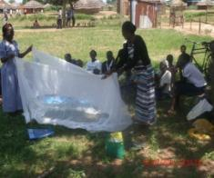

- Home based care support to PLHIVS and their family members including psychosocial support, drugs adherence monitoring, guidance and counseling, follow-up and referral, home based care kits etc.

WOSO teams during 4-tent outreach WOSO staff educating HIV+ pregnant mothers and care givers
(HCT) of HIV+ children on correct uses of Mosquito net in a home.
.
Partnership and quality improvement
- WOSO have good working relationship with Agago district local government leadership and they are actively participating in SCIPHA project activities implementation processes which has contributed to a greater improvement in HIV/AIDS services delivery in the district
.

HIV Focal point person, Secretary health Agago district Local Government, PHA member, DDA, and WOSO staff during radio talk show at Radio Luo FM – Pader on HIV/AIDS services.

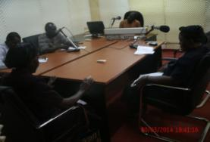

Data quality audit.

- Quality improvement/data quality audit by JCRC SCIPHA project has build the capacity of WOSO to implement HIV/AIDS interventions in line with the Ministry of Health (MoH) guidelines
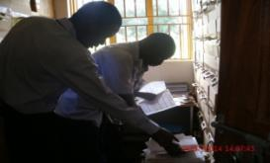

Regional Data Manager and District Data Assistant during their visit to Patongo ART clinic.

SCIPHA Project Success story and best practices.
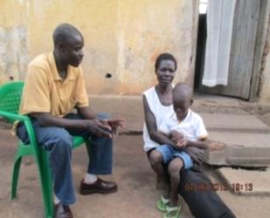  Project counselor during the fact finding of the child health problems. |  | A boy of 10 years old, resident of Oporot ward, Patongo Town Council and being taken care of by his step mother who is a widow and PLHIVS. Both biological parents of the boy had died of HIV/AIDS when he was only 4years old.  During family support visits in Nov.2014, WOSO counselors came across the boy and his caretaker at their home in Oporot ward. According to the care taker, she said the boy has been living with HIV/AIDS since his birth, the boy suffered from red eyes, general body weakness, severe skin rushes, and wound all over his head for 2 years without any proper treatment. The boy was enrolled for HIV/AIDS services at Patongo HCIII but the health conditions of the child never change and no longer go to school for studies. WOSO counselor counseled the care taker and gave her referral letter to St. Joseph hospital Kalongo for further treatment and gave them treated mosquito net, medicated cream, soap for the boy and the care taker was educated on the effective uses. (WOSO counselor made appointment for the next home visit/follow-up).
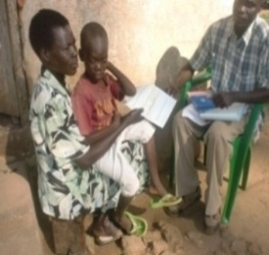  Support follow-up referral |  | Next follow up of the patient in Feb.2015, counselor found that the health conditions of the child is rapidly worsening; all his eyes is too red, total body weakness, not eating food, (observed and caretaker testified) immediately WOSO counselor wrote referral form and referred the child to Joint Clinical Research Centre of Excellent in Gulu for further investigation and treatment services.
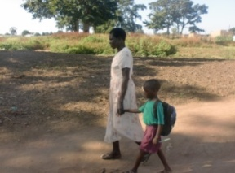  Child has improved and is able to go to continue with his studies like other children |  | After visiting JCRC Regional Centre of Excellent and got the right treatment, Aprol.2015 the child health has improved; he can now see well, no body rushes, eat food well, have strength, plays with other children and goes to school for studies. The family is now happy, appreciated SCIPHA project for supporting and saving the lives of their child.  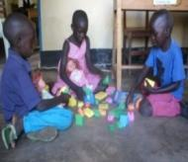
WOSO implemented strategies for PMTCT services

Strengthened the PMTCT services among grass rot women by initiating and supporting vibrant community based MAMA mentors clubs who actively supported mobilization, sensitization and referral of pregnant women for ANC, EMTCT, HCT and FP services to health facility.

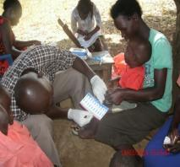
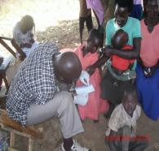
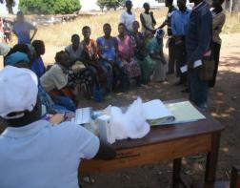
HIV+ mother testing for HIV of her exposed children Pregnant women accessing
HCT and PMTCT services

EMTCT strategies continued

- Sexual and reproductive health rights (SRHR) education for women and young girls
- Encouraging the family planning methods (dual protection) or using condom correctly and consistence.
- Encouraging frequent health facility visit for the case of rape and defilement.
- Encouraging women to bargaining for safer sex and abstains from sex for the case of young girls
- Formation of community based mama mentors clubs to support mobilization, sensitization, encouraging HIV+ pregnant women to access EMTCT, ANC, FP and HCT services and referral network and advocating for HIV positive women`s rights at community levels
- Supporting couple counseling at testing for HIV (CCT).
- Supporting pregnant mothers to visit health facility for ANC at least three times before delivery and provide post natal follow-up especially for HIV+ mothers at community.
- Support pregnancy mothers to access ANC services (During pregnancy, delivery and child breast feeding).
- Encouraging mothers for family planning services.
- GBV prevention and response.
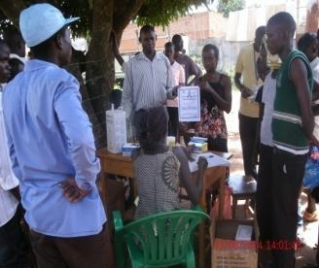
Couple receiving couple HCT certificate.

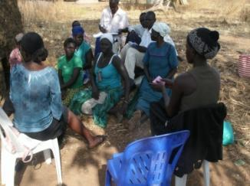
Support given to WER LWORO DISCORDANT CLUB has improved the quality of life of wer lworo discordant club members and these was justified by; testimony given by the members of the club especially risk reduction counseling support improved the life of the discordant couples, also SACCO support boosted their saving and making available fund for borrowing by members to start business income generating activity and now 80% the members are economic self-reliance, project support improved their households peace since during their weekly meeting they are being sensitized on Gender based violence prevention and children rights in the family, the family can meet minimum basic need and increased their weekly saving in the club compared to the life before the support from SCIPHA,

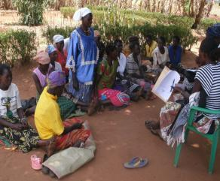
Support given to Kwo-mit mama club has improved the quality of life of the club members and these was justified by success story given by members of the club Akullu Ajuleta that support given to club boosted their activity on income generating and HIV/AIDS community mobilization and home based care support at community levels, she said SCIPHA project has made her to live up to date because she defaulted from ARV drug for 2 weeks with intension to die because of no support to her as the result of stress, then one day one member of kwo mit mama club reached my home during her home visit to PHA family and got me at home on the bed with no hope of life then the member counseled me for about 3 hours and later she promised to come back the following day, the following day she came back and continue counseling me and gave me referral to Patongo Health centre III and later she rolled me as member of Kwo-mit mama club for other support like IGAs social support to improve quality of my life and now I follow my ARV drug uptake and my lives has improved.

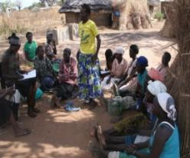

GUM-PAT-PAT MAMA Club during the SACCO Meeting, The mother standing giving testimony on her households lives improvement as a results of WOSO-SCIPHA project

