ANNUAL REPORT FOR THE YEAR 2013
ON THE ACTIVITIES OF

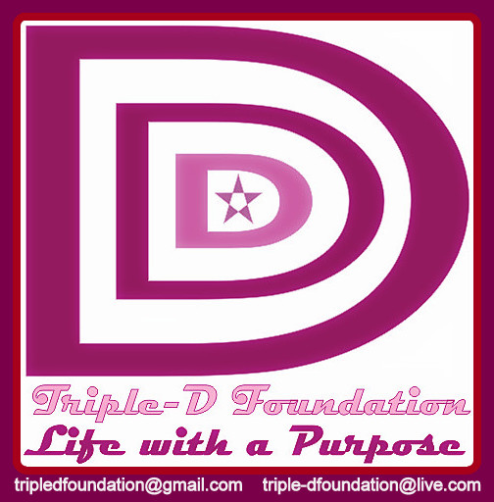
TRIPLE-D FOUNDATION
(TDF)

CONTENTS

- DIRECTOR’S REPORT ----------------------------------------------------------3
- INTRODUCTION --------------------------------------------------------------3
- VISION/MISSION STATEMENTS --------------------------------------------3
- ACTIVITIES IN THE YEAR 2013 ----------------------------------------------3
- LEADERSHIP TRAINING -------------------------------------------------3 –4
- LEADERSHIP & ACADEMIC SKILL DEVELOPMENT PROJECT- 3 –4
- HIV/AIDS PREVENTION PROJECT -------------------------------------------4
- PROJECT FUNDING ----------------------------------------------------------- 4
- ADMINISTRATION--------------------------------------------------------------- 5
- MANAGEMENT TEAM -----------------------------------------------------------6
- ORGANIZATION CONTACT ----------------------------------------------------6

SDIRECTOR’S REPORT
INTRODUCTION
Triple-D Foundation (TDF) is an independent non-partisan, nonprofit, educative and human-development organization based in the Gambia. TDF became officially registered on February 5th 2013, for the purpose of helping youths to maximally utilize their potentials by encouraging the habit of self-DISCIPLINE, self-DISCOVERY, and self-DEVELOPMENT through training and education.
In spite of our numerous challenges, we have been able to keep track with our Mission and Vision. Several meetings were held by the members to draft a plan of action for the next three years. Some members stopped attending meetings while new members were also joining. By and large, we give God all the glory for keeping and leading us throughout the journey of year 2013.
Vision statement:
Tripled-D envisions a Gambian community, where people are living in friendly, sanitized, and peaceful environment with access to basic education and are fully aware of HIV and AIDS.

Mission statement:
Triple-D is a non-profitable and non-political organization whose mission is to assist and guide the YOUTHS, (men and women) in looking inward with the aim of maximizing their potentials and natural gifts through a process of self-discipline, self-discovery and self-development, through education and training, formulated with developmental plan rooted in the awakening of spirit and mind, for a successful and purpose-driven future.

ACTIVITIES IN THE YEAR 2013
LEADERSHIP TRAINING
LEADERSHIP & ACADEMIC SKILL DEVELOPMENT PROJECT was launched as our first official project in line with our Mission and Vision statements of helping youths to develop or maximize their potentials. The contents of this workshop include:
1. Philosophy of success and achievement.
2. Fundamentals of leadership Psychology.
3. Speech-Making and Communication Skill.
4. Tips on other academic subjects.
The 1st Leadership training workshop took place on September 28th 2013 at National Nutrition Agency Mile 7, Bakau. It was successful. More members were drawn to the organization.
This was followed by the second version of the leadership workshop which took place on October 26th 2013. The last session of Leadership & Academic Skill Development was held on November 24th 2013.
The feedback we keep getting from the participants indicate that problems of pent up, redundant, undeveloped, underdeveloped, unused gift and potentials, are gradually been solved as these gifts and potentials are being discovered and developed through practical training.
HIV/AIDS PREVENTION PROJECT
Having observed the growing trend of young people involvement in self-injection (through drug abuse), tattoo, prostitution and pornography and in compliance with TDF goals and action plan on Health, HIV/AIDS PREVENTION PROJECT was embarked on. The Seminar took place on November 23rd in NaNA Conference Hall, Mile 7, Bakau, under the theme “HIV/AIDS PREVENTION PROJECT” (AVOIDING THE DANGERS OF HIV/AIDS).
There were 43 participants drawn from various Schools and backgrounds. The workshop, based on the participants assessments, was fulfilling and rewarding.

PROJECT FUNDING
In Triple-D Foundation, all projects, activities and administrative cost so far have been self – funded. We are grateful to God for enablement through His mercy.

ADMINISTRATION
We had a serious challenge in the area of our board membership as some members holding vital positions such as General Secretary, Deputy Chairman, and so on, were constantly absent from board and general meetings. However, necessary adjustments were made by allowing volunteer members to play their official roles. The following charts shows the names and positions of board members.
THE NAMES OF THE BOARD OF THE ORGANIZATION
S/no | Name | Title
1 | Pa Seedia Gassama | Chairman
2 | Liz Olayinka | Head of Finance
3 | Fatou Krubally | Welfare Officer
4 | Echen Jatta | Project Coordinator
5 | Moses Jassey | General Secretary
6 | Lawrence Owoyemi | Executive Director
7 | Sukai Suso | Treasurer
8 | Oulimatou Ceesay | P.R.O.
9 | Emmanuel Owoyemi | Member
10 | Nicholas Jeremiah Jatta | Member
11 | Fatoumatta D. Jallow | Member

MANAGEMENT TEAM
The chart bellow displays the names and roles of TDF Management Team.

THE NAMES OF THE MANAGEMENT TEAM OF THE ORGANIZATION
S/no | Name | Title
1 | Dr. Lawrence Owoyemi | Executive Director
2 | Echen Jatta | Project Coordinator
3 | Liz Olayinka | Head of finance
4 | Sainobou Mbye | Program Coordinator
5 | Suzan Abazeid | Social Secretary
6 | Yusupha Touray | Administrative Secretary

ORGANIZATION CONTACT

Triple-D Foundation
Old Jeshwang, KMC.
Greater Banjul
The Gambia.

Tel: +220-7805015, +220-6884131
E-mail: tripledfoundation@gmail.com
www.facebook.com/tripledfoundation

