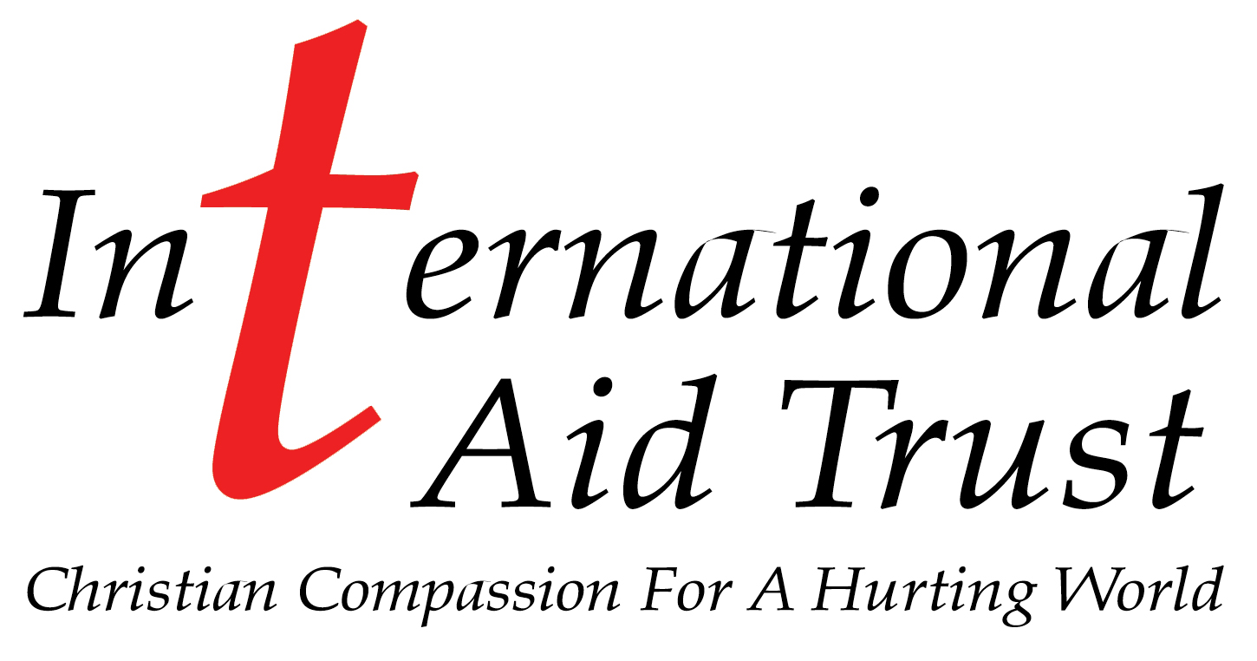 | Longton Business Park  Station Road  Much Hoole  Preston  PR4 5LE  Tel: 01772 611000  Fax: 01772 619933  Email: office@internationalaidtrust.org.uk

A Christian humanitarian charity that has come from dreams and small
beginnings – to helping many thousands, both at home and abroad.

International Aid Trust began its work in 1991. During my first visit to the former Soviet Union I saw images of pain and suffering that would never leave me and returned home with a dream, a vision to make a difference. Today that dream has become a reality and despair has been turned into hope for a better future for many thousands of needy, including those of our own country. We have a wonderful team of volunteers, caring dedicated individuals with hearts of gold, who give of themselves to help others. Without them none of this would have been possible.

Our work includes the following:

- UK: Helping the needy here at home by networking with other UK charities, which includes; rehabilitation of offenders, the long term unemployed, occupational therapy for youngsters with learning difficulties, supporting and re housing programs for the homeless, practical help for the disadvantaged, training for long term unemployed, NVQ’s (in warehousing and fork truck driving). Much of our UK work is of a personal nature and therefore cannot be publicised.

- Humanitarian Aid: Collection, sorting and delivering millions of pounds worth of much needed aid to many different countries including; Albania, Afghanistan, Belarus, Gambia, Ghana, Georgia, Kenya, Malawi, Moldova, Mexico, Romania, Russia, Swaziland, Uganda, Ukraine, Sri Lanka and many other destinations. Each request is carefully considered from many different angles. Our dedicated team of managers identify the needs and then administer the aid distribution. Last year we are averaged 2 forty-five foot articulated trucks and containers per week.

- Deprived Children’s Holidays: Every year thousands of needy children are given Christian recuperative holidays at our two centres near the Black Sea coast in Ukraine, plus six others that we operate within Ukraine and Belarus. Hundreds of jobs have been created at these centres, and also in the cottage industries that we support.

- Christina’s Houses: Providing houses for disadvantaged children, (i.e. street children and orphans) by building or buying properties, plus renovating and equipping them. These houses are staffed by very caring house parents who are (to all intents and purposes) real parents. These are supported and staffed from local churches.

- Family sponsorship program: We now support over eight hundred children and adults in one hundred and sixty families within Eastern Europe, and soon to be operating in Africa.
£15- £20 per month can double a poor family’s income.

- Caring for the sick: We provide medical and surgical care for people of all ages.

- Drug & alcohol rehabilitation: Help and positive assistance is given to many young men, women and children at over twenty centres at which we support and monitor.

- Various building projects and restoration projects.

- Pastoral care for many thousands is supported by us through our network around the world.

Some of our successful projects include:

- The joint Rotary IAT Village in Sri Lanka following the tsunami in 2004, a very difficult but ultimately successful project.

- The building of the Harvest International /IAT International Orphanage near Colombo in Sri Lanka.

- Expansion of prison ministry, including the provision of teachers for the youth, (14-18 yrs) remand centres where 90% of the inmate are illiterate. Most of these were given their first custodial sentences after stealing food, or money to fund drugs.

- Disabled centre at Myakie Ukraine. This was built in Lancashire, transported, and erected by us. It has enabled young invalids to experience something unknown to them before, free, caring holidays with all the necessary facilities. (We now need to acquire a left hand drive mini bus for this project).

- The purchase and conversion of a derelict children’s nursery, into a home for forty rescued youngsters in central Ukraine, now nearing completion.

- The equipping of a premature baby unit in the Odessa region. We were able to supply used equipment from hospitals in the UK, it was shipped out and then installed by Dr Yuri. This was opened in July 2005 and now for the first time premature babies are being given a fighting chance. Our first success story was a little girl who weighed in at 1.2 kilos and since then many under term babies have been saved to the delight of their parents.

- The equipping of a new sixteen bed, breast cancer unit, with every item for the two wards collected in the UK and despatched from our warehouse.

- Completely re-equipping a large maternity hospital.

- Building block manufacturing. An amazing project, creating jobs, supporting families and meeting very necessary needs.

- Tent holidays: For the last few years, as part of our general children’s holiday project, we have held tent camps in Eastern Europe. Now, with the help and support of Rotary, we have built up a much bigger and improved, “Tent Holiday” program. The tents have been provided by Rotarians who have rescued them after the various music festivals around the country. They have then been collected by IAT and then sorted into different type’s and sizes, then shipped to our various projects, some for disaster relief and others to provide holidays for very needy children.

Last year we held a “Tent Camp” for 450 children and their helpers on the Black Sea coast, near Balaclava in the Crimea. It was a wonderful success. The camp site is situated in a National Park with the only access by ferry. The tents and other equipment had to be transported over the mountain pass by a (new) 7.5 tonne, 4x4 ex army truck towing a field kitchen that we had hired. (We are now looking to purchase these items from the Army Surplus for a bargain price of £3,000) Clean, clear seas, fishing, water sports, walking, rock climbing, swimming and endless sunshine. The common answer from the children, when asked about their holiday was, “It is paradise!” Next year we hope to expand this vision with more camps in Crimea and at our “New Hope” site near Odessa.

So much has been achieved that we can only touch on it here. Would you like to join us in our vision to help the needy? Lives are being changed forever because someone cares. We need contacts for dried and tinned food of every description, summer and winter clothing, medical supplies, equipment and ideas to begin cottage industries, and of course funds to make all this possible.

A word on finance: Not one penny of public donation goes into admin. All these costs are generated by our marvellous charity shops selling donated goods and raising more than half of our income. Our admin is currently running at les than five percent and we do our utmost to make every penny count, using the most cost effective means of transport and other essentials.

Every pound is hard won and we make every penny count

Please ask for a speaker or for an audiovisual presentation for your church, club, assembly or conference etc.

Don’t put your donations into a “Black Hole” We can tailor make a project to fit any budget.

We need you; our dream is growing.

Rev Bernard Cocker
Founder & Director

