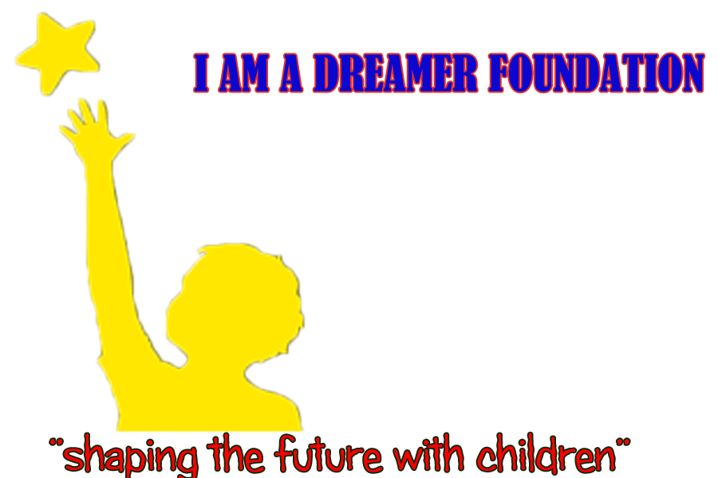

I AM A DREAMER FOUNDATION
“HELPING DREAMERS BECOME ACHIEVERS”
I AM A DREAMER FOUNDATION is a unique organization that helps children, families and communities by helping children categorized as Orphans and Vulnerable Children (OVC) achieve their desired dreams.
MISSION (Why do we exist?)
Our mission is to educate and empower children, the next generation of change agents, whose dreams and actions transform the future of South Africa, Africa, and the World.
We are going to achieve this through educating children to confidently address life’s challenges, thrive in the global economy and catalyse positive change.
VISION (What is the future we seek to bring about?)
- Helping dreamers become achievers.
We want the communities in which each child has the opportunity of optimum growth and development, and each family is able to provide the best for its children.
I AM A DREAMER FOUNDATION AIMS TO:
- Demonstrate ambition: we are keen to succeed in step-changing our results and inspiring others through our vision for the health of the children.
- Work well with others: showing respect for others and working cooperatively to facilitate better results all round.
- Be creative: able to come up with new ideas to improve children’s lives.
- Be appreciative: for the support we receive from all quarters.
- Professional: working hard to improve standards and deliver on our commitments.
- Open: honest and transparent in our dealings with others.
- Have fun: working in a serious and important area, but aiming to enjoy so.

OUR CORE VALUES (What core ideals guide our decisions and actions?)
We are Child Centred
Our children are at the centre of every decision we make. We are committed to ensuring their well-being and positive development.
We Model Excellence
We pursue excellence in everything we do. We are continuously improving to better serve our mission.
We Inspire
Our children, community members, staff and supporters grow through their relationships and achievements with us.
Leadership
We listen to and learn from our community. We address the root causes of community problems and mobilize resources for the common good.
Equity
We strive for equity and we focus primarily, but not exclusively, on children who are orphans and vulnerable.
Inclusiveness
We practice and champion inclusiveness in our community. We honour diverse strength, needs, voices, and backgrounds of all members of our community.
Accountability
We serve as stewards for our stewards for our community investments and honour the charitable intentions of our donours to meet current and future community needs. We hold ourselves to the highest standards of ethics, integrity, service, and fiduciary responsibility.
Our Purpose is Clear
We are intentional in every aspect of our programs. Our experiences are carefully designed to support children in the achievement of our outcomes.

We Use Resources Wisely
We ensure our finances, people, facilities, supplies and equipment are used to their best advantage.
We Value People
We regard all people as created and loved by God. We give priority to people before money, structure, systems and other institutional machinery. We act in ways that respect the dignity, uniqueness and intrinsic worth of every person – the poor, the donors, our staff and their families, boards and volunteers. We celebrate the richness of diversity in human personality, culture and contribution. We practice a participative, open, enabling style in working relationships. We encourage the professional, personal and spiritual development of our staff.
We Are Partners
We accept the obligations of joint participation, shared goals and mutual accountability that true partnership requires. We are willing to receive and consider honest opinions from others about our work.

OUR COMMITMENT
We acknowledge that values cannot be legislated: they must be lived. No document can substitute for the attitudes, decisions and actions that make up the fabric of our life and work. Therefore, we covenant with each other, before God, to do our utmost to uphold these Core Values, to honour them in our decisions, to express them in our relationships and to act consistently with them wherever Dreamer foundation is at work.

OUR APPROACHES

DEVELOPMENT APPROACH
I AM DREAMER FOUNDATION’S approach to development is focused on improving the well-being of children, especially the most vulnerable. A commitment to sustainability is at the heart of all we do.
Building on local assets in collaboration with communities and partners, I AM DREAMER FOUNDATION sustain well-being of children by working at four levels:
Children
Empowering children with good health, spiritual nurture, and basic literacy, numeracy and essential life skills. These skills enable children to be productive, contributing citizens and agents of change throughout their lives.
Households and families
Improving household resilience by increasing livelihood and caregiving capacity. Caregiving includes physical, psychosocial and spiritual care, as well as issues of resource allocation and gender equity within households. This ensures that increased income and assets lead to improved child well-being for both girls and boys.
Community
Strengthening the resilience and capacity of communities and partners to respond to present and future challenges to child well-being.
Enabling environment
Working to ensure that systems, structures, policies and practices (at local, national, regional and global levels) support and protect the well-being of children, especially the most vulnerable.

EDUCATION AND LIFE SKILLS APPROACH
Life without education is a life without opportunity. We help children, especially the most vulnerable, access quality education and attain functional levels of literacy, numeracy and essential life skills. When children can read, they can better advocate for their rights and help provide for their families.
In order to reach these goals, we work with children, families and communities so that:
- Children read, write and use numeracy skills.
- Children make good judgements, can protect themselves, manage their emotions and communicate ideas.
- Children can access and complete education.
Dreamer Foundation works with parents, community members and local partners to ensure that:
- Parents are equipped to help their children learn in the home.
- Community volunteers are trained to host after-school activities.
- Whole communities get the opportunity to create learning materials for children that reflect their traditions, values and language.

HEALTH APPROACH
I AM A DREAMER FOUNDATION is committed to improving the health and nutrition of women and children in the areas in which it works, contributing to the global reduction of under-five and maternal mortality.
Good health is the foundation of a child’s life. Dreamer foundation aims to ensure that mothers and children are well nourished, protected from infection and disease, and have good access to essential health services.

CHILD PROTECTION APPROACH
Child protection is a top priority. The first commitment is for Dreamer Foundation itself to be safe for children. Building on that foundation, Dreamer foundation seeks to empower children, families, communities and partners to prevent and respond to exploitation, neglect, abuse and other forms of violence affecting children, especially the most vulnerable.
Together with its partners, I AM A DREAMER FOUNDATION supports
- Preventing exploitation, harmful traditional practices and violence against children in their families and communities.
- Protecting children living in vulnerable situations in communities
- Restoring children who have been abused, neglected or exploited.
DREAMER FOUNDATION uses a systems approach to child protection. This approach helps strengthen the protective environment around children, as well as the children themselves, by addressing child protection issues in a comprehensive and sustainable manner.
Dreamer Foundation defines a child protection system as a set of coordinated formal elements (for example, national legislation or social services) and informal elements (for example, families and churches) working together to prevent and respond to abuse, neglect, exploitation and other forms of violence against children.
It affirms the role of parents and caregivers as the first line of support responsible for care and protection of children, while also affirming the responsibility of the country to guarantee the care and protection of children.

GENDER APPROACH
Integrating gender into programing can be the key to catalysing transformation in a community. Applying gender equity across the life cycle can break cycles of poverty and deprivation, allowing boys and girls to enjoy life in all its fullness.

I AM A DREAMER FOUNDATION EXISTS TO ENSURE ORPHANED AND VULNERABLE CHILDREN REALIZE:
- The right to a stable, loving and nurturing environment
- The right to health care and nutrition
- The right to clean water and electric power
- The right to a quality education
- The right to equal opportunities
- The right to guidance from a caring adult
- The right to be heard and participate in decisions that affect them
- The right to be prepared for active and responsible citizenship
- The right to protection from abuse and neglect
- The right to live in conditions of dignity and freedom
- The right to spiritual development
- The right to live with their parents or relatives, if possible.

WHAT DO WE DO?
We have a well-established system of community based care and support for orphans and other vulnerable children (and their families) that involves capacitating and supporting community based Fieldworker teams to respond to the basic material, physical, cognitive and emotional needs of orphans and vulnerable children (OVC) within their communities.
In brief, we do this by engaging and training residents from the communities in which we work to identify and address the basic needs of families caring for orphans and other vulnerable children in their communities.
With the support of I AM A DREAMER FOUNDATION staff, these Fieldworkers then address the basic material, physical, cognitive and emotional needs of OVC households in their community by:
- Identifying indigent families caring for orphans and other vulnerable children in their communities
- Working with the extended family to identify and place an adult caregiver in the household if needed.
- Conducting regular home visits to monitor and support these families
- Providing emergency assistance to those families in dire need.
- Facilitating access to relevant state grants
- Facilitating the establishment & maintenance of household food gardens
- Facilitating access to community based self-help / micro finance groups
- Facilitating access to school fee remissions
- Distributing school uniform items to OVC’s.
- Conducting regular school visits to monitor the attendance and performance of OVC’s in their care
- Monitoring the health of family members during home visits and facilitating OVC and caregiver access to local primary health care facilities whenever necessary
- Facilitating OVC & caregiver access to professional welfare services and counseling.
- Facilitating community based Life-skill programmes for teenagers and support groups for Caregivers & and younger Children

HOW DO WE DO IT?

The following criteria are used to identify vulnerable households in the communities in which we work:
- There is at least one orphan under the age of 18 living in the household, or
- The parents/caregiver is terminally ill, or
- The caregiver/parent is physically, mentally or emotionally incapable of providing appropriate care to the child(ren) or
- The biological parent(s) have abandoned the child (ren) (their whereabouts being unknown).

AND
- The household income is inadequate to meet the basic needs of the child(ren), or
- The care given by the parent/caregiver is inappropriate (i.e. there is physical, sexual, emotional or economic abuse, neglect and/or exploitation), or
- The child (ren) displays emotional and behavioural difficulties that necessitate support.
Once identified as vulnerable in terms of these criteria, households are supported via a structured system of household intervention that is designed to systematically address their basic material, physical, cognitive and emotional needs and move them from a state of vulnerability to increased stability and self-reliance. The foundation will be using the phased model of household support and development as explained below:

Stage 1: Identification (months 0-3) | Stage 2 Support/intervention (months 4 upwards)
- Household baseline assessment  - Fieldworker assignment & fortnightly home visits  - Caregiver placement (needs based) and Document & Grant applications  - Emergency food relief (needs based)  - Provision of critical furniture & equipment (Needs based)  - School attendance & performance assessment  - Health assessment, education & testing | - Monthly home visits  - Grant access & grant usage monitoring  - Emergency food relief (needs based & until grant secured)  - Food garden development & support (Voluntary)Caregiver access to Self-Help / Micro Finance groups (voluntary)  - School attendance & performance monitoring  - School uniform provision (need & criterion based)  - Health monitoring & treatment compliance support (Voluntary)  - Emotional Well-being monitoring & access to individual or family counselling (voluntary)  - Family engagement in memory work (voluntary)  - Access to OVC life-skill program (voluntary)  - Access to Children’s support group (voluntary)  - Access to Caregiver support groups (voluntary)

WHY DO WE DO IT?

THE PROBLEM
It has come to our realization as the Foundation that even though South Africa and other African countries have successful transition to democracy; poverty, illiteracy continues to dominate the lives of millions of South African children and their families.
- 54% of all children in South Africa (approximately 18.6 million) live in poverty with a per capita income below R671 per month;
- 31% of all children in South Africa live in households where no adults are employed in either the formal or informal sector;
- 17% of all children in South Africa in households where there is child hunger (the lack of regular meals);
- 23% of all children in South Africa live in overcrowded households;
- 21% of all children in South Africa have been orphaned (either single or double);

Children growing up in these circumstances are rendered extremely vulnerable by, amongst others:
- The demands of having to care for dying parents
- The trauma associated with the loss of their parents
- The loss and lack of material security (household income, shelter, security of tenure and physical protection)
- The lack of food security resulting in hunger and an increased risk of malnutrition
- The loss of childhood as a result of having to take on adult roles (e.g. provider and caregiver to younger siblings)

This results in:
- An increased likelihood of absenteeism, failure and premature exiting from formal schooling
- An increased risk of substance misuse and involvement in (survival) crime
- An increased vulnerability to exploitation (violence, sexual abuse, child labour etc.)
- An increased vulnerability to emotional and behavioural difficulties
- An increased vulnerability to HIV infection and teenage pregnancy.
Ultimately, this maintains the cycle of poverty and undermines the ability of the child to live a full and meaningful life.
OUR HOPE FOR FUTURE
We look forward to a world where every child experiences Jesus’ promise of life in all its fullness.
Where they are protected, cared for and given the opportunities to become all God meant them to be.
Where they grow strong in communities free of need and full of promise.
Where families are valued, creation preserved and the most vulnerable live in security and confidence. Where they become responsible citizens of well-led nations.
Where peace and justice reign and all have the right to contribute.
Where they flourish in a world where the treasure of our hearts and the measure of our wealth is the happiness and well-being of all children. In such a world, we all taste the joy of the Kingdom of Heaven.

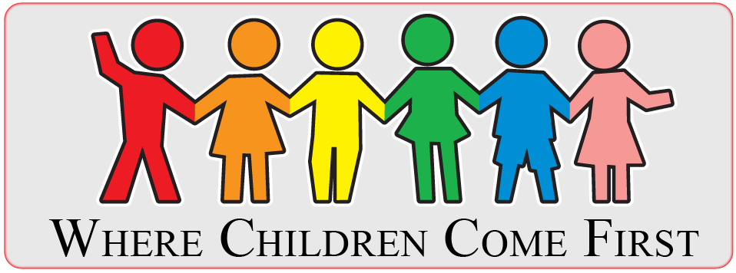
I AM A DREAMER FOUNDATION

