Executive Summary:
Personal Details:
Name of venture | M/s Tribal Enterprises Pvt Ltd  (Regd. No. ADCC/2/WV/14-2011, Government of Manipur)
First Name | Joseph Joute
Last Name | Joute
Position | Managing Director
Direct Telephone number | +91 9862829250
Mobile Telephone Number | +91 9862829250
Contact Email | josephjoute@gmail.com
Address | Rengkai, Bible Hill, Churachandpur, Manipur, India
Postal Code | 795 128
City the venture is located | Churachandpur
State is venture located | Manipur, India
Website | http://biblehillyouthclub.wordpress.com
Structured of legality | Sole proprietorship
Year the venture incorporated | 2011
Which sector does your venture target? | Livelihoods
About the Venture | A social enterprises that generate 6 regular employments, Rs. 30, 60, 000 net profit and directly impacts 1800 women a year
The turnover, gross profit and net profit for the last 12 months | Add your financials in INR (Indian Rupees)
  Year | Turnover (INR lakhs) | Gross Profit (INR lakhs) | Net Profit (INR lakhs)
  2012 | 63, 00, 000 | 57, 60, 000 | 30, 60, 000

The Innovative Social Enterprises:
Starting with $ 32, 000 (Rs. 17, 28, 000) grants from the International Fund for Agriculture Development (IFAD), Rs. 6, 00, 040 from family and self, and Rs. 10, 27, 674 contribution from the organization. I construct a Community Training & Production Centre, 28 x 16 feet one story building and installed with 6 innovative (Eastern-based technology) weaving machines in 2011.

Women Empowerment:
Women, who have no income before, depending on shifting cultivation and forest products, are now able to earn Rs. 5, 000 to Rs. 6, 000 a month (Rs. 250-300 a day) with just 8-10 hours of working in an environment friendly, pollution free working conditions producing eco-friendly fibres of traditional modern-women wears, stimulating sustainable economic growth and positive social changes. I reach out to 72 women and youths in weaving skill training and provided 6 regular employments a year.

The Products: The products are market-based eco-friendly traditional modern-women wears/designs for which the market demand is still rising. Some pictures of our products are given below:

Pictures of Our Products: (below)
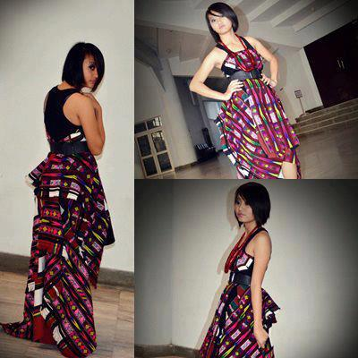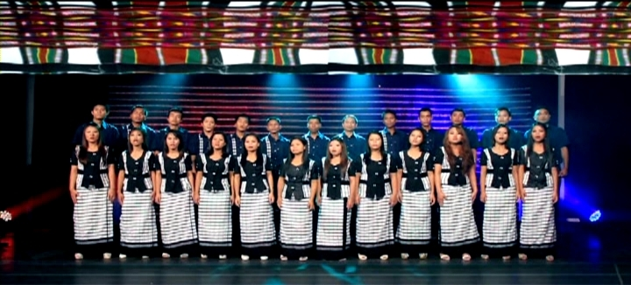
Fashionable designs call Hmar-Puonlaisen: Our products are order and wears by Gospel Choirs:
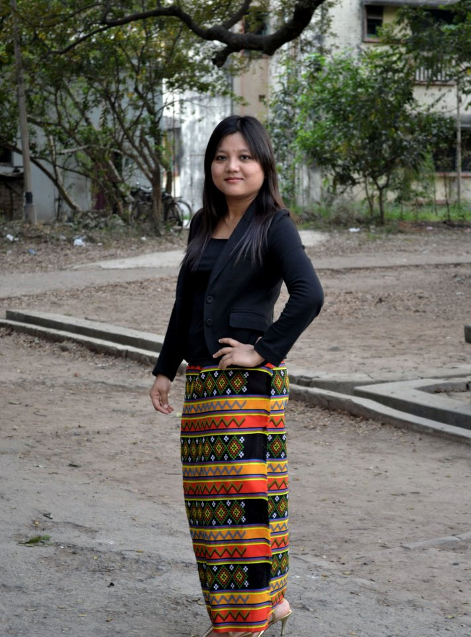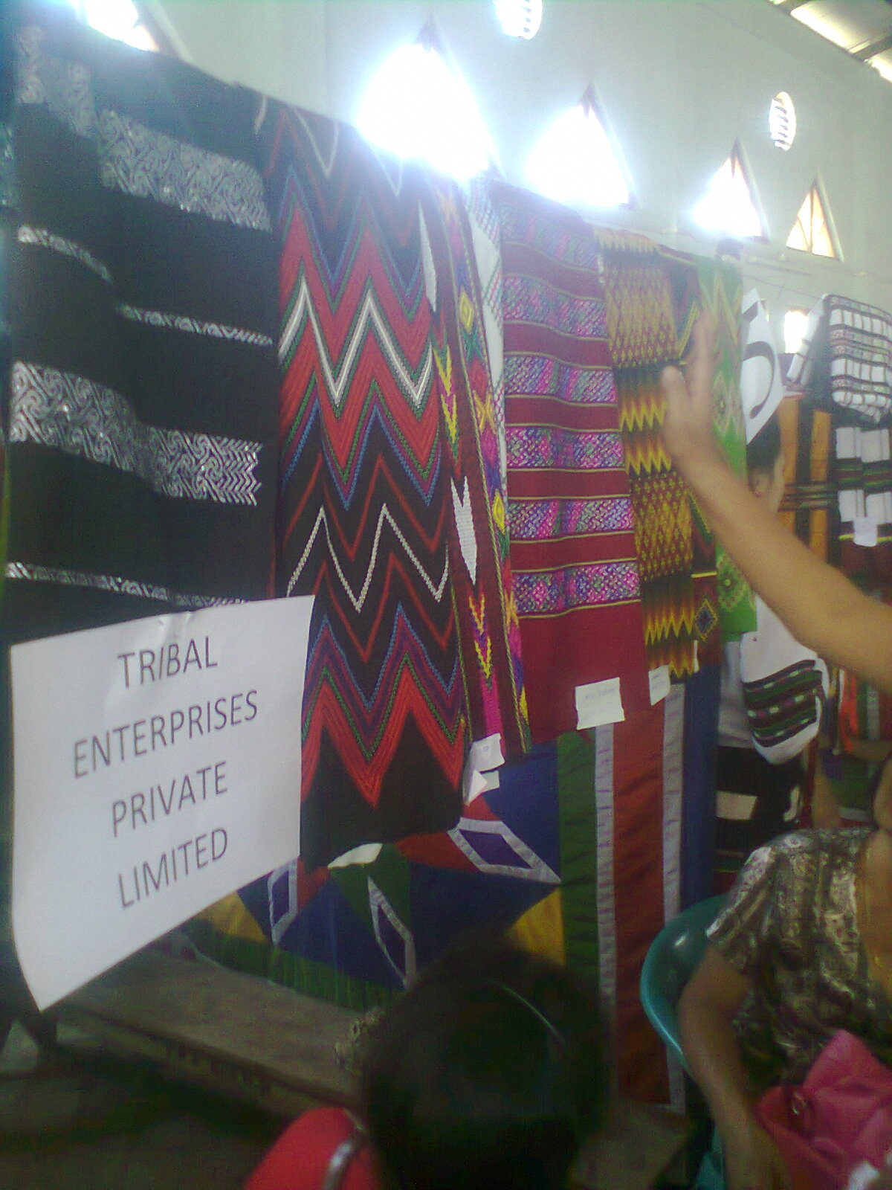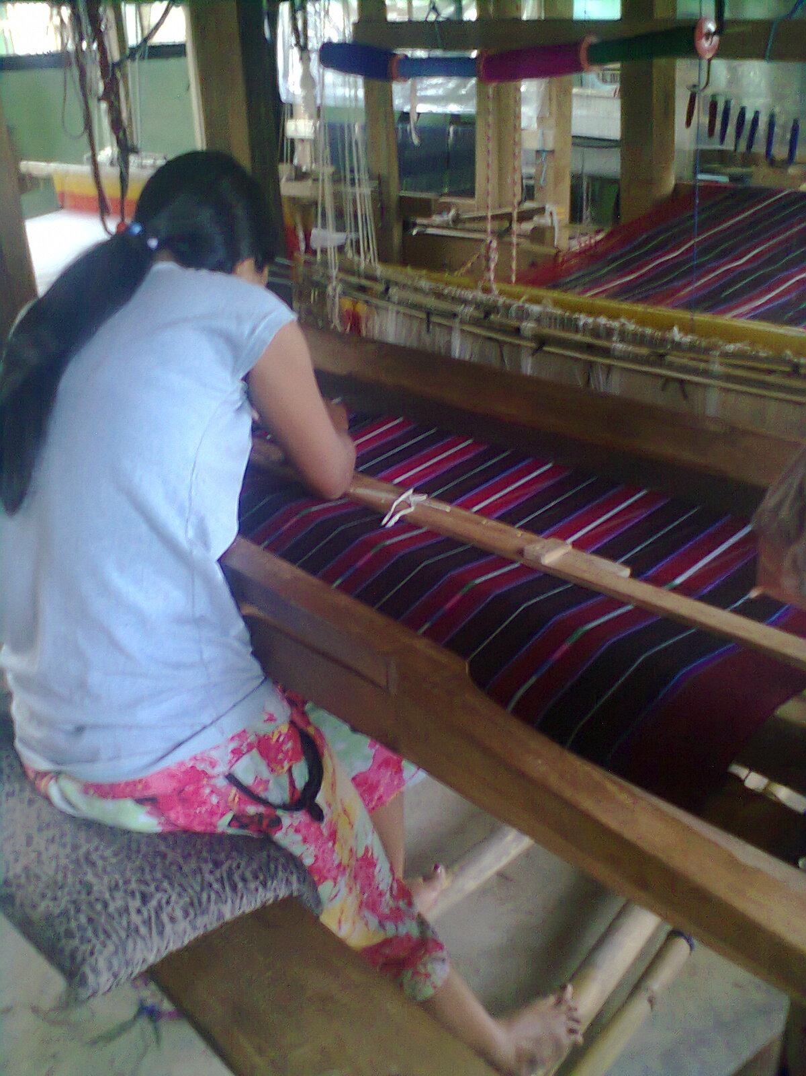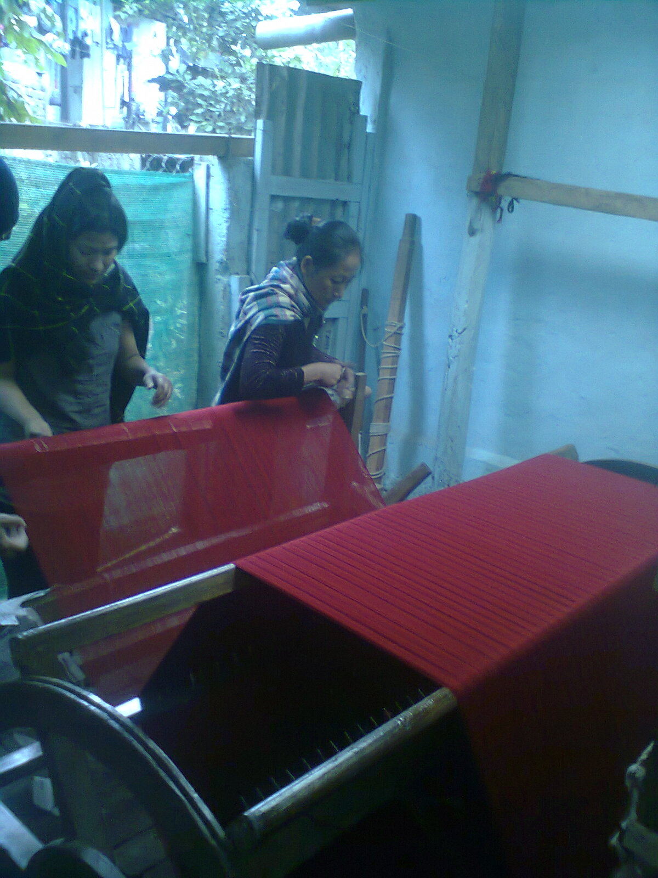
For women and youths in different shapes & styles: The machines that weave the products

How it Works: Designed Production:
No of Machines: | Working Hour a day: | Cost of Product: | Daily/Weekly Production: | Monthly Production: | Total Amount in a Year:
1 | 8 hrs a day | Rs. 3, 500 | 1 pieces a week | 4 pieces =  Rs. 14, 000 | Rs. 1, 68, 000
6 | 8 hours a day each | Rs. 5,000 (Better designs) | 1 pieces a week each (present) | 24 pieces =  Rs. 84, 000 | Rs. 10, 08, 000
Future Plan/Forecasted  (See 3 Yrs Plan) | By upgrading the machines to produce 1 product a day. This is where I hope the Artha Venture can help me develop the machines with finance and technological knowhow.
1st Year:  10 machines | 8 hrs a day each | Rs. 3, 500 | 10 pieces a day | 250 pieces a month =  Rs. 8, 75, 000 | Rs. 1, 05, 00, 000
2nd Year:  20 machines | 8 hrs a day | Rs. 5, 000 | 20 pieces a day | 500 pieces a month = Rs. 25, 00, 000 | Rs. 3, 00, 00, 000
3rd Year:  30 machines | 8 hrs a day | Rs. 5, 000 | 30 pieces a day | 750 pieces a month = Rs. 37,57, 000 | Rs. 4, 50, 00, 000

NOTE: The Plan is to increase the machine every year with 10 and replicating the system/mechanism to others settings to other North Eastern States and mainland India.

Joseph Joute, Managing Director
M/s Tribal Enterprises Pvt Ltd
Rengkai, Bible Hill, Churachandpur, Manipur, India Tel. +91 9862829250, E-mail: josephjoute@gmail.com


