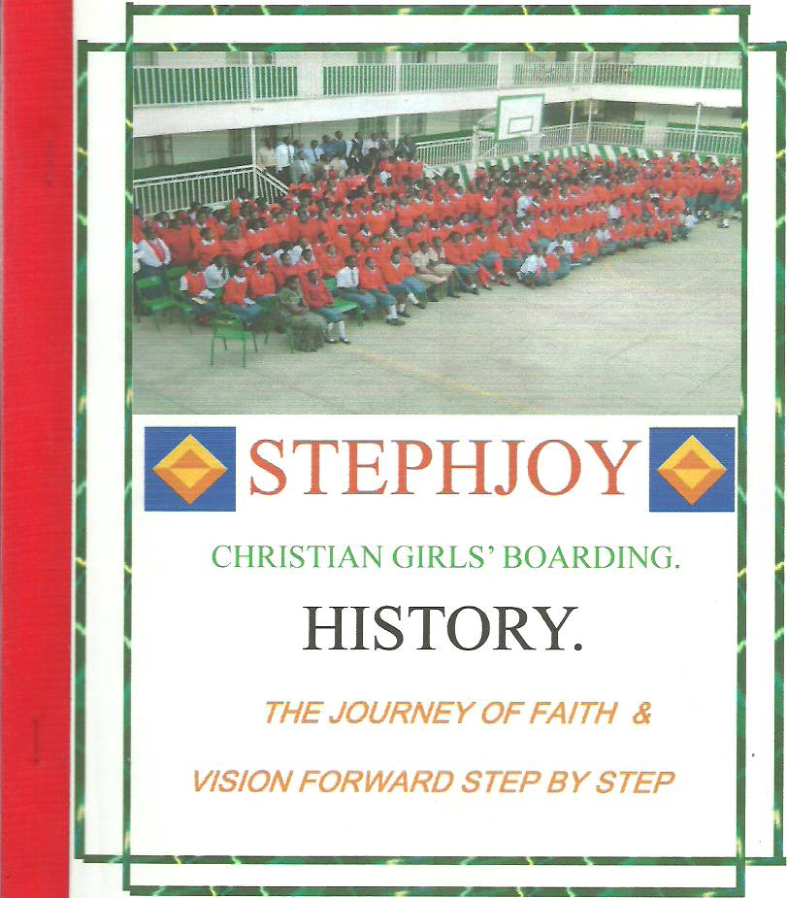

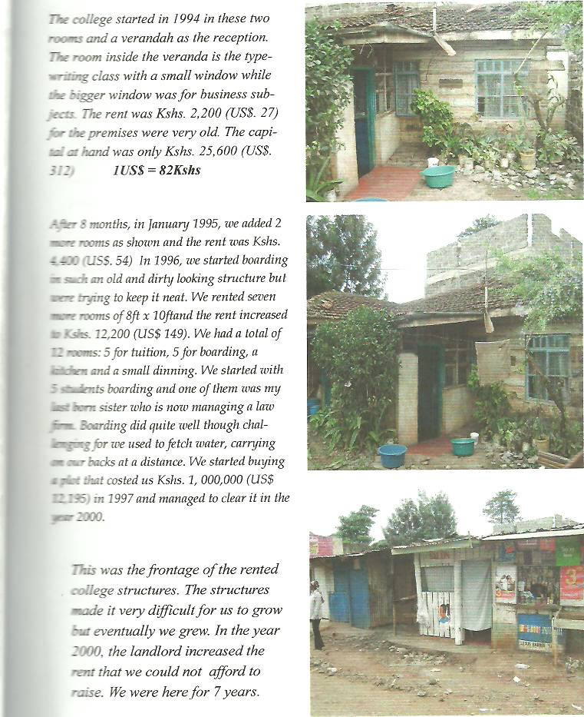

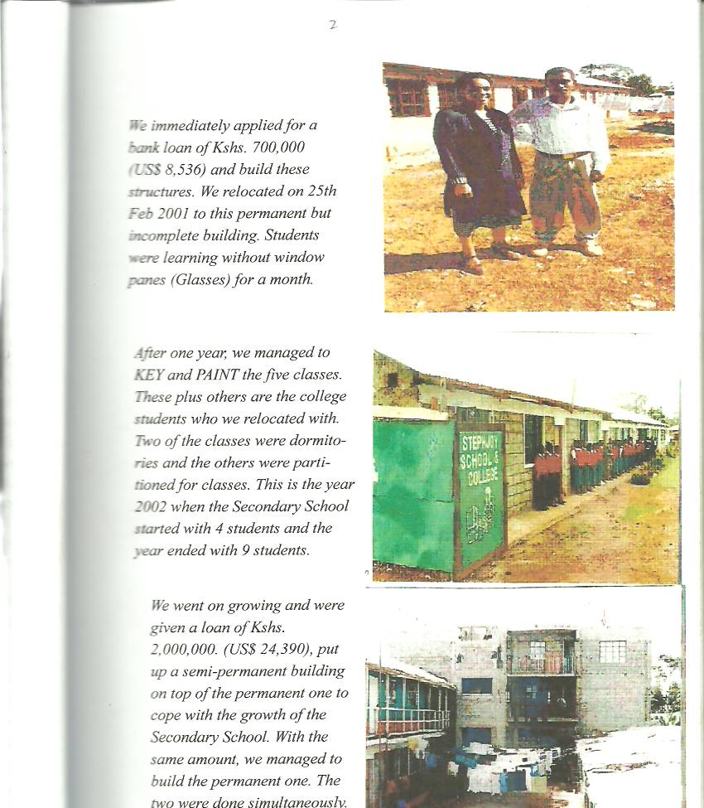

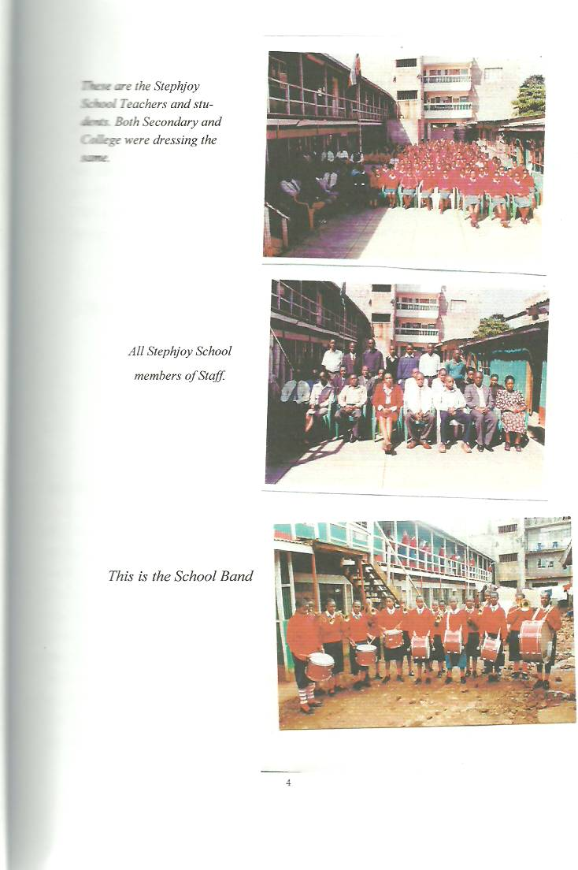

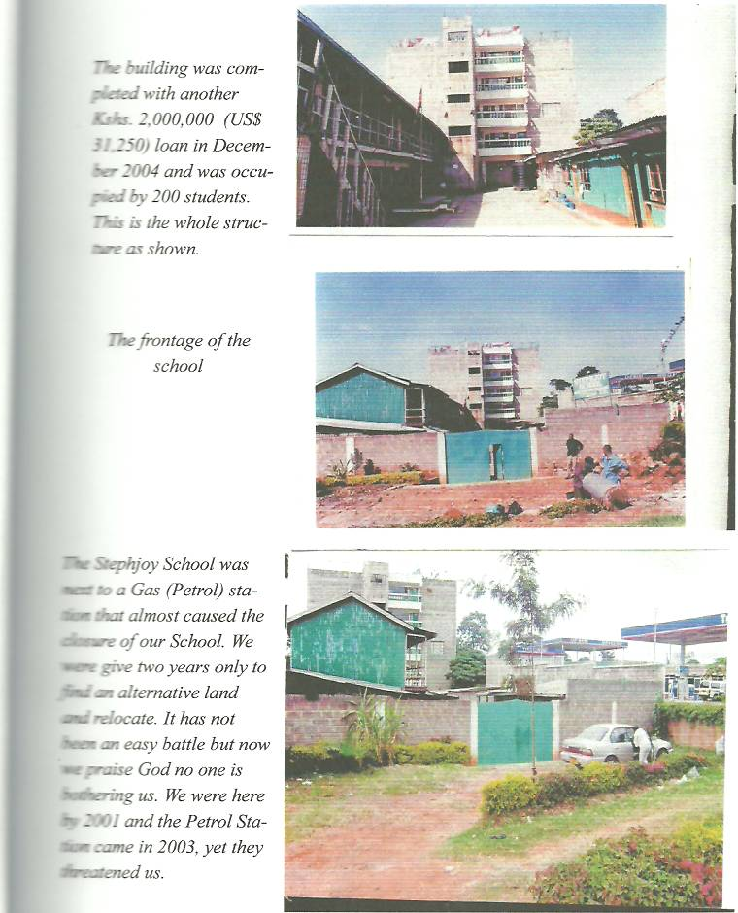

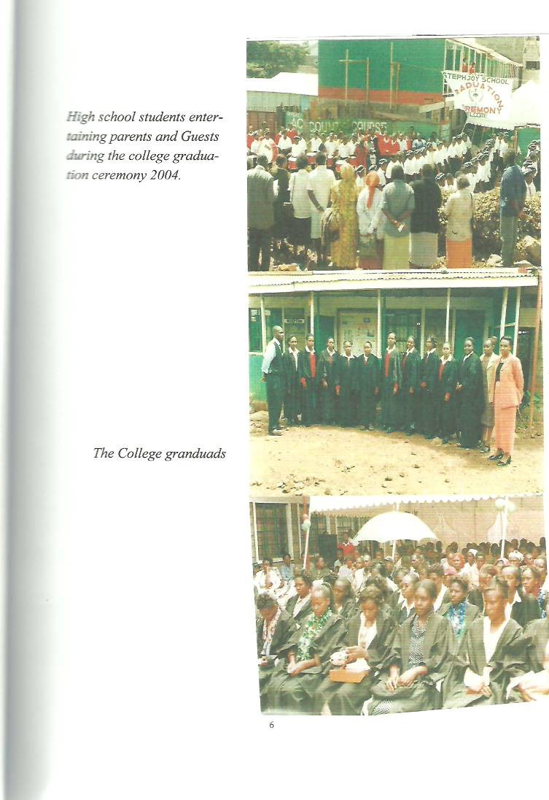

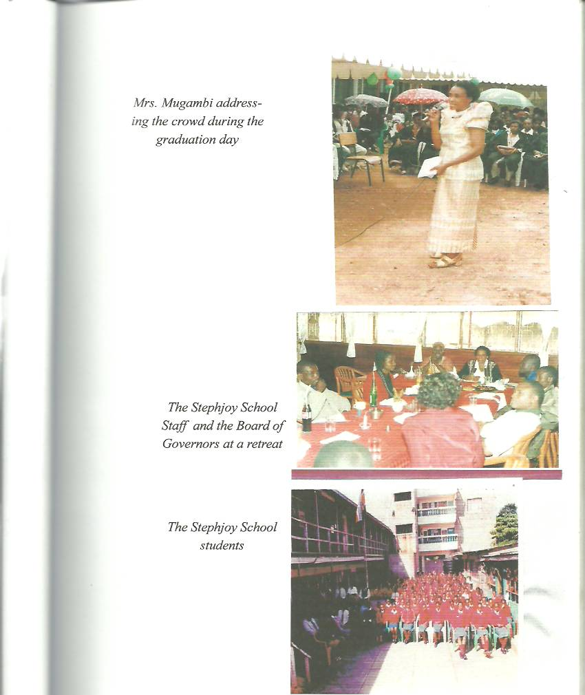

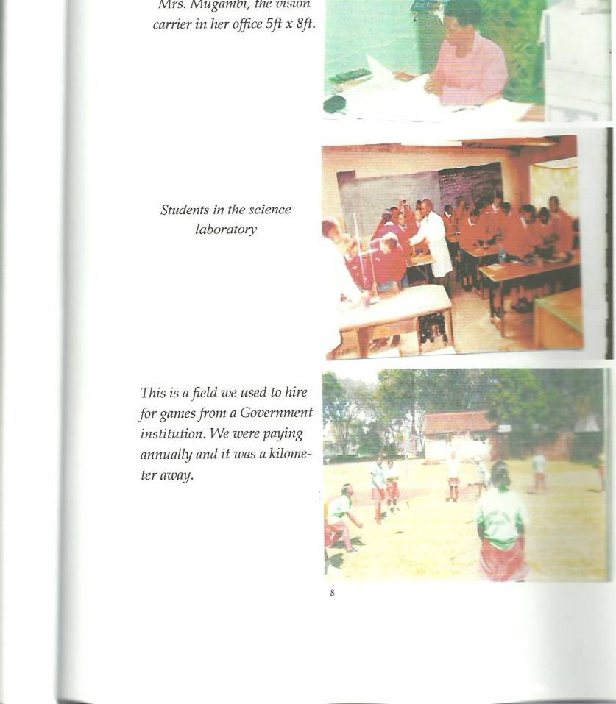

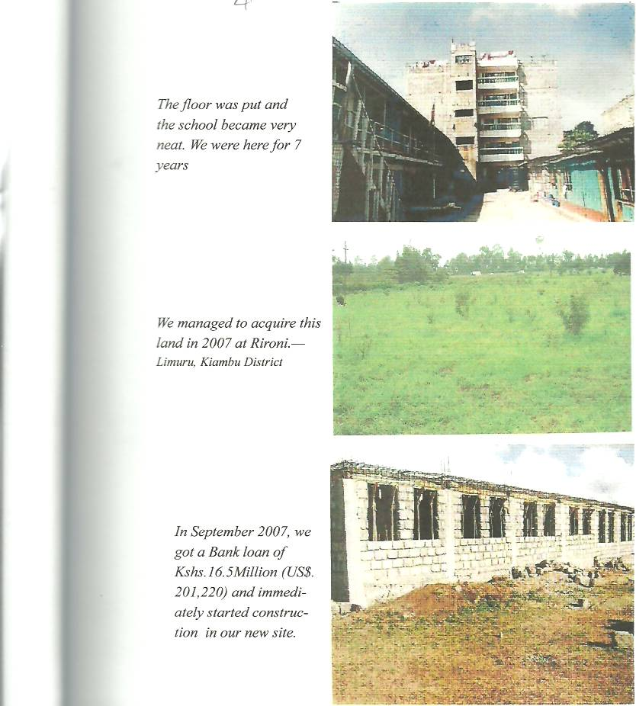

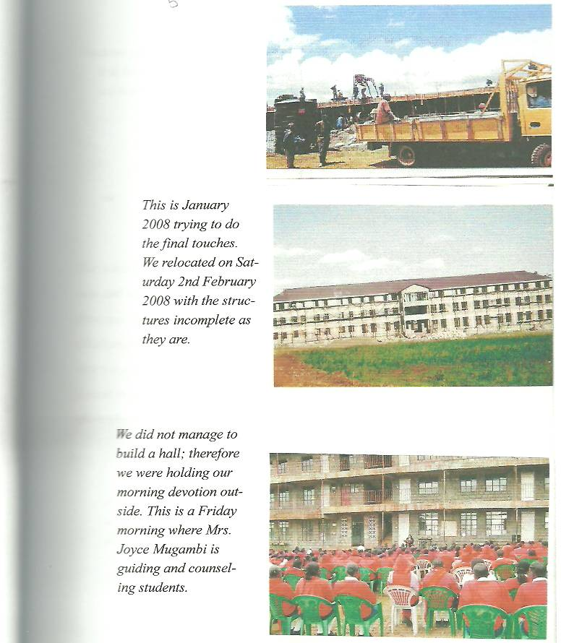

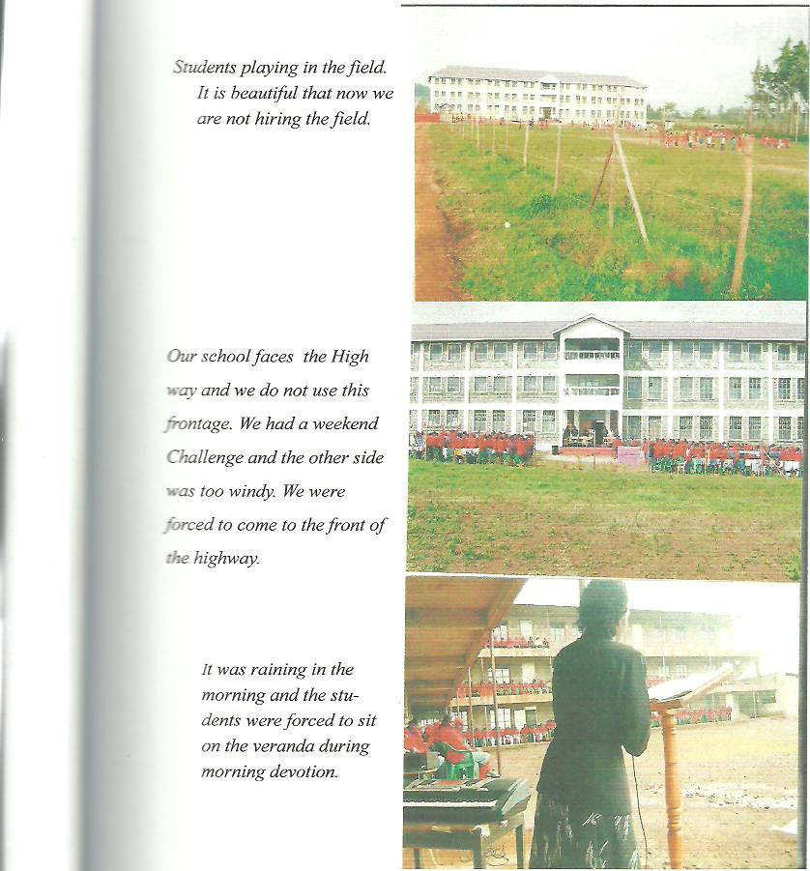

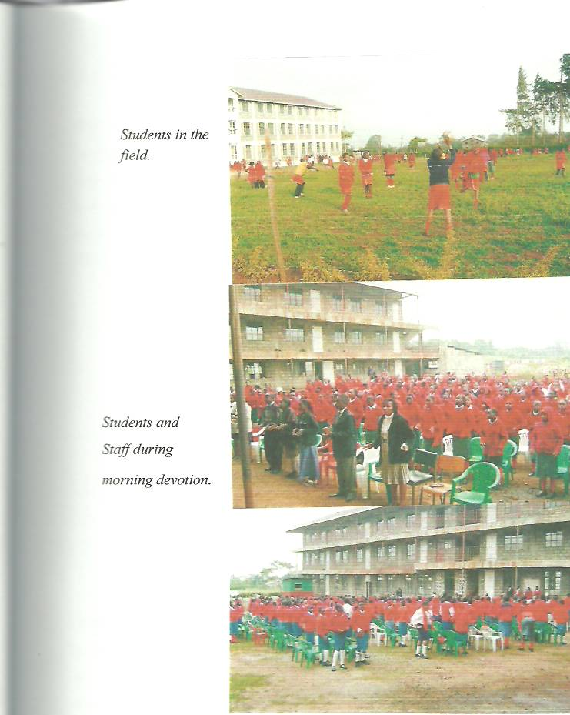

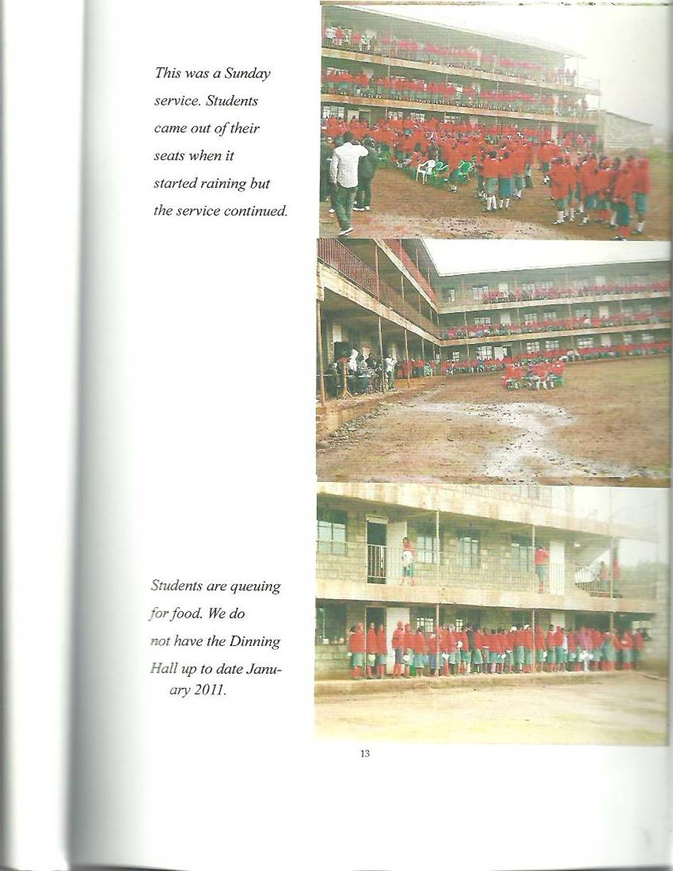

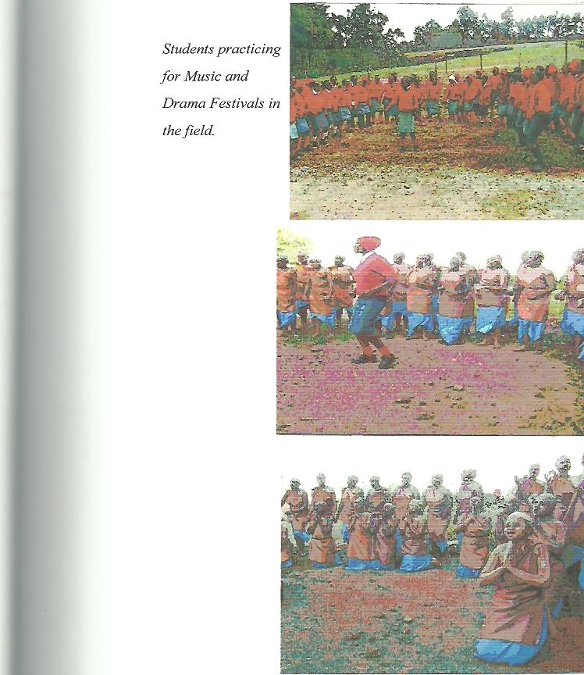

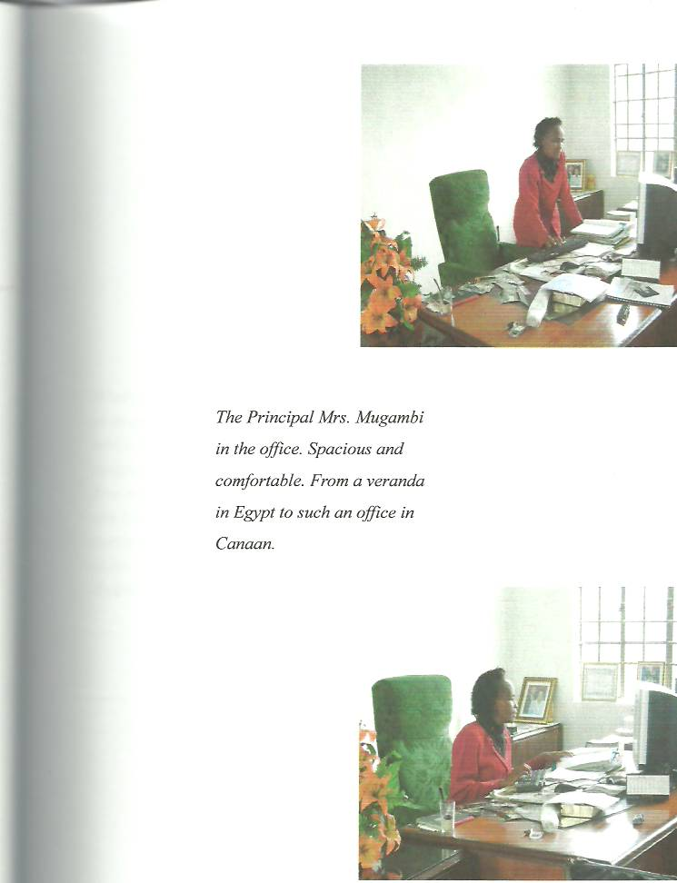

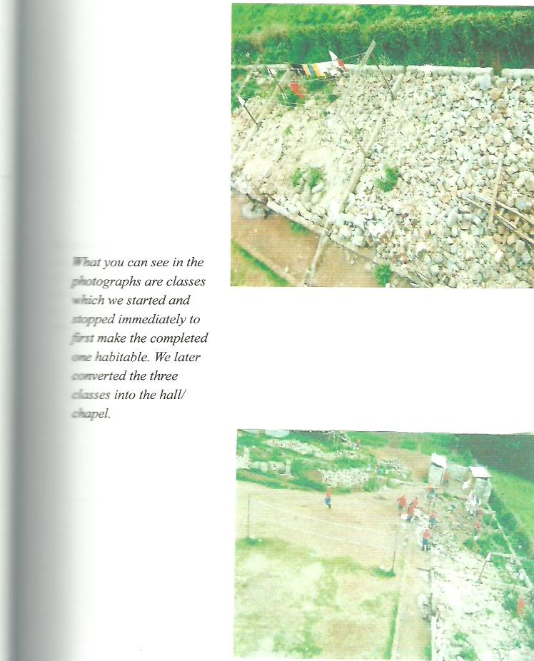

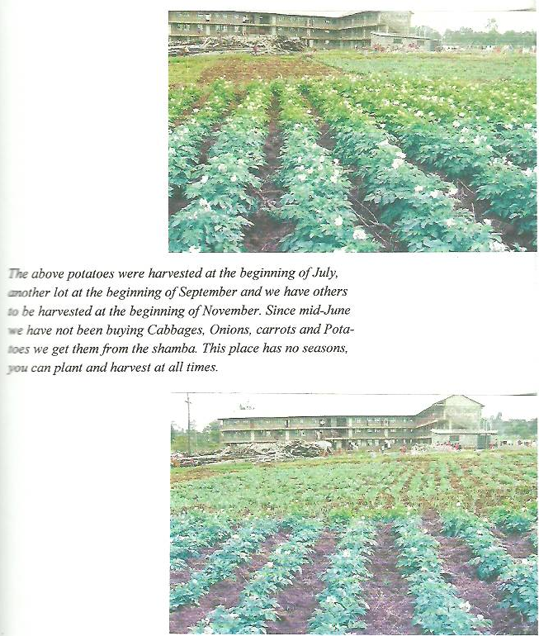

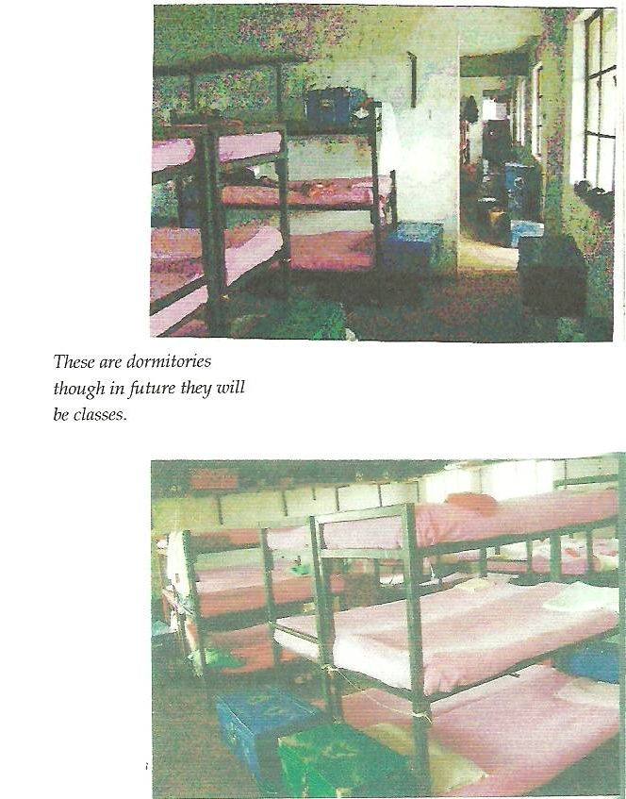

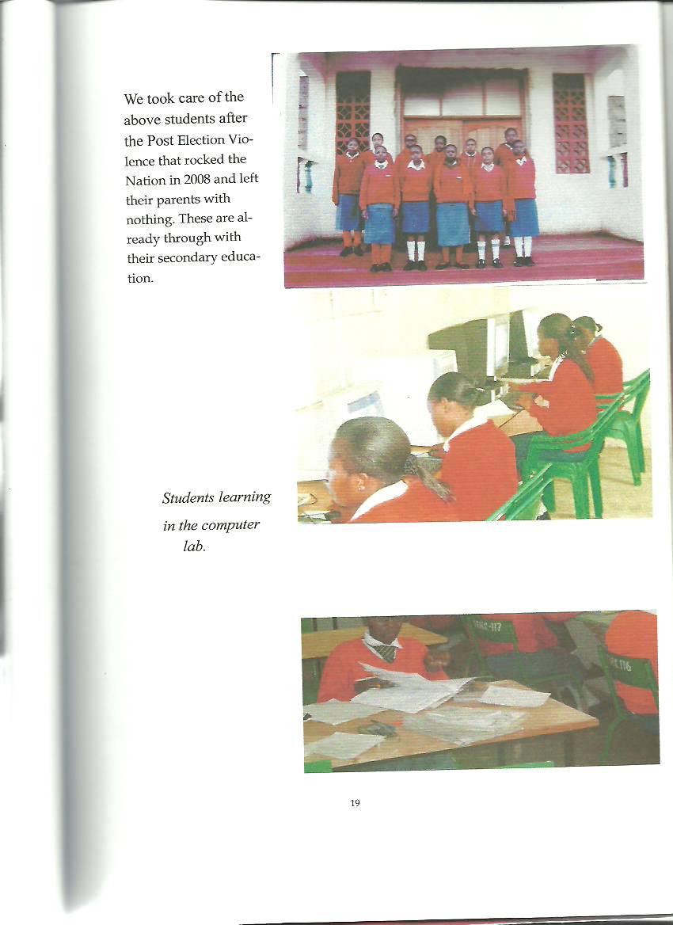

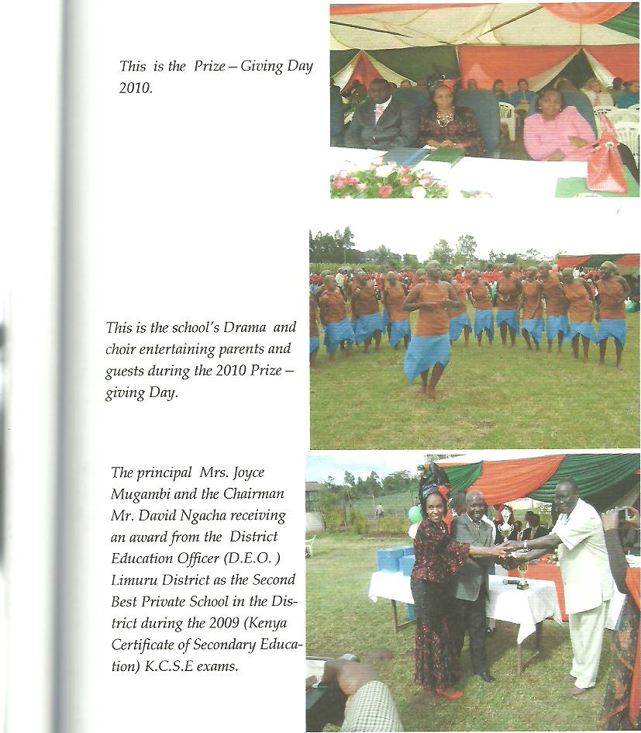

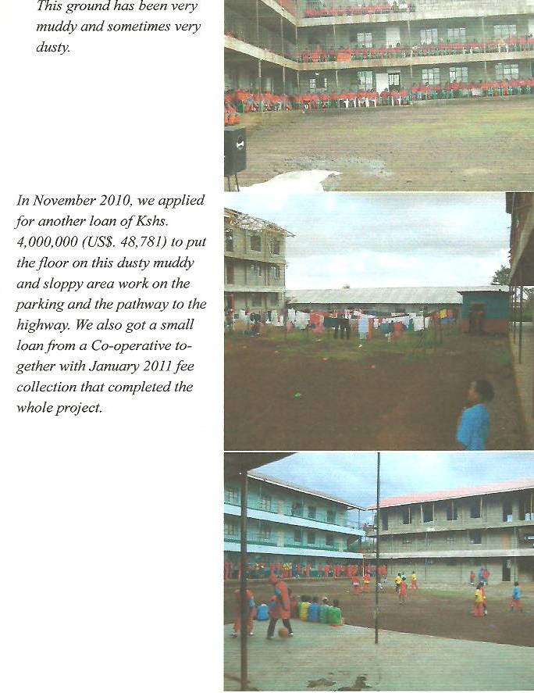

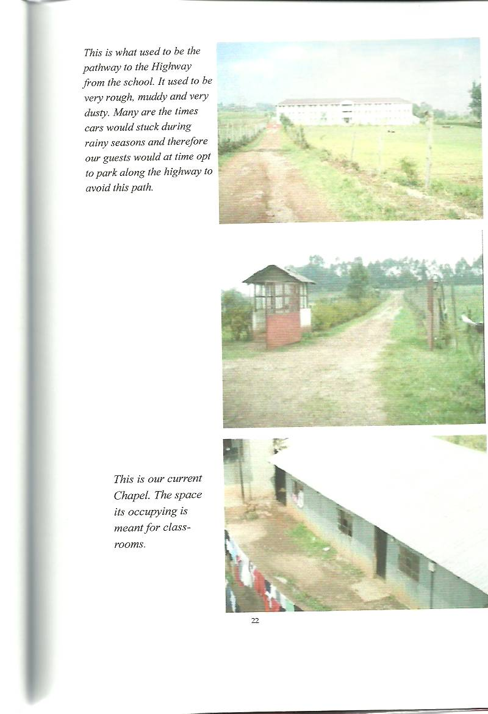

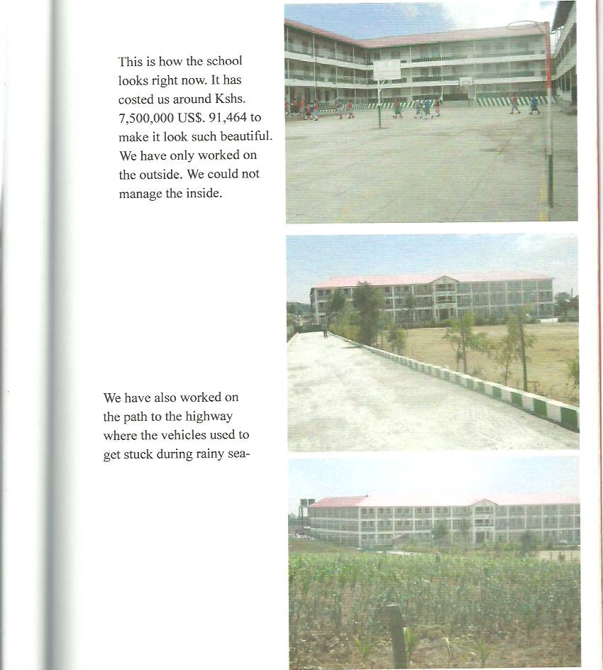

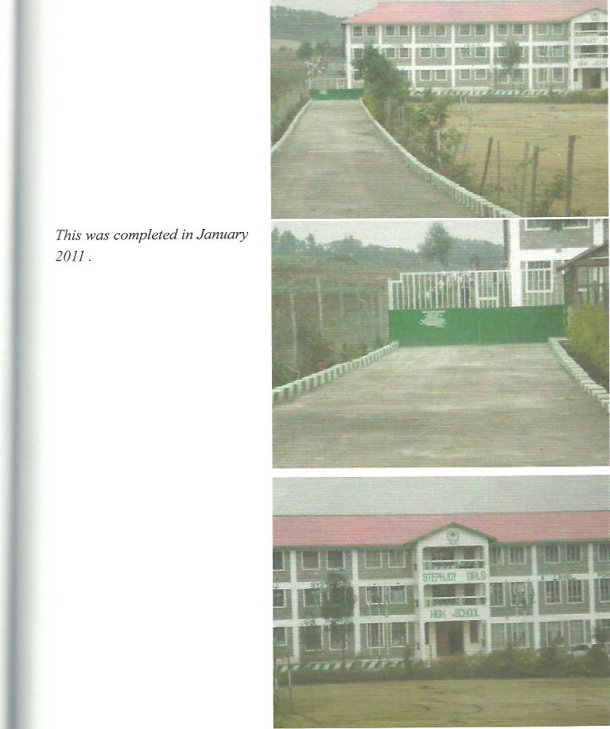

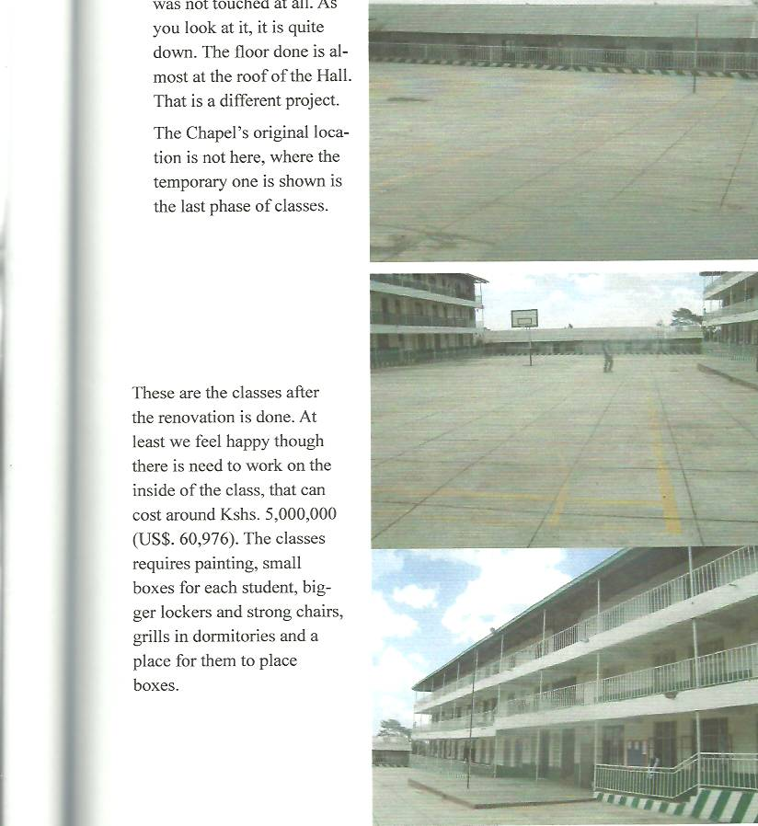

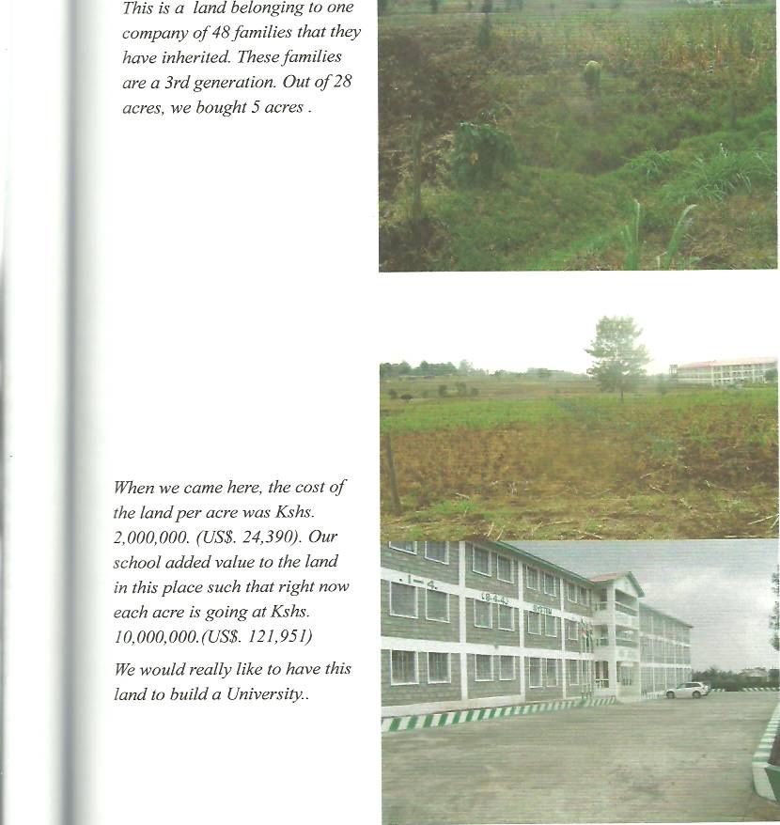

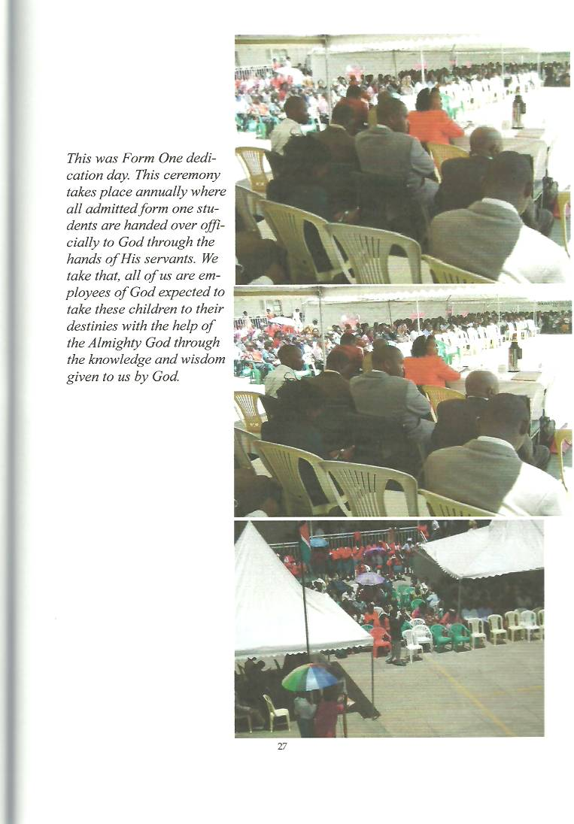

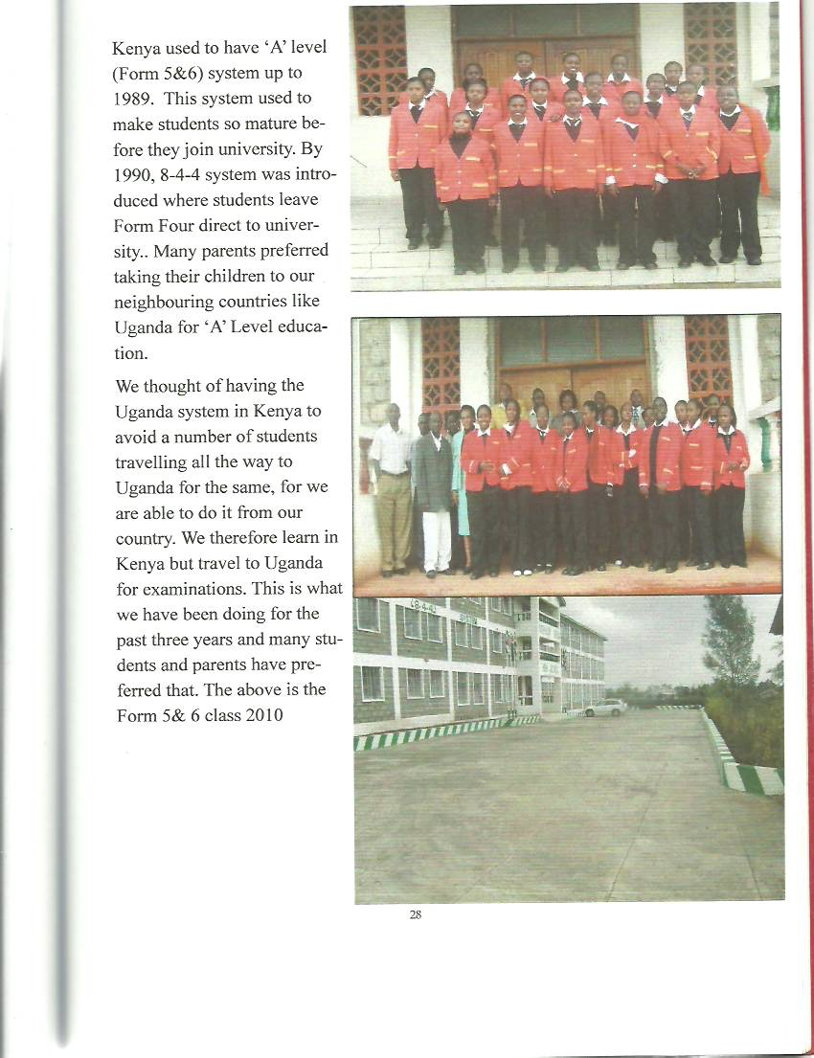

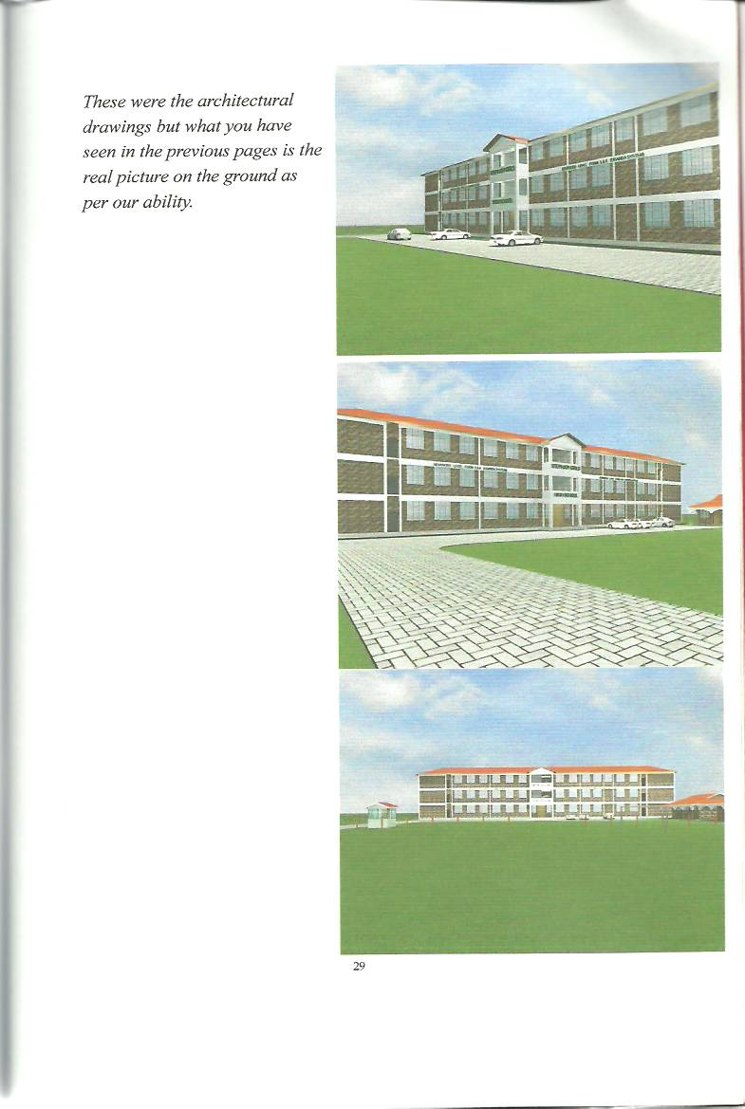

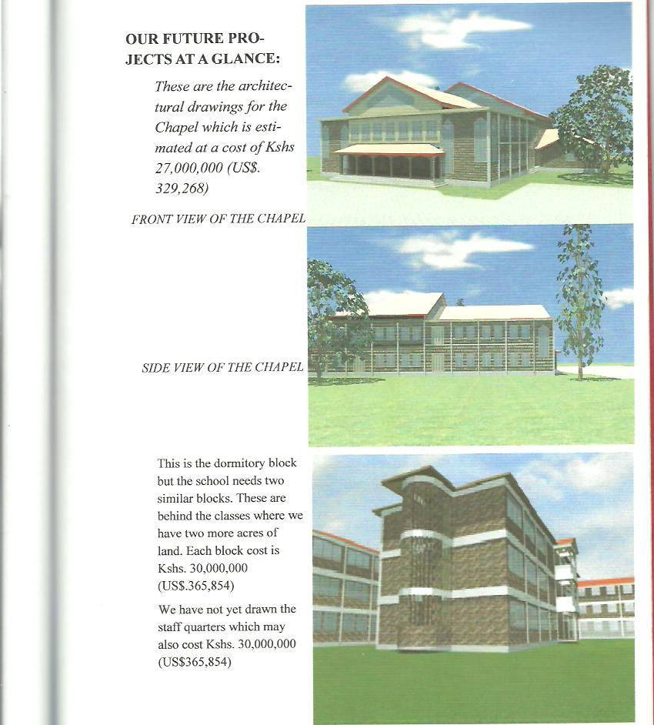

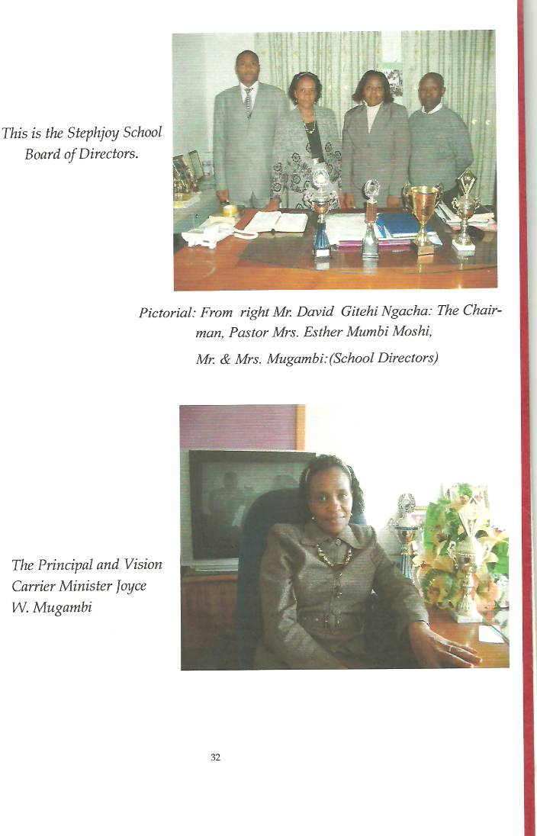

URGENT STEPHJOY SCHOOL NEEDS IN ORDER OF PRIORITY - US$ 1 = 82

- We really do not want to loose the teachers that we have and the competition with other private schools is very high. Our school is a ministry where we cannot raise fees anyhow and our current fee is half of many private schools. Our desire is to increase their salary by US$122 per teacher and we have 25 teachers. Any assistance offered even half of this will be highly appreciated.

- We bought a bus on bank loan in January, 2012 at US$70732.

- Our school fees has been US$342 per term (four months) full boarding, eating, sleeping and everything but the government abruptly added two weeks for each term to reduce vacation, we increased US$24 for the two weeks and the parents had demanded that their children take a piece of bread every morning which we were offering the children twice a week. We bought second hand machines and we are baking in school enabling us to provide for the children daily. This we increased by US$24. From May 2012 our termly fees comes to US$391 still half other private institutions.

The following four items we have already applied for a bank loan of US$304,878 to manage them. We are only afraid of the high bank interest which is 25%. We have pleaded that they come down for life must continue.

- Due to the increase in numbers of our students, the school demands three (3) laboratories which we are doing at US$48,780.

- Our school has no dining hall and we have planned to do four open classes where the chapel is to improvise them as the dining hall until a time we shall manage to do one. This will serve us for some years for it will work like a hall and thereafter will be partitioned for classes. We will spend about US$97,560.

- The whole school is not painted inside and a few other finishing required. We have planned to spend about US$36,586 to do total completion of the existing building.

- Nationally, there is a demand for a Stephjoy Boys Boarding School and we have found a land of 8.5 acres costing US$134,147. It is very hard to find such a land together and therefore we are trusting God to manage it. We better wait to build the school after some years as God enables us. For our boys school to take off it requires US$ 304,878.

We have put all our facts on the table for you to make a decision on how to assist us.

God bless you brethren as you think about us. Our account numbers are (Stephjoy School Ltd) Equity Bank: A/c No.0150291851090 or 0150295428123 and National Bank A/c No.01020051153300.

Yours in the Lord’s service
STEPHJOY GIRLS HIGH SCHOOL

JOYCE W. MUGAMBI (MRS)
DIRECTOR

