
Village Concern Uganda
(VCU)

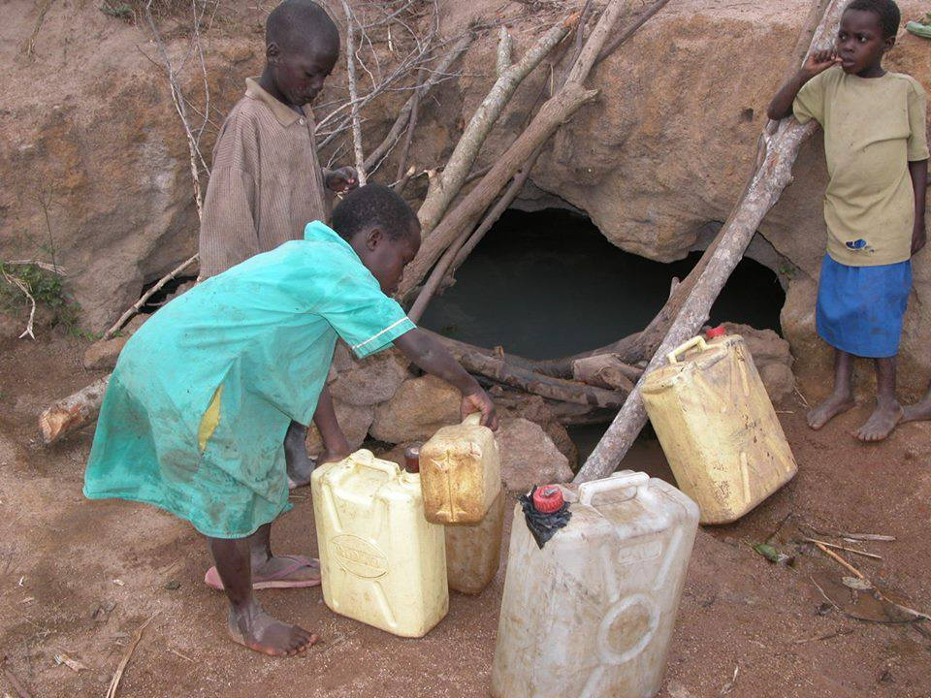`
Kids struggling to access Safe water

Lending a Hand to the Lives of Disadvantaged Children

Organizational Profile and Strategic Plan

Contacts:
Basembera Nicholus villageconcernuganda@gmail.com
Tel: (+256) 0755111945
Tel: (+256) 0780124302

Deuteronomy 15:11, Exodus 17:12, Galatians 6:2, Hebrews 6:10
“…. It does not matter to have a lot to give or little, it is the Heart that Matters”

Background

The idea of Village Concern Uganda (VCU)was envisioned by Basembera Nicholas and conceived by 4 community volunteers that are passionate about the well-being of children and that have over the past years sacrificed their time and given their resources to children in various orphanages and other needy children in different situations. It is our conviction that children should grow up fully integrated into the community to enable them to reach their full God given potential.

VCU strives to provide accommodation to the homeless and destitute, welfare, health needs, education and other basic requirements to vulnerable and orphaned children of HIV/Aids and other natural catastrophes.

The children at our help survive on donations by well-wishers, grants and small income generating projects that include among others; piggery, small enterprises, agriculture, etc to enable their caretakers offer parental care, psychosocial, emotional, spiritual support and attending to the day-today needs of the children.

VCU is currently operating in Jinja district and the neighborhood where vulnerability is high considering the extreme poverty levels, increasing dropout rates of children from schools, increasing HIV/Aids prevalence among children and the communities that pose a daunting challenge to those with responsibility to children.

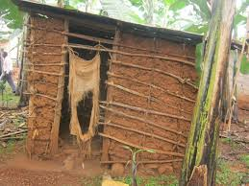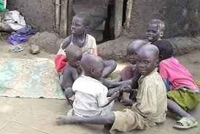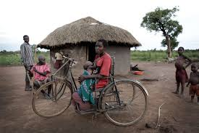
An over view of our beneficiaries

Moreover, with rampant poverty, these orphans can’t care for themselves. Old people above 68 years are often left to care for them, these two are helpless. Non- HIV/AIDS orphans are equally vulnerable children who need to be helped too. These children, apart from failure to raise school fees (tuitions) are also unable to meet their basic needs, food, shelter, medical care, sanitary towel for mature girls. Besides this, there is an increasing number of children who are;

- Sleeping on concrete beds and rancid garbage piles every night – streets, sewers, dumps

- Scavenging amongst human waste and excreta for rotting morsels and scraps to eat

- Huffing glue and other substances in order to numb the cold, hunger, pain…and shame

- Prostituting themselves for basic food and shelter.

- Trafficked and sold into sexual bondage, even at five years old and younger

- Abused and brutalized by sexual predators, local gangs, corrupt police officers, and slum lords.

- Victimized by HIV/AIDS-infected men who believe that sleeping with young virgins can cure the disease.

- Recruited into lives of thievery, smuggling and drug dealing.

- Abducted to serve as child soldiers or sex slaves of soldiers.

- Exploited as child laborers or slaves in sweet shops, eating kiosks, bus and taxi parks.

- Executed by local businessmen and officials who view them as dirty pests interfering with trade and commerce

- Sacrificed in occult/witchcraft rituals

- Robbed of childhood, self-esteem, innocence and hope.

Those who are lucky to be in school walk 6miles or more to reach the nearest school where they can attain free education and go without meals at school for the all day and do not have access to basic scholastic requirements such as shoes and so get up being infected by Jiggers which makes them to move in pain.

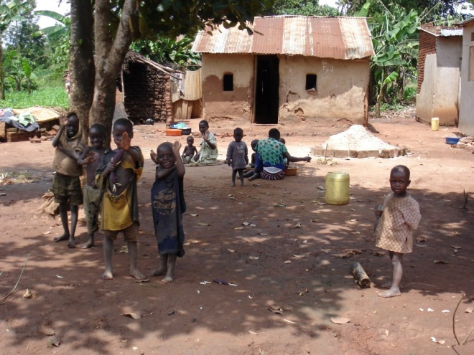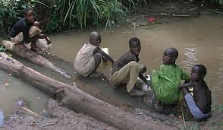

Thirsty children seking hope while others staunt journeys seeking for safe water

Justification

Despite the government’s effort to enable everybody access education through introducing universal primary education (UPE,) some children in the area have failed to continue with education simply because they can’t afford scholastic materials such as uniforms, books, pencils, feeding and other necessities of life.

Even at secondary level much as the government has tried all it can to introduce universal secondary education (USE), still some children especially orphans and needy are unable go to
school like their counter parts at the primary level they can’t afford the basic necessities of life.

Village Concern Uganda does not aim at challenging government programs but to supplement on government’s effort in helping orphans and the other needy children and their households reach their full potential.

Village Concern Uganda was therefore founded as a response to these problems faced by these orphans and other vulnerable children in Jinja and beyond.

Village Concern Uganda was set up to give hope to the lives of these orphans, to find their tuition to pay their education, to give them relevance in life, feed them, not just with any food but a balanced diet that gives them resistance to diseases.

Not only the above but to find them some shelters and where possible to give them a belonging, responding to their ailments /sickness through medical care and counseling them. Indeed, the
Organization has come up to actualize them to their situations so that they are able to overcome them.

In our children support program, we want to strive to help even more children and to do what we do as best as we can.

Our strategy sets the direction of our work for the next coming years and now through applying immediate interventions to meet the needs of our beneficiaries. This strategy offers guidance to staff, trustees and volunteers to shape and focus our plans. It is also useful to our partners who are at the forefront of implementing change for the lives of the children we care for most, and to our supporters whose generosity and belief in our work make it possible for our programs to continue.

Our strategy builds on the successes of the past and seeks to optimize our contribution to improve the lives of the children who are at the heart of our work.

Our Children support program exists to Help Orphaned, Poor, Exploited and other marginalized children in our areas of reach.
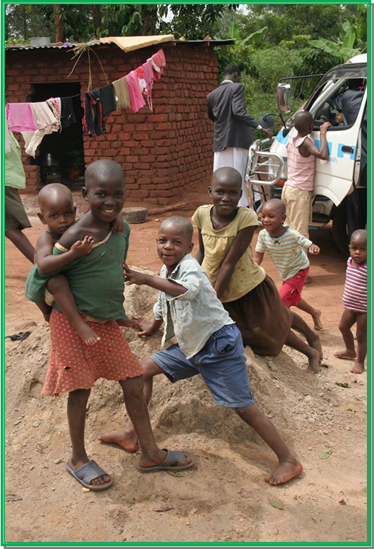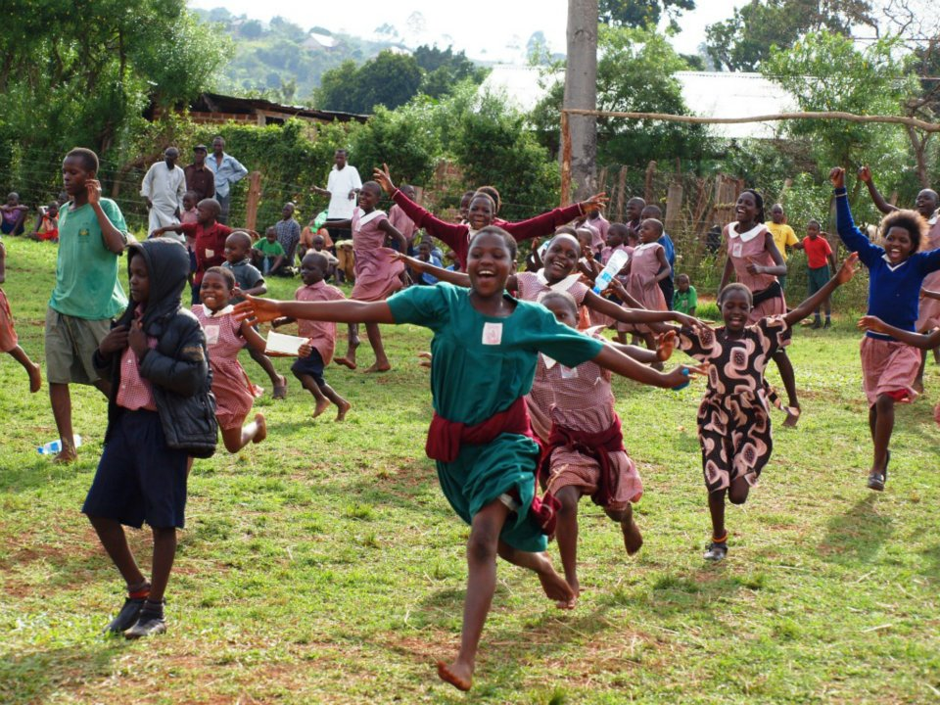

Our Vision

We envision in a community where orphaned and other vulnerable child in the communities we reach receive education and adequate care/support to enable them to reach their full potential and positively impact on the development of their societies.

With the above in mind, our child care support program’s goal is:

An over view to emphasize the quality of life and advance the rights of children.

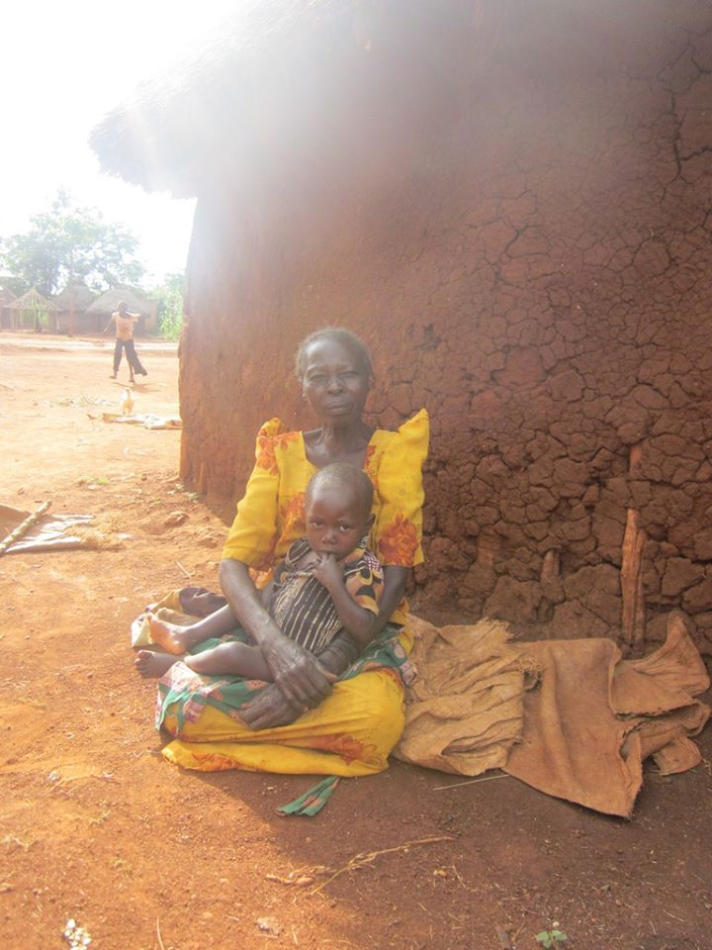
To encourage children and families to participate in processes which enhance their equality, self-reliance and long-term sustainable development.

- To provide practical support wherever possible so that children can grow up within their own families and communities.

- To provide the necessary care and support to the OVCs to nurture their mental, spiritually, physical and emotional growth and wellbeing

Our Objectives

Our objectives are in line with the National Orphans and Other Vulnerable Children Policy (NOOVCP) and are as follows:

Support and protect orphaned children from fatalism, rights abuse and oppression and provision of a conducive environment for their development and growth.

To provide basic and skills-oriented education to the children and their caretakers to enable them to earn a living

Provide adequate health care and protection from diseases and ill health conditions.

Mold and up bring children who are God fearing to disseminate the gospel of the word of Jesus.

To provide emergency protective care, transitional families and community reintegration services for orphans and other vulnerable children.

To operate as an approved, registered and compliant children’s organization

To provide a safe shelter and family-like environment for orphans and other vulnerable children who have no one else to take care of them.

To provide children under our care with adequate diet, clothing, access to safe health- care, age-appropriate education and guidance, while protecting them from neglect, discrimination, violence and abuse.

To endeavor to reconnect with existing loving family members that can provide proper care for the children. Where a child is unable to return to his or her parents or extended family, to connect children under our care with loving foster and adoptive parents with whom they can experience one-on-one affection and close family relationships.
To reduce vulnerability by providing support for caretakers and the families of vulnerable children in field such as education, health, family planning and resourcefulness

Funding

To fulfil our mission, our funds come from a wide range of activities ensuring that we have a good balance of unrestricted and restricted funds. These are raised from within Uganda and the rest of the worldwide from friends, sympathizers, fundraising events, well-wishers, volunteers and grants.

We seek more well-wishers, friends, sympathizers, and charities, local and international organizations to join our efforts with international networks of likeminded organizations dedicated to improving the future of the most disadvantaged children.

Our Values

- Integrity: We bring the highest ethical standards to all our decisions and actions.

- Transparency and Accountability: We are open and honest in everything we do and we strive to optimize the systems in place that make us accountable to all our stakeholders.

- Optimism: We focus on the positive difference we can make to children’s lives and
Celebrate success.

- Resourcefulness: We look for innovative ways to minimize our costs and maximize our effectiveness and impact.

- Partnership: We work collaboratively with our local and international partners, and value their knowledge, priorities and recommendations. We believe that by joining our efforts with local initiatives we can make a real difference!

In achieving this, we are aware that every child deserves a loving environment, a family and parents or caretakers who cater to the child’s physical and emotional well-being and development. We also believe that children belong in families and not in institutions. We therefore put at our hearts love, care, compassion and philanthropy with Christian Values in everything that we do.

What We Do

VCU’s scope is to Help Orphaned, Poor and Exploited children, including disabled children, those living in vulnerable communities. This is achieved through providing, promoting
and advancing children’s rights to necessities, including education, basic support, legal,
nutritional and health care, aimed at sustaining their long-term development.

“We cannot all do remarkable things for the suffering children in the country, but do the small things that we do with great love”

VCU supports sustainable developmental work, and in the communities where we have a presence. We offer and advocate for relief whenever our partners need our support.

VCU does and will stay engaged in these communities as long as there is a need for our support and when our available resources allow it.

Target beneficiaries

We are committed to and shall continue helping the following target groups:
- Orphans and Vulnerable Children (OVC)
- Street and Working Children

- Disabled and Chronically Ill Children
- Trafficked and Displaced Children
- Educationally Disenfranchised Children
- Their Families and Communities.

VCU’s thematic areas:

Our work stretches across the following sectors:

- Public Health and legal support.

- Spiritual nurturing

- Education and Vocational Training

- Nutritional and basic support

- Water, Sanitation and Hygiene (WASH)
- Service delivery and capital support (building schools, academies, clinics)

- Protection from abuse

- Basic support

How we work

VCU doesn’t do the work we are doing with exception of local partners, Non-Governmental Organizations (NGOs) as well as Community Based Organizations (CBOs), Faith Based Organizations, friends, sympathizers, well-wishers, local authorities and many more.

VCU implements projects directly and indirectly through our local partners. In the future, we will continue to work in this way. We have a bottom up approach to partnership and we see our partners as equal. Together we strive to improve the lives of children and communities we serve, and we are open to learn from each other.

We value quality of service provision and programs and for this we commit to build and enhance the capacity of our partners, empowering them, collaborating and learning with them to build a sustainable future for the children and the communities we serve.

We use a rigorous approach to selecting partners who share our same ethos, with an active nature of nurturing them. We respect their capabilities and respond to their needs.

VCU is a network grassroots initiative that wants to develop partnerships beyond projects. We are much interested in our sustainability which has contributed to the growth and relevance of organization and recognized our achievements so far as a humanitarian network.

What we plan to do

In the coming years, we aim to scale up the number of children we reach.

We commit to provide them with quality services, offer protection and help them to meet their basic needs.

Through a holistic approach we aim to empower the communities where our targeted children live, so that they can become self-reliant and can sustainably take care of their entire families.

We do not want to encourage institutions. Indeed, we promote de-institutionalization of children wherever practical and encourage the development of alternative care including placement within a family environment. We do however recognize the role that some
formal care can have when working with children with complex needs and are committed to reviewing this in the context of work and the needs of the children we work with.

OUR AIMS

1. Promoting child protection and children’s rights

All VCU staff and partners will be trained on child protection issues.

Partners will develop and implement child protection policy and those who have one will strengthen it.

Children, their caregivers and their wider communities will be empowered to uphold and
Protect children’s rights.

- Promoting de-institutionalization of children

A model of best practice will be defined, informed by local needs and disseminated to all relevant partners.

Good practices will be researched and a policy paper produced.

- Promoting sustainable development while strengthening and empowering the communities to sustain the impact of our work

More women and men, in our project areas, will be empowered to meet the basic needs of themselves and their children.

Access to essential services, like clean water, education and healthcare, within communities we support will increase.

4. Strengthening our partners’ capacity to provide quality of services to children and implement
quality programs

Partners will have an increased capacity to deliver quality programs and services to achieve a positive change in the communities they serve.

Partner organizations/initiatives will be profiled, and a capacity development plan developed with support from VCU agreed and tracked.

VCU will have an internal budget line to support partners’ and staff capacity
development.
Partners and VCU staff will have increased capacity to monitor progress of projects and learn from successes and failures.

Planned Programs:

Increase the number of partners and projects supported in communities.

Put in place MELA systems (Monitoring, Evaluation, Learning and Accountability) and frameworks for all projects supported.

Establish Programme Cycle Management system with provision of proposal and reporting templates, guidelines on selection of projects and guidelines on working with partners
and partners’ selection criteria.

Establish and maintain partners’ profiling and partners’ capacity building processes for all
current and future projects.

Develop manuals and tools for mainstreaming cross cutting issues, such as Gender, HIV/Aids, Human rights Protection.

Strengthen presence and voice within current networks of likeminded organizations.

Engage with further networks/alliances to ensure we have a voice in advocacy on issues regarding the improvement of the lives of disadvantaged children.

Continue to develop our small grant schemes in countries where we have country representatives with effective selection, monitoring and evaluation of projects.

Build in country relationships with donors

OUR COMMITMENT

  - VCU will continue to be a volunteer led charity. However, through the years to come and the journey of growth, VCU shall become an organization where staff and volunteers work together.

  - VCU commits to improve its HR systems and policies and produce a Staff and Volunteer Handbook that will contain all policies necessary to manage staff and volunteers. While the vision bearers and enormous contributions volunteers make will never be underestimated nor overlooked and volunteers will be encouraged and nurtured, VCU realizes that to have a well-functioning organization, the efforts, commitment and contributions of its staff need to be adequately managed and rewarded.
  - Staff development and training is at the heart of our strategy and will be aimed at maintaining and enhancing the knowledge, skills, attitudes and effectiveness of staff, assisting them to meet more fully their own needs and goals, and preparing them to fulfil their duties and responsibilities.

  - We will provide opportunities for regular reflection on, and evaluation of, goals and activities in the context of career development, the realization of individual potential and of the overall aims and objectives of the charity.

  - We intend to put in place a training budget in order to provide funding for staff to attend relevant courses and workshops outside the charity where such attendance will
contribute to the individual’s work or area of work and the work of the charity. We believe that at the heart of staff training and development will be the process of reflection on current and future work and development possibilities, through an appraisal mechanism.

  - We intend to ensure a spirit of opportunity and openness providing an inspirational and motivating environment aiming to have an effective, transparent and accessible system to raise issues in a spirit of openness and transparency, working together with cross- cutting initiatives to link together a successful team.

Challenges

VCU faces challenges of supporting children and it is even worse with the inflation hitting Uganda today, the children are often lacking what to feed on, education, clothes, beddings, shelter and medical care. These children are abandoned because their parents /guardians cannot afford the basic needs, therefore run away from responsibilities. Other children are born orphans for instance a child is born and a mother dies, then when the father marries other women, they are subjected to domestic violence and torture. Other children are abandoned by their parents with no one to help. Such Children end up on street on absolutely nothing. The country has not done much for such children; it’s only the organizations that are trying to

protect them and provide basic needs in an institutionalized setting. Apart from those children who need a conducive environment for them to play and enjoy all their rights like their counter parts. Village Concern Uganda have the compassion to help such disadvantaged children but as a voluntary initiative we are limited with resources. Our plight is to reach out too many children but we can’t do this in isolation of external support.
Our Call to You

We have come a long way over the past. The coming years are vitally important in allowing us to continue to shape, scale and develop effective services and extend our influence so that we can help more and more children.

VCU aim to improve on OVC basic welfare, education and health of the OVCs through
Interventions/strategies that directly and indirectly relate to children’s welfare and support,
Cognitive and psychological support, etc

The starting point is availing the children with basic needs that will help them grow physically, psychologically and socially. Our urgent needs for this purpose includes but not limited to:

Clothing – We are always appealing for Clothes, nappies, etc. for ages up to 18 years. Worn-out or old clothes to you may be of paramount importance to children in Uganda some of whom have no access to any one piece. Feel free to send them to us as gifts to the children; they will be grateful to you.

Welfare – We shall be grateful if you assist the children with Foods items. Children need good food for proper growth and increase their resistance against diseases and malnutrition like complications.

Beddings – For proper growth of children, adequate sleep is paramount. Blankets, bed sheets and mattresses are required for this purpose.

Medicine – We have mobile medical visits to vulnerable families to attend to the health demands of our children since most of them have complications relating to their poor backgrounds. A child who is HIV positive needs adequate and timely healthcare. Some of our children have HIV and it is incumbent to us and you, to take good care of them, not to despair or lose hope, as they are victims of circumstances mostly contracting HIV from their mothers. (MTCT). You can help us with medical drugs, equipment or financial support for this purpose.

Educational sponsorship – After all the above is done, the child is ready for school. Education is one of the gifts you can ever give to an African child not forgetting that 45% of Ugandan children do not go to school. Please support our children to stay in school.

VCU Strategic Activities
    - The Children Care and Counseling Ministry

Under the Childcare and counseling ministry, Counselors shall continue to reach out to the children, socialize and exchange views and opinions with the children about social life, Fellowships and Bible studies and conduct Sunday school sessions at the church on Sundays, and evening Glory on Wednesdays. The ministry shall also be in charge on welfare and educational facilitations and monitoring of these children looking for sponsorships as well as monitoring the health of these children.

    - The Sunday School Ministry

VCU will ensure that Children know the values of worship and Christianity to build successful families, societies and nations. Children are the pillars of the next generation and therefore must learn to put God first in whatever they do. VCU shall strengthen the Sunday School Ministry in Communities of our reach to make it possible for children to learn, interact and share views about Christianity and today’s living.

    - Educational and skills development

VCU endeavors to make education for the OVC Children a priority and possible. Child sponsorship is one of the ways through which one can channel support to help an orphan attain education and a bright future. Support is channeled directly to the respective schools and through VCU. Other alternatives shall be put in place such as Income generating projects like piggery, fruit farming, poultry, crafts making, bakery and confectionary projects, etc to provide income to the VCU for school fees and other scholastic materials necessary. Our major focus is to equip practical vocational skills to these orphaned Children to adapt to the new challenges in life.

    - HIV/Aids sensitization and awareness

HIV/Aids prevalence is still high though the level of sensitization has increased. In a nutshell, the level of prevalence among children is increasing. This is as a result of increased children involved in sex trade for a living, mother to child infections, low sensitization among children since it is a taboo to carry out sex education among children, etc. This has resulted into increased dropouts from schools as children drop out to look after their sick relatives, increased HIV/Aids infection and death among children, etc. It shall therefore be our paramount importance that children and the entire community are involved in HIV/Aids prevention campaigns, at school, homes and in
the community, through child friendly counseling, behavioral training, and awareness messages at schools and general sensitization of the community.

    - Child development and Child outreach

Child development entails the promotion and monitoring of children’s basic welfare, as well as cognitive and psychosocial development. Because we are dealing with orphaned and other vulnerable children, most of them live a life of total despair with nothing to neither eat nor drink and nobody is bothered anyway. This is made worse by the deteriorating socio-economic status of the communities around them. Our starting point therefore shall be to ensure food security, good health, cognitive and psychosocial stimulation and putting in place social support mechanisms to ensure holistic child development.

    - Volunteer Programs

VCU shall continue to recruit both local and international volunteers to work hand in hand with the organization, share and exchange knowledge and ideas and perform specific tasks to achieve the set objectives.

We recruit Volunteers who can participate fully in the spread of the word of God, Children’s
Welfare, education, health, community centered programs and also counselors.

With your generosity and support, we commit ourselves to continue;

Provide care and support for neglected and abandoned children

To provide education support to orphans and vulnerable children in our area of reach

To improve the health of orphans and vulnerable children in communities that we serve Purchase of beddings and clothes for vulnerable children
Provision of food and shelter

Alternative care for neglected and abandoned children
Training of staff and community on care and support Provision of scholastic materials and uniforms
Provision of fees (child sponsorship) to children under our care Skills development for children in upper classes
Provide recreation activities for vulnerable children

Carry out psychosocial care and emotional support for disadvantaged children in the community.

Information on health, hygiene and nutrition and ARV therapy for those living HIV/AIDS positively

We shall be grateful for your Assistance in changing a Child’s Life
Under VCU

Frequently Asked Questions – About VCU Child Sponsorship Program

How Does The Sponsorship Program Work?
Every time someone becomes a sponsor, two lives are forever changed. The lives of sponsored children are changed as a result of your financial gifts. With your support and the assistance of other caring sponsors, we try to develop the ability to sustainably maintain ourselves. Your sponsorship will help make programs possible that will address your sponsored child’s (and other children’s) most basic needs—programs that provide basic medical care, school fees and other supplies.

The children also benefit in ways you cannot imagine. The love you provide through a simple letter or gift may be the encouragement a struggling boy or girl needs to make it through another challenge.
You will see firsthand how you have given your sponsored child the chance for a brighter, hopeful future.

The second life that is changed is yours. How can the photographs, letters, or drawings not touch you from your sponsored child?

How much are the costs?
We don’t have specific sponsorship costs as costs may vary depending on a number of factors including schools and classes they do attend. However, we encourage you to be faithful in your financial support and appreciate a minimum of at least one-year and above commitment to the sponsorship program. Remember that the sponsorship costs will cater for medical expenses, school fees and other basic requirements like clothes, food and shelter.

How will my child sponsorship contribution be spent?
School fees, medical fee, basic support will directly benefit your children but one of the most effective ways of helping children is to combine your sponsorship gifts with those of others. Your child will not benefit exclusively as benefits will be shared. This system ensures that children who may not have a sponsor of their own will still benefit from our programs. This is done to ensure equity to avoid feelings of betrayal and un supportiveness to those who may not have sponsorship.

May I choose the child I want to sponsor?
Yes! When enrolling, you may request for children that need sponsorship and we shall always send you a full profile for the children’s that need sponsorship. Currently VCU has a list of 62 children who need your sponsorship. If you do not have a preference, a child where sponsor support is needed the most will be selected for you.

Can I give a sponsorship gift?
Yes! You are able to share the gift of child sponsorship with a loved one by selecting a child and requesting for a child sponsorship form at villageconcernuganda@gmail.com

Who can I contact if I have questions about the sponsorship program?
You may contact VCU’s Sponsorship Program Coordinator at villageconcernuganda@gmail.com

How long will my sponsorship last?
We hope that you will want to be part of VCU’s work for a considerable length of time. Committed support from sponsors will allow us to achieve lasting results. However long you will be with us, your sponsorship is very important to us. There is no set age limit for children in our sponsorship program. A child may be in her late teens but still needs to continue attending school or learn a Skill. As long as a sponsored child is in a project associated with VCU, she will continue to receive assistance.

We will notify you when your sponsored child becomes self-sufficient or if she leaves the program. At
that time we’ll introduce you to another child who needs your help.

Can I visit my sponsored child?
Meeting your sponsored child can be a most valued experience that strengthens your relationship and understanding of VCU’s work. In keeping with our commitment to child safety, all visits to VCU must be coordinated through VCU’s Secretariat well in advance. Prior to visiting your sponsored child at his or her school, a notice will be required from VCU. We hope you understand that these steps are necessary to ensure the safety of the children.

Can I correspond with my sponsored child?
We encourage you to build a relationship with your sponsored child. You may send letters or cards to
your child as often as you wish. We encourage you to write at least once a month. A hand written letter is more personal; however, we will accept e-mailed letters, which will then be printed and given to the respective owner. The more you write to the child you sponsor, the more she will reap the benefits of your relationship.

What should I write about?
VCU suggests you share a bit about your life, family, where you live, your culture, and what you do. Please personalize your letter. That makes it meaningful. Also ask your child about his or her life.

We ask you to be sincere and realistic in language and manner in which you write consistent with the values and Norms not forgetting that these are children.

What should I avoid writing about?
Please refrain from writing about your material possessions, or anything else which may stress the difference between you and your sponsored child. Another topic to avoid is Pornography and politics. Also, do not include any personal contact information such as phone numbers, e-mail or mailing addresses. This is to protect your privacy as well as to avoid direct appeals for financial aid from your child.

Can I send packages to my sponsored child?
We understand you may want to send packages to your sponsored child; however, VCU only accepts registered packages that may include clothes or other things that may be shared. Slow delivery, the possibilities of loss, theft or damage are some of the risks associated with sending unregistered packages.

Thank you for being part of Village Concern Uganda (VCU).

