Saving Lives through the Provision of Surplus Medical Aid to Rural Health Units in sub-Saharan Africa

About Inter Care
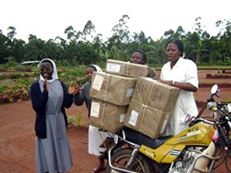
Inter Care is a unique charity, established over 40 years ago. Having identified an urgent need in Africa, the charity committed to recycle surplus medicines which would otherwise be incinerated, along with medical supplies such as dressings, instruments and devices and donate them to rural health units in some of the poorest parts of Africa.
Inter Care aid arriving in Cameroon

Inter Care is a UK, licenced registered charity. In 2012 the charity received the highly prestigious Queens Award for Voluntary Service. Recognising and rewarding excellence in voluntary activities carried out by groups in the community, the award is the highest given to volunteer groups across the UK. Inter Care was also the subject of a BBC Inside Out Programme broadcast in 2013, which followed some of our staff on a monitoring visit to a number of the health units we support in Malawi.

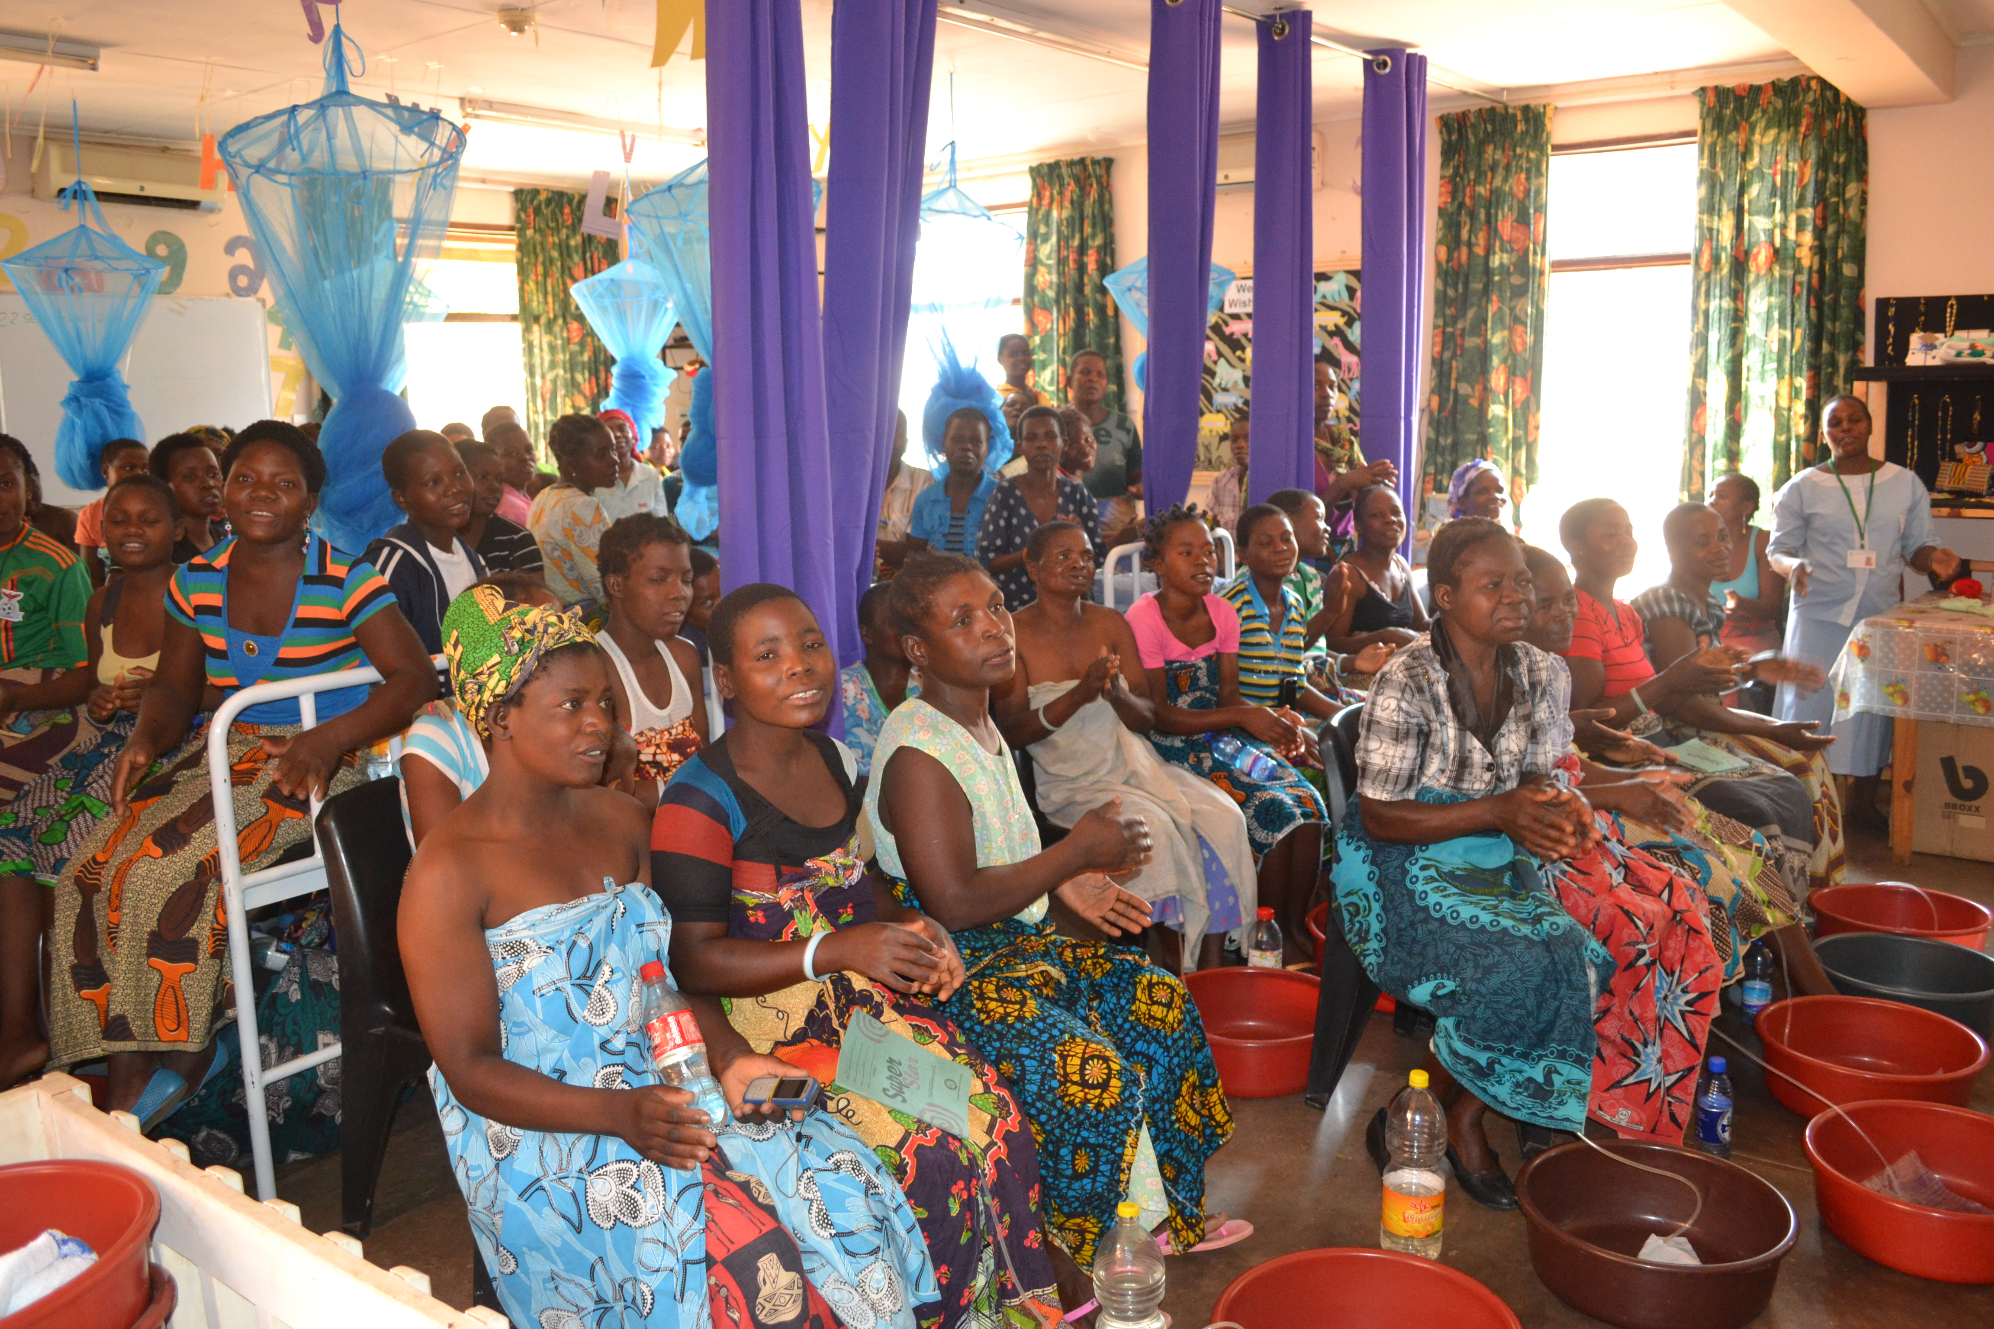
As a small charity, Inter Care relies heavily on the support it receives from over 60 volunteers, many of whom are medically trained, to help recycle the surplus medical aid that we receive from medical professionals and medical companies. Our low overheads and unique approach means we achieve a huge impact on the lives of some of the poorest people in six sub-Saharan African countries. The catchment population of the health units we support is over 10 million. We have sent out £734,000 worth of aid to the clinics we support across Africa since the start of September 2014.
The Fistula Centre, Malawi

The way we work not only benefits around 130 health units in rural Africa by providing them with vital medical supplies, but also makes use of surplus medicines from pharmaceutical companies and medical wholesalers, that would otherwise be incinerated. In addition, by recycling healthcare products donated by health care professionals, Inter Care also helps reduce NHS waste.
Inter Care is beneficiary led, therefore we respond to the specific needs of each health unit we support. Many of these request treatment for conditions such as malaria, bacterial, fungal and worm infections, along with painkillers and antibiotics to treat both adults and children. We also send medical supplies such as dressings, instruments and devices and educational materials such as medical reference books regularly donated to us by the British Medical Association.

The health units we support include hospitals, health centres, infirmaries, prisons, dispensaries, schools, orphanages and centres for the disabled. Inter Care has a strict monitoring and evaluation system which ensures the efficiency, effectiveness and impact of our work. Every health unit supported by Inter Care has undergone a detailed process of assessment before being accepted as a suitable beneficiary of the medical aid we provide and is visited by Inter Care staff as part of our monitoring and evaluation procedures, usually once every three years. Furthermore, Inter Care requires beneficiary clinics to acknowledge each consignment they receive, before further aid is sent to them. Inter Care is entirely funded by voluntary donations.

Inter Care receives no money from the government, major companies or statutory sources and therefore relies on the support it receives from donors such as trusts and foundations.

