Kabbey Upekshita - A Soliloquy of Rural Arisans
An initiative of Pratyasha-livelihood Promotion through sustainable economic development
  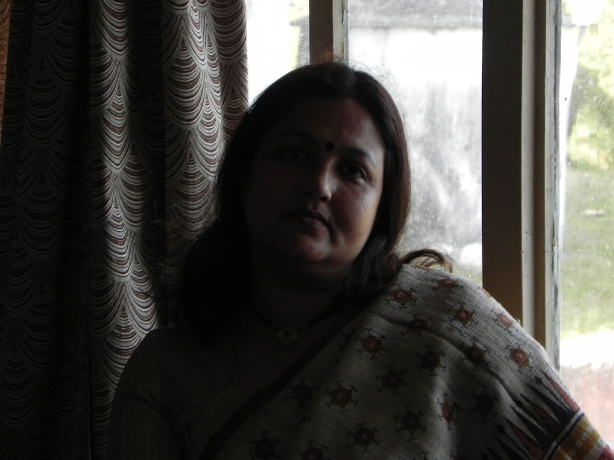
  Director, Kabbey Upekshita
  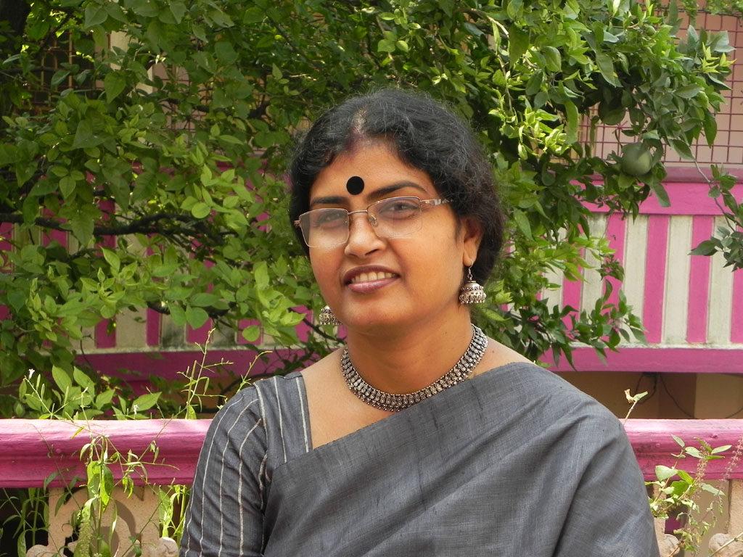
  Associate partner of Kabbey Upekshita

Rural Artisans in West Bengal are custodians of great art and heritage, and the unique variety and exquisite quality of the hand made products puts them in the niche collectors’ category. Ironically despite the high levels of skills of these artisans and high national and international demands for these products, the artisans associated with many crafts have been teetering on the brink of subsistence and are often forced to abandon their traditional skill for unskilled labour markets.
They are particularly handicapped by their inability to access resources, capital, information, markets, as also the entitlements from the government and society. This is further compounded by their lack of mobility and illiteracy.
Market remain inaccessible to many craftpersons because they often do not understand the dynamics of mainstream markets and full value chains. Lacking interface with markets, they are often exploited at the hands of middlemen and aggregators. Mostly, their products are either sold at the local markets or to middlemen and the craftsmen are meagerly paid/ compensated. Given the vulnerability of the poor, the terms of the trade are exploitatively adverse when they interface with the markets and participate in the value chains.
Craftsmen of Birbhum District, west Bengal had mastered the art of craft for long. Metal craft is an integral part of the region- pots, utensils, vessels etc. have been made out of variety of materials like copper, bronze, bell-metal. The braziers of Dubrajpur and Nalhati turn out articles of a better finish, which find a ready sale out the district. Ornamental Brass materials manufactured at Lokepur in Khoyrasole Block. They are made to order , and there is a considerable demand for them among Europeans. The Tribals of remote Birbhum , since ancient times, have been using cane and bamboo to give expression to their art and to earn a living.
‘ Solapith’ the core of a plant ( Aeschyromene Aspere) that grows wild in wet marshlands of Birbhum District. In malleability, in texture, in its luster and sponginess, in its ability to turn into ‘ light as air’ beautiful ornamentation-‘ Solapith’ work as unique creation of ‘Malakar’ craftsmen. Main raw materials of this craft is the stem of the kuhila plant. People collect those kuhila plants before the ditch dries up. The outer harder brown skin is removed by exert hands to reveal the inner soft white portion of the stem and then the inner portion is fragmented into different shapes and reinforced by colouring as required. Regarding the creativity of these crafts, it has its unique styles. The feasibility and proficiency of the artists carries the tradition of the antique creation and dexterity.
Dokra craft is one of the earliest known methods of non-ferrous metal casting known to human civilization. The oldest form of metal casting ‘Dokra’ is popular because of its primitive simplicity. It is a very important handicrafts because of its more or less exclusive folk character. Made by tribals, Dokra is notable for its strength and sharpliness of design. Its motifs are mostly drawn frm folk culture. While among the animals, the elephant is most popular, other motifs, include human heads, kings, means or miniature replica of measures, containers with lids, images of deities like ganesh and Durga. Of late some utilitarian articles like candle stands, ash trays and pen stands are also being made keeping the essential folk design intact.

Handicraft and kantha stich sarees and other products of ‘KabbeyUpekshita’-an initiative of ‘Pratyasha’:

