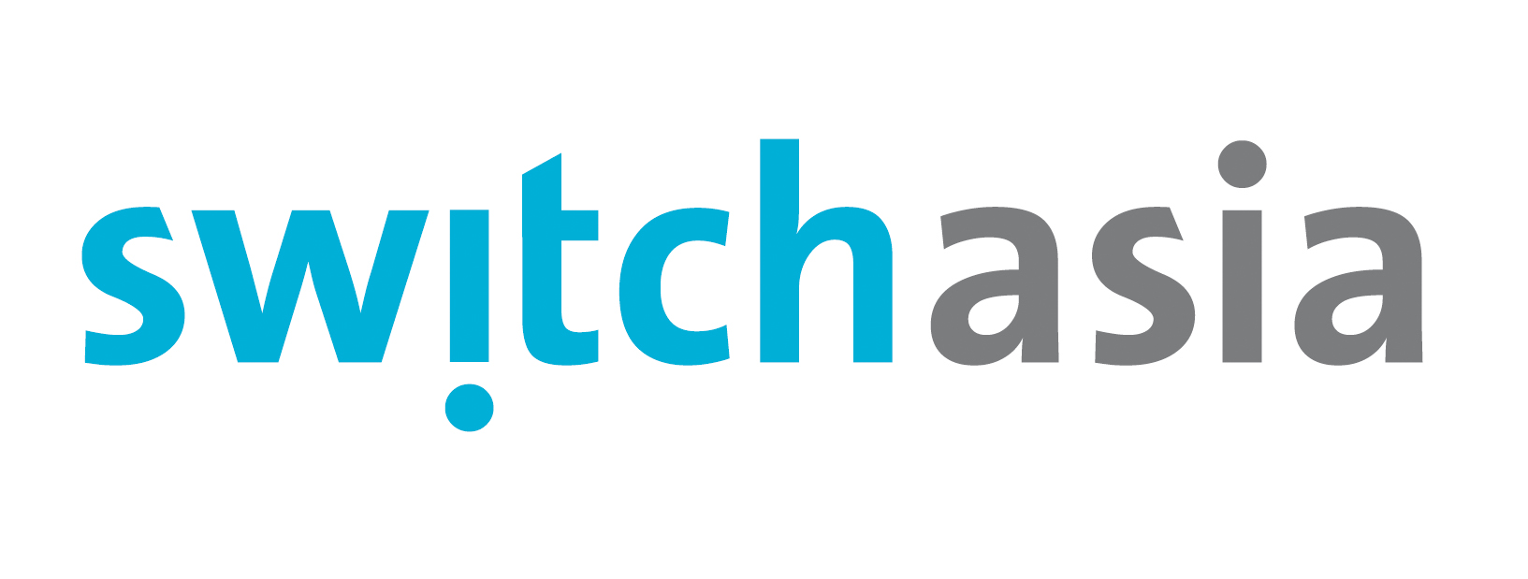
SWITCH-Asia project fact sheet

Information submission form
Project title | Promoting Fair Trade and Sustainable Consumption in India  PRO SUSTAIN
Overall aim  (40 words max.) | A growing group of middle class consumers in India have started questioning the ‘conventional’ manufacturing process and are now buying goods that are fairly traded and/or organic. This provides opportunities for Indian farmers and artisans to market their fair trade products nationally and escape from poverty. PRO SUSTAIN wishes to catalyze this process.
Project background  (100 words max.) | All project partners are committed to fair trade because of the benefits export markets have delivered to small-scale farmers and artisans in India, but they have also perceived huge missed opportunity to expand these benefits by tapping India’s latent market demand for fair trade, sustainably produced products. This project aims at overcoming the barriers to develop an Indian domestic market for fair trade products. It builds on previous EU supported projects, which focused on developing a fair trade certification label for the Indian market and elevating producer awareness on fair trade markets.
Project objectives  (50 words max) | Overall objective: contribute to building environmentally sustainable production and consumption practices that help reduce poverty amongst poor farmers and handicraft producers in India. Specific objective: create a consumer market for fair trade products in India that measurably contributes to the improvement of rural livelihoods and provides farmers and artisans with the resources necessary to follow environmentally sustainable production practices
Project activities  (100 words max) | 1: Raise awareness of fair trade products among consumers; 2: Convert corporate procurement to fair trade; 3: Develop a dedicated retail channel for fair trade through creation of a commonly-branded network of FTF-I members’ shops; 4: Gain access for SFC fair trade certified products in mainstream retail channels; 5: Secure commitments/tap opportunities from government ministries and other agencies to promote fair trade.
Total budget | € 1.040.376 (EU contribution: 80 %, or € 832.301 )
Duration | 36 months (starting from 1 January 2010)
Photo
Lead partner | Humanist Institute for Cooperation with Developing Countries - HIVOS
Partner 1 | International Resources For Fairer Trade (IRFT)
Partner 2 | Fair Trade Forum-India (FTF-I)
Associate 1 | Shop for Change Fair Trade
Contact person | Mrs Ria Hulsman, Coordinator Office for Donor Relations ODR - HIVOS
email | odr@hivos.nl
Telephone No. | +31 70 3765500

