PLANNING ACTIVITY
PLANNED IMPLEMENTATION ACTIVITIES
Activity ↓ Month → | AUG | SEPT | OCT | NOV | DEC | JAN | FEB | MAR | APR | MAY | JUN | JUL
Needs Assessment | x
Registration & Enrolment of Beneficiaries |  | x | x
Training of Trainers Program begins at AIDEST Centre |  |  |  | X | x | x | X
Formation & Orientation of Women into Production Cluster Groups |  |  |  |  |  |  |  | x
Procurement of Working Equipment/Tools |  |  |  |  |  |  |  | x
Establishment & Registration of Business Centres & Enterprises |  |  |  |  |  |  |  | x | x
Services/Product Marketing & Distribution |  |  |  |  |  |  |  | x | x | x | x
Project Evaluation |  |  |  |  |  |  |  |  |  |  |  | X

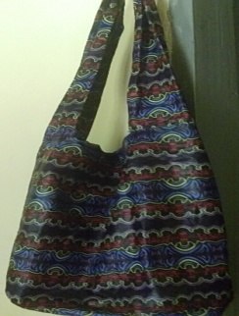
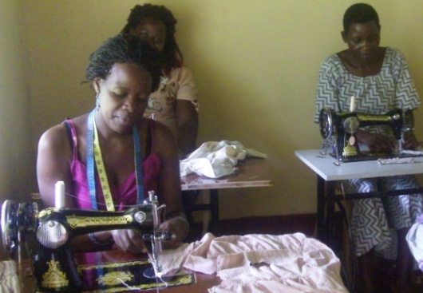

WOMEN ENTERPRISE AFTER SKILLS EMPOWERMENT
 | DESCRIPTION | CALCULATION | AMOUNT (US$) | TOTAL (US$)
Needs Assessment & Identification of Beneficiaries
 | Needs Assessment | Field Survey expenses 3 pple x USD 58 | 175 | 175
 | Sub-total:
Acquisition of Equipment | Sewing & Knitting Machines | 30 Units x USD 115 | 3,450 | 11,239
 | Industrial Grade Sewing Machines/Leatherworks | 8 Units x USD 218 | 1,744
 | Furniture | Assortment x USD 1,160 | 1,160
 | Computer set | 1 Unit x USD 384 | 385
 | Hairdressing Equipment | Assortment x 4500 USD | 4,500
 | Sub-total:
Skills Empowerment Training | Learning materials | 160 women x USD 4 | 640 | 7,040
 | Training User fees | 160 women x USD 39 | 6,240
 | Certificates of Completion | 160 women x USD 1 | 160
 | Sub-total:
Women Production Cluster Groups & Business Centers | Registration of Businesses | 0nce x USD 200 | 200 | 4,200
 | Group Businesses start up capital | 8 Clusters x USD 500 | 4,000
 | Sub-total:
Administrative & Other Operational Expenses | Volunteer allowances | Travel & Refreshments | 600 | 2,335
 | Workshops & Seminars | 3 wkshops x 1 yr x USD 500 | 1,500
 | Stationery | Lumpsum | 35
 | Miscelleneous Expenses | Labour, repairs, hire | 100
 | Project Evaluation | 2 x a year USD 50 | 100
 | Sub-total:
TOTAL (Funding Requested) | 24,989

