FLAME profile
FLAME FOUNDATION

Postal Address:Plot NO 134 Mian Colony, Near Al Masood Medicare, Main Road Faisalabad.
Contact Number:+92 41 8734954, +92 41 8716272
Email Address:flamepakistan.org@gmail.com
Website Address:www.flamepakistan.org

Table of Contents:

SR.NO | Title | Pg#
 | PART 1
1 | Organizational Detail | 3
1.1 | Introduction | 4
1.2 | Flame Goal | 5
1.3 | Flame Vision | 5
1.4 | Flame Mission | 5
1.5 | Flame Objectives | 5
1.6 | Core Values | 5
1.7 | Thematic Areas | 6
1.8 | Sources of Income | 6
1.9 | Geographical Coverage | 7
 | PART 2
2.1 | Organogram | 8
2.2 | Board of Directors | 9
2.3 | Staff Detail | 9
2.4 | Past Experience | 10
2.5 | Flame Policies and Procedures | 11
 | PART 3
3.1. | Gallery | 17
3.2 | Registration Certificate | 19

Organizational Detail:
FLAME ORGANIZATION
Type of the organization (CBO/NGO/  Private sector/Others – specify) | NGO
Name of the head of organization | Eric Lazarus
Postal Address: | Plot NO 134 Mian Colony, Near Al Masood Medicare, Main Road Faisalabad
Office phone number: | +92 41 8734954, +92 41 8716272
Email: | flamepakistan.org@gmail.com, eric@flamepakistan.org
Website: | www.flamepakistan.org
Key Contact person – Name & Designation: | Eric Lazarus (Director)
Contact number of Key Contact Person: | +923316673462
Legal status | Registered under the society Act 1860
Registration Number | RISC/FSD/589
Registration Date | 24 November 2008
Head office | Faislabad

  - INTRODUCTION:
FLAME foundation is aNon-profit and Non-political developmentorganization. It has been registered in Faisalabad under society Act 1860. Flame Head office located in Faisalabad and its regional office located in Karachi, Chak, Jhumra and Abbottabad and has also its office formally located in KPK. Flame Organization was established in the middleyear of 2000 to cautious on the betterment and development of Marginalized communities with a dream to generate a society with equal citizenship. It works throughout Pakistan for the development of communitiesThe basic goal of this foundation is to eradicate main issues of society like discrimination,human rights violation, hardships of access to basic health facilities ,challenges in educational field ,poverty and natural disasters etc.
FLAME visualizes a society that is free of poverty, injustice and discrimination and where allhave access to basic human rights and live with pride. FLAME is targeted at working with poor, deprived and oppressed sector of the society to eliminate their sufferings through community based sustainable projects and programs.

- Community mobilization
- Infrastructure development
- Capacity building projects
We Trust on Partnership
We together find solutions
We keen for alteration
We make a modification

- Advocacy and awareness
- Networking/ Linkages Development with stakeholders.

Flame visualizes “sustainable communities attain fair economic, social, political, cultural development through native community organizations”. Furthermore, Flame aspire to become self- sustaining resourceful, disciplined and specialized training and support institution access to under fortunate with a view to build capacities of community organizations as model development organization. Flame mobilizes communities, facilitates for development of village organization and links them up with resource organization.

The FLAME has developed partnerships and associations with public and private sector organizations tocomplement and enhance each other's strengths and resources for achieving the familiar goals. FLAME’s strength lies in its highly competent, experienced and committed team with capability to adopt new approaches towards achieving sustainable development. Team is frequentlymotivated to bring the energy of hope and long lasting success to the marginalized and vulnerable communities in rural areas of the provinces.

  - FLAME GOAL:

- Poverty alleviation and Sustainable development through creation of self- Help and self-reliance
amongthe people.

  - FLAME VISION:
- FLAME envisions a society that is free of poverty, injustice and discrimination where all have access to basic human rights and live with arrogance.

  - FLAME MISSION:
- To work with poor, miserable and oppressed sectors of the society and to eliminate their sufferings through community based sustainable development programs.

  - FLAME Objectives:
- To perk up entrance to basic social services as health, education, water & sanitation.
- To strengthen and empower women through increased engagement in economic activities and improved basic services focusing on health and education.
- To undertake participatory development program for poverty alleviation and improvement of quality of life of the poor people.
- To promote the culture for sustainable development.
- To introduce new techniques for endorsement of agriculture, forestry, water resource management and livestock.
- To Provide Emergency Relief to most marginalized groups in adversity affected areas.

  - CORE Values:

- Socio-economic Justice
- Gender equality
- Human Dignity
- Minorities and rights protection
- Faithfulness
- Right based Development

  - Thematic Areas:
FLAME main focus is to working in the following thematic areas:

  - Sources of Income:
FLAME is welcome Donations of:

1.8GEOGRAPHICAL Coverage:

FLAME Foundation Pakistan (FLAME) is located and registered in Faisalabad, with itsRegional Offices in Nawabshah Sindh, ChakJhumra, Mansehra, Shohal MedanBalakot and BrarKot, AJK. Flame was set up in the mid of year 2000 to concentrate on the betterment and development of marginalized communities with a vision to generate a society with equal citizenship. Millions of people are illiterate, unaware of their rights and have lack of access to basic health and education facilities. Based on these rationales. FLAME was formed to generate innovative strategies at grassroots level for better health, education and livelihood of the suffering communities.

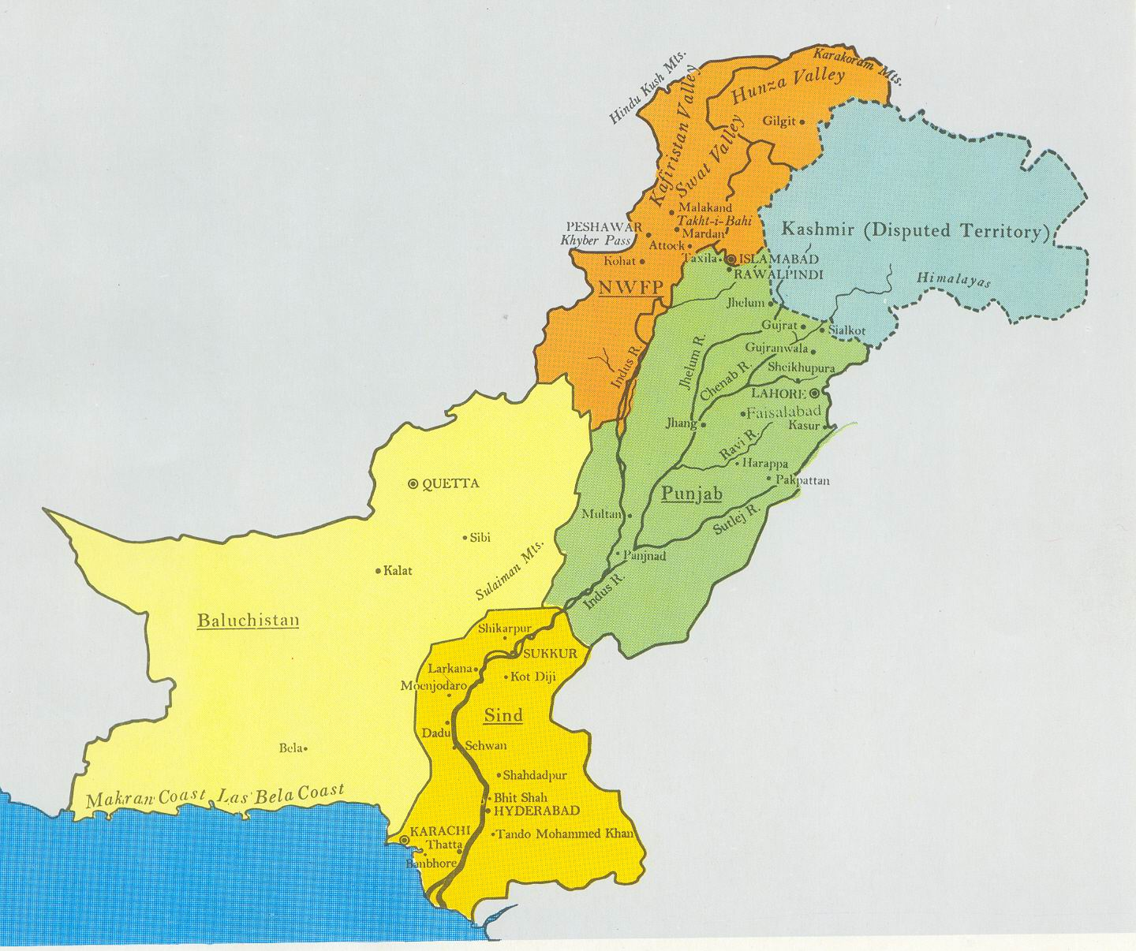

2.1.Flame Organogram:

2.2.FLAME STRUCTURE:
FLAME has well organized structure which is based on independent system and participatory communication and working on day to day business of the organization. The Board of directors supervised the organization and offers the technological guidance and visualization to the organization as per rules and policies of the constitution. All development programs in FLAME are directed and supervised by the chief executive who is responsible for the efficient and effective implementation of the organization as per rules and regulations of the constitutions. The Chief executive Director is responsible for supporting the senior staff management and support staff for smooth and active implementation of program activities of the organization.
board of directors:
Sr.No | Name | Designation | Contact Number | Email address | Qualification | Experience
1 | Eric Lazarus | Chairman | ₊₉₂ ₃₃₁ ₆₆₇₃₄₆₂ | eric@flamepakistan.org | BA | 30 years
2 | Virginia Simon | Vice Chairman | ₊₉₂ ₄₁ ₈₇₃₄₉₅₄ | flamepakistan.org@gmail.com | BA | 15 years
3 | JamshedSamroon Gill | General Secretary | ₊₉₂ ₃₀₀ ₆₅₅₂₈₀₄ | jamshed@flamepakistan.org | MA, MBA | 8 years
4 | SarfrazMasih | Finance Secretary | ₊₉₂ ₄₁ ₈₇₃₄₉₅₄ | flame@flamepakistan.org | B.Com | 15 years
5 | Yasmin Joseph | Board Member | ₊₉₂ ₄₁ ₈₇₃₄₉₅₄ | flamepakistan.org@gmail.com | MA | 25 years
6 | Shama Babar | Board Member | ₊₉₂ ₄₁ ₈₇₃₄₉₅₄ | flamepakistan.org@gmail.com | BA B.Ed. | 15 years
7 | Adnan Christopher | Board Member | ₊₉₂ ₄₁ ₈₇₃₄₉₅₄ | flamepakistan.org@gmail.com | MBA | 7 years
2.3. Flame Staff Detail:
Name | Designation | Contact Number | Email ID
Mr Eric Lazarus | Director | ₊₉₂ ₃₃₁ ₆₆₇₃₄₆₂ | eric@flamepakistan.org
JamshedSamroon Gill | Project Coordinator | ₊₉₂ ₃₀₀ ₆₅₅₂₈₀₄ | jamshed@flamepakistan.org
Arooj Maria | Accountant | ₊₉₂ ₄₁ ₈₇₃₄₉₅₄ | flame@flamepakistan.org
WaleedRaza | Office Coordinator | ₊₉₂ ₄₁ ₈₇₃₄₉₅₄ | flame@flamepakistan.org
Aslam Patrick | Education Coordinator | ₊₉₂ ₄₁ ₈₇₃₄₉₅₄ | flame@flamepakistan.org

2.4PAST EXPERIENCE:

FLAME Organization has been done lot of projects for the sake of community as well as for sustainable development. Detail of previous projects has been mentioned in given below table.
Project Title | Donor’s | Geographical locations | Project outputs | Project Duration  From-To | Budget  PKR
Equipping Rural Women through Health awareness,  Nutritional Education and Food Safety program in Chak 424 JB Montgomerytwala Punjab Pakistan | Associated Country Women of The World  London | Chak No 424 J.B. Montgomery wala Faisalabad | - Increase adoption of healthy foods  - Gain awareness and skills related to thrifty shopping and preparation of nutritious foods  - Increase adoption of diet-related practices for chronic diseases | December 2015 to  June 2016 | 4,16925
Provision of School Furniture and electric water coolers in St. Anthony's High school Antoniabad District Okara | Combined services Third world fund Ireland | Chak no.10/4L  Antoniabad Okara | - Students gain confidence  - Focus more on their Studies  - Low risk of water born diseases  - Self confidence promote among teachers | July 2015 to  November 2015 | 6,78000
Utilization and Enhancement of Organic Agriculture for Better  Health and Environment in Diocese of Faisalabad, Pakistan. | Caritas Belgium | Chak No 424 J.B. Montgomery wala Faisalabad | Information about the current situation in the concerned communities regarding market and organic production of dates, fruits (citrus, guava), sugarcane, medicinal and herbal plants is collected, and analysed.Organic Agriculture in selected sub-sectors (date palm, citrus fruits, sugarcane, medicinal and herbal plants) in the targeted communities is strengthened.  Participation and capacity of communities is improved. | November 2012 to December 2013 | 937,200
Emergency Appeal for Flood Affected Community of Dera  Ghazi Khan and Rajanpur, Punjab Pakistan. | CARITAS Italian, Italy | Gaddai, Jampur and Rojhan | The following necessities were provided to 300 affected families:  One package of foodstuff for each family which includes flour, rice, pulses, milk, cooking oil etc. for one month.  Blankets per family provided. | November 2012 to December 2012 | 5,514,500
Emergency Appeal for Fire Burnt Houses of Al-Rehman Colony,  District Nawabshah, Sindh Pakistan | Kinder Missions Werk Germany | Al-Rehman Colony, District Nawabshah, Sindh | Provided emergency humanitarian response to the burnt houses survivors through food, nonfood items to the 25 affected families. | June 2012 to July 2012 | 1,155,500
Emergency Appeal for Flood Affected Families of District  Nawabshah, Sindh Pakistan | CARITAS Italian, Italy | Goth Jumna Khan, Goth Wahid Bookish, Al-Rehman Colony, Goth  Haji EisaJamali, and Goth Haji Mohammad IshaqBangwar | To provide emergency humanitarian response to the rain and flood affected people through assistance and provision of foodstuff, drinking water and tents to flood-affected 400 affected families. The following necessities will be provided to 400 affected families. | January 2012 to February 2012 | 5,220,000
Agricultural Rehabilitation Of Small Farmers In Chak No. 51 GBKhushpur, District Faisalabad, Pakistan. | Caritas Belgium | Chak No. 51 GB Khushpur, District Faisalabad, Pakistan | Provide Urea and DAP fertilizers to 100 farmers to recover fast from rain affects. | May 2011 to July 2012 | 578,449
Rehabilitation Program for the Flood Survivors in Mansehra and  Muzaffarabad AJK, Pakistan. | CARITAS Italian, Italy | Shohal Medan, Jaghir, Kotbala, Zamiri, FaujiMohallaBrarKot,  ShaheedGali, Shoran, Khangar, and Patreend | Provide poultry sets (15 egg laying hens + 01 cock) to 250 families.  Provide livestock (pair of local breed of goats) to 125 families for better milk and meat production. | September 2011 to August 2012 | 10,127,000
Emergency Appeal for Flood Affected Families of District  Nawabshah, Sindh Pakistan. | Kindermissionswerk, Germany | Goth Juma Khan, Goth Wahid Bookish, Al-Rehman Colony, Goth  Haji EisaJamali and Goth Haji Mohammad IshaqBangwar. | Emergency humanitarian response to the rain and flood affected people through assistance and provision of food for affected children, free medical service, medicine and hygiene kits to 400 flood affected families. | October 2011 to January 2012 | 2,963,490
Emergency Appeal for Flood Affected Families of District  Sanghar, Sindh Pakistan | Kindermissionswerk, Germany | Francis Nagar, Winho Daro, Bangli/Morocoli, Dar, and Dhilyar | Emergency humanitarian response to the rain and flood affected people through assistance and provision of blankets for affected children, free medical service, and medicine to 300 flood affected families. | January 2012 to June 2012 | 3,143,025
Rehabilitation of Water, Sanitation and Hygiene Services for  Earthquake Affected Families of U/c GariHabibullah and  Talhatta. | CARITAS Italian, Italy | MohallahPandi, Kari Mohallah, Daryal, Lasmera of UC Garhi  Habibullah and Jharian, Kotbala, Gul Seri, ShowalMaidan, Zameri  of UC Talhatta. | Establishment of sound sustainable environmental services (Water supply, Sanitation, Hygiene promotion) for 752 poor families through community mobilization and strengthening of community based organizations. | Septembe2010 to August 2011 | 9,667,180
Household food security, nutritional education and productivity  enhancement in Chak No 51 GB Khushpur Faisalabad | Caritas Belgium | Chak No 51 GB Khushpur | Publicity through wall chalking  Establishment of Community Resource Center  2 Nutrition Education Programs  Training to Households on Sustainable Organic Farming and Small Business  Establishment of Block Nursery / Central Village Nursery  Household Gardening / Kitchen Gardening  Tree Plantation Program | Septembe2010 to August 2011 | 423,470
Providing Health cum Free Medical Services to the Flood  Affected People of Tehsil Balakot, and District Nowshera | Action Medeor Germany | Tehsil Balakot, UC GarhiHabibullah of District Mansehra  Timeframe 1st December 2010 to June 2011 | Free Medical services to the flood Affected people. | December 2010 to June 2011
Rehabilitation of earthquake victims through sustainable  livelihood program | CARITAS Italian, Italy | 10 Areas of District Mansehra KPK and Muzaffarabad AJK | Rehabilitation and empowerment of 750 earthquake hit families (5250 individuals) through sustainable livelihood program.  To set up 10 adult literacy centers for helping the adult illiterates to read and write. | January 2009 to Decembe2010 | 8,897,650
Financial Assistance Request for Purchasing Vehicle | CARITAS Italian, Italy | NWFP and AJK | Toyota Land cruiser purchased | October 2009 | 2,082,500
Sustainable Development of Earthquake victims through  Household food security nutrition education and safe  environment program in the affected zone of N.W.F.P and AJK Pakistan | CARITAS Italian, Italy | 10 Areas of District Mansehra KPK and Muzaffarabad AJK | To sustain and improve the Health, Nutrition and Environment of the poor of the poorest in the earthquake affected zone of NWFP and AJK Pakistan.  Project publicity through wall chalking and publication of literature. | May 2009 to April 2010 | 5,467,400
SHG- Self help Group | KNH, Germany and EPS Lahore | Chak No.196 R/B Ghona, Galilabad,Barnala Road, Faisalabad,  MuhallahAlipur, ChakJhumra, Tehsil ChakJhumra ,District  Faisalabad |  | 2006-2009
Income Generating Goat Scheme for 30 poor rural farmers and  their Families in Khushpur, Tehsil Sammundri District Faisalabad-  Pakistan. | La Libula Italy | Khushpur, Tehsil Samundri, District, Faisalabad-Pakistan | Distribution of 60 Goats to 20 women. | 2010 | 283,000
Emergency appeal for immediate relief services for Buner IDPs  (Internally Displaced People) suffering from war against  terrorism in KhazanaDheriMardan N.W.F.P. Pakistan. | CARITAS Italian, Italy | Buner, Mardan, Khazana Dairy, Swat, Kanju. | A total 100 tents were purchased for 100 victimized families.  350 packets of Foodstuff including includes flour, rice, pulses, Cooking oil, sugar, milk, juice, biscuits, etc. for 350 families.  Total 700 blankets for these families were also purchased.  100 cooking pans of 5 kg capacity and 100 of 3 kg capacity.  600 water glasses, 600 plates, 100 water jugs all of stainless steel and 600 tea cups. | August 2009 to October 2009 | 4,725,000

2.5.FLAME POLICES AND PROCEDURE:
Flame is responsible for Planning and policy formulation for the body of organization. Executive Director is responsible for overall management and supervision of organization. In accumulation, he responsible to provide guidance and support to the subordinates as well as he can approve Budget. Executive Director can prepare progress report and Budget of projects. He can call meetings for subordinates regarding his need and consultancy.
Program Manager of organization responsible for work in the following area sponsorship and Awareness, Education, human rights, development program.Abovementioned fields separately possess their Project Managers/Officers, so that their management can be good.
RECRUITMENT Policy:
FLAME has established its Human Recourses development department, and volunteers providing their services give preferences for employments.Technical posts are appointed on the basis of complete satisfaction and purely on merit, through newspaper.FLAME is equal opportunity employer and women are encouraged.Human Resource Department will prepare the contents of the advertisement in consultation with the Project Manage/Officer and Admin & Finance Department. Admin & Finance Department will arrange its publication in the newspaper.Manager Human Resources will receive all applications and will short list them and prepare summaries for review by the Executive Director.Manager
Human Resources will send the interview call letters after consultation with the Executive Director. The interview board will consist of:Executive Director/Manager Human Resource, Head of the respective department, Member Executive Committee. All interviewers will assess the candidates on the prescribed interview appraisal forms.Department Heads will not induct any employee unless she/he has an appointment letter issued by Executive Director/ Director Human Resources on official letterhead of FLAME.
FINANCIAL AND ADMINSTRATIVE POLICY:
The financial administrative policies of human development organization (FLAME) are based on clearly defined standard financial & administrative system and procedure. The section of administration and finance ensures the program/project budget in line with the defined work plan. The section is responsible for coordinating logistics and financial support for the program/project activities of the organization.
The financial management of the organization is based on the principles of transparency and accountability. It is devised and followed by a well-defined and documented accounting system and carries out annual audit of the finances.
MONITORING AND EVALUATION Policy:
Monitoring and Evaluation is necessary to measure the program performance and effectiveness. FLAME has well established monitoring and evolution system, which supports all projects programs in their data collection, Data management and information generation. In addition through the supportive supervisory mechanism at all program level, keep the communication of information and feedback mechanism more effective. This information used to review the progress to take timely decisions regarding the modification in project implementation and future planning.

PART 3:
Gallery:
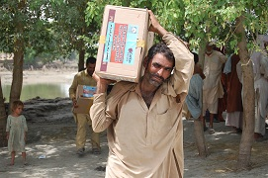 | 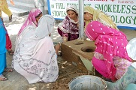
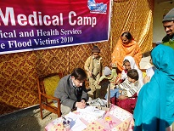 | 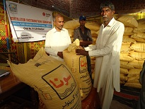
 | 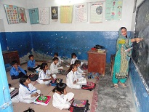
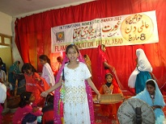 | 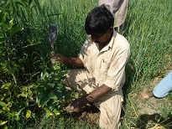
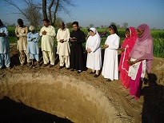 | 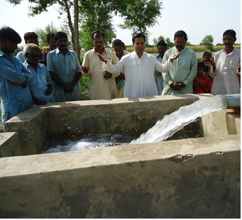
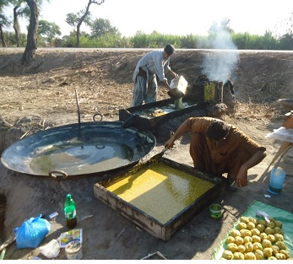 | 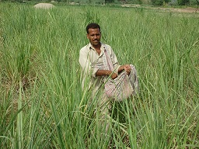

Registration Certificate:

