NATIONAL ASSOCIATION FOR RURAL INTEGRATION
(NARI)
(Regd. No.116/2001 under Society Act XXI of 1860)
D.No.19-9-22/G1, Jaya Nagar, Tiruchanuru Road, Tirupati – 517501,
Chittoor Dist, Andhra Pradesh, India
Mobile:+919849605885, Email:nari2001@gmail.com

Vision:

Empowerment of women and Children in India
Mission:
- To enable self-managed vibrant peoples institutions to protect rights of women and children, promoting better livelihoods by utilizing local resources, skills up gradation and effective utilization of various developmental programs of Governmental and others.
Core values:
- Empathy towards women
- Honesty
- self reliance
- Truthfulness
- Faith in the power of women
Basic information of NARI
Name | : NATIONAL ASSOCIATION FOR RURAL INTEGRATION (NARI)
Address | : D.No.19-9-22/G1, Jaya Nagar, Tiruchanuru Road,  Tirupati – 517501, Chittoor district, Andhra Pradesh
Contact Details | : Mobile:+919849605885, Email:nari2001@gmail.com
Name of Chief Functionary | : N.Rajani, Msc, M.Phil
Act under which registered | : Registered Under societies Act XXI of 1860, Registration No 116/2001, Dated: 23/04/2001
FCRA no. | : FCRA No: 010140440
Pan card no: | : AAAAN4218N
Objectives:
- To Protect the Rights of Women and Children
- To enhance sustainable livelihood opportunities for the poor and marginalized families
- To eradicate Child labor practices and providing rehabilitation programs
- To Protect the rights of tribal & Nomadic Communities
- To facilitate the community to maintain gender equality and equity.
- To empower the adolescent girls and women to get aware of various women issues and measures to be taken up
Approaches and Strategies:
- Convergence with various government Welfare and Development Programs like Andhra Pradesh Rural Poverty Reduction Programme (Indira Kranthipatham), National Rural Livelihoods Program, National Urban Livelihoods Program, Women & Child Development Programs, Arogyasree, SHG-Bank Linkage Program, Sarvasikha Abhiyan, Jan Dhan Yojana, Swatcha Bharath and forthcoming developmental programs
- Convergence with Govt. Departments like Revenue, DRDA, ICDS, Police, PRIs.etc
- Convergence with the NGOs and CBOs working for the development of poor
- Enhance research and advocacy for influencing policy decisions of Government towards poor
Area of operation: NARI has been working in 6 Mandals at present - Srikalahasti, KVB Puram, Yerpedu, Renigunta, Tirupati Rural and Pulicherla mandals in Chittoor Distrist of Andhra Pradesh. Based on the programs, NARI will enhance their activities in other Mandals and Districts
Details of Activities undertaken and grants received
S.No. | Year | Name of the Activity | Amount released  (In Lakhs) | Donor | Remarks
1 | 2009-10 | Tailoring and hand embroidery | 0.66 | NABARD, RO, Hyderabad | Completed
2 | 2009-10 | Prevention of Child Marriages | 0.80 | DKA Austriya & Mahita, Hyderabad | Completed
3 | 2010-11 | Protection of Child Rights Program | 0.10 | DKA Austriya & Mahita, Hyderabad | Completed
4 | 2010-11 | Bio- diversity conservation | 0.07 | Ministry of Environmental & Forests | Completed
 | 2010-11 | 1.Hand Embroidery,2.Applique Patch work,3.Fabric painting | 0.95 | NABARD, RO, Hyderabad | Completed
5 | 2011-12 | - Tailoring and hand embroidery,2.Fabric painting,3.Mirror &Kundhan work,4.Hand Embroidery in Nellore District  - 5.Aryan work,6.Hand Embroidery,7.Chemiki & Beeds work,8.Mirror & Kundhan work,9.Fabric painting,10.Applique work | 3.320 | NABARD, RO, Hyderabad | Completed
6 | 2011-12 | Reduction of Stigma in Mental Health | 1.17 | Public Health Foundation of India & Ministry of Health and Family Welfare, New Delhi | Completed
7 | 2011-12 | Awareness Generation Program (AGP) | 0.10 | AP Social Welfare Board-Hyderabad | Completed
8 | 2011-12 | School at work sites at brick industry | 3.738 | Rajiv Vidya Mission & Aide et Action, Hyderabad | Completed
9 | 2012-13 | Dental Health camps- | 0.12 | Meenakshi Ammal Dental college, Chennai for | Completed
10 | 2012-13 | Awareness camp on NREGS | 0.11 | Nehru Yuva Kendra,Chittoor | Completed
11 | 2012-13 | Water Sanitation Health and Hygiene access to Dalith communities (WASH survey) | 0.67 | Water Aid & NECDOR New Delhi | Completed
12 | 2012-13 | Bio- diversity conservation | 0.122 | Ministry of Environmental & Forests | Completed
13 | 2012-13 | AHVY cluster Development programme | 1.584 | Ministry of Textiles-New Delhi, | Completed
14 | 2013-14 | Hand Embroidery | 0. 32 | NABARD, RO, Hyderabad | Completed
15 | 2013-14 | Bio- diversity conservation | 0.13 | Ministry of Environmental & Forests | Completed
16 | 2013-14 | Water Sanitation Health and Hygiene access to Dalth communities State level orientation programme | 1.64 | Water Aid & NECDOR New Delhi | Completed
17 | 2014-15 | 1.Aryan work,2.Zari& Zardhosi work,3.Dying & Sari rolling,4.Tai & Dye,5.Dying & Batik printing,6. Screen Printing | 2. 34 | NABARD, RO, Hyderabad | Completed
18 | 2014-15 | skill development Trainings on Handicraft trainings-Maggam work | 3.00 | ALEAP, Hyderabad | Ongoing

Major initiatives by NARI:
NARI is a voluntary organization, has been working for the last 10 years in Tirupati and rural areas of Chittoor district on women empowerment and child protection like prevention of child marriages reduce of child labour practices etc. The founder of the organization is a committed Development Activist, worked with ICDS for some time and started NGO as women leading organization for women empowerment.
During the fellowship period, the NARI secretary observed and studied several issues of Tribal communities. The NARI concept is initiated to stop the dangerous ill effects of the Tribal communities, to uplift the socio economic status of the tribal communities through enrollement of all the children in formal schools, eradicate child labour practices & child marriages, stop migration, persuade women economic empowerment. The following are the major activities taken by the NARI with the funding support of NABARD, fellowship and others.
Livelihood promotion trainings:
Trainings for skill up-gradation :.
- Training on Tailoring and Embroidery Training for 25 women at Vedam village in Srikalahasthi mandal ‘Chittoor Dist.
- Trainings to 530 SHG women on Hand embroidery,applic patch work ,Kundan and mirror work , Fabric painting and Zari zardhosi work etc., with the support of NABARD in Srikalahasthi, KVB Puram, Tirupati rural & Pulicherla Mandals of Chittoor Dist
Dying &Sari Rolling,Upparapalli,Tirupati Rural
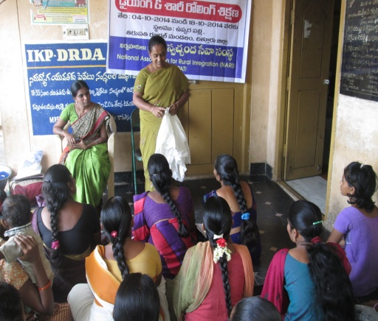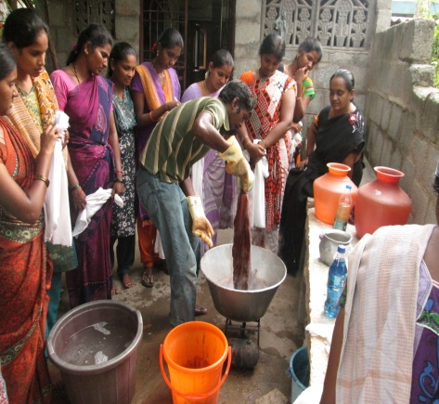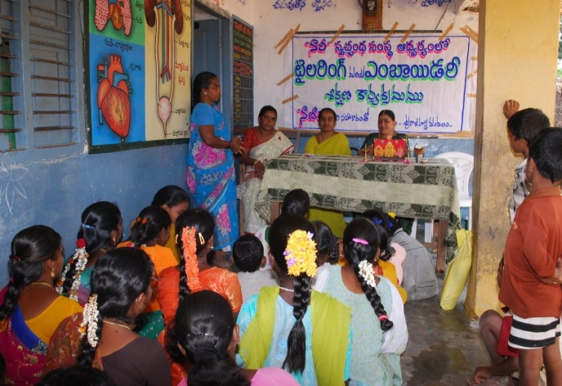
Addressed by Smt. Sithalakshmi, MPDO,Srikalahasthi

- Trainings to 90 SHG women on Hand embroidery, Kundan and mirror work, & Fabric painting in Venkatagiri mandal, Nellore Dist.
- Training on Tailoring and Embroidery Training for 25 women at Bandupalem village in Venkatagiri mandal, Nellore Dist.

Ambedkar Hastha Silpa vikas yojana (AHVY)
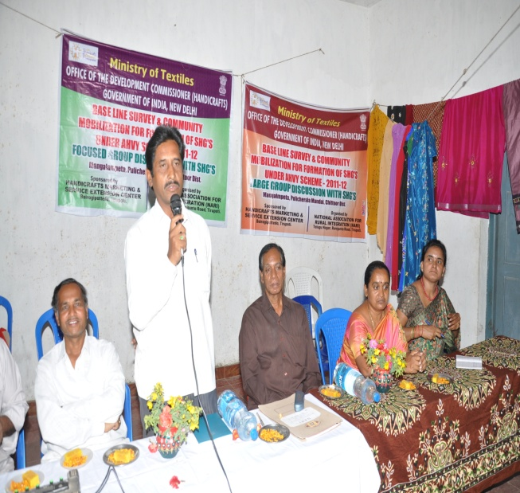
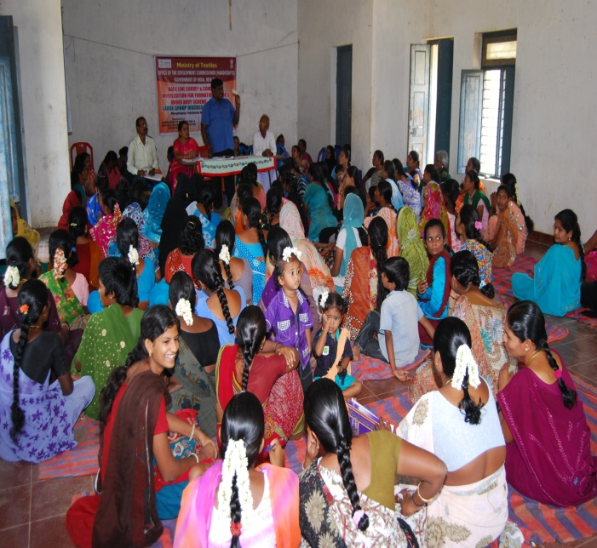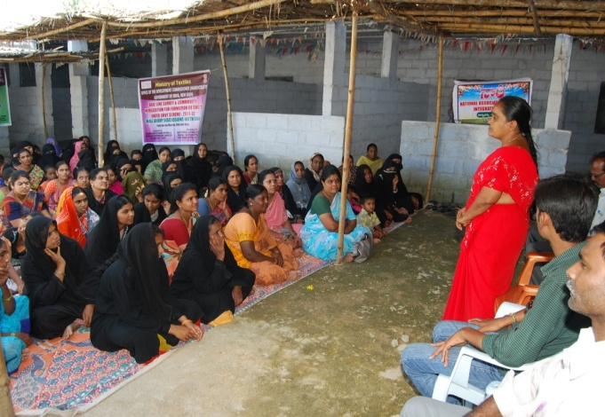
Addressed with Artisans by Addressed with Artisans By Mr.Prabakar Reddy, SGB manager N.Rajani,Secretary,NARI

- Promoted Common Interest groups (CIGs) with with 594 women under Ambedkar Hastha Silpa vikas yojana (AHVY) in different works on zari & zardhosi work, Applic work ,Patch work ,Mirror work and Fabric painting ,completed their Base line profiles and proposed to further Skill up gradation and Design development trainings with the support of Development commission of Handicrafts Ministry of textiles, New Delhi.
Activities against child labour and child marriage practices
- NARI is working for Protection of Child Rights & Prevention of Early Child Marriages in Srikalahasti, Yerpedu, KVB Puram and B N Kandriga mandals with the support of DKA Austria & Mahitha.
- Identified drop out children enrolled in to nearby the schools.
- Sensitized SMC committees on RTE Act-2009 & Child rights.
- Organized anti Child Marriages campaigns during Mahasivarathri festival at Srikalahasthi every year.
- Organized adolescent girl’s awareness camps on child marriages.

Awareness on Child marriages

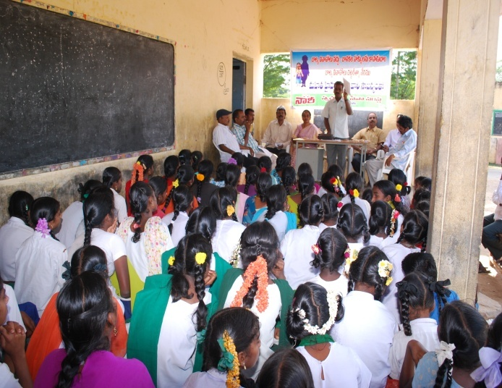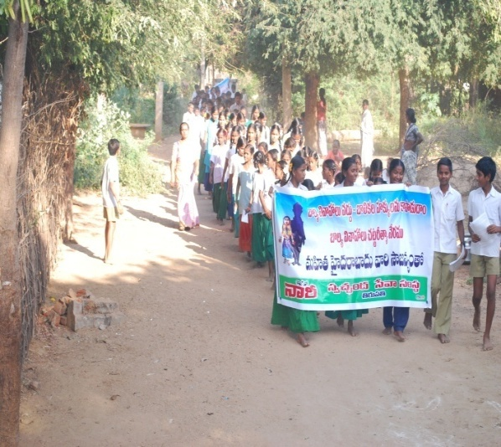
- Formation of Social Action Committees for prevention of child marriages, they were committed to work as watch dog committees on prevention of child marriages & protection of child rights.
Activities with Nomadic communities:

- 48 Nakkala families are residing at Eswaraiah Nakkala colony of Empedu panchayath, Srikalahasti mandal. One Mr Eswaraiah took initiation for getting house sites and agricultural land. Govt., provided120 acres of land to the 48 families. NARI facilitated for formation of 4 SHG’s in Eswaraiah Nakkala colony and provided bank linkage with the support of Velugu. NARI also initiated for land development with the convergence of MGNREGA. They are making flower pots and soft toys and they will sold it at temple places like Tirumala, Tirupati, Vijayawada and other states also.
Health and nutrition activities

- Promoted Health and Nutrition education.
- Organized Health and Nutrition awareness campaigns with the support of CARE, Hyderabad
- Organized mental health camps for Stigma Reduction on mental illness with the support of PHFI & Ministry of Health and Family Welfare, Govt of India, New Delhi.
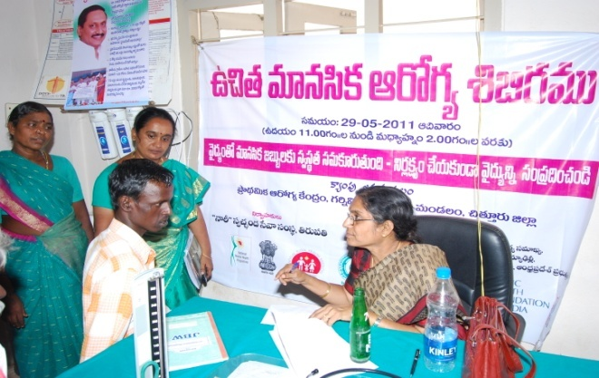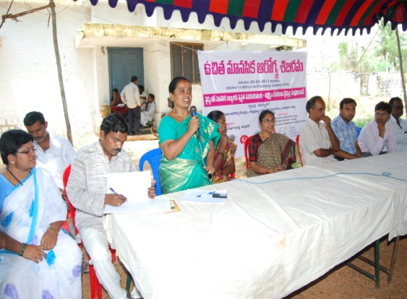
Dr.Sesamma treated Mentally ill patients
- Conducted KAP survey with 112 members of care givers, Non care givers and students on Mental Health & Stigma reduction.
- Organized Mental health camps at K V Palli and KVB Puram mandals with Psychiatric Doctors. 256 Mental ill patients was Identified. The patients referred to SVRR Hospital Tirupati for further treatment.
Schools at work site for migrants:
- Organized 16 works site schools at Brick industries with Orisha Migrant families of SC/ST. 623 children mobilised at Tirupati rural & Chandragiri mandals of Chittoor district with the support of RVM and Aid at Action. The main purpose of these schools is to eradication of Child labour and main stream into formal schools.

Inaugurated Migrant Work site schools by Mr.Maheshwar Reddy PO, RVM
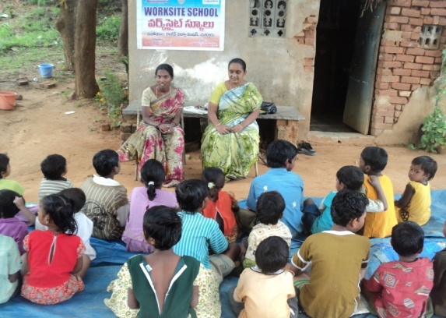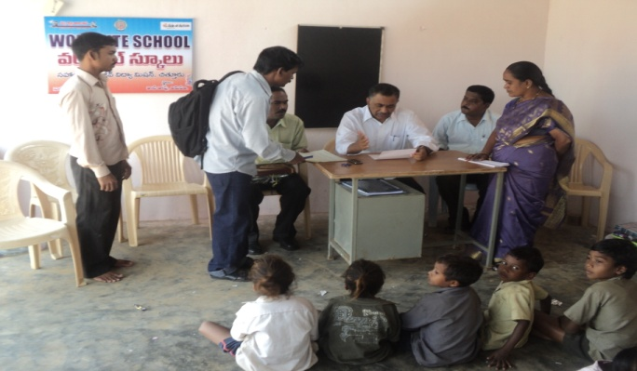

WASH Services to Dalith & Tribal communities
- Assessing Access of Dalit Communities to WASH Services/Rights & Entitlements” 500 Dalith& Tribal households survey was conducted in 3 mandals Srikalahasthi ,K V B puram and Thottambedu with the support of NECDOR& Water Aid Project.
State level orientation training on WASH services
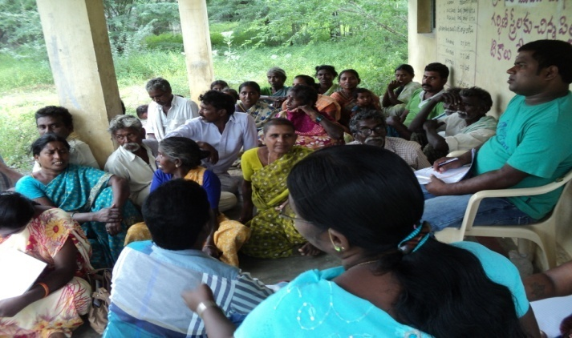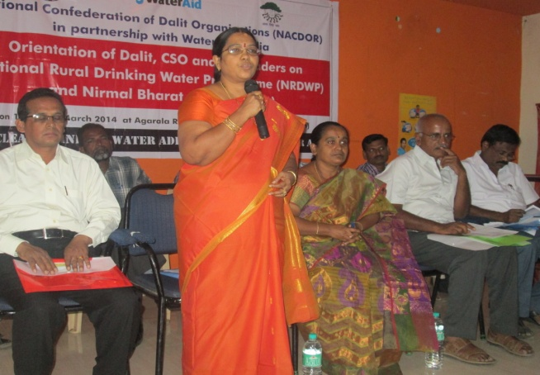
Addressing by Mrs.Nagapadmaja,Project Director,MEPME,Tirupati
- Organized State level Orientation training on Nirmal Bharath Abiyan & National Rural Drinking Water Programme with Dalith PRI members and NGO leaders at Tirupati, Chittoor district with the support of NECDOR & Water Aid, New Delhi
Other activities:
- NARI is mainly Promoted social action committees in 9 villages and trained on social issues.
- Trained farmers in sustainable agriculture on soil and moisture conservation.
- Capacity building trainings conducted to 35 Self Help groups on lively hood opportunities.
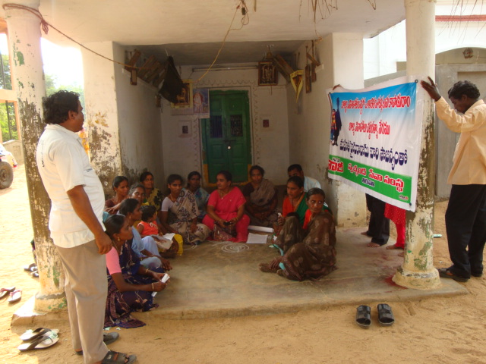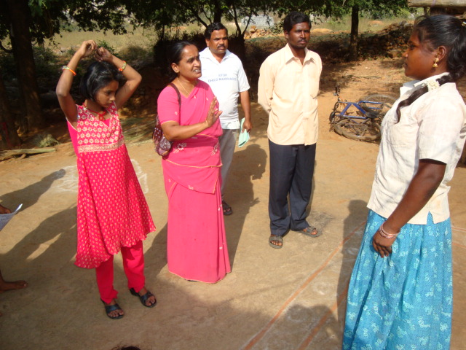
Meeting with Social Action Committee at vedam ST colony on issue of Child marriage
- Organized National environmental campaigns on Bio Diversity conservation with support of Ministry of Environment and Forest New Delhi.
- Organized legal awareness camp on Domestic Violence act 2005 with the support of WINS,
- Awareness created to children in schools on RTE act-2009
- Women legal awareness camps on the exposure visits were organized to empower and protect themselves from all sorts of discriminations, violence and exploitation to the needy families of Srikalahasthi mandal

N.Rajani
NARI,Secretary,
Tirupati

