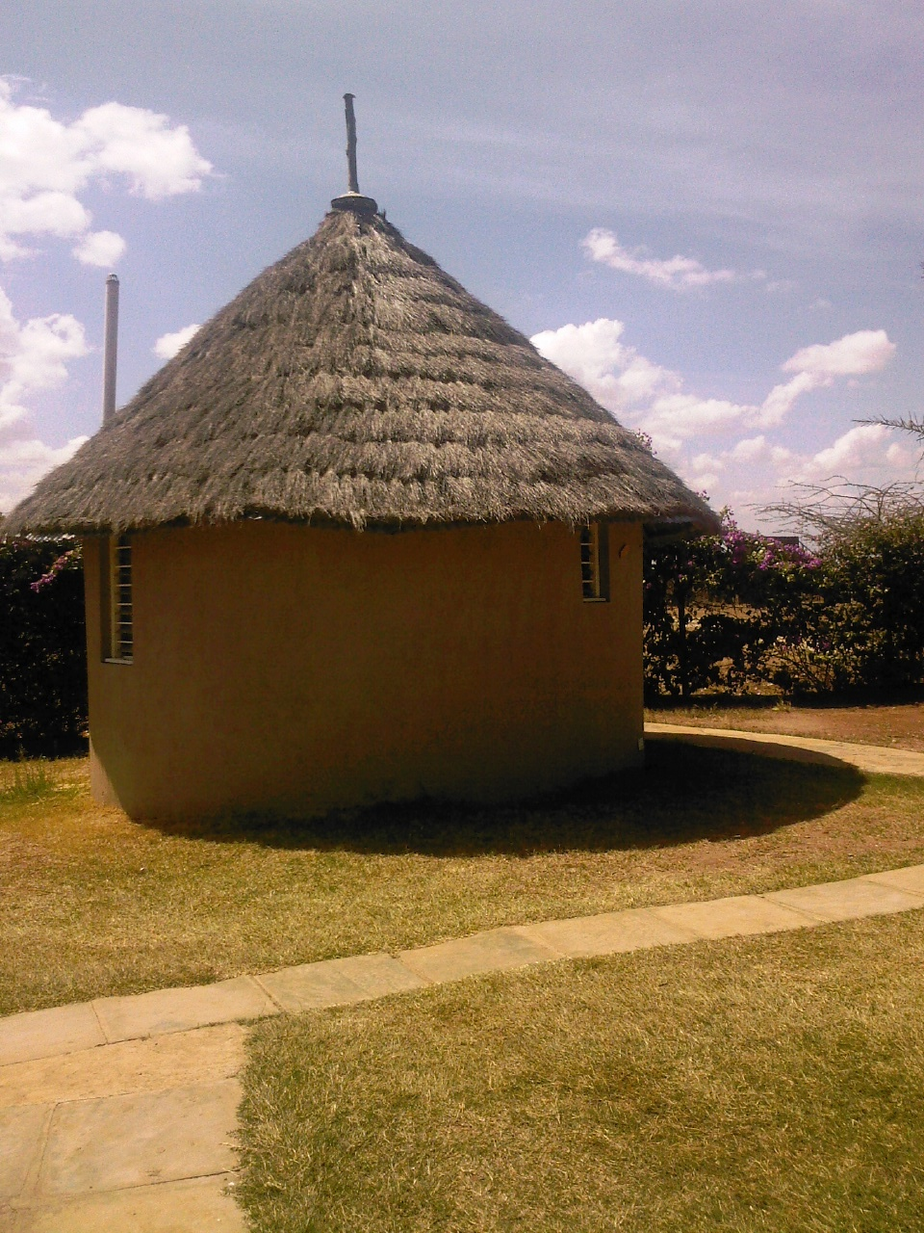

Kamba cultural /education center and museum

Preserving our culture, traditions and heritage for posterity

KAMBA CULTURAL/EDUCATIONAL CENTER AND MUSEUM

INTRODUCTION TO THE IDEA OF THE CENTURY

Background Information

The project Kamba Cultural /Educational Center and Museum is an off shoot of Mulala Conservation Movement which began as a school club of Wildlife Clubs of Kenya in Mulala Secondary School of Makueni District, currently Nzaui District in 1992.The clubs patrons Mr.Josephat Musyoka Mua (now residing in the USA) and Julius Mutuku Muindi envisioned the building of such a center.
The movement had initial support of Mbitini Catholic Mission and the Bikira Maria Catechetical training center and Mulala Secondary School.
The movement had material sponsorship from the Wild Life Clubs of Kenya, Africa Wildlife Foundation, Daphne Sheldrick Wildlife Trust, Kenya Wild Life Service, IUCN, World Resources Institute, The Royal Society for the Protection of Birds, Nature Kenya, Department of Social Services Makueni, United Nations Environment Programme (UNEP), Kenya Energy Non Governmental Organization (KENGO), Econews Africa and East Africa Wild Life Society.
The main activities were teaching the youth in and out school and the general public conservation education and sustainable development.
The movement won many awards from UNEP.Kenya Wild Life Service and the Royal Society for Protection of Birds.

The movement then decided as a gift to the Kamba People and the rest of humanity to come up with the center, which will among other things also carry on with the initial goal of conservation but also preserve the Kamba Culture for posterity.
These will be done through Lectures, Talks, Traditional Dancing Exhibitions, Recording of Traditional Songs, Identification and Preservation of Kamba Traditional Shrines, Recording the stories of Kamba Heroes to serve as role models, Teaching and exhibiting traditional agricultural crops in a bid to stave off food insecurity in the region, Holding Kamba Language Classes for those from other tribes and countries working in the region and teaching and preserving Kamba Rituals and Rites.

PROJECT MANAGERS

- Julius Mutuku Muindi
Humanitarian Worker
World Vision – International
Nairobi – Kenya
- Mulu Muia – MA Archeology
Research Scientist
Archeology Division
National Museums of Kenya
Nairobi - Kenya
- Jelvas N Musau
Humanitarian Worker
United Nations High Commissioner for Refugees
Dhaka
Bangladesh

Problem Statement
The Kamba People have in this century experienced a myriad of problems never before witnessed. These problems include environmental degradation which has cut drastically their agricultural production, Human and Wildlife Conflict and illegal poaching in the neighboring Tsavo East and West National Parks, Amboseli National Park and Chyulu Game reserve. This has led to frequent clashes with authorities.
The Kamba have also experienced social problems like the recent rise of burning schools in Kamba land. It evident the current generation has lost identity and direction these could only be gleaned from elders.
The center will address the above issues and others for the benefit of present and future generations and for global posterity. It will also stimulate sustainable development in Kambaland hence reduce poverty.
Such a center does not exist any where in the country and it is long overdue. It will be a benefit to Kamba People, the country and the whole World.

Goal and Objectives

To preserve and disseminate the Kamba Culture in order to foster peace, social well being and development for posterity.
To collect and disseminate conservation education in order to promote sustainable development.
To create employment for the local population through various activities of the center hence reducing poverty

Objectives
- To preserve the Kamba Culture in order to strengthen its appreciation and respect among the Kamba people and all humanity by holding annual cultural events as the culture is quickly disappearing.
- To provide the needed literature to all interested in Kamba Culture and to those doing research in past development practices, agriculture, peace, initiations, religion, trade etc from all over the world.
- To offer conservation and development education to the present generation so they appreciate the need for sustainable development wherever they will be for the benefit of humanity.
- To offer community training on all aspects development from sustainable agriculture, conservation and social well being.
- To offer permanent community training schools on Agriculture, Low cost housing, Conservation, Solar Energy, Computer Literacy and Kamba Language.
- Conservation and protection of disappearing medicinal plants of the Kamba people through establishment of herbariums and botanical gardens.
- To promote Ukambani and Kenya as a tourist destination by cataloguing and where necessary preserving all places of natural and cultural heritage throughout Kambaland e.g documenting and creating access to cultural shrines and also by holding traditional dancing contests using the dancing styles that are rapidly disappearing and revive the dormant ones.
- Organize volunteer activities to be done by volunteers from all over the world which will promote development in the region and open the world to the Culture of the Kamba people of Kenya.
- To be a one stop information shop for all issues past and present of the Kamba People and Ukambani
- Marketing of Kamba traditional wares e.g. wood carvings and sisal baskets. The Kamba are the best carvers in the world yet the marketing has not been very good for their wares.
- Preserve the Kamba Language through teaching it to Kambas born in urban areas and all those interested.
- Preserve Kamba artifacts, Kamba rituals and rites for use in the Museum.
- Preservation of Kamba Music old and contemporary and propably even make income from it.This includes Myali,Mbathi sya nzeke,Kilumi,Kilui,Mbalya,Mbeve,Ngoma,Kinze etc
- Competitions in traditional dancing styles of the Kamba e.g Kilumi,Kinze,Ngoma,Ngulukulu,Kyeso,Oxen Ploughing competitions etc

KAMBA CULTURAL/EDUCATIONAL CENTER AND MUSEUM

JUSTIFICATION

  - A brief History of the Kamba People
The Kamba have had their traditional home in what is now called Ukambani. This has been their home for at least four to five centuries. Although oral history acknowledges that the Kamba came from the south in the region of Mt. Kilimanjaro.
The creation myth that has been handed down for generations is that the Kamba were created by the same creator who created the universe Mulungu (God). They believe that God created the first Kamba man and woman and placed then on top of Mt. Nzaui. (Nzaui is 25 kilometers north of Emali. Emali is 120 Kilometres from Nairobi on the Nairobi – Mombasa road.) Note: some excusions from the center will includes treks or cycling to Mt.Nzaui to see foot prints imprinted on rock of the first Kamba Man and woman.
Nzaui is also where the famous Scottish explorer and missionary Peter Scott died allegedly after being bewitched by a famous Kamba Witch Syumbesa of Nzaui.

Another version of the story has it that the Kamba were not placed on the mountain but were pulled out from the center of the earth via a hole or a cave on the same mountain Nzaui.
It is also believed there was a certain lineage of Kamba people who were transparent and the last perished in a heavy downpour around 1910 AD.
The Kamba and their descendants then spread out around the mountain where helped my Mulungu who brought rain to make the land productive and gave them domestic animals such as dogs, cattle, sheep and goats.

This myth of creation seems to be completely at odds with the oral traditions and stories which state pretty conclusively that the Kamba were not always in Ukambani, but migrated there around five centuries ago. The majority of them came from the plains around Kilimanjaro in the south in Tanzania. It is also claimed the Nyamwezi of Tanzania are also Kamba, the Kamba arrived in Ukambani propably in various migrations.
There are plenty of oral stories that talk about “ndia ya Mulungu” whose description fits the present day Lake Jipe in the Kenya – Tanzania border.
There is an exception of a Kamba group called Mumoni who say they came from the coast and are propably related to the Mijikenda of the Kenyan Coastal strip.

The reason for the main migration was in search of water during proplonged drought,as there is no oral history that talks about war.

According to oral history the Kamba were originally semi nomadic, and possessed large herds of cattle, like their neighboring Maaasai.Unlike the Maasai they did rely exclusively on cattle, but also practiced cultivation, gathered edible plants and roots and hunted used bows and arrows and also traps.

Once in Ukambani area agriculture took over as primary means of subsistence aided by the higher rainfall in Mbooni hills where they first settled.

Agriculture encouraged the Kamba to settle and from there they spread to cover the whole of their present territory in Lower Eastern that is Mwingi, Kitui, Machakos and Makueni.

During this time the forested hills were explored and exploited, iron ore was extracted from river bed soils and worked upon to make hoes, arrow heads and with riverside reeds they made arrows. The Kamba utilized edible plants and seeds and they also singled out plants with medicinal values which they prescribed to patients depending on their needs.

TRADE
As the Kamba population increased living space in the hills became scarce forcing some to move to drier locations at lower altitude. The drier climate and poor soils obliged the Kamba in the lowlands to rely more on livestock and also as a survival mechanism they began to began to trade. These was necessary during the times of drought and locust invasion which used to strike Ukambani on average of six years or so (some oral stories seven extended periods of extended periods of droughts since the 1890s) these caused frequent famines in Ukambani until early part of the nineteenth century.

Trade was primarily conducted with the Kikuyu at first who occupied the richly fertile central highlands of Kenya.
In return farm produce (millet,sorghum,yams,beans,cattle etc) the Kamba bartered their own manufactured goods Medicinal Charms,Beer,Honey,Iron tools, Ivory and Brass armlets, Brass Chains, Beaded Clothes, Digging tools, Snuff Containers, Arrowheads and the hunting lethal poison ivai.Trade was conducted with coastal people normally the coast was referred to as Usuini where oral stories talk of Mukuna uku and as far away as the Tanzanian Highlands.
As the Kikuyu had no need to trade (the Kamba called these trade kuthuua, meaning search for food.) It was the Kamba who had gone to them and so overtime they acquired in depth knowledge of the people surrounding them.

THE IVORY AND SLAVE TRADE
Trade began to take a more important cultural importance towards the end of the eighteenth century when a succession of particularly bad famines swept through Ukambani. The period coincided with the boom in ivory and slave trade, which was controlled by the Arab and Swahili traders centered on the Island of Zanzibar off the Coast of Tanzania coast. With the knowledge of the Kenya Interior the Kamba were the ideal middle men, and by the early part of nineteenth century were regularly moving between the Rift Valley and the Coast dealing not only with the Kikuyu and Swahili but also with Embu, Mbeere, Chuka, Tharaka, Samburu, Taita and even Gusii close to Lake Victoria in the far west of Kenya.
By the middle of nineteenth century they held virtual monopoly over the supply of ivory. Ivory was obtained by Kamba themselves – especially by those from Kitui by hunting elephants. They are believed to have used magic in hunting the elephants. In return for the ivory they obtained trade goods from the coast such as glass beads, salt, cloth and copper) which they exchanged for food with highland tribes.
These economic pursuits created a class of professional hunters with highly developed techniques for pursuing and killing elephants, in which their traditional skills of arrow making and poison making came into use.

The trade altered more than the Kamba economy it also touched on their social way of life as the Kamba began to use goods from the coast themselves: blue calico worn as head gear became an emblem of warrior status, copper wire was worn round the necks of women: and beads and shells became objects of value in bride wealth negotiations.

DECLINE
The Swahili and Arab who envied the Ivory laden Kamba Caravans arriving at the coast keenly watched the success of the Kamba in Ivory trade.
The town of MARIAKANI named after MATHYAKA the Kamba word for Quiver, because this is where the Kamba left the Bows and Quivers as they could not enter Mombasa with the bows and arrows.
The Arabs had already made several attempts to penetrate the interior of the region in eighteenth century in order to take control of the slave trade, but only in the middle of the nineteenth century when Seyyid Said established himself in Zanzibar did their efforts finally pay off.
He circumvented the Kamba by the simple expedient of moving further west and by the 1880s traders from Zanzibar and Mombasa were operating both in Mount Kenya region and were reaching far north toward Lake Turkana.

  - LOCATION OF THE KAMBA CULTURAL CENTER
The center will be located six kilometers North Emali, Emali is 120 kilometers from Nairobi on the Nairobi – Mombasa road, these makes the center to be accessible from both Mombasa and Nairobi and it will be in the middle of a typical Kamba Village and to be accessible by road by both domestic and foreign tourists and visitors.

The center occupies over TEN acres and in it was a shrine used in thanks giving by KAMBA women to thank God when the crops did well. The last sacrifice in the shrine was in 1960.

The center will be twenty kilometers from the famous Nzaui hill where oral stories have it MULUNGU (God the Creator) put the first Kamba Man and Woman. Nzaui was also the burial place of famous Scottish Missionary and Explorer Peter Scott before he was later removed for burial in Westminster Abbey. Excursions will be organized from the center to Nzaui the hill of God.

The center is six kilometers from Masue hill which was used by MAU MAU as they fought for independence they used caves there as hideouts the caves were later used as the seat of King’ole; King’ole was a disciplinary Kamba court that had the power of life death over those accused. They would sentence a man to death – shoot him a poisoned arrow and charge the family of that man for the arrow.
Trekking and Riding excursions will be organized from the center to Masue hill.

About five hundred metres from the center sits a Kamba shrine of MWANAGALI which was used and still is in use to sacrifice to gods during armyworm invasion and also to ensure fertility of crops in that area. The center will be in consultation with Kamba elders to facilitate visits to the shrine.

Ten kilometers to the North from the center is the Kyemundu shrine used to sacrifice to the gods to appease them to bring rain, today it is still in use and for the same purpose. Near the shrine is also the famous breasted tree whose breasts used to shed blood when there was looming danger in Ukambani referred to in the book TREES MYTHS AND MEDICINE. (co authored by Julius M Muindi who is also the founder of the Center)The tree has now been cut it was near the present Muambwani Sec School.

To the North two kilometers is Mbitini Catholic Mission which was established in 1925

The center will be in NZAUI district,MBITINI division in MULALA location in ITETA sub location in UVILISYANI village.
The area is served by piped water from Mt Kilimanjaro and electricity under rural electrification.

  - WHY A KAMBA CULTURAL CENTER AND MUSEUM
The Kamba being one the tribes of Kenya do not have a serious cultural center and museum. There are small ones that came up and collapsed and others still running but specializing only in accommodation and selling wood carvings.
The center is important in this era of globalization where whole cultures are threatened with extinction.

The center will also be a center for conservation education for lack of awareness of conservation and its benefits is damaging the already vulnerable semi arid Makueni
Informal education programmes directed at the adults who are the main culprits in the environmental degradation will be held here.

The Museum cultural center will be nonprofit making generating income to run itself, it will be a permanent institution to the service of the Kamba people open to the public it will ACQUIRE,CONSERVE,RESEARCH,COMMUNICATE and EXHIBIT for the purposes of STUDY,EDUCATION and ENJOYMENT material evidence of the Kamba people and their environment.
The cultural center will bear out a relationship with the past that attaches value to tangible traces left by the Kamba ancestors and aim to protect them and even make them essential to the functioning of the present day Kamba Society and humanity as a whole. Such as collections as will be in the Museum will constitute Universal Cultural Heritage.

The World Heritage does not belong to us we belong to it. Our actions today determine the fate of those who are yet to come – just as our fate has largely been determined by what has gone before us (UNESCO Masterworks of Man and Nature)

The center will be in accordance to the convention concerning the protection of World Cultural and Natural Heritage which states in part:-
- Considering that the deterioration or disappearance of any item of cultural or natural heritage constitutes to a harmful impoverishment of the heritage of all Nations of the World ,
- Considering that parts of Cultural of Natural Heritage are of outstanding interest and therefore need to be preserved as part of our World Heritage of Mankind as a whole.
(General Conference of UNESCO Paris 17th Oct 1972).
- There is need for Kenyans to develop various enterprises including cultural centers in order to capture tourists both domestic and foreign whilst preserving cultures for posterity (Late Hon. Karisa Maitha Minister for Tourism and Wildlife August 12th 2004)
- Thousands of new friends visit each year to see and enjoy our unique heritage. One we are determined to preserve for future generations and the rest of the World.(Daniel T Arap Moi Former President of Kenya)

The Center and Museum will tell the history and culture of the Kamba people which has enriched all Kenya and humanity as a whole.
All the tribes and the races of the world are connected; hence the whole of Kenya and the rest of humanity should be involved in protecting the Kamba Culture and heritage. IT IS HUMANITYS’ HERITAGE.

The Museums, primary purpose will be to safe guard and preserve the heritage of the Kamba as a whole. It will also present interactions between Kamba culture and Nature.

Finally the Museum will work for the endogenous development of the Kamba Social communities whose testimonies it will conserve while lending a voice to their cultural aspirations
This community museum will be attentive to social and cultural change and help the Kamba to present their identity and diversity in an ever changing world.

