TABLE OF CONTENT

- Director’s letter
- Purpose and Aim of organization
- Mission
- Vision
- Objectives
- Organizational background
- Governance and accountability
- Activities and programs
- Strategies
- Achievements
- Finances
- Inventories
- Miscellaneous
- Partnership
- Success stories
- Challenges / Difficulties
- Recommendations
- Projections for the current year
- Appreciations
- Annexes

VOICE OF GRACE FOUNDATION (V.G.F)- CAMEROON ANNUAL REPORT FOR THE FISCAL YEARS 2011-2012 AS AT 31ST DECEMBER 2011

Introduction: Aims/ Mission /Vision/ objectives, legal status, governance/ history:
Purpose/Aim
To empower rural women and single teenage mothers(youths) economically, create and sensitize them on such issues as pertaining to their rights(health, education, sexual reproduction /Rights), civil engagement, participation, gender equality and promote the fight against gender based and domestic violence, discrimination against youths and women.

MISSION of VGF:
“To enhance the tool of economic growth through the rule of law and good governance at the national and international levels with focus on a) Economic empowerment, b) Poverty Alleviation c) Socio-economic sustainable Development, d) Social Integration e) Human Rights and the fight against Gender based and Domestic Violence; f) and the promotion of the fight against HIV/AIDS and gender Equity( since poverty is a multidimensional and involving not only a lack of income but a lack of basic services and lack of participation of life processes that often influence people ways of lifestyles)

The Vision:
To alleviate poverty by building job creators out of the marginalized in the community and promote the human rights of women. This means it is a rural community enjoying human rights, social and economic justice and equality between men and women and youths,. These most disadvantaged are empowered with the tools necessary to a more participatory role in their community economically, socially and educationally in order to contribute concretely to the development of the overall rural communities in Cameroon and across the globe.

Objectives:
Thus, according to its strategic framework document, its primary objectives will be as follows:-
- Promote sustainable development, poverty alleviation and good governance with respect to Millennium Development Goals (MDGs)
- Train and place on jobs the unemployed youths(single teenage mothers)
- Build capacity of youths and women in Business Operation and Resource Management
- Foster economic empowerment through poverty alleviation
- Place youth and women both individually and collectively on the path of sustainable growth and development
- Strengthen economic and social development as well as socioeconomic justice
- Promote gender equality
- Hault the marginalization of youths and women in employment and globalization processes and enhance their full beneficial and integration in the global economy.
- Bring together influential and well-thought leaders to stimulate a ‘Cross Disciplinary Creative Approach’ in addressing the common global challenges (poverty, diseases, environmental degradation and insecurity.)
- Work for the advancement and development of rural communities
- Foster leadership trainings and community Mobilisation
- Uphold the environmental auditing / and policies formulation for resource management.
- Promote democratic reforms and democracy building principles
- Provides critical information on the peace process predicated on the belief that informed citizens form the majority of those that can jeopardize or destabilize the peace of the nation (because of mass unemployment)
- Fight violence, discrimination of all sorts against women/ youths.
- Create awareness and sensitize the public how to end gender based violence through educative talks(IEC,BCC and Campigns)
- Fight cultural malpractices against women eg female genital mutilation, sexual harassment and abuse.
- Promote agriculture and related activities.
- Facilitate an outline review and appropriate teachings on the social issues circumventing HIV/AIDS and a practical approach to combating the pandemic.

The Organization Background
The Voice of Grace Foundation (V.G.F) is an accredited Anti-Poverty, Social and Humanitarian Organization founded in November 2006 ; with the main objective to empower rural women ,single teenage mothers, unemployed youths and other marginalized of the rural and urban poor communities economically, create and sensitize them on such issues as pertaining to their rights( health, education, sexual reproduction), civil engagement , participation and promote the fight for Gender based violence and Discrimination against women; and above all creating jobs as a means of fighting unemployment and poverty alleviation. Based in Limbe Cameroon, Fako Division, South-West Region of Cameroon; the foundation is a non-profit making, humanitarian foundation that does not discriminate on the basis of sex, race, region, tribe or ethnic orientation. As a satellite, VGF Limbe has a great diversity and a variety of youths and women (ethnically, culturally, linguistically and religiously). The youths are made up of school dropouts, street children; HIV/AIDS orphans youths, disable and underprivileged who formed the bulk of the marginalized populace. The rural woman is a n epitome of poverty and its associated ills (prostitution, suffering, widespread diseases, poor and low living conditions, low disposable household income, voiceless, discrimination, violence,
Inequality etc)
Thus, Voice of Grace Foundation - Cameroon is a non-profit making Social and Humanitarian Organisation with Registration Nº 756/G.37/D.14/1/VOL T/T BAPP, recognised by Law of Association and NGOs of 12/12/1990 and its Decree of Implementation Law No 92/455/PM of 23/11/1992 and governed by the provisions of Law No 92/006 of 14/08/1992

The Project Inception (Dr. Ndonwi Wilfred -Executive Director and Founding President)
Driven by the Director’s passion to assist single teenage mothers( youths) and women who often lack the opportunity to participate in life processes that affect their own life the organization was set up in fulfillment of this purpose. This was as a result of the untold misery and tattered appearance exhibited by the numerous rural and urban poor women population.(especially those discriminated against). This passion grew more when the Director within a day counseled forty-five(45) bartered and disfigured women by their rude less husbands.(victims of violence and assaults) , some , just for the fact that they requested for food money or hospital bills either for themselves or their children. More so, research has revealed that because of little or no economic powers most women are seen by their husbands as procreative machines , and stigmatized with such labels as ‘poverty’ and ‘liability’ – meaning object of ridicule and shame, disgrace, and waste of resources.

Furthermore, women have the potentials to change whole community and families, yet are so under- resourced and under-valued. To help give the woman the image she deserves and develop the untapped potentials in them, the project started up by giving non refundable minute sums as initial capital or seed capital to these numerous socially disadvantaged which eventual grew into this full National and International Project program – “The empowerment of the Voiceless.”
Couple with the fact that most men love to use money and power to destroy young women and girls; and suppress the youths , the founders deemed it necessary to create a forum where they can help to educate these young ‘preys’, sensitize them and campaign against such deviant attitudes.

In a nutshell, the project exists to fight social exclusion, promote youths and women economic justice and empowerment, fight cultural malpractices against women and youths, and esteem the image of these marginalized populace, encourage participation in decision making, and promote their rights, be them civil, political, social, economic or cultural. These are appropriate ways of addressing these sensitive issues that often culminate in juvenile delinquencies as prostitution, clandestine emigration, cheating, arm-robbery, drug addiction etc. Thus, helping to stabilize the society; and as such deviant acts are being kept under control to some extent, since poverty is the mother of all crimes. Also the fact that many strikes are born out of disgruntlement, ignorance, habits and cultural influence, the project is aimed at educating, sensitizing, empowering and building a violent free society and impacting youths with the importance of positivism amidst challenges and hopelessness rather than disillusion.
In fact this is the tool to foster economic development and justice for the women, facilitate the social and economic integration of women, protect their vulnerability (rights), build women capacity on resource management (entrepreneurial skills), advocate and mobilize resources for the advancement of the rural and urban poor women and strengthen the fight against practices that subject people to inhuman treatment.

Governance, Decision Making, and Accountability:
a) Structure:
The VGF is consists of a general Assembly of thirty (30) members of which 75% are women; that elects an Administrative Board which in turn assigns an Executive Board on the basis of their specialization. The administrative board is a 4:3 representation (4-female: 3 men). This board consists of officers responsible for the following programs: Human Rights/Domestic Affairs, Income Creation and Micro Enterprising (Empowerment Grants-project), Skills and Vocational Trainings, Capacity Building and Enhancement (Entrepreneurship), Community Development Services and Psychosocial Support & Care and Circular Education, Health Information and Awareness, Sanitation and Water( Community Participatory Hygiene And Sanitation Transformation- Com. PHAST)
The committees of the respective programs meet on a monthly basis to implement the Programmatic Monitoring (P&M). In addition, the Programs Coordinator conduct field visits regularly .
Financial Reviews take place every three (03) months with the participation of the external evaluator (Auditor) while the Executive/Administrative Committee carries out a biannual project evaluation. The project evaluation is carried out every six months on the center and sector levels.
b) The Management Structure:
The hierarchies of the organization are the Executive Director who doubles as Council of founders’ Chair and the Board Chair. These with the other executive bureau members draw policies which are voted in the general assembly of members. The council of founders, which serves the role of the both the board and administrative /executive bureau is the ultimate power of the organization. But the decision made by this must be deliberated on in the general assembly of members since this forms the majority. If the general assembly votes against a decision, the council of founders cannot enforce it or continue with it. This is to ensure democracy and fair assessment of projects or decisions in a more favorable and considerable way.

The Board is assigned on the basis of competence, specialization and qualification, through universal suffrage of at least 2/3 of the general assembly of members’ votes. The executive/administrative board with the exception of the Executive Director, as the vision coordinator is elective and each member has a three term of office and renewable.
Membership of the organization is made up of the founding members, honorary members and ordinary members. But all of this constitutes the general assembly of the organization. This body (GA) is the final authority of the organization since the council of founders (Board) cannot take a decision and past it without its approval. All the members do have a say and as such decision making is participatory. Everyone willing to offer services and /or can contribute to the wellbeing of others can become a member especially if he/she fulfills the conditions required.(see appendix B) member list.

Activities And /or Programs:
Voice of Grace Foundation’s entire Program activity is summarized into six key areas; which constitute the core thrust of the foundation’s Women- Community Centered Holistic, Comprehensive, integrated Sustainable Development Program Initiative. These include; Economic empowerment, Educational empowerment, Health Education and Awareness, Women’s Human Rights, Leadership and Engagement, Community Developmental Services;
The organization main activities are health, water and sanitation, education, human Rights, sexuality, health education, micro financial services,/micro credit projects, democracy, community developmental services.
This program activity is summarised into six main areas which formed the core thrust of the VGF’s Women-Youths Community Centred Holistic Comprehensive Integrated Sustainable Development Program Initiative (WYCCHCISDPI). These include
- Economic Empowerment
- Leadership, participation and engagement
- Health Education ,Information Awareness & Sensitisation
- Human Rights
- Community Sustainable Development Services(Water and Sanitation, Agriculture and related activities, Outreach
- Education
Project Strategies include
a) Microfinance Approach
b) Leadership Training and engagement
c) Micro Enterprise Development Approach
d) Agricultural Development and Alternative Livelihoods for Youths
e) Resource mobilization, sensitizations and awareness, Advocacy, vocational training and capacity building, empowerment grants /seed capitals etc

Achievements:
The closed of 2011 saw a leap frog of the organizational activities; ranging from skill strengthening to micro enterprise development. Other key issues that gave credit to the institution were; the provision of scholastic needs to the underserved pupil and students, financial assistance to the needy, debt relief, charity and enabling the hungry feed.
These and many more are made clearer in the tables below:
Academic Donations:
Project activity | year | No of beneficiaries | Amount | Results | Remarks
Academic Donations | 2010  2011 | 25  35 | 200,000  241,7500 | 41,750 | 10 more pupil were

The organization incurred an additional forty –one thousand due to the increase in the number of beneficiaries in 2011; giving a percentage rise of 24.39%. An indication we achieved a positive bench mark this year. (See appendix 1)

Vocational Trainings:
Project activity | year | No of beneficiaries | Amount  FCFA | Results  FCFA | Remarks
Vocational/Skill Trainings/Job mentoring | 2011 2010 | 15  8 | 1,500,00  1,000,000 | 500,000 | 7 more beneficiaries

Training and mentoring or placing on jobs through seminars and renounced centres is one of our key strategies to fighting poverty. Hence as seen above the years under review made some stride in this area. Fifteen candidates were trained in 2011 as compared to eight in 2010 giving a percentage increase 30.43% in this project area. This activity entails that much funds be budgeted since after completion beneficiaries need to be placed on job. Even though, this entails much funds, the organization is doing quite much to see that the goal of this particular activity is attained despite financial constraints.(see appendix 2)

Micro-Enterprise Development (Empowerment Grants)

year | No of beneficiaries | Amount | Results | Increase / | Remarks
2011 | 45 | 2.325,000 | 1,111,000 |  | 35
2010 | 10 | 1,214,000 | 1,111,000 | percentage | 47,8%

This is a key strategy design to aid the organization in its objective of empowering the underprivileged to combat abject poverty. The objective of this program is to grant empowerment or seed grants to the ultra poor to start some income generating activity. We have been able to provide some empowerment grants to the number of the beneficiaries as shown in the table above. Their activities range from fabric manufacturing, sowing and embroidery, saloon and beauty. The beneficiaries through the gesture of Voice of Grace Foundation-Cameroon has been able to help themselves, pay education, medical care for their children; and increase their erratic disposable household income. Other beneficiaries are currently undergoing training by the former ones. This would be our next target next year as we continue to support them settle on their own businesses after graduation.
However, this particular program is a very big challenge to the organization as it entails a lot of financial support from the organization to meet the increasing demand of the beneficiaries. As can be seen the percentage rise (47, 8%) indicates a progressive trend in the number of beneficiaries. If poverty must be made a history in the globe the poor must be considered in capital creation activities as this! (see appendix 3)

Workshop/Seminars/ Trainings and Capacity Building
Year | No of beneficiaries | Amount | Results | Increase / | Remarks
2011 | 275 | 725,000 | 118,000 |  | 175
2010 | 100 | 607,000 | 118,000 | percentage | 19,43%
Workshops and Seminars on trainings and capacity building on issues of violence, discrimination, justice and equality record a huge success for this period under review. We also organized business seminars, leadership and engagement training and held workshops on health related issues where community members were taught the importance of maintaining simple hygiene to avoid contamination. The health issues were treated with emphasis on behavioural communication changes (BCC) and information Education Communication (IEC). In this wise, communities were taught how to manage malaria, prevent it, and other diseases like cholera, dysentery, diarrhea by observing simple hygiene and clean up campaign. This forum is also a medium we used to highlight sanitation issues like wrongful disposal of waste (appendix 4a, 4b, 4c) and these show the bad practices as to waste disposal and water contamination and other related hygiene issues.
The increase rate (19, 43%), in the number of seminars is an indication that the communities need these workshop so as to redress their behavioural pattern in community health.

Psychosocial Support:

Year | No of beneficiaries | Amount | Results | Increase / | Remarks
2011 | 225 | 957,525 | 106,175 |  | 130
2010 | 95 | 851,350 | 106,175 | percentage | 12,47%

The table above clearly shows that the organization continues to apportion a reasonable amount to support those in need. This program include: provision of social need (medical bills, debt relief, food and clothing). This is purely charity and for the last year was able to assist two hundred and twenty-five beneficiaries. It should be noted the beneficiaries are increasing exponentially. This is an indicator that more funds need to be readily budget to take care of beneficiaries of this program.

Research

year | No of beneficiaries | Amount | Results | Increase / | Remarks
2011 | 07 | 225,000 | 75,000 |  | 05
2010 | 02 | 150,000 | 75,000 | percentage | 50%

This is not really a subject of importance to us except for the fact that we carry out research for data collection as raw material for project writing. Hence the amount spent so far has mostly been on feasibility studies on proposed project. The percentage increase (50%) in research cost clearly indicates our search for partnership as explained. This is a direct representation of the increased number of projects submitted in the year under review. Even though we did not succeed in soliciting any financial support form potential partners; we believe that to some extended our interest in promoting and empowering rural , urban poor women and single teenage mothers is paramount to the organization. This primordial interest must be communicated beyond boundaries to all funders and interested corporate bodies that wish to support our mission through any form of investment. We would therefore continue to research into issues of social – economic development that are importance in promoting the advancement of the woman. (See appendix 6)

Finances:
The organization is self financing. The organization has an independent account in a well recognized financial institution. The bank information of the organization is as follows:
Bank Name: Unity Cooperative Society (UNICS)
Sappa Road Down Beach Limbe
Telephone: (+237) 22 04 16 93
Fax: (+237) 22 04 16 93
Account Name: Voice of Grace Foundation (V.G.F.)
Account Number: 0880014080011X or 37320801342374

Swift Information:
Bank Name: Ecobank
Account Name: Unity Cooperative Society (UNICS)
Account Number: 000151002902002482701.
Swift Code: ecoccmcx

The year under review received an income of five million, one hundred and forty-six thousand, four hundred and sixty-eight (5,246, 468) francs CFA. This comes from diverse sources like service earned fees, registration fees of all sorts, Social Funds Collection Commissions etc. An expenditure to the tuned of nine million, nine hundred and fifty thousand, two hundred and seventy-two (9,950, 272) francs CFA on project activities, operational expenses, administration, office and other miscellaneous incurred; giving an excess expenditure of four million , eight hundred and three thousand, eight hundred and four francs( -4,803,804) francs CFA over income. The financial statement best describes this. (See appendix D)
The budget for the current financial year (FY 2012-2013) stands at twenty-five millions, two hundred and nineteen thousand, nine hundred and fifty-eight (25,219,958) francs CFA.(appendix D)

Inventories: The Voice of Grace Foundation has as inventory the following:

- Office Table ------------------------------ 250,000
- Computer(Desktop Pentium 3)--------- 220,000
- Printer( Deskjet 890) -------------------- 45,000
- Computer Stand -------------------------- 15,000
- 03 Plastics Chairs/table ----------------- 20,750
- A set of Cushion and carpet----------- 405,000
- TV Set/ DVD disk palyer ------------- 95,000
- Sanyo Spaekers --------------------------- 48,000
- Secretary Chair --------------------------- 18,500
- Office Chair -------------------------- 85,000
- Calculator--------------------------------- 4,500
- Registers---------------------------------- 19,600
- Library ----------------------------------- 100,000
- Internet----------------------------------- 89,500
- Digital Camera ------------------------ 85,000
- Memory Card-------------------------- 10,000
- Phone Mobile------------------------- 15,000
- Memory card-------------------------- 2,500
- Sign Board----------------------------- 35,000
- T-shirts-------------------------------- 76,500
- Flags----------------------------------- 25,000
- Staple Machines(02) --------------- 7,000
- Stamps---------------------- 25,500
- Complementary cards----- 30,000
- Electrical appliance----------- 31,500
- Cupboard/stand--------------- 135,000
- Scanner
- Printer Epsonstylus 3 in 1 120,000
- Photocopier Epson
- Fax machine ---------------------------- 10,000
- Photocopier Canon 1550---------------- 250.000

Total Inventory Worth = 1,802,350 fcfa

Miscellaneous:
The organization organized an open-day ceremony which took place at the women Empowerment Centre Limbe. This occasion witnessed a massive turn out from the local population of Limbe municipality and its environs. However, the luke-warm attitude of the government officials remains a call for concern.
We just gained registration into the membership of Women‘s Forum Limbe. This is evidence that we are an organization dedicated to the advancement of women. (Appendix 7)

Partnership:
We heartily thank the following international and national organization for their collaborative support. The Schwab Foundation for recognizing and recommending efforts to other social actors, like the World Economic Council, University of Siegen through their recommendation this University has become one of our potential partners in which they can now comfortably carried out the research survey on social enterprise- Social Entrepreneur Survey “How Social Relations foster Social Values”. On this topic, the officials this university contacted us with the questionnaire of 17 pages and 66 questions which were answered with detailed information. This organization through this information has gained reputation from the board of this institution and a new partnership is in the pipeline. Thanks to the Schwab Foundation who recommended the organization to them. Not forgetting Care International and American Jewish Services which, through their respective Presidents and Chief Executive officers (Dr Helen D.Gayle & Mrs. Ruth Messinger) for their total commitment in recognizing the social values that we uphold in promoting activities for the advancement of the women.
Also, is the contribution of the Commonwealth Foundation in recognizing the role we play in the promotion of the right and socio-economic development of the women. This is appreciated through an international survey of civil society in which our participation was counted indispensable for its success.
Furthermore, we greatly appreciate Dr. Howard White of International Initiative for Impact Evaluation (3ies) for constantly updating us with all available opportunities with this organization and other development partners like DFID, USAID, and Copenhagen. We equally extend heart felt thanks to the CEO and President of the World Health Council – Dr. Jeffrey L. Sturchio, for sending us all monthly and weekly health updates from the council. Measureless thanks go to Stefan Huber and Angela Marti, both secretary general of the ReSource Award and corporate director of Corporate Citizenship, Swiss Re Company for their formal invitation to the organization to participate in the Resource Watershed Award each year. We pray and hope this not only end at the invitation but go along way to establishing a fruitful partnership in the nearby future. For Grameen Trust Fund, we thanked its Executive Trustee, Prof. Dr. Yunus Muhammed, for inviting the organization to the replication annual training programs which, not only spur our thinking but is opening up other avenues for the organization and widening our scope so that we are able to use this method thereby increasing our impact on our target population. We equally acknowledged the gift made to us by the Micro insurance Innovation Facility. We received four 2010 annual report copies from them. We equally received an acknowledgment letter recommending our project objective to serve the poor through economic development to low income households. These are sampled partners from the lot of international collaborative organizations.
On the other hand, our national partners are Christian Women Faith Forum, Women Forum, Women Empowerment Centre, Vocational training and employment (partnership still in the pipeline) as well as that of other ministries. The women, Community Based Organizations, Women of Purpose, and Serious Girls Associations are all local partners to VGF. We collaborated mainly on criss cross programs. VGF has been actively involved in capacity building for these partners and financial support; especially to some CBOs in the North West Region using its partner organization- the Link Cooperation Cameroon. Through this, we administered assistance to orphans, women and single teenage mothers in the region. Thanks to the Link Cooperation Cameroon for the tremendous work they are doing with VGF. Our local government is not left out. We greatly acknowledged the active involvement of the Senior Councilor- Mr. Tony Baleba Joseph of the Limbe City Council. He has been a source of support and breaking some of the obstacle we could not break on our own. Once more, we appreciate you and pray we do have many people like you to represent the masses and their troubles to the government as you are doing.

Success Stories:
- Sophie Achu: Thanks to the Voice of Grace Foundation, which help to pay off my debt from a group that I borrowed money; I became a fugitive because of this debt. Now I can stay home, take care of my children and sleep in peace since I am now free from my debtors’ harassments. Once more thanks to VGF- Cameroon
- Pascaline Frinwie: I was on the street with no place to put my head, and my daughter out of school. Thanks to VGF-Cameroon benevolence that has helped me to become a responsible mother. My daughter can now go to school and I have a shelter as well. They help to establish me on a business.
- Ngozi Blessing: I, heartily thank this organization for giving voice to the voiceless. I was without hope. But through the financial assistance offered to me and my husband we were able to start up a small business which eventual aid us to purchase a bike and pay our child tuition.(appendix 8)
- Honourine Mande: I lack words to thank the organization for giving me hope, when all my hopes were dashed and shattered. Through their timely financial assistance, I will be privileged to seat for the General Certificate of Education(GCE) ordinary Levels and my younger brother is able to be back to school.
- Amina Issatou & Mimouna Yausifu: VGF is really an organization to reckon with. We are Muslim’s sister but are currently learning a trade under the sponsorship of this organization. We are into fabric manufacturing and tailoring (Seamstress). Thanks to God’s given organization as such we would never be anything.
- Mrs. Ngomba Pascaline Ateghem: Words are not enough to express our heart felt gratitude to the Voice of Grace Foundation (VGF) – Cameroon.
- My husband through financial assistance from the organization has been able to set up a small business which has enabled us come out of poverty. We now pay our cost of living with ease (medical, nutrition, accommodation, electricity and water), above all this has increased our erratic household income. (see app
- Muhammed Ngusama /Glays Ake Koffi: Semi finalist and Finalist in the Nursing training school of Limbe. We want to thank and appreciate VGF-Cameroon for the unfringing support through our nursing Aid training and Internship where it covered all our costs incurred. We are particularly grateful and recommend that their effort is worth supporting.
- Mrs. Aseh Asombang Judith: As a widow life was without hope. My children were constantly being driven for fees. Food was difficult to come but Voice of Grace Foundation- Cameroon brought sunlight to my family by providing us with financial assistance which enables me to start a small business. I now fried gateaux and supply to some secondary school around. This has saved us from the scourge of poverty.

Challenges /Difficulties:
- Our main challenge has been in the areas of institutional support (financial, material and equipment.) The organization is in need of equipment like copiers, computers, Laptops, printer, scanners, video cameras, Projectors, flipchart stand, office chairs, tables, fixed phone and internet apparatus.
- Breaking through the government policy to provide assistance to the needy is a big hurdle to overcome.
- The number of beneficiaries to the project kept on increasing on a daily basis. This increase has raised the budget to an exponential level that we would be fully committed to seeking support from the international and national communities to assist us me their demand.
- Membership’s contribution to the growth of the organization is very weak.
- We lack volunteers, and recruiting salarised staff increases our expenditure.
- Partnership is for now on voluntary basis.

Recommendations:
- Our membership into the women’s forum will increase our advocacy in the social Network of women organization.
- We have increased our budget in this current year so as to add up the inventory into the office and meet up with project demand with or without external financial support.
- We have diversify our income sources so as not to overly dependent on one source
- We are currently seeking more volunteers into the organization as well so as to increase the manpower need in the organization.

Projections for the current year
- The office now has a new site, at Revival Street Alpha Club Towe
- The Website would soon go operational(www.voiceofgracefoundation.org)
- The organization is seeking volunteers
- The address and phones and contacts remain unchanged
- We seek support in kind, cash and material wise
- We seek funding or books for our library
- Launching of the health in Pregnancy Grant for rural and urban poor women this year.
- Launching of the Weekly Show on “Responsible Adulthhood/parenthood”
- Launching of the Monthly Show on “Women and the World”
- The adult literacy centre for older people
These projections will be implemented this current year. Hence we seek support on all diverse areas so as to enable us realize the goal of these programs.

Appreciations:
Voice of Grace Foundation Cameroon appreciate the efforts of its partners, collaborators and well-wishers that has contributed immensely to the great success of the organization for the Fiscal year 2010 and 2011 and we look forward to a more committed and cooperative year 2012. God bless you as you donate to support us give life to a dying world!
Always remember that when you give to the poor you lend to the lord who will repay you a hundred fold. This fiscal year we have touched lives like never before and all these were made possible through your significant support; in kind and otherwise.
You all are wonderful. Keep the lights burning! We look forward to a more successful year.

Best Regards.

Administrative Board &Executive Bureau (see appendix A)
Name | Sex | Position | Qualification
Rita M Fousso | Female | Board Chair | MA Linguistics
Ndonwi Wilfred N | Male | Executive Director/ Council Chair | PhD BA./NSM/PFIN
Cynthia Ndukong | Female | Executive Secretary/Vice Executive Director | BSc Biology/Enironmental Study
Meh Loveline | Female | Psychosocial Support /CDS Coordinator | MSc. Gender/Deveolpment/Mgt
Nforchu Mabel N | Female | Legal Adviser/ Human Rights Coordinator | LLB & Maitrise International Law
Tebid Ethel | Female | Peace, Conflict Mgt/Circular Edu Coordinator | MSc Social Antropology
Dione Syvie Eduh | Female | Finance Secretary | BSc Economics
Che Ayari mercy | Female | Accountant /Treasurer | BSc Accounting
Esua Essembieng | Male | Program Associate/Public Relation Officer | BSc Political Science
Ngutih Amelia Anwi | Female | Skills/Vocational Trainings Coordinator | HND Community Development/Designing
Ivoline Kibong | Female | ITC Training Coordinator | BTs Technology
Neba Priscilia Lem | Female | Program Associate/Public Relation | MSC Natural Resource Management
Emmanuela Kewe | Female | Finance Administrator | BSc Banking and Finance
Sirri Mercy Munkaa | Female | Vice finance Administrator | Banking &Finance
Tangie Emmanuel |  | Research Coordinator | BSc Agriculture/ Community development
Tancho Felix Suh | Female | Project coordinator | BSc Environmental Science
Muwanki Akongnwi Bih | Female | International Representative (China) | MA Linguistics
Akeh kofi Priscilla | Female | International Representative (France) | BA Sociology

MEMBERSHIP OF VOICE OF GRACE FOUNDATION(appendix B)

NAMES | Country
Nsanyi George Ghefah | Cameroon
Meh Loveline Galiwa | Cameroon
Nganu Pascaline Lem | Cameroon
Funwi-Gabga Neba | Spain
Godwin Ayari C. | Cameroon
Ndonga Gabriel | Cameroon
Tancho Felix S. | Cameroon
Ambesi Hans | Cameroon
Nforchu Mabel | Cameroon
Mofor Kewe Emmanuela | Cameroon
Ndenge Godlove | Cameroon
Fossuo Collins Ojong | Cameroon
Linette Yunga | Cameroon
Elisabeth Enanga | Cameroon
Ndonwi Wilfred | Cameroon
Nkafu Collette Asong | Cameroon
Ntoni Veronica | Cameroon
Lesinki Ntendah C. | Cameroon
Orock Peter Ayuk | Cameroon
Lawrentine Eposi | Cameroon
Nadia –Veronique | Cameroon
Akwa Beryl | Cameroon
Amelia Anwi Ngutih | Cameroon
Limunga Lindwina | Cameroon
Forbeteh Killian F. | Belgium
Ndifon Michael Ayuk | Cameroon
Ngwa Amah | United States of America
Muwanki Akongnwi | China
Orok Ojong | Cameroon
Tangyie Emmanuel | Cameroon
Sandra Namondo | Cameroon
Acha Edwin | Cameroon
Esseimbeng Esua Simon A. | Cameroon
Munka’a Mercy Sirri | Cameroon
Ambe Gloria Akamsa | Cameroon
Daniel Suh Ngwa | Cameroon
Denis Neba Numfor | Cameroon
Loveline Sirri Ngwa | Cameroon
Bih Emmaculate | Cameroon
Josephine Binwi | Cameroon
Roseline Nforne | Cameroon
Ameli Justine Ameh | Cameroon
Caroline Nguefor | Cameroon
Mafor Beatrice | Cameroon
Che Clara Lum | Cameroon
Abongwa Akongnwi Che | Finland
Ndifor Ernest Barche | Denmark
Atanga Elvis Nji | Switzerland
Saji Emmanuel Nyambi | Cameroon
Annette Andong Lilian | Cameroon
Judith Lum | Cameroon

Appendix C- Organigram.

Appendices 1 –below: Honourine Mande and the Brother tell the world their story
Success story No 4

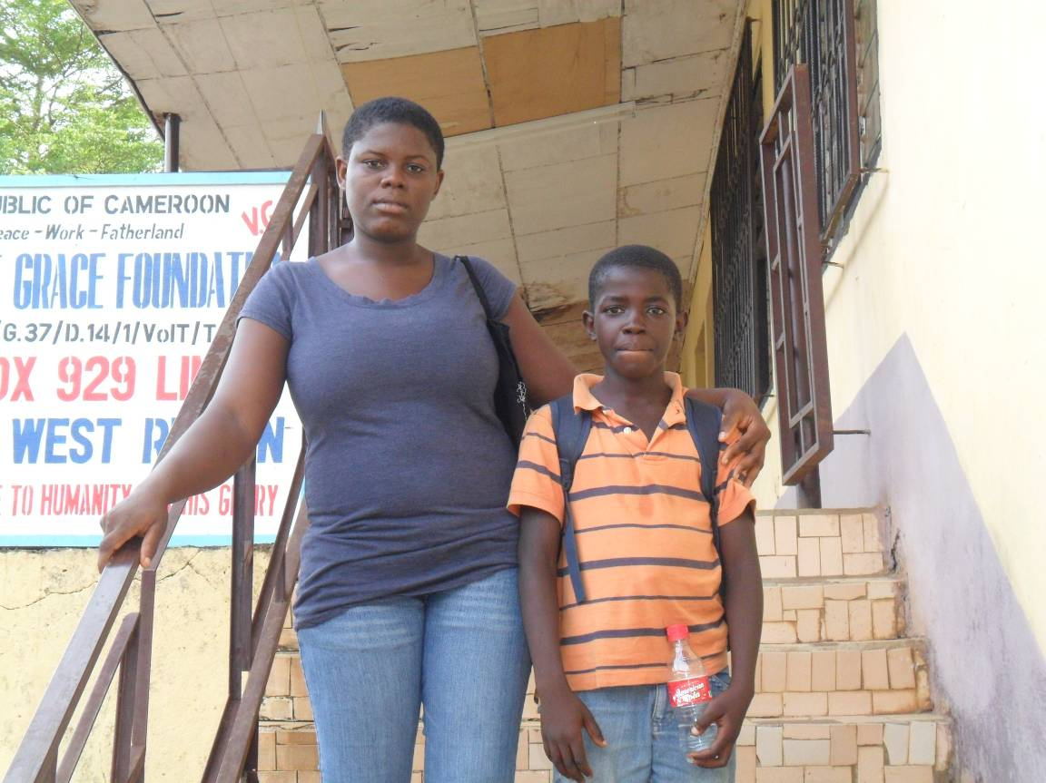

Honourine Mande and Younger Brother regain hope through Voice of Grace Foundation Cameroon (tuition and scholastic needs)
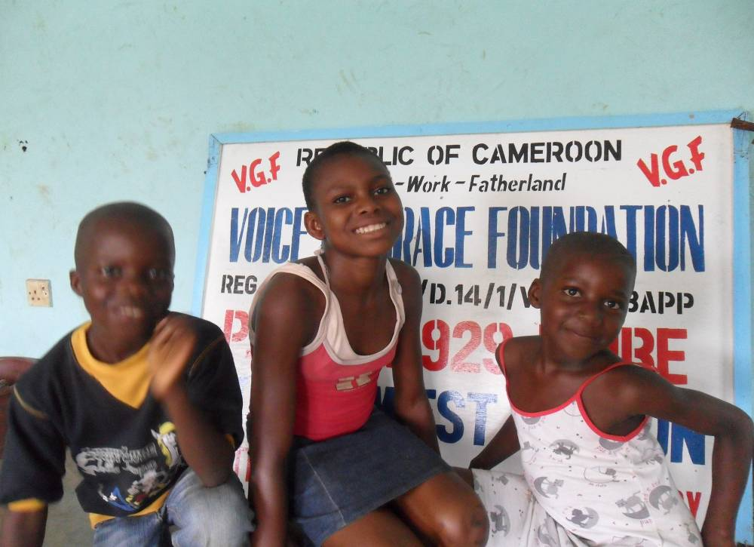

Voice of Grace Pupils Beneficiary – Gain scholastic financial support- Thank the Voice of Grace Foundation Cameroon for being our source of strength and hope.

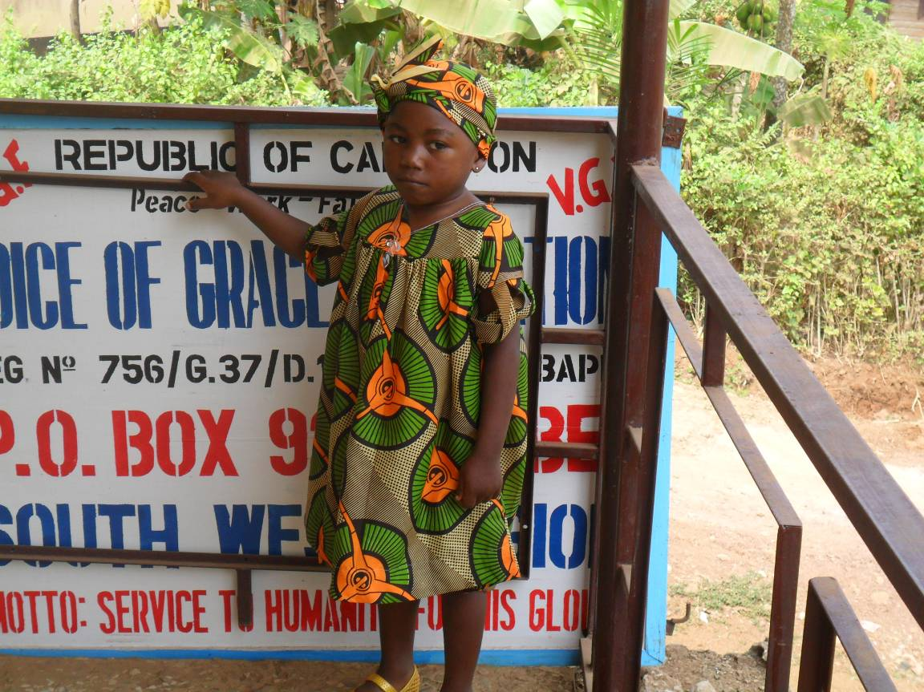

Pollet Akonwi thanks VGF for paying her school fees, and taking care of her medical bills. Voice of Grace Foundation Cameroon, thank you for giving me reason to live!
Appendices 2- Vocational training 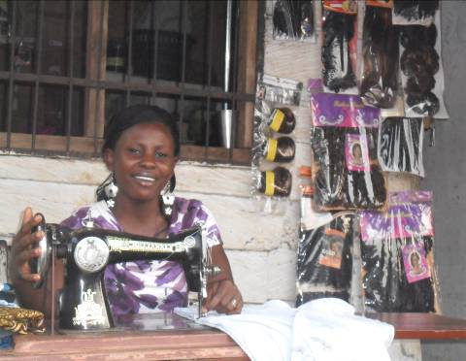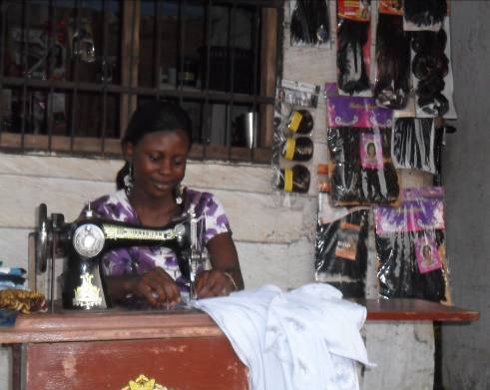

VGF your support to the teenager like us proofs your mission is true. Thank you for giving me life through this largess.

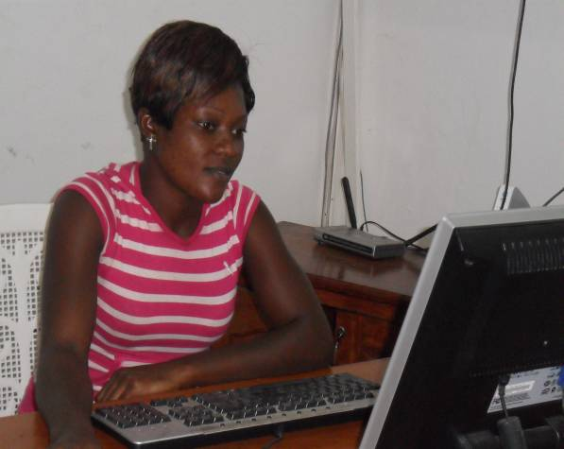
Emilia transforms her status as low minded single teenage mother to a heroine through the vocational training program of VGF.(from a cleaner to a hostess), I was nothing but through the Voice of Grace Foundation Cameroon mission of empower the single teenage mother and rural and urban poor women, I am what I am today. God bless you.

Appendices 3- Micro enterprise development/Small business Scale Financing
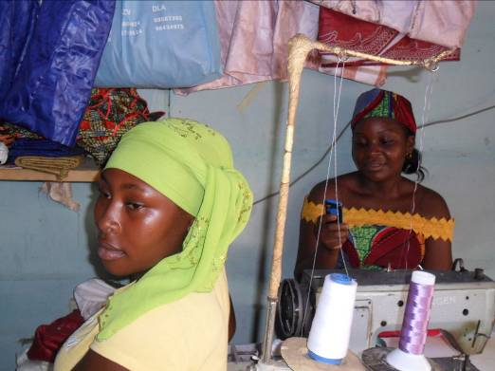
Amina Issatou & Mimouna Yausifu, share their testimony to the world. They can now make fabric and produce African wears that is fast capturing the town. Even though tradition deprived us of education, we are back in the blues and are paving our way back to life. Thanks to Voice of Grace Foundation - Cameroon

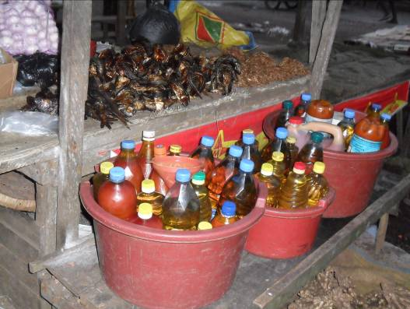
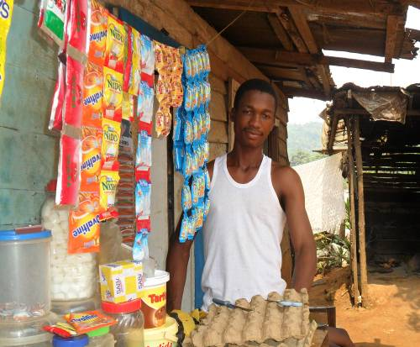
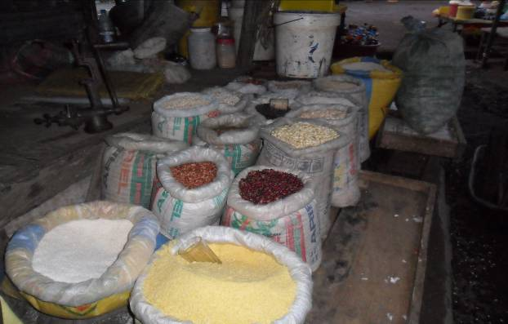

Mr. & Mrs. Ngomba (Pascaline Atenghem)
demonstrate the power of seed grant/or capital. The Voice of Grace Foundation –Cameroon has changed my life through the seed capital granted to my wife. I work as a security guard a pay of less than one dollar a day. To pay accommodation, take care of my commitment when they fall due is a difficult dream to realize. But VGF has changed all of this and we have stepped out of poverty with ease. Indeed we are a living testimony of what this benevolence.
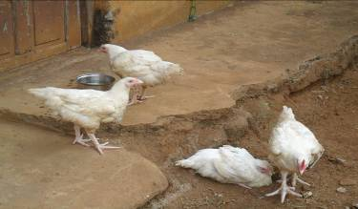
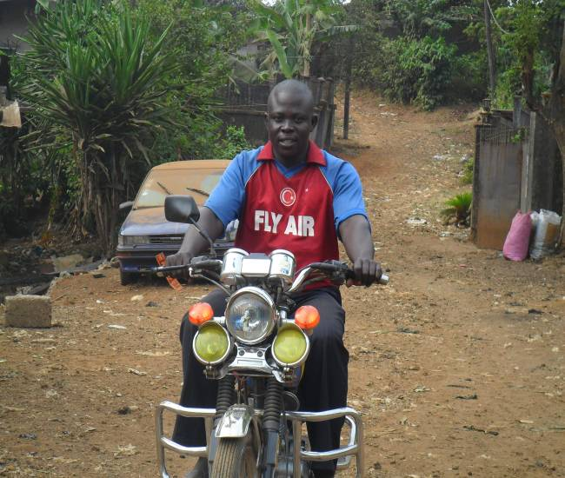
Mr. Ndeh Ernest Njinwi through the Voice of Grace Foundation Cameroon-Social Facility Investment Fund gained self employment.

Hardly could I pay my accommodation, fend for my family nor send my children to school. But through the Social Facility Investment Fund support I was able to obtain a Senke Motor Bike for myself. I have now through this auto employment, changed my life. All my three children are back to school and my wife is at the verge of completing her saloon work. Thanks to VGF for lifting the fallen!

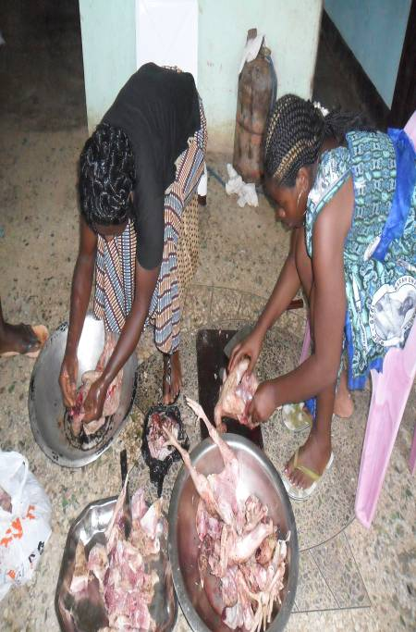

Fighting hunger amongst the poorest of the poor is one of VGF-Cameroon Outreach program, where food is usually prepared taken to the sick, needy with no one to look after them every week. This is an example of such preparation. Below is are some pictures of such days in the office where orphans have the opportunity to share with
us at VGF ‘s office
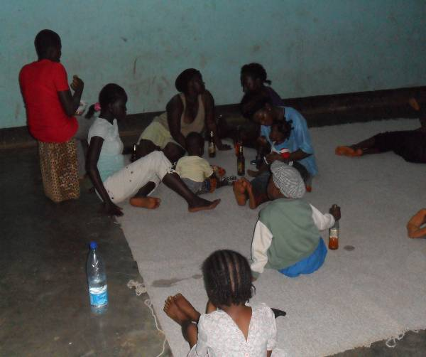
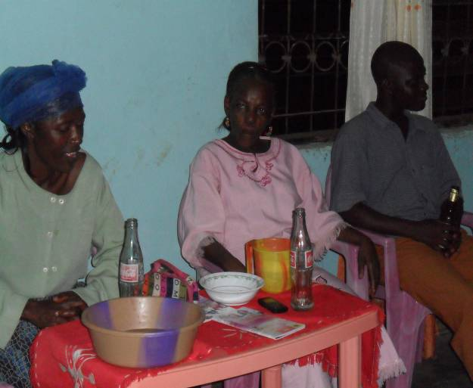

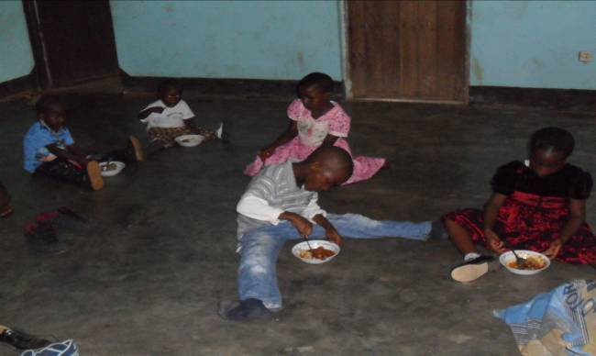
sharing with the children makes them grow responsibly , learning, love, sharing and giving.

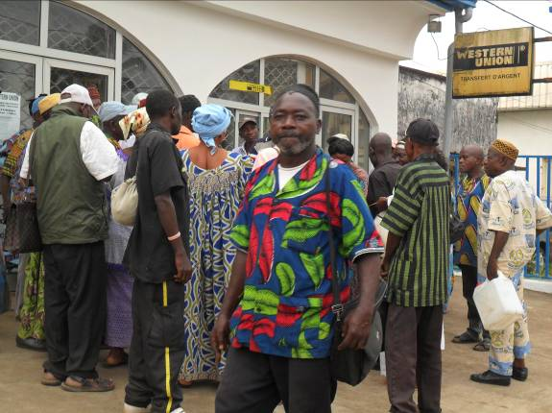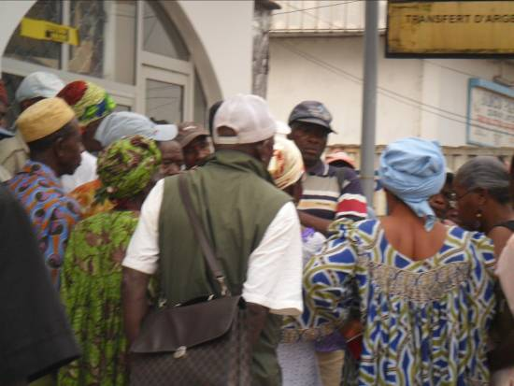

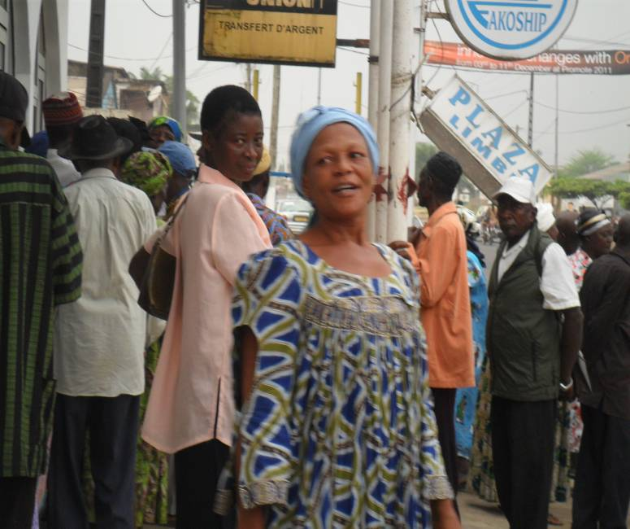
We thanked the Voice of Grace Foundation Cameroon for this largess they have shown to us. We wish for many more of such gestures and pray that other organization should emulate their example. Again thank you for being our source of strength.

The old people queuing up to receive their Christmas gifts at the Bank made available by Voice of Grace Foundation. The joy and excitement is out rightly express by this mother. This is still part of our outreach programs.

Com.PHAST
The pictures below show the improper ways of waste disposal. Disposing off dirts in
the water contaminates the waters.
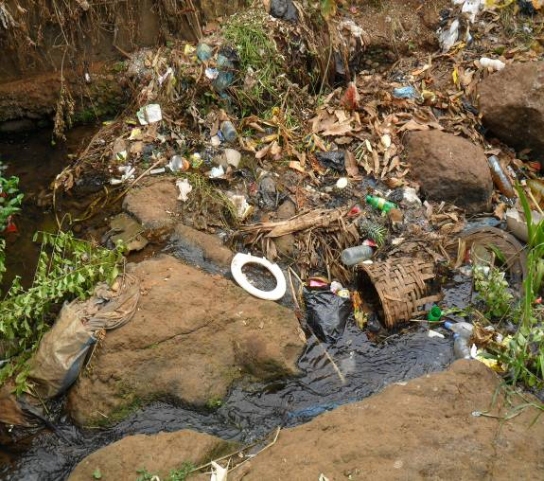
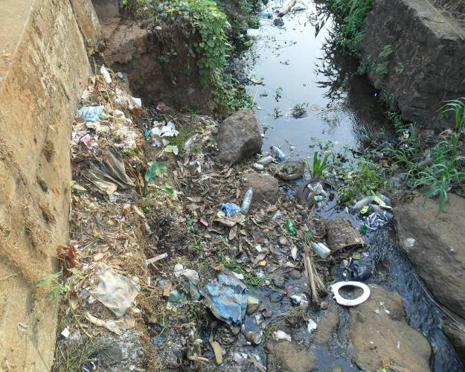

We have started a training program to change people behaviour on this in the primary schools. We envisage to enter the community this year with the PHAST Program. See the picture below. This is aimed at preventing contamination which often leads to widespread of waterborne diseases like cholera, diarrhea, and dysentery etc. as well as clean up campaigns.
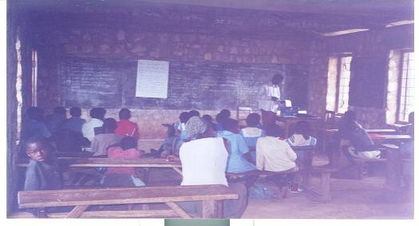
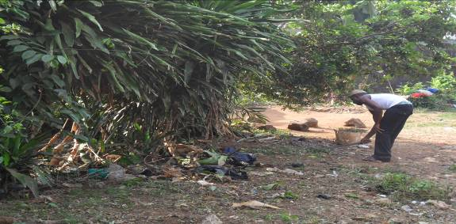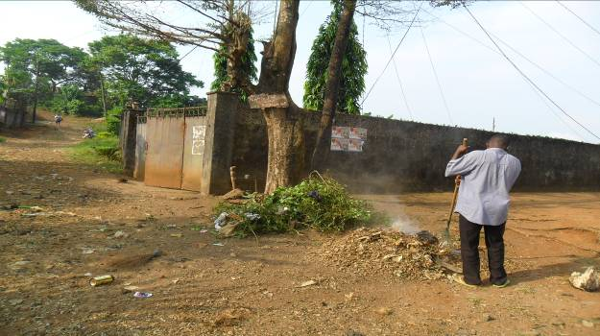
With the first clean up campaign launched, our environment is now taking a different shape. People have begun practicing what we are doing. We intend making this program a contest so as to get more people involved. Through this approach, simple hygiene would be maintained and many would lead healthily.

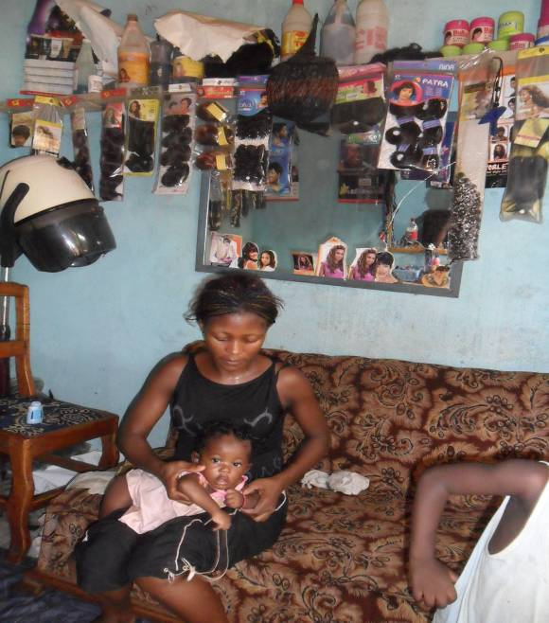
I heartily thanked Voice of Grace for supporting and making what I am. When I completed my elementary primary it was not easy for me as a young girl. My father wanted me to go and marry instead of bordering him with the issue of a vocation. It was a hard nut to crack. But thanks to the benevolent of Voice of Grace Foundation that intervened and made a success. I am now a responsible mother of two and can comfortably support my husband in the home.
Long live Voice of Grace Foundation Cameroon! I pray your light will never grow dim.

The Open day ceremony saw a great multitude that came from far and near to bore witness to this occasion. The pictures below highlight the essence of this day in VGF

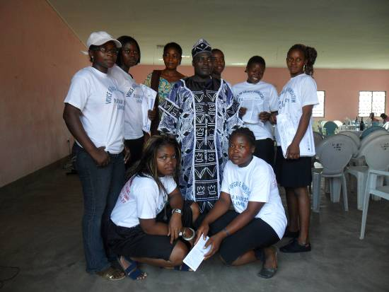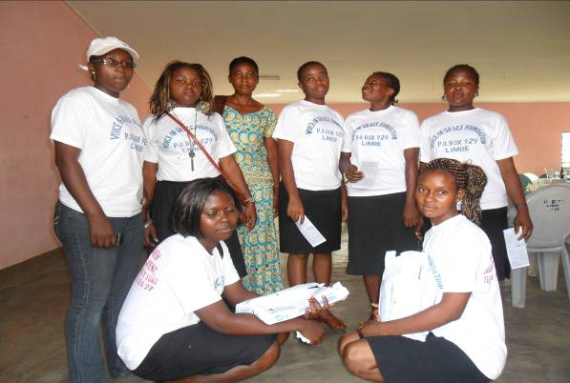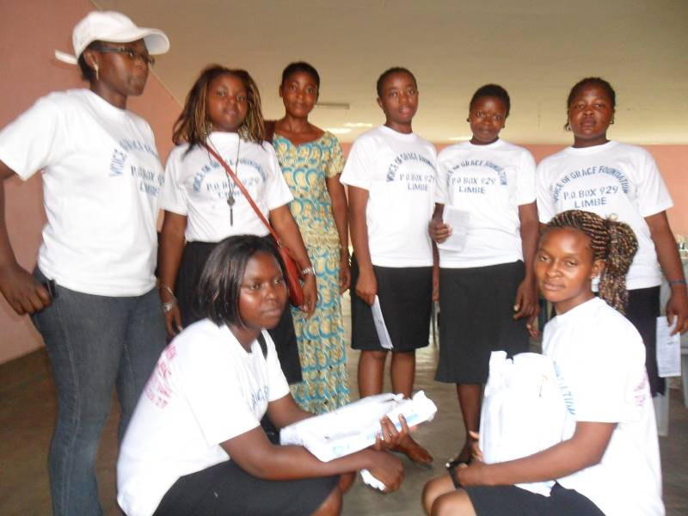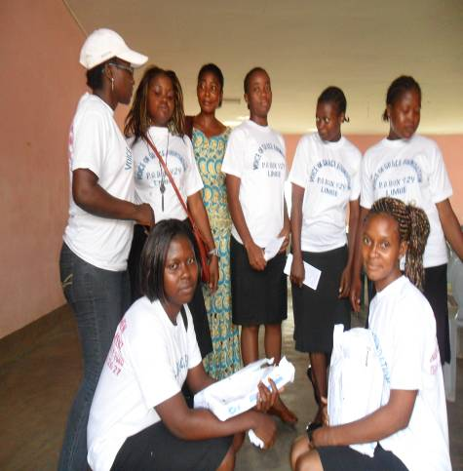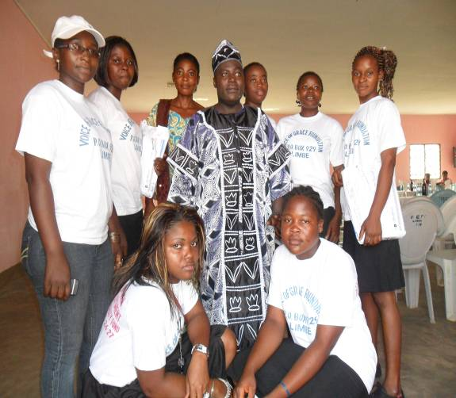

Voice of Grace Foundation Director with the Vocation training programs beneficiaries during the open day ceremony. Celebrating the lives of these young girls is really a fascinating experience to the crowds that was overwhelmed with the tremendous activities of VGF.

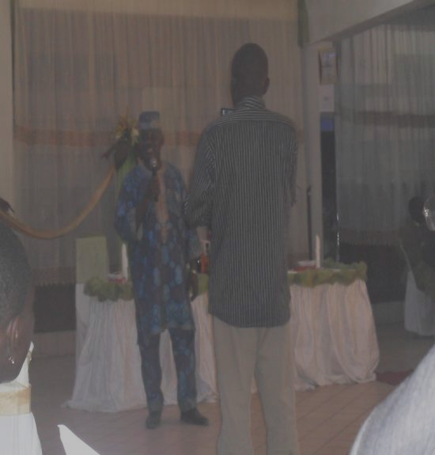

Celebrating five years of achievements and accomplishments, five years of lives transforming experiences, greatness, love, joy and hope with Voice of Grace Foundation Cameroon. An elite Moses Taku applauding the transforming scenario he witnessed on the Open day ceremony.
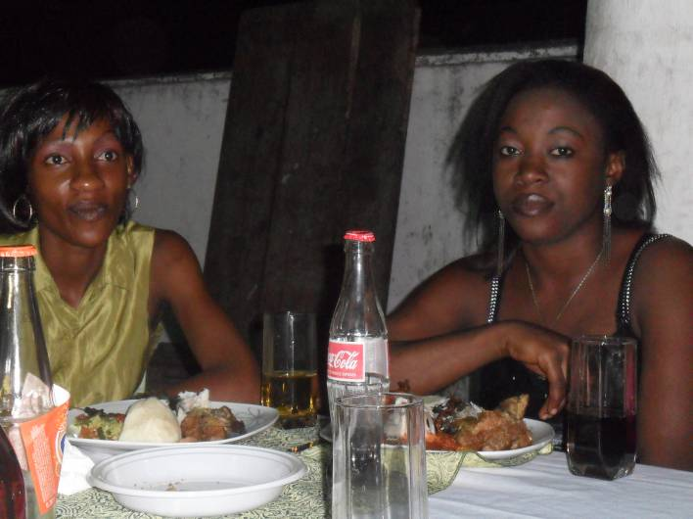

Beneficiaries celebrating the open day occasion in a magnificent way.

Some cross section pictures of the office before renovation 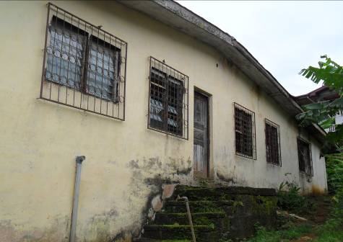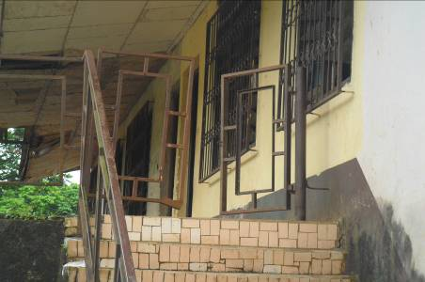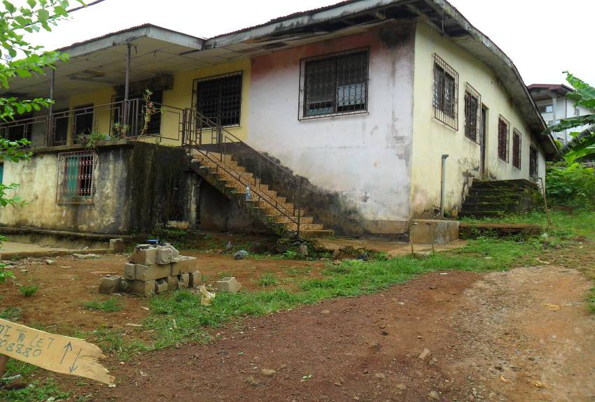

These pictures show the state of the office when it was not yet renovated. It was a delepileted building. But the organization has put in some effort to make it befit its status. See the pictures below.

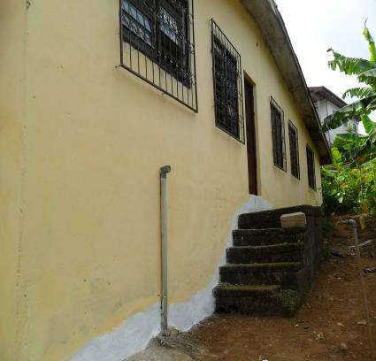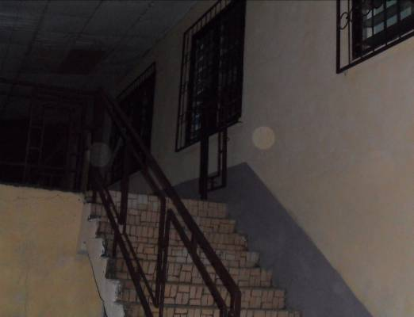

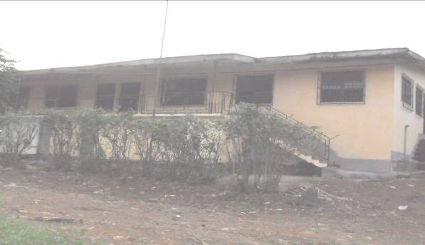
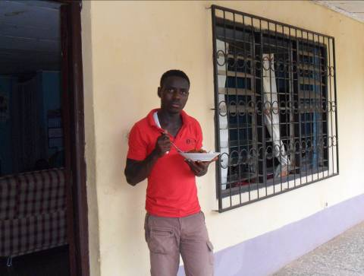
These are cross sections of the office after renovations.

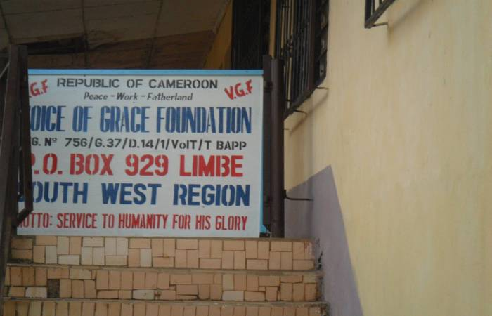
This is Voice of Grace Foundation Cameroon Sign Post in front of the office premises. Visitors coming to the office cannot mistake it as it sign post is put at a strategic point of the office.

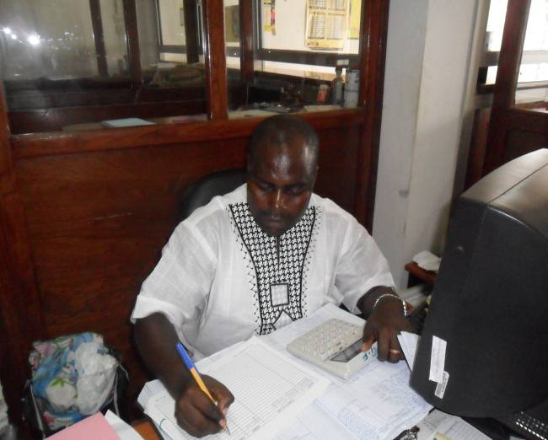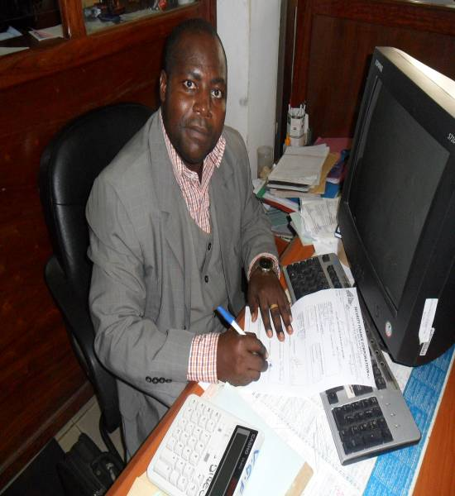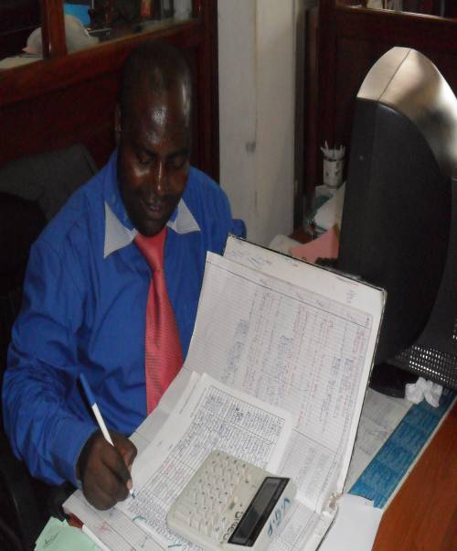
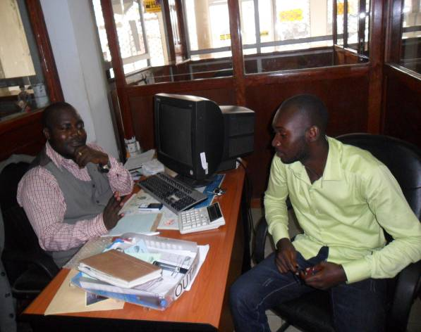
Director of Voice of Grace Foundation Cameroon working on the financial report for the fiscal year 2011/2012 and the annual budget for the 2012/2013

Director explains the mission of Voice of Grace Foundation to a quest visiting the office.

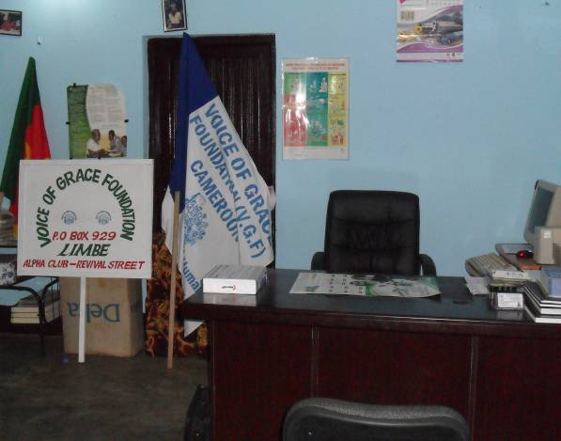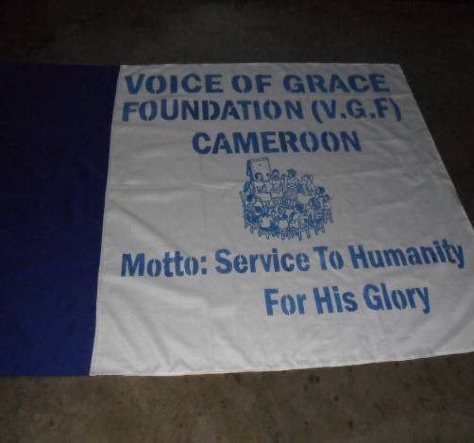
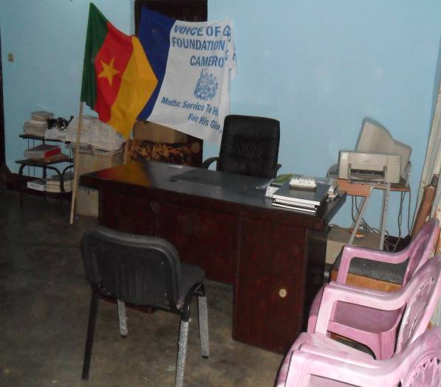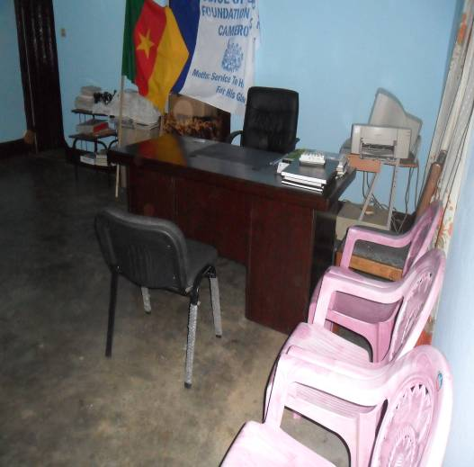

The Voice of Grace Foundation- Cameroon office in its uniqueness.

