BEES KEEPING PROJECT PROPOSAL:
Youths and
Widows Association
Biwang Village
TABLE OF CONTENTS
Name of the Organization: | Biwang Youths& Widows Village Associations Projects {BOWAP}
Banking Details: | Stanbic Bank Uganda Limited SWIFT Code:SBICUGKX  USD Account number 04096521 Deutsche Bank Trust Company Americas New York, NY SWIFT Code:BKTRUS33  ABA:021001033  Account Number:9030002570849  Account Name:OLARA GABRIEL
1.INTRODUCTION
2.DESCRIPTION
3.BACKGROUND
4.GOAL & OBJECTIVES
5.METHODOLOGY
6.PROJECT ESTIMATES
7.PROJECT BENEFITS
8.MONITORING & EVALUATION
9.CRITICAL RISK $ ACCOUNTABILIY
10.APPENDICES
11.CONTACTS & PHOTOS
12.ESTIMATED FUNS

BEES KEEPING PROJECT PROPOSAL: BIWANG YOUTHS AND WIDOWS VILLAGE ASSOCIATION PROPOSAL {BOWAP}

- INTRODUCTION

The Biwang Youths and Widows Village Association Project (BOWAP) is a voluntary, non governmental, non political and
Multisectorial organization which is run by Adults and youths of different disciplines and different
Nationalities in close cooperation with local communities in Northern Province of Uganda.
It is linked to other Village Concept Project in Pader through the International association of
Village Concept Projects and its main goal is improvement of health and living conditions in
Underprivileged communities through increased self-reliance and responsibility, establishment
Of sustainable development initiatives and resource management as well youths capacity
development.
BOWAP was formed in May 2011 having developed from the Community Health Project in the
Pader Commune, Uganda. The scheme was init iated by a partnership between Widows Women, Elders And the Youths of different talents.
The BOWAP follows an inter-sectorial approach. In the moment there are three running Micro
Projects and two initiatives:

Micro projects

-HIV/AIDS Awareness Micro Project
-Hygiene, water and sanitation Micro Project
-Income generation
Initiatives
-Let the little children come to me orphan center support initiative
The participation of the community is an essential aspect of the implementation of the project
and, more generally, of basic health care. The key factors of the proj ect are the people of the
Community. They are empowered to greater self-reliance and more act ive and responsible
Involvement in improving their own health. Thus, they are involved in all stages of Proj ects.
From the initial planning through to the evaluation.
The bees keeping project aimed to empower economically the local most vulnerable people
(Widows association from Biwang Village, Omot Sector/ Northern Province of Uganda) with
bees keeping skills and capacity as way of addressing rural poverty and general health issues.
The Bees keeping is emerging in Uganda as a successful agricultural practice for local people in
rural areas. The pract ice of bees keeping has intrinsic health benefits through the provision of
food of great nutritional value which is lacking in the target community. A bee keeping requires
few inputs and capitalizes on a ready supply of pollen.
In rural areas in Uganda, there is almost an unlimited source of pollen and bees aid great ly in
the natural cross pollinisat ion of local crops. Health benefits for local people reliant on small
agriculture to provide food are cent red around the enriching quality ies of honey in a diet which
is usually dependent upon staple foods such as bananas, potatoes, beans and maize. Uganda-BOWAP

2. DESCRIPTION

The average per capita income of Uganda is evaluated at 250 $ US and about 70% of the total
population are earning less than 1 $ USD per day. The full establishments of one hive costs
around 300,000 UGX. The projected revenue per one hive and annually is estimated at 40,000
UGX thus the bees keeping project represents a viable and sustainable microeconomic
enterprise which provide health benefits and its practical insurance against crop failure and
local unemployment. There is major potential for grassroots poverty alleviation and
empowerment of local people (Widows) through the practice of beekeeping.
This project aims to establish 60 hives on the land of the Biwang Central community (Biwang Village),
in the sector of Omot, Pader district in the Nothern Province of Uganda.
These hives and the initial training of 50 members of this local community will be used as platform for support of 50 widows who are interested in beekeeping.
The major goals of this project are to provide new income scheme for the work for the widows
in the community and to alleviate poverty through the training and support of local people in
the practice of beekeeping.
The project details, project management, Full costing, critical risks are given I this proposal.
Project site: Biwang Sub sector, Omot sector, Pader district in the Nothern Province of
Uganda
Beneficiaries: 100 Youths,and 50 women (widows) members of the widows association from Biwang

3. BACKGROUND

Uganda has been deeply upset by the 1986 genocide, Civil wars, and the ensuing events, and is yet to
come to terms with its past. The event caused the uprooting hundreds of thousands orphaned
and widowed.
Uganda is a poor rural country with about 90% of the population engaged in (mainly
subsistence) agriculture. It is the most densely populated country in Africa and is landlocked
with few natural resources and minimal industry. Primary foreign exchange earners are coffee
and tea. The 1986 genocide decimated Uganda's fragile economic base, severely impoverished
the population, particularly women, and eroded the country's ability to attract private and
external investment. However, Uganda has made substantial progress in stabilizing and
rehabilitating its economy to pre-1986 levels, although poverty levels are higher now. GDP has
rebounded and inflation has been curbed. Despite Uganda's fertile ecosystem, food production
often does not keep pace with population growth, requiring food imports.
Most of the populat ion (98%) in the proj ect s target area has been reset t led there since
1986.The villages there have accordingly experienced massive unrest due to the newly settled
population, widows and orphans, which now represent the majority of the population, causing
demographic imbalance with huge economic impact. The living standards and the health
conditions of the population have deteriorated considerably due to domestic crisis in Uganda.
The needs assessment showed various needs apart from health, with strong inter-linkage and
inter-dependencies. However, health remains the central focus.
Other problems include low levels of literacy, high proliferation levels of AIDS, high fertility
rate and limited opportunities for employment.
The project area, Biwang is a hilly region (1660m-2100m of lat itude, about 29 42 and
2 33 of longitude) with a various kind of flowers and trees.
The social-e
conomic climate of the target population has great been affected by the 1986
genocide. Many have lost their members due to the genocide and others due to the HIV and
AIDS.
The bee keeping project will contribute to the poverty alleviation in the target population,
empower the beneficiaries, contribute to the improvement of health conditions of the
beneficiaries as well to the social-economic status in the target community (the widows
association is made up by people widowed by 1986 genocide, other widowed by HIV and AIDS
and others have their husbands in prison accused of genocide and by working together ,we
hope that this can foster the process of unity and reconciliation and to fight the stigma and
discrimination that fuel those affected by HIV and AIDS).
The bees keeping practices offers various benefits.
Economic benefits: production of honey (called in the history of humanity the food of gods ),
beeswax (used to make candles, sealing wax, beauty products, etc.), royal jelly, propolis,bees
venom,etc.
Environmental benefits: Pollinisation and fecundation, bees used to monitor the urban and
industrial pollution
Medical benefits: Apitherapy (honey used as antibacterial agent also used to prevent sclerosis)
Honey is used to produce different pharmaceutical products such as syrups
Players use honey as a good and secured source of sugar because of its hydrophilic, anti
diabetic properties.

4. GOALS AND OBJECTIVES

The main objectives of the project is to contribute to the alleviation of poverty in rural areas
of Omot Sector , contribute to the improvement of health and social-economic conditions in the
vulnerable groups of the community as well to promote sustainable development initiatives,
creativity, self-reliance and responsibility in the community.
To establish 60 hives and train a core contingent of 50 local community members in the
practice of beekeeping.
To introduce 70 local people (members of widows association) from Biwang village
to beekeeping as a means of providing personal and collective income and reducing
local poverty with a targeted 80% adoption rate.
Improvement of local health standards through the use of bee products such as honey
and propolis.
To provide financial resources for the work of the widows association in women
leadership training, project management, proposal writing, etc.
To establish an innovative model of microeconomic enterprise which can be replicated
in other parts of the region.

5. METHODOLOGY

Bees keeping in Uganda
Apiculture is the deliberate rearing of honeybees for production of honey and other bee products.
The practice of bee keeping is not new in Uganda and in the target community in particular. It was
done entirely in rural areas and on small scale for exclusively the production of honey.
It is in 1956 that the first modern hive was introduced in Uganda by Mr Roger Bauduin.
Current honey production in Uganda is 846 tons per year and this is done using traditional means
that require modernization. Uganda honey seems to be much appreciated and can as well be
exported.
The government of Uganda recognizes the bees keeping practice as an economic activity and a
potential contribution to the poverty alleviation and through the Ministry of agriculture, live stocks
and animal resources is trying to develop this practice and address the problems affecting this
sector.
The target area (BiwangSub Sector) has xerophytic vegetation that favors beekeeping
development. The major cash crops (coffee, bananas, sunflowers, etc.) and other trees such as
eucalyptus, pinus patula , serchostachys scandens, Share nutsetc. available in the Biwang forest where
nearby the hives will be established provide an interdependence system in which the bees
assist in carrying out cross pollination and fecundation. This eventually leads to higher yields
with farmers benefiting from richer crops. In turn the bees use these flowers as nectar and
pollen sources, which will eventually provide good quality honey with which the people will
generate income to improve their living standards.
Similarly the xerophytes vegetation in this area biologically enhances the existence of a large
And various population of bees.
In addition the climate of the area offers trophyic conditions for development of bees.
The temperature is 16-20 centigrade degree the whole year and rain is estimated at 1800-2500
Mm. This area has been greatly endowed with bees keeping and has not been utilised thus far.

The choice of the bee species and the types of the hives

The bee species and hives type choices influence the production. Hence we will put more
emphasizes on this.
Researches done in other areas of Uganda near the project site (Biwang Valley small forest and Omot-sec forest)
showed that the bee species apic malefic andonsonii is very productive and grow very well within
the conditions of the area thus we will selected this bee species for the project.
The queen of this specie produces 2500-3000 eggs and will be replaced each year.

The choice of the type of the hive is also essential. Based on former researches done here are the
Comparisons:

Types of Hive | Durability | Production per year |  | Costs
 |  | Honey | Cire
Ugandan Hive | 5 Years | 10-20kg | 1.8kg | 160,000 UGX
Kenyan Hive | 10 years | 15-25kg | 2.25kg | 200,000 UGX
Traditional Hive | 30 years | 15-30kg | 1.1kg | 270,000 UGX
Longstroch Hive | 20 years | 20-70kg | 0kg | 300,000 UGX
The project will use only longstroch and Traditional bee hives to maximize the production of honey. Given that the
wax is not produced at high quantity and its market is not good (1 kg of wax is sold at 5,000UGX on
local market and 1 kg of honey is sold at 8,000UGX)
The project beneficiaries have experience in bee keeping but the project intent to conduct a
training on bees keeping before the project starts. Many BOWAP facilitators are agriculture and animal
Keepers they will use their skills and knowledge to
make the project a success.

6. PROJECT ESTIMATE

Establishment of 60 Hives
Items | Numbers of Units | Unit Cost | Total Costs UGX
Hives | 60 | 300,000 | 18,000,000
Smokers | 10 | 150,000 | 1,500,000
Overalls | 10 | 100,000 | 1,000,000
Veils | 8 | 100,000 | 800,000
Gloves | 10 | 50,000 | 500,000
Wax[Cost/kg] | 15 | 70,000 | 1,050,000
Wires/Nails | 6 | 400,000 | 2,400,000
Total UGX |  |  | 25,250,000UGX
TOTAL in. USD |  |  | $= 10,100 USD

Training

Training will be divided into 3 phases, which will be run over a period of six months, and will
Cover the content summarized in Appendix 1. The training will involve both theory and
Practical elements with each phase involving three days of theory and two days of practical
Application. The training will be done by an independent beekeeping expert who has worked in
Apiculture in the region for at least 5 years.

Items | Numbers of Units | Unit Cost | Total Cost UGX
Transport for Facilitation | 30 days | 70,000 | 2,100,000
Stationary and Paper Work |  |  | 3,500,000
Consultancy Fees | 4 Trainers | 1,000,000 | 4,000,000
Follow up for Supervision and Monitoring |  |  | 6,000,000
Total Costs For Training |  |  | 15,600,000UGX
Total Costs for training |  |  | 4,640USD
FINAL COSTS TOTAL :Costs for Training and project estimates in one year in USD | Training costs + Projects estimates costs | $=6,240+$10,100 | $=16,340 USD

TOTAL COSTS IN= USD=6,240$ +10,100$ USD= 16,340.

7. PROJECT BENEFITS

One longstroch bee hive produces an average of 55 Kg of honey per year with few inputs
Required after establishment. One kg of honey in Uganda sells for around 8,000UGX ($ USD
2.7).
60 Longstroch hives can generate at least 21,500,000 UGX (9,000 $ USD) per year. 1$ USD=2,500
UGX
In a country where the average per capita income is US $ 250, beekeeping thus has enormous
Potential to galvanize the income of poverty stricken local people.
Given the projected costs and benefits one beehive would pay for its establishment costs and
More in the first year. With very little maintenance and ongoing labour required after
Establishment of the hives, apiculture is an extremely cost effective agricultural activity.
This project will be established on community land and a core group of 50 local people will be
Fully trained in beekeeping and will be supported in establishing their project. This will ensure
That local people are given access to a system of support and mentoring throughout the
Establishment of their own hives. The establishment of bees keeping project for widows
Association in rural areas of Omot sector (Biwang Village) will have benefits in augmented
Income, greater daily sustenance of the families of the members of the association and the
Ability to generate substantial savings in making wax based products needed for a subsistence
Lifestyle.

8. MONITORING AND EVALUATION

The BOWAP facilitator will weekly visit the project to monitor the progress. The association will
Produce weekly and monthly report on the progress of the project.
After 6 months BOWAP will assess the project in collaboration with its partners. Assessment will
Look at financial benefits, social benefits, achievements against goals and financial reporting.
After the assessment there will be a meeting with BOWAP, Partners, project beneficiaries and
Focus on planning for the phase two of the project

9. CRITICAL RISKS AND ACCOUNTABILITY

Critical risks associated with this project include:
-Poor adopt ion rate of part occupants and wasted teaching resources
-Wasted bee products in initial raids due to inexperience
-Vandalism to hives
-Longer lag time in establishment and product ion
The project managers will be fully accountable. Financial reporting mechanisms have been
Established and financial reports will initially be expected on a quarterly basis.

10. APPENDICES:
Appendix 1.
Training content

Major Topics | Sub-Topics
Bee Biology | -The Colony  -Workers Drones ant the Queens  -Duties of the Queen, workers and Drones  -Impregnating of the queen swarming  -Queen less Colony  -The unfertilized queen  -Bees Calendar
Bee keeping technology and equipment | -Types of bee hives[Traditional, longstroth e.t.c]  -Construction of different types of Hives  -Advantages and Disadvantages of above different bee hives  -Smokers  -Veils  -Bee hive tool  -Overall bee gloves and boots  -Advantages of bee equipments
Bee keeping rural development | -Factors considered in starting a bee keeping project  -Apiary site selection  -Tree species that favors honey productions  -Looking after bees  -Feeding bees
Hiving of Colonies | Use of baiting methods  -Use of catches box  -Use of clustered swarm  -Transfer of wild colonies  -Hiving by dividing as established colony[colony multiplication]  -Uniting a swarm to a colony  -Use of honey combs and burning method
Bee pathology | -Broad disease  -American foul brood  -European fowl brood  -Other abnormal conditions include; the children brood, store brood, the bald brood store brood Nosema- like protozoa [nosema apis]  -Dysentery  -Paralysis
Factors Militating bee industry I Uganda | -Bee predators  -Natural climatic condition  -Human activities  -Poor management of colonies  -Absconding
Common practices in apiary management | -Controlling swarming to your advantages  -Hive inspection  -Brooding  -Formation of a nucleus  -Prevention of robbing  -Feeding of bees  -Watering of bees  -Keeping of records  -Colony records  -Operational records
Manipulation of bees, extraction of honey and other bee | -Honey harvesting and what to look for [quality]  -Extraction of honey [processing] traditional methods and modern methods of processing.  -Bee wax extractions  -Equipment needed
Bee keeping economy | -Government stand  -National apicultural policy  -Structure of bee keeping industry in Uganda  -Market potential  -Products from the industry
Pollination and bee flora | -Foraging flowers for field bees  -Shelter establishment  -Trees that favor honey production e.g. acacia species, eucalyptus, Share Nuts.  -Environmental issues put into consideration  -Low frequency use of pesticide

The President of the Biwang Orphans and Widows Village Association.
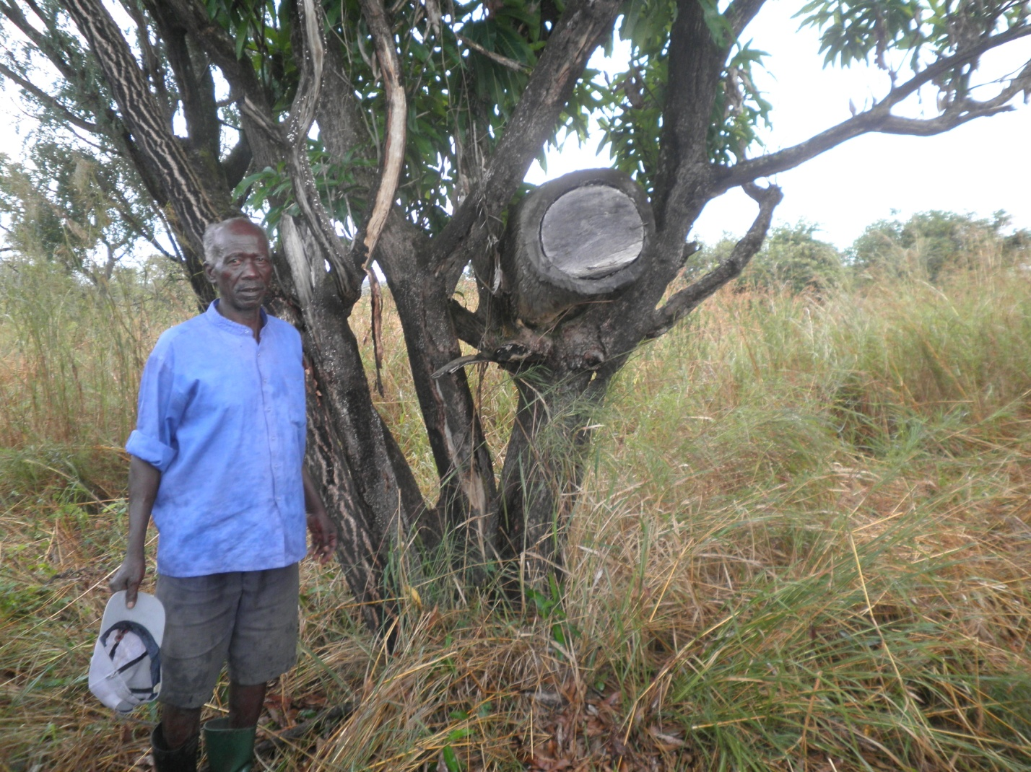

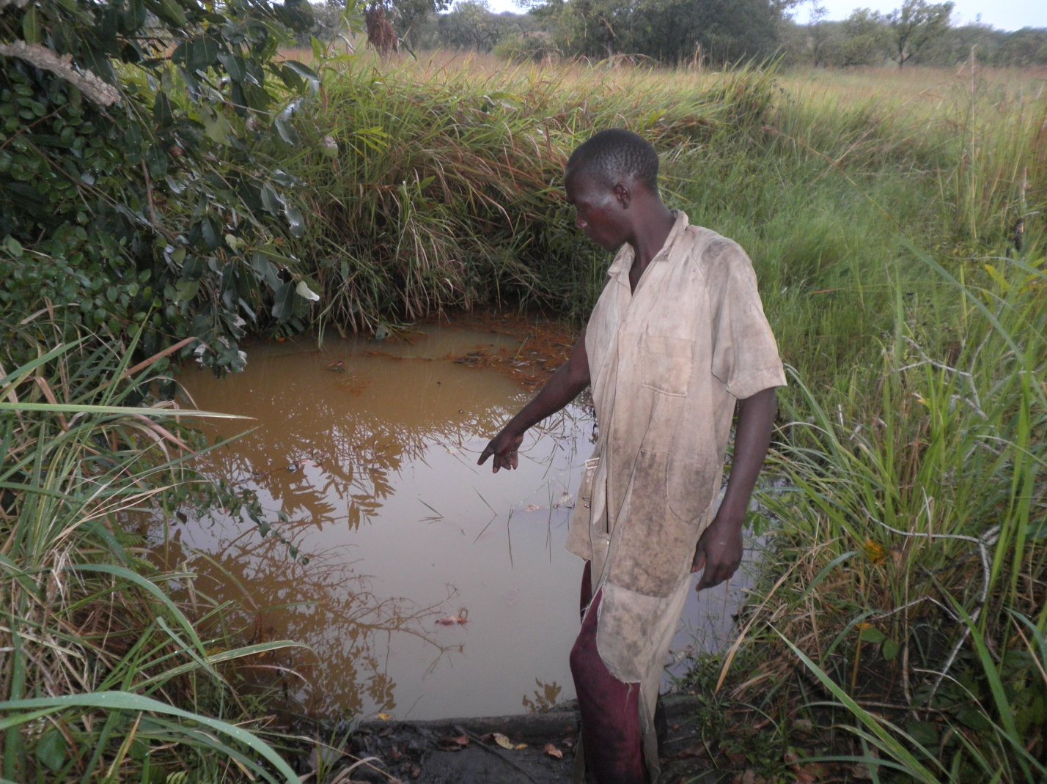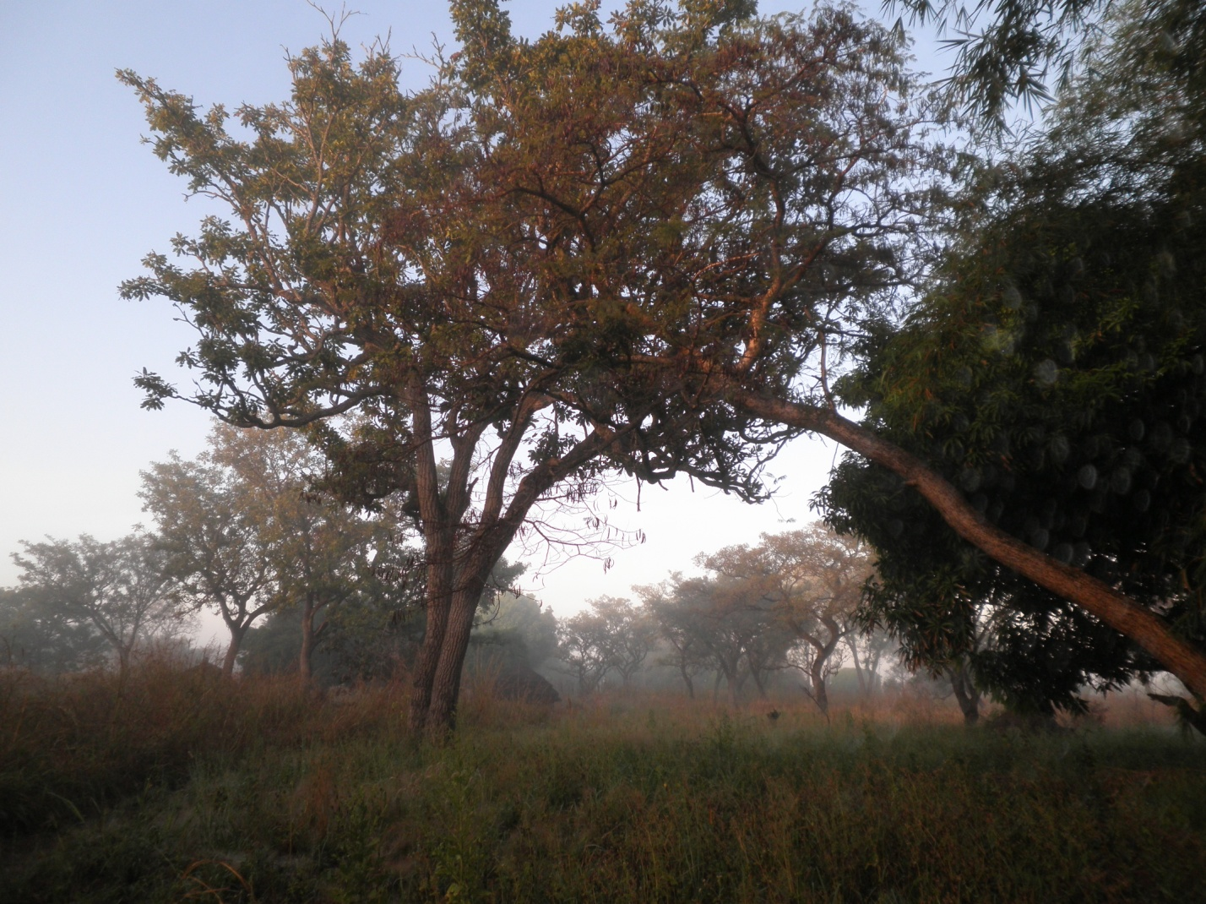 Groups of Biwang Village Widows.
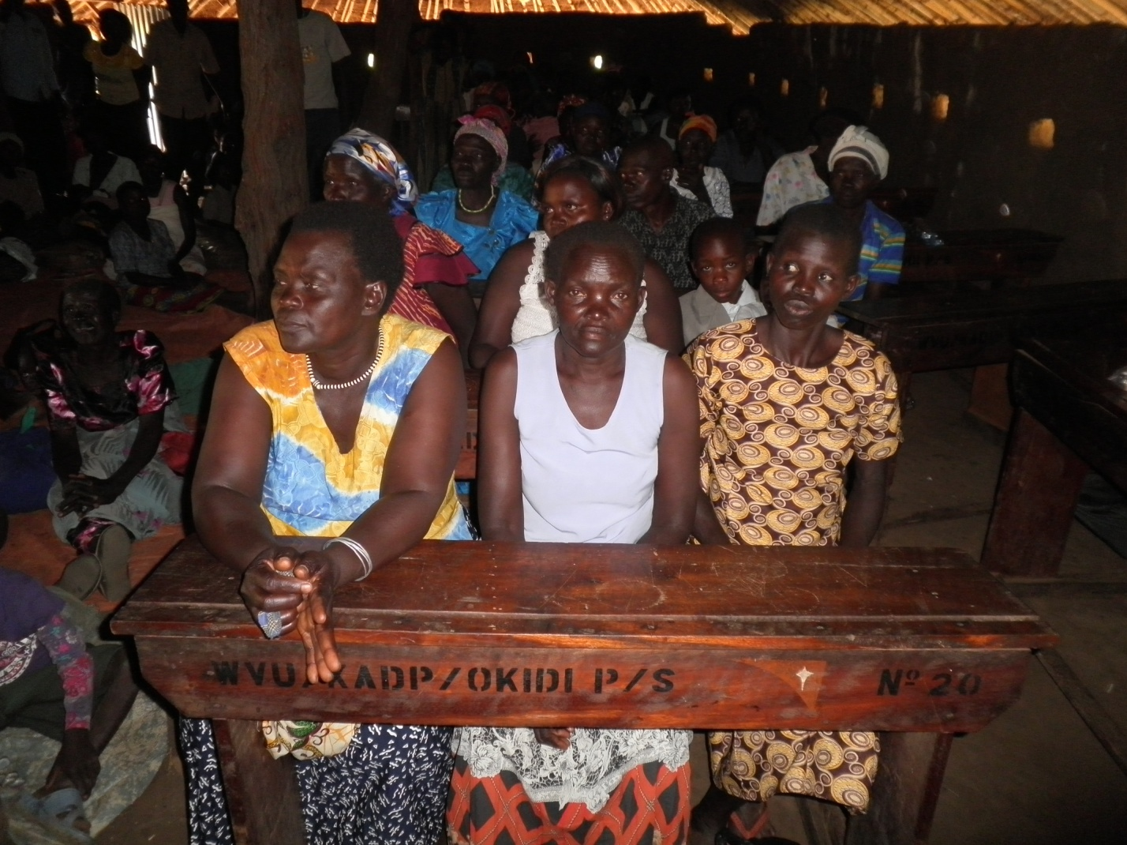

Groups of Youths of different Talents for Biwang Village .
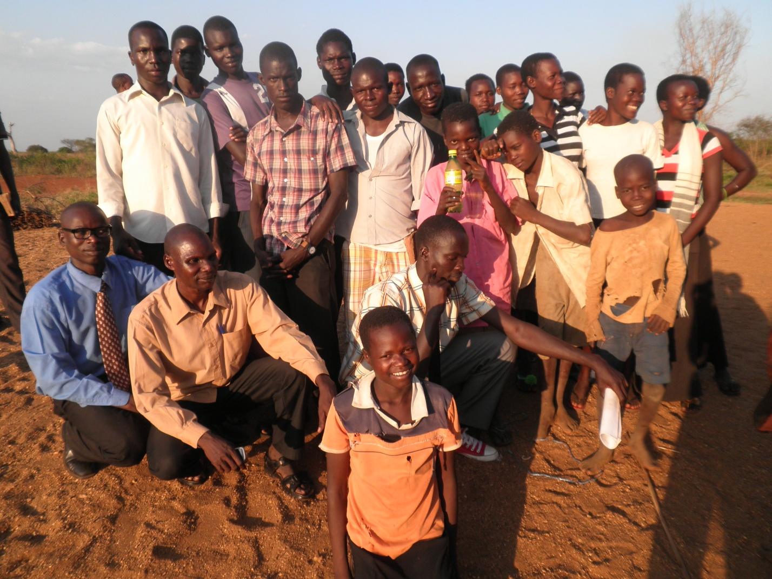

11. CONTUCTS

Project Managers and Contacts Persons:

- Gabriel Olara
BOWAP Coordinator
Personal Mail:gabriel.01engi@gmail.com
Tel:+256777002786

- Adiyo Colline
Head of income generation BOWAP
E-mail:adiyocolline@yahoo.com
Tel:+256777188513

- Julious Peter Okwera Ladi
President of the Youths and Widows Associations
E-mail: juliouspeterokweraladi@yahoo.com
Tel:0782458986

12. ESTIMATED FUNS REQUESTED

Establishment of | 60 Hives | 25,250,000 UGX
Training Costs | - | 15,600,000 UGX
Total in UGX |  | 40,850,000 UGX
Expected Total SUM: USD | $=16,340 USD

. REFERENCES:

Contacts
District Agricultural Officer
1.Robert Emasu
Mail: robert.emasu@yahoo.com
Phone:0793271012

