BRANCHES OF LIFE

INTERNATIONAL

(BOLI)

ANNUAL REPORT

FOR THE YEAR 2012
TO THE PROBATIONAL OFFICER
LUBAGA DIVISION
KAMPALA CAPITAL CITY AUTHORITTY

CC.The Commissioner Ministry of Gender and Social Development
CC.Health Inspector Lubaga Division

welcome - a word from the Executive Director
I am pleased to present the Annual Report of Branches of life International (BOLI) for the year ending 2012 .
since the foundation of BOLI in 2007, it has been gradually moving in the line with its objectives. Therefore iam happy to note that this year 2012, the Organization has registered tremendous positive achievements of reaching out to the young generation by resettling them back to their families ,feeding,medication,education and teaching them development skills. On an important note , we would like to thank our donor ,Omwana Foundation from the Netherlands who has enabled us to execute the organization activities by availing us with school fees. we only say "God reward you abundantly".
In the years to come , we would like to put much effort on increasing the children's standards of living. their resettlement rate, sponsorship package and establishing a permanent Children's home with in radius of 40 kilometers from Kampala Capital City Authority. All these programs are aiming at giving the children a better meaning of life.
I would like to thank the Community we work with for their continued Trust and support, not forgetting the local Leaders and even the International volunteers. We say "thank you for the dedication."
Finally, we look forward for the successful conclusion of giving disadvantaged children a second chance at life.
With the best wishes
................................
Kalunda Charles
Executive Director
ACTIVITIES CARRIED OUT
ACQUIRING PLOT AND BUILDING
This year 2012 , the Organization managed to acquire a plot of land and it was done by the funds obtained from
EDUCATION SUPPORT
Under this programme, the organization has managed to lobby for children sponsorship and currently all the children in the home got sponsorship and are all going to school including the sixteen girls and 3 boys who live with their Guardians in the neighboring community. To execute this activity very well, volunteers mainly from Netherlands and Germany have donated scholastic materials to children rendering programme to be effectively and efficiently run.

These children on this programme are studying well and produce promising progressive termly reports which are encouraging the organization leadership to put much effort on them such that they act as a good example of vulnerable children who succeeded in getting a second chance of life.
PROVISION OF WELFARE TO CHILDREN
By using donations, the organization has managed to cater for the welfare of children living in the home. They are fed posho, rice, potatoes, cassava, beans, vegetables, meat sugar, cooking oil and salt. Other food items from developed countries are donated to them by volunteers from Netherlands and Germany.

Also clothes are donated to them by volunteers and even shoes. So the organization leadership just provides shoes to only those who miss being given by the volunteers. Also the home managed to get a visiting nurse who comes in whenever needed.

FINANCIERS
Branches of Life Internationals' Administration team, headed by the Executive Director are a life time of our every time work in addition to searching for finances from here and there. Always in a right place at a right time, the service that our work needs in order to continue running cost effectively and accountably.

The administration department undertakes legal and finance aspects.
Legal:- That is decision making accurately, staff recruitment, proper documentation and record keeping plus law advices to all activities going on in the organization.
Finance:- Finance department processes are laid out funds received accordingly which depends mostly on the workmanship tires sly of the organization Executive Director and his team for fund sources to run the Organization. Our staff in the finance department supervises spending and keeps accurate financial records.

BOLI FUNDING SOURCES FOR YEAR 2012
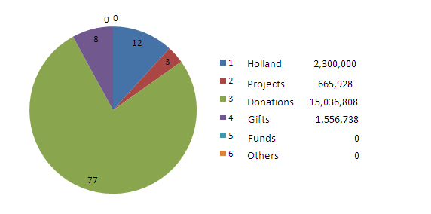
19,559,474
%
%
%
%
%

