‘School Mukhi’ (Towards School) –
Childhood stimulation and school enrollment

Detailed project concept

Submitted by: Revolutionary Ideology of Voluntary
Entrepreneurs And Realistics(RIVER)

Submitted to: HP

Background of the organization, its track record and achievements over the years:
Conceptualised by the doctors for structuring a healthy tomorrow, RIVER within four years (estd. 4th December 2003) has come up strongly in building the urban society in terms of health and education. RIVERIANS felt the vacuum, created all around us/nation in health, education awareness and other health concerns along with poor socio cultural, economic and important nation building activities are jeopardized by all means and started with their nation building process within there own limits. These years have been a period of hard work. The main focus area has been health with recent on look in childhood-education. The organization has tried to serve the people of Baranagore Municipality covering area of 7.12 Sq. Km. and population of 564,649 along with peoples within adjacent Kamarhati Municipal area and nearby people dwelling/squtting around and along Ganges- bed.
RIVER for its services towards the community has received appreciation and words of courage/support from Municipality &others sp. Govt agencies all along.

Details about the project holder and the core team:

The Secretary/E.D. of the organisation Dr. Arup Kr. Banerjee will head the project.
The core team of the organisation includes hard working volunteers and field staffs and professionals from different fields, like Academics, Financial sector, development as well as field sector.

Prof. Dr. Birendranath Roy, Veterinarian/Educationist (PRESIDENT)
Mr. Arun Kr Byabortta, Financial Analysist (TREASURER)
Ms. Sanchari Datta, Development professional (ASST.SECRETARY)
Mrs.Indrani Banerjee,(Programme officer)
Details of other projects of RIVER
Jyotirashi- A mass of enlightened students
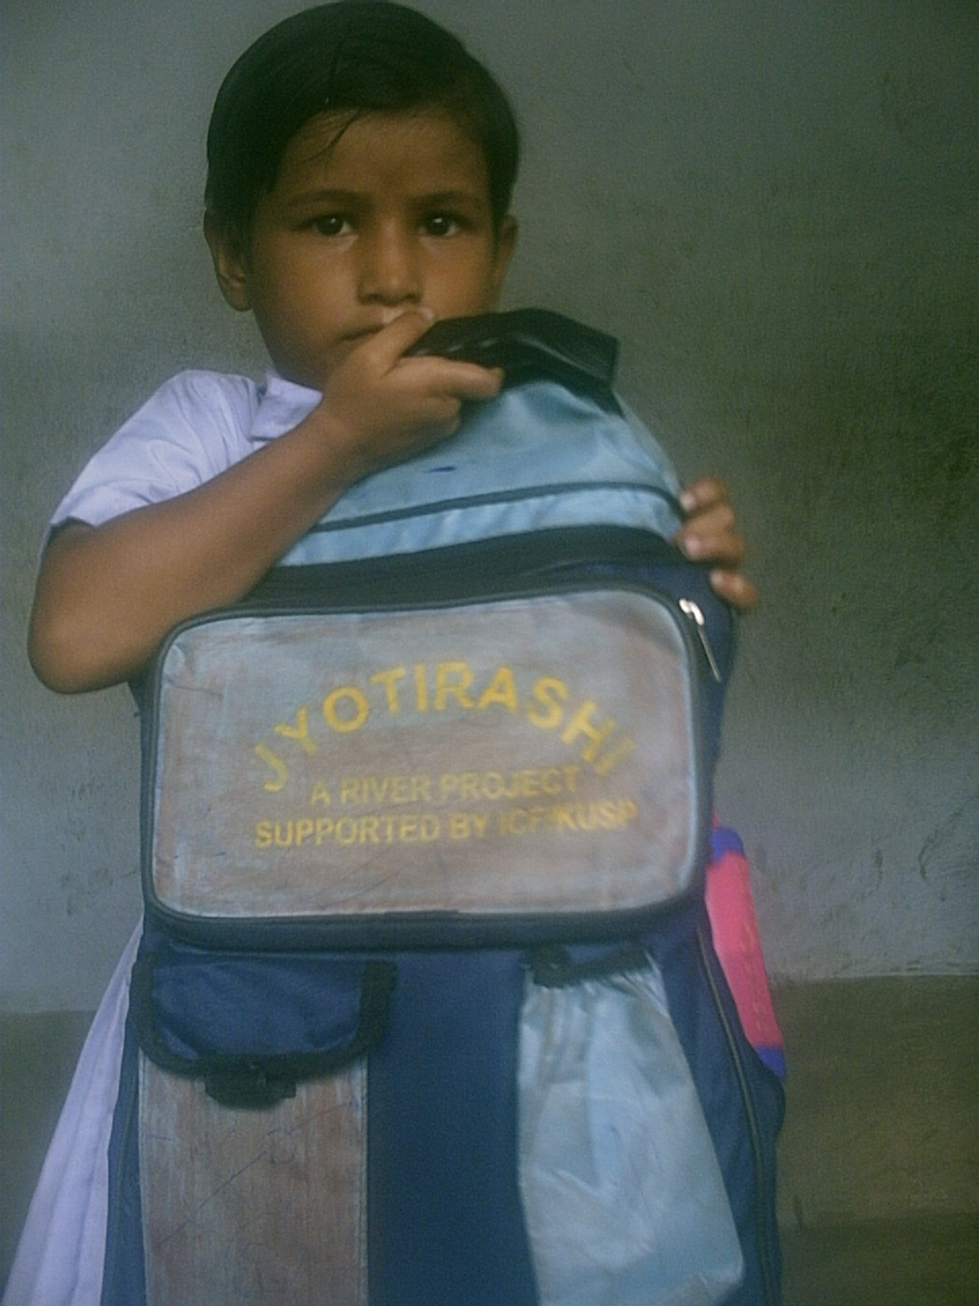
RIVER is preparing a group of students who are being sensitized on social issues specially ‘Education For All’ and will raise funds by collecting and selling out the waste materials (not garbage) of their schools & homes and then will take decision how to use that fund on mainstreaming out of school slum children and their retention through coaching support. This programme covered 120 out of school children from 87 slums of Baranagar Municipality with 216 children from 36 privileged schools who have been sensitized to generate fund from waste for the less privileged. The programme is almost at the verge of completion. The outcomes of the project have been balance, where children from majority of the schools took interest to generate funds and the group leaders showed immense significance to motivate their fellow mates. The out of school children are attending schools regularly and
They are monitored and supported closely by organisation staffs.
This programme is supported by I/CF-KUSP, GOWB.

Community Mobilization for Health, Hygiene & Sanitation and Nutrition:
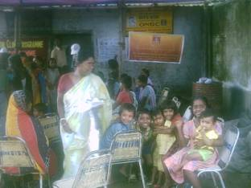The project is focusing to achieve a clean and healthy environment so that occurrence of viral and infectious diseases as well as communicable can be decreased. In slums the major lacking is awareness on hygiene and sanitation, which is the de-facto cause of viral infectious diseases. To ensure decrease in occurrence of such diseases among the community steps is being taken to clean the environment of slums by cleaning their surroundings, removing garbage from inside &besides their houses, planting trees(even medicinal) and cleaning water bodies nearby. Along with this to improve the nutritional and immunization status of children linkage with Government IPP/CUDP/ICDS programmes & also WHO is ensured to complement national immunization drive. The health promoter within the community through regular home visits and meetings provides counseling for better health care practices. Health camps, nutrition camps, awareness generation within the area half yearly are being organized to spread the message to a larger section who are unaware of their heath needs. The community is sensitized of the causes and its precaution as well as prevention. Also to support the community health curative health support is provided within the slum. A low cost clinic has been opened which even provides some basic medicines.
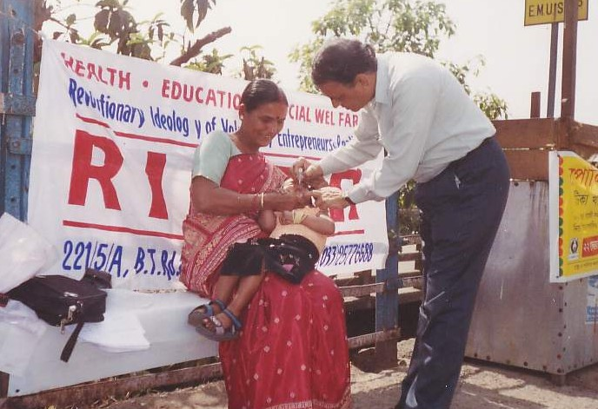
The project has received recognition from Municipality-ULB and community with great support from all stakeholders with direct participation of nearby CBO’s. This programme is supported by ONGC.
PPI-Pulse Polio immunization prog. with ULB(GOVT)as well as WHO (as monitoring agency at HOWRAH-Dist. –WB)

ARV for street-dogs& Awareness on Zoonoses with ULB’s and WB Vet. Directorate/Vet. University, CSPCA & IMA.

HIV/AIDS Awareness – World AIDS Day Celebration and throughout awareness generation among general population as well as truckers/vehicular operators plying nearby highly congested DUNLOP area on the causes and consequences along with precautionary/preventive measures of this deadly disease .For last 4 year’s this programme is supported by SAC’S(WBSACPS,GOWB).

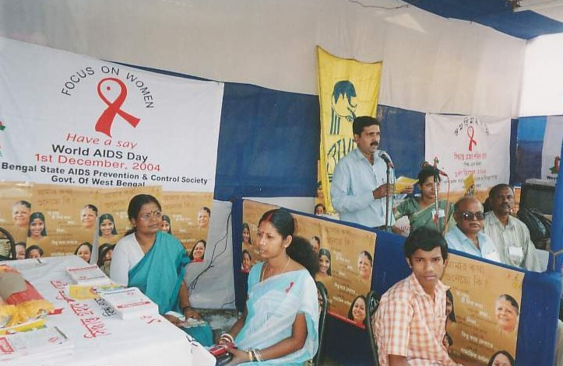
Complementing Immunisation Drive- vitamin A supplementation in support with Government (ULB) and CINI& local CBO’S.

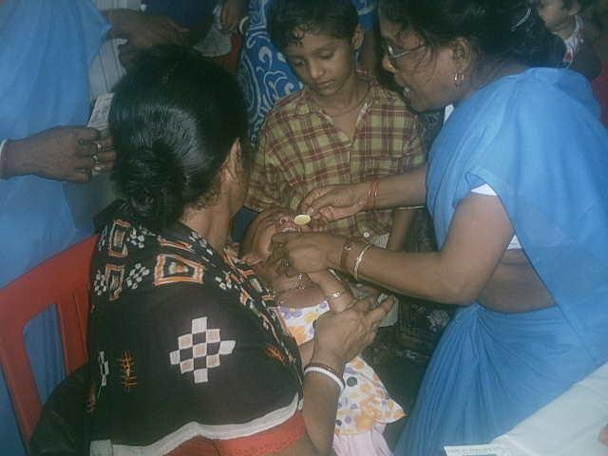
E-Slum- Computer based training programme for slum youths with computers provided by TCS.

Context of the project School Mukhi------
It is globally acknowledged that investment in human resources development is pre-requisite for economic development of any nation. Early childhood (the first six years) constitutes the most crucial period in life, when the foundations are laid for cognitive, social, emotional, health-physical/motor development and cumulative life long learning with habit formation. Children play because it is fun, but play is also key to their learning-it helps build their curiosity and confidence, develops skills of language, thinking, planning, organizing as well as decision making. Family members, surrounding peoples and other caregivers play a crucial role in this they need to know the major milestones that show that the child is growing normally. Moreover they also need to know when to seek help and how to provide a caring and loving environment for a child especially with disability both physically & mentally. Unfortunately early childhood care is almost nonexistent for poor communities in India and in most third world countries. Due to inadequate knowledge and skills, children receive poor quality of care at home with no stimulation, during the most crucial period of their mental and physical growth. This lack of awareness coupled with illiteracy also hampers their child’s school preparedness and performance, leading to children not going to school, drop outs, low attendance in schools.

As per 2001 census, India has around 157.86 million children, constituting 15.42% of India's population, who are below the age of 6 years. Of these only 7.1% of the children are in West Bengal. But a significant proportion of these children live in economic and social environment which impedes the child's physical and mental development.

Even after the efforts of Sarva Shiksha Aviyan (SSA), Integrated Child development Scheme (ICDS), the percentage of literate children below 7 years is only nearing 70% little higher compared to national level. This is pertinent with only 8% (March 2000) of whole country’s ICDS centers providing service and primary schools existing in West Bengal. The effort of State government has been of negligence. Monitoring has been poor; quality of service has been low.

There remains a huge gap from supply as well as demand side. There are not sufficient number of ICDS centers compared to children, even the number of sanctioned ICDS by Center per year have not been achieved by state. Also percent of children enrolling to ICDS pre-schooling and receiving service is only 16% of total 0-6 year’s children, but relatively better compared to national status of 10%. This data’s provide a gloomy picture for the future when we all are trying to move forward in achieving the MDG. These figures are complemented with the high rate of dropouts between classes I to VIII, almost 71% significantly higher than the national average of around 54%. All these are correlated to the socio-economic situation of the families and lack of awareness among these families.²

In the area where operating, 65 slums under Baranagar Municipality, the picture in no less severe. Among total 5276 children between the ages of 5-9 years one third (30%) are drop outs. This is a concern in implementation of Jyotirashi project how to retain the children enrolled in school. It is understood since these children are the first generation school goers they receive little support from the family in education also majority of the children are not mentally and physically developed to take the stress accompanied with economical factor leading to high drop outs. . These children have never been to school before and also their family environment has built in their carefree attitude. These families do not feel the need to send their children to school. As they know they will lead their life earning bread for the family sustenance. Thus it thus realised that for more enrolment and retention in to school they have to be prepared from early childhood along with developing the skill of their parents. As a result the project idea was conceived to improve the school retention and more enrolment into school.
Scheme also planned for Welfare of Working Children in Need of Care and Protection
Objective:
Provision of opportunities including non-formal education, vocational training, etc, to working children to facilitate their entry/re-entry into mainstream education in cases where they have either not attended any learning system or where for some reasons their education has been discontinued with a view to preventing their continued or future exploitation.
Target Group:
The programme will lend support to projects in urban areas, not already being covered by the existing schemes of the Ministry of Labour, which provide support for the wholesome development of child workers and potential child workers especially those who have none or ineffective family support such as children of slum/pavement dwellers/drug addicts, children living on railway platforms/ along railway lines, children working in shops, dhabas, mechanic shops etc., children engaged as domestic workers, children whose parents are in jail, children of migrant labourers/sex workers, leprosy patients etc.
Programme Component:
The programme will focus on measures such as [a] facilitating introduction to/return to the mainstream education system as children at study are not children at work, [b] counseling to parents, heads of families, relatives of the targeted children so as to prevent their exploitation, and [c] give vocational training wherever necessary.
The programme will be implemented through composite centre for providing any/all activities as indicated above.
Project- Socio-economic profile of the slums where the intervention will be operational.

Municipal Area: Baranagar
Ward Covered | 19 | Bustee Covered | 65
Total Population | 19562 | Total House hold | 4622
Hindu family | 4505 | Muslim family | 117
General | 3524 | OBC | 32
SC | 932 | ST | 11

Among around 7000 adult male population close to 80% have some earning, while only 50% of this population are engaged in organised sector like factory as labour or driving. Rest are based on unorganised sector leading to huge poverty within the slums. The women work as housemaids or are engaged in vending of plastic items.

Detailed project activities. - This needs elaboration. Information needs to be provided on the long-term goals, activities, curricular design, learning approaches, ongoing assessment, role of teachers and communities etc.

Goal- Retention of enrolled school aged children through better childhood stimulation

Activities –
  - Developing age specific curricular design with technical persons
  - Training of community workers and supervisors on child care.
  - Meeting with parents and care givers
  - Identifying children within 2-6 years
  - Home visits and counselling
  - Play house learning for children
  - Providing nutritious food and health check ups for children
  - Enrolment of children 5+ above to govt. primary schools
  - Meetings with stake holders.
  - Monitoring
    - Developing check lists for tracking growth
    - Developing MIS system for tracking progress of project

Pre-implementation activities:
The ground has to be prepared before the launch of the project. The curricular and methodology counselling the children have to be developed. This will be developed with the help of technical person of the concerned field. After that training will be provided to project team. At the same time monitoring and data management system will be developed.

Implementation level activities:

Identifying children within 2-6 years: project team with help of Government IPP/CUDP project, home visits, and meetings within community will identify children. In this project we will be working with 12000 populations. Hence no. of children between 2-3 years will be around 120-150 each year (10-12% of total population is children within 2-3 years). Another 10% of children will be of the age of 3-6 years hence around 120 children will attend play house and their development will be worked upon and simultaneously prepared for school in play house.
Their will be four community workers each looking after 30 children (2-3 years) each year and three teacher cum counsellor at play houses. One of them will have an extra responsibility of being the project coordinator. In play house their will be ayahs to help the teachers.

Home visits: Child stimulation will be the main activity which will be done by field staffs at individual level for children aged 2 to 3 years. During weekly home visits by four field staffs looking after 30 children each year will work with the child and their parents and caregivers on their physical, cognitive, motor and emotional development through age specific games activities etc. also they will be sensitised on child health, immunization, nutrition and education. Each worker will give around 45 minutes time at each household level, hence looking after 5 children each day.

Play house learning: Along with this their will be three community play houses for children aged 3+ to 5+ years, where they will be prepared for school going and at the same time get enrolled in primary schools. For building in community play house appropriate space will be identified which will be decorated with toys, games and other essential requisites, so that it attracts children.

Nutritious food and health check up: The project will be providing low cost nutritious foods to children in play house. Health checkups will be provided to the children and their mothers on a monthly basis.

Enrolment to primary school: Children above 5plus will be enrolled into government primary schools. They will be provided initial support for school enrolment. They will be provided with school dresses, bags and books/khatas. Weekly visits will be made to primary schools to monitor the attendance, performance and progress of the enrolled children. Need based coaching support will also be provided for those children coaching support will be provided for enrolled children.

Meetings: Quarterly meeting will be done with different stake holders like ULB. Primary schools teachers, ICDS workers.

Monitoring: To maintain quality of work, monitoring and supervision will be done thoroughly. Development of the children between 2-6 years will be tracked through indicators.

Strategies used while working with community members

Community based individual and group activities through home visits and play house and Linkages with local institutions- ICDS, Primary school, CBO’s and ULB.
Linkages with the various stakeholders.

Linkages with government system will be made at every level of project implementation, starting from developing curricular for child development. ICDS- Anganwadi activities will be followed and similarity will be built in.
For health support linkages will be made with government programmes for immunisation and preventive/curative health support.
Children will be enrolled into government primary schools.
Community based organisation space will be used for preparing play house and their support will be immensely required for its maintenance.

Process to measure psychological development of the children and their educational performance & the frequency of assessment?

Check list based on physical, motor, emotional, cognitive development as per age will be made and on a monthly basis each child will be tracked to measure their development. As per development charts next steps of action will be taken for each child.
Linkages with ICDS, also working towards strengthening the ICDS centres in these operational areas and an initial attempt to work with the government pre-schools
Linkage with existing ICDS as well as government centres
(though few & limited as per requirement) will be done during the whole project period in terms of curricular- development and for enrolment of identified children.

What percentage of the global budget is the funder’s component----

We for the project are requesting ------------ INR over three years. This will form 50(fifty) percent(approx) of total RIVER budget.

SCHOOL- MUKHI

TIME FRAME –1 Year

SL. | ACTIVITY | SUB –ACTIVITY | TIME LINE | CURRENT-STATUS
01 | Project guideline |  | First Month | Completed
02 | Selection & recruitment of Staffs |  | 1st&2ndMonth | - Do-
03 | Training recruitment of staff & exposure visit. |  | Do+3rdMonth | On going.
04 | Base line survey | House listing, Data entry, Identification of children (A+B+C category), Analysis& Report preparation | Do. | -Do-
05 | Play house selection & decoration, selection of Nutrition agency  Attendant recruitment. |  | 2nd &3rd Month | - Do -
06 | Meeting/Camps | Primary Schools, Parents, Community  Stake holders (ULB, ICDS, SSA etc.),awareness/immunization/Health camps, Daily supervision | 1st Month  Onwards | - Do -
07 | Development & printing of BCC Materials |  | 3rd Month | To start yet.
08 | Enrollment of children (category B=100 children, Category A= 100 children) | Category B in play house, Category A in GOVT. Primary Schools, daily supervision | 2nd Month  Onwards | To start yet  (After end of summer vacation of schools)
09 | House visit of selected children (category C=100 children) | Category C children at their houses with Weight, Nutrition and Growth chart/Health record Preparation/ Maintenance with immunization records etc., Daily supervision. | 2nd&3rd Month | Ongoing
10 | Classes starts (CategoryA-100 children & CategoryB-100 children) | a) Play house with check-ups, nutrition & uniform for Category B-all 100 children, and, b) Category A at Govt. primary schools with need – based support materials& after noon coaching support for all 100 children. | 3rd Month  Onwards | To start yet  (After summer vacation  Of schools)
11 | Follow up & routine monitoring with regular visits and update meeting | Quarterly report preparation along with accounting/audit reports & and sending to SDTT with documentation. | 1st Month onwards for 4 (Four) Qrts. | On going
12 | Dissemination workshop |  | End of 3rd yr. | Not within 1st yr.
N.B.Category A (Children aged between5-7yrs.),Category B (Children aged between3-5yrs.),Category C(Children aged between2-3yrs

RIVER’S ORGANISATION PROFILE:

Sr. No.
 |  | Name  Address  Tel No.  Email  Date of the establishment of the NGO  Name and Designation of the authorized signatory for signing the legal agreement if and when the grant is sanctioned  Contact Person |  |  | REVOLUTIONARY IDEOLOGY OF VOLUNTARY ENTERPRNEURS & REALISTICS (RIVER),  221/A, B.T.Road, 2ndFl.Kol-700036, 24Pgs(N), W.B  033-25789658,25776688,21154104  rivercalcutta@yahoo.co.in  river.calcutta@gmail.com  4.12.2003  DR. ARUP KUMAR BANERJEE SECRETARY/EXECUTIVE-DIRECTOR  DR.ARU P KR.BANERJEE
1 |  | Profile(general) of the Organization :  Is registered as  (i) Trust  (ii) Society √  (iii) Sec. 25 Company  (iv) Others |  |  | Give Registration Details (eg.  Registration no., date, Valid upto etc. along with a certified true copy)  Regn.NoSL-1L-18383 of2003-2004dt.4.12.2003  ii) Society  Certified true copy (bearing all details) to be sent via postal delivery, if reqd.
2A |  | Registration certificate U/S 12 A of the Income Tax Act 1961 of the Organization | Certified true copy (bearing all details) to be sent via postal delivery, if reqd.
B |  | Registration certificate under the Foreign Contribution (Regulation) Act, 1976 if any | -------------------------------
C |  | Previous year copy of the Income Tax Return | Certified true copy (bearing all details) to be sent via postal delivery, if reqd.
D |  | Copy of last Income Tax Assessment Order | Certified true copy (bearing all details) to be sent via postal delivery, if reqd.
3(a) |  | PAN No. | AAAAR3056Q
3(b) |  | TAN No. | NA
4 |  | Audited financial statements for the last 3 years | To be attached, if reqd.
a |  | Audited consolidated Balance Sheet | Certified true copy (bearing all details) to be sent via postal delivery, if reqd.
b |  | Audited consolidated Income & Expenditure Account | Certified true copy (bearing all details) to be sent via postal delivery, if reqd.
c |  | Audited consolidated receipts & payments Account | Certified true copy (bearing all details) to be sent via postal delivery, if reqd.
d |  | All schedules forming part of the financial statements | Certified true copy (bearing all details) to be sent via postal delivery, if reqd.
e |  | Auditors Report | Certified true copy (bearing all details) to be sent via postal delivery, if reqd.
F |  | Notes on significant Accounting Policies | As per ICAI Accounting Rules.
g |  | List of existing organizations which financially support the grantee’s activities | I/CF-KUSP, ONGC, SACS, ULB/GOWB, IMA, TCS, SDTT, GOI (Dept. of Env.)
H |  | Staff & Salary Structure
 |  | Number of Staff | Total |  |  | Male | Female
 |  | Salary Below Rs. 10,000/- | 10 |  |  | 3 | 7
 |  | Rs. 10,000 to Rs. 20,000/-
 |  | Rs.20,000/- to Rs.30,000/-
 |  | Rs. 30,000/- to Rs. 40,000/-
 |  | Rs. 40,000/- and above.
5 |  | Any other tax exemption certificates under the following sections which the NGO may have (attach certified true copy)
A |  | Section 80-G - For NGO approved u/s 80 G donor can claim deduction from taxable income subject to certain limits. | Certified true copy (bearing all details) to be sent via postal delivery, if reqd.
B |  | Section 35 AC – Donor can claim 100% deduction from taxable income in respect of donation to an Organization approved by the National Committee for carrying out any eligible project or scheme. | NA
C |  | Section 35 (1) (ii) – Donor can claim 125% deduction in respect of donation to a Scientific Research association  (iii) Donor can claim 125% deduction in respect of donations to a university, college or other institution to be used for research in Social Science or Statistical Research. | NA
D |  | Section 35 CCA – Donor can claim 100% deduction for donations to Organizations  which undertake rural development programs. | NA
E |  | Section 35 CCB – Donor can claim 100% deduction for donations to Organizations which undertake program of conservation of natural resource or Of afforestation. | NA
F | Area of Operation: |  |  | 24 PGS.(N) and(S), Kolkata, Medinipur(E).
G | Focus Area: |  |  | Education(Childhood stimulation with mainstreaming & Health care), Community mobilization with health care, community clinic, camps, awareness generation towards HIV/AIDS, hygiene, sanitation, plantation, mother & child health care.

Census of India 2001
Department of women and child development, GoI website
Survey conducted by RIVER in the slums

